Hebrew GRAMMAR Quest

Table of Contents

# Copyright

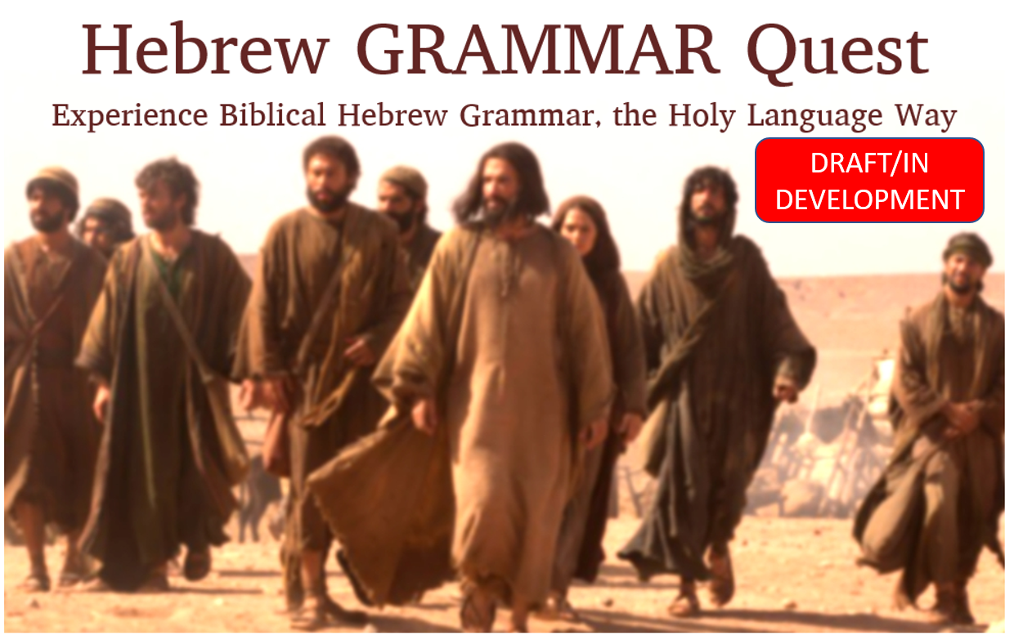

*Updated*: 2021-01-12

© 2021 Holy Language Institute. All rights reserved.



Creative Commons

This work is licensed under the Creative Commons Attribution-NonCommercial-ShareAlike 4.0 International License.

This license is for personal use only. This publication may not be downloaded, redistributed, re-uploaded, published, or used for any other purposes without explicit permission from the copyright holder.

If you received this book and you are not a member of Holy Language Institute, [become a member](https://holylanguage.com/subscribe.html) today! Subscribing will give you access to the full Hebrew GRAMMAR Quest course materials, as well as access to our founder, Izzy Avraham’s, complete library of teaching materials.

Unless, otherwise noted, English Scripture quotations taken from the NASB. Copyright Copyright © 1960, 1962, 1963, 1968, 1971, 1972, 1973, 1975, 1977, 1995 by The Lockman Foundation. Used by permission.

Scripture quotations marked ESV are taken from The Holy Bible, English Standard Version, copyright © 2001 by Good News Publishers. Used by permission. All rights reserved.

As applicable:

* Vocabulary portions of this book and accompanying Anki deck are derivatives of [00_vocabulary.pdf](https://hebrewsyntax.org/bbh2new/00_vocabulary.pdf) by John Beckman, used under [CC-BY-SA](https://creativecommons.org/licenses/by-nc-sa/4.0/).
* Grammar portions of this book and accompanying Anki deck are derivatives of [00_study_guide.pdf](https://hebrewsyntax.org/bbh2new/00_study_guide.pdf) as well as the “overhead” files for each chapter (for example [Chapter 1-The Hebrew Alephabet](https://hebrewsyntax.org/bbh2new/01_overheads_bw.pdf), and so forth for each successive chapter) by John Beckman, used under [CC-BY-SA](https://creativecommons.org/licenses/by-nc-sa/4.0/).

The photographs of Israel to begin each lesson are courtesy of the [Pictorial Library of Bible Lands](www.bibleplaces.com). Used by permission.

Biblical Hebrew text is courtesy of tanach.us (version 26.0).

# Getting Started / Getting Help

1. How do I navigate around this book?
2. How do I get started?
3. What is in a typical lesson, and how long will it take?
4. How to report an issue, error, omission, or improvement opportunity
5. How to ask a question if you get stuck

## Navigating this book

In the upper-left corner of this page, you will see a series of icons.

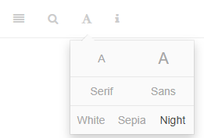

These do the following tasks:

* the file drawer expands/collapses the sidebar table of contents; you can also click s
* the magnifying glass toggles search input; you can also click f
* the big A allows you to change the font size and theme
* the little i shows you available keyboard shortcuts

There are several ways to navigate from page to page within this guidebook:

* Use the left-navigation sidebar (type s to reveal/hide)
* Click the left or right arrow on each page to go forward or back
* Use the left or right arrow keys on your keyboard to move forward or back
* Use hyperlinks on selected pages, like this one: Continue to the Introduction section

## Book features

Along the way, you’ll see some informational boxes. Here is what they mean:

QUEST

* The Lesson Itinerary - learning objectives
* Ruth Pursuit, Hebrew Quest Study Passages, and other “Quest” related topics

STOP

* Equipment Check - concepts from previous lessons you should know before starting the next lesson
* Other “Dont’s”

LIGHT

* A critical point not to be missed
* Other “Do’s”
* You will often want to MEMORIZE the concepts in a LIGHT box

INFO

Additional information that is good to know

CAUTION

A potential pitfall, such as a concept that could be easily confused with another

We also have footnotes[1]

## Quick Start Instructions

These instructions will get you up and running with the course.

**Anki NOTE**: Eventually, you can do all work from a mobile device. *For the initial Anki install, you do need to do these steps from a desktop or laptop*. The Hebrew GRAMMAR Quest Anki deck can only be imported into the desktop Anki application.

1. Download and install the [free Ezra SIL font](https://software.sil.org/downloads/r/ezra/EzraSIL-2.51.zip).
2. INSTALL ANKI
   1. [Sign up for a free Ankiweb account here](https://ankiweb.net/account/register).
      * Doing this allows you to synch your data to the cloud and mobile devices
   2. [Download and Install the Anki Program (Mac/PC/Linux)](https://apps.ankiweb.net/).
   3. [Download the Hebrew GRAMMAR Quest (Preview Version) Anki Deck](./images/Hebrew%20Grammar%20Quest%20PREVIEW.apkg)
   4. Change the Anki settings as described here.
   5. As desired, download the Anki app to your phone or tablet.
      1. The [Android app](https://play.google.com/store/apps/details?id=com.ichi2.anki) is free
      2. The [iOS app](https://itunes.apple.com/us/app/ankimobile-flashcards/id373493387?mt=8&ign-mpt=uo%3D4) is $25 - see discussions in the Appendix for additional discussion as to whether the cost is “worth it”
      3. Synch
         1. In your *desktop* Anki, click on synch (enter Ankiweb credentials) - upload to Ankiweb if asked.
         2. In your *mobile* app do the same, except here click download from Ankiweb
         3. Should you go back and forth between mobile and desktop, make sure you synch each time, and be careful when you select upload to or download from to make sure your information is flowing in the correct direction
3. You will need a Google account to complete many of the activities in this course
   1. if you do not already have one, or would like to create an additional account only for this course, click [here](https://accounts.google.com/signup/v2/webcreateaccount?continue=https%3A%2F%2Fwww.google.com%2F&hl=en&dsh=S-1425209384%3A1610207553422339&gmb=exp&biz=false&flowName=GlifWebSignIn&flowEntry=SignUp)
4. Open the [course checklist](https://docs.google.com/spreadsheets/d/1t0C7JlygyUqgF_aQWbhq7h3s_VDn0VuvISJn5mp-LdE/copy) for you to keep track of your progress in this course.
   * Download a copy of the checklist to your personal Google Drive, where you will be able to complete it online
   * Be sure to update it as you complete each lesson, which will help you stay on track to earn Badges, Unit completion Certificates, and ultimately, Graduation!

## A Typical Lesson

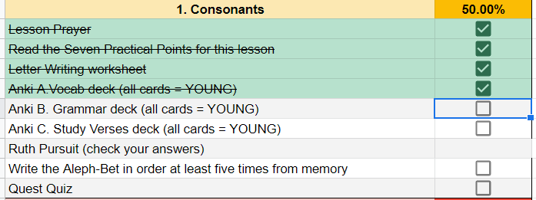

In this course, you won’t just read; you will DO! This course is going to be jam-packed with activities. Below is what will be inside a typical lesson[2]:

|  |  |  |
| --- | --- | --- |
| **Title** | **Description** | **Estimated Time** |
| READING |  |  |
| Lesson Itinerary | The lesson’s key learning objectives | <1 |
| Equipment Check | Things you must have in your backpack before proceeding with the next phase of your journey | <1 |
| First Thought | A Bible verse from the lesson in Hebrew, audio from Izzy, and a brief devotional | 5 |
| Lesson Points | The main grammar concepts - Our goal is to give you just enough information to get started in Anki. You can easily identify the Lesson Points as they will be the numbered sections in each lesson. 1.1, 1.2, etc. | 15-45 |
| ACTIVITIES |  |  |
| Word and Verse Warm-ups | Starting with Lesson 3, these are brief “stretching” exercises before doing the Anki workouts, narrated by Izzy! | 5-10 |
| Anki[3] | This is where the majority of your learning will take place. There will be three stages to each Lesson. | 60-180 total (Anki is meant to do a little each day as driven by the software’s algorithm) |
| A. Vocab | By the end of the course, you will have around 500 Hebrew words memorized |  |
| B. Grammar | Here, you will work through (and at times grapple with) the main grammar concepts discussed in the Lesson. |  |
| C. Workbook | Brief Hebrew word activities to reinforce the grammar concepts. In Unit 3, the focus shifts to what is called “parsing” of verbs. Verb parsing means identifying the root, stem, person, gender, number, and meaning of a verb. |  |
| D. Study Verses | You will begin to translate from Hebrew to English. This component may not be easy at first but stick with it! Although these verses are similar to the *Hebrew Quest* Memrise modules, our goal for the Study Verses is translation and comprehension, not rote memorization. |  |
| Worksheets | Additional activities to reinforce learning (selected lessons) | 30-45 |
| Ruth Pursuit | Similar to the “bag the letter” in *Hebrew Quest*. You will identify examples of grammar concepts in Ruth Chapter 1 | 15-60 |
| Quest Quiz | Self-assessment activity to measure your familiarity with the material for YOU to assess whether you are ready to advance in your quest to the next lesson. No grades are recorded or granted in this course. There are no quizzes after Lesson 11. | 15-30 |
| Twelve Tribes Badges, Unit Completion Certificates, and Graduation | Fun things to mark and celebrate the completion of various stages of your GRAMMAR Quest | 3-5 |
| TOTAL | Depending on how fast you work: | 2.5-6 hours per Lesson |

Of course, some lessons will be more involved than others, and each of us works at different paces. One of the beautiful things about a self-paced class is the pace is not set by a course syllabus. The pace is set by YOU!

DON’T BE OVERWHELMED! YOU GOT THIS!

Use the Course Checklist to help keep you organized and do a little bit at a time. Instructions for accessing this were back on the Quick Start page. If you haven’t already downloaded it, you can get it [here](https://docs.google.com/spreadsheets/d/1t0C7JlygyUqgF_aQWbhq7h3s_VDn0VuvISJn5mp-LdE/copy)

Also, for those seeking additional translation practice and exposure to the Hebrew Bible, we have an OPTIONAL *Hebrew Quest* Study Passage Track beginning with Lesson 13. You will read through the passage, compose a translation, then watch (or re-watch) the *Hebrew Quest* video where Izzy walks us through the passage. There is more information on this in the Unit 3 introduction.

## Report an Issue

Please do not hesitate to report any errors, omissions, or improvement opportunities. In fact, we’d rather hear about mistakes sooner rather than later! Feedback is anonymous.

If you have a specific question about the content or are stuck on a concept, please use the Get Help question form instead of the Report an Issue form.

[Open form in new window](https://forms.gle/qhBToGubVgmjdFbx6)

## Ask a question

While this is a self-paced course with no formal instructor or teaching assistant, we want to provide a way for you to get help and ask a question should you get stuck.

We request that before you submit a question, you read through the lesson a couple of times, then attempt to do the Anki cards for that lesson. Sometimes by doing this, things will “click” on their own. If you are still unclear, we are here!

Use the form below to ask a question. Please note, we are staffed by volunteers, so please allow a few days for us to research and get back to you.

If you have general feedback or wish to report an issue, please use the Report an Issue form instead of the Get Help form.

[Open form in new window](https://forms.gle/tNsvwrhci3nGkvvV6)

# About This Course

* Why is Holy Language Institute offering a Hebrew grammar course?
* What makes our course distinct?
* How does this grammar course relate to *Hebrew Quest*?
* What if I haven’t finished *Hebrew Quest*?

## Why a Hebrew Grammar course

If you are familiar with our ministry, you know our flagship course ***Hebrew Quest***, which introduces our students to Yeshua and our Jewish Bible.

***Hebrew Quest*** was designed to get students into the Hebrew text as quickly as possible, with minimal focus on learning rules. For many of our students, this approach is quite successful; but, we also noticed other students began to drop off between lessons 12 and 16, after the lessons on the Aleph-Bet. For some students, these lessons were too much Hebrew grammar too fast, and for others, it was not enough Hebrew grammar.

As we searched for a resource to recommend to these students, we noticed that they tended to fall into one of two camps:

1. A workbook or a series of videos that are entirely self-paced/self-directed
   * Sometimes these are too easy, and we tend not to learn very much
   * Additionally, with this format, there is no way for a student to get feedback on progress
2. Academic/Seminary level textbooks and courses
   * These materials are incredibly rigorous with copious amounts of reading, rote memorization of paradigms, lectures and exams
   * The pace is usually fast, and the stress level is high, focusing on due dates and grades.[4].
   * The textbooks generally are much more detailed and advanced than most of our students need (or would enjoy)[5]

Additionally, with either option, our students would incur additional fees to purchase these materials.

Many of the resources we researched are top-notch. Depending on a student’s goals, we would not hesitate to recommend them. It’s just that they were not quite what we were seeking for our students.

*(continued)*

## Why Our Course is Distinct

Our goals for a Hebrew grammar course are the following:

* Academically challenging, but with a low-stress level
* Primary emphasis on understanding God’s Word, using grammar rules, paradigms, and memorization as a means to achieve this goal. The “final exam” should be whether you can understand the Bible, not whether you can conjugate a Niphal verb.
* Self-paced for independent learning but with mechanisms to provide feedback, encouragement, and ways to celebrate students’ accomplishments in the course
* Aligns with our [Holy Language Learning Philosophy](https://holylanguage.com/learning-philosophy.php): emphasize active forms of learning over copious amounts of textbook reading and long lectures
* Compliments (not replaces) and integrates with *Hebrew Quest*
* Inexpensive and straightforward to develop, deliver, and maintain
* Free of charge for our students
* Most importantly, the course must be Yeshua-centered that approaches learning Hebrew grammar as a spiritual as well as an academic endeavor (which is also a big part of our Learning Philosophy)

We have talked a bit about our Holy Language Learning Philosophy. Our belief is you learn best by doing. Izzy discusses this is greater detail in the clip below from **Hebrew Quest** Lesson 1:

## Relationship to *Hebrew Quest*

One way to think of Hebrew GRAMMAR Quest is “Hebrew Quest: Extended Edition”!

Suppose you were to take a hypothetical microscope and inspect Lessons 13-15 of *Hebrew Quest*. These are the lessons where Izzy reviews Nouns, Pronouns, Verbs and so forth. Under that microscope, Hebrew GRAMMAR Quest is what you would see. Hebrew GRAMMAR Quest will start with a brief review of the Aleph-bet and the vowels we learned in *Hebrew Quest* Lessons 1-12. Then we begin our deep dive into grammar topics touched upon in *Hebrew Quest* Lessons 13-15.

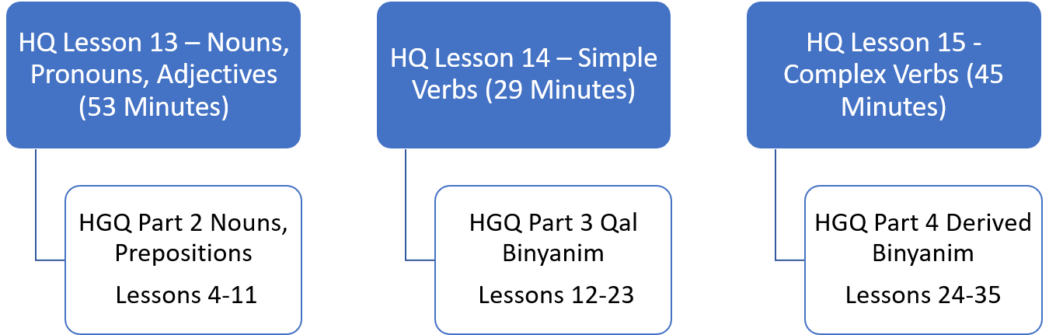

## Completion of *Hebrew Quest* is NOT a Prerequisite!

If you *have* finished *Hebrew Quest*, Hebrew GRAMMAR Quest might be a logical next step.

On the other hand, maybe you started *Hebrew Quest* but hit some roadblocks. In that case, Hebrew GRAMMAR Quest can provide you with important underlying grammatical concepts so, eventually, you can return to *Hebrew Quest* and finish up. We’re going to help you with this goal. In the second half of this grammar course, we will incorporate several of the [Study Passage](https://holylanguage.com/ot-readings.html) sections of *Hebrew Quest*.

If you are interested in learning some of Hebrew’s inner workings, you’re in the right place!

Additional questions regarding *Hebrew Quest* and Hebrew GRAMMAR Quest:

* Do I need to complete *Hebrew Quest* before I start Hebrew GRAMMAR Quest? Quick answer: NO!
* When I complete this course, should I go back and finish *Hebrew Quest*? Quick answer:: YES!
* I haven’t started either course. Which should I do first? Quick Answer:
  1. Complete *Hebrew Quest* Lessons 1-15 (don’t worry about whether you fully absorb the grammar material in Lessons 13-15)
  2. Hop over to Hebrew GRAMMAR Quest and complete the full course, including the *Hebrew Quest* Study Passage track, if possible
  3. When you finish here, return to complete *Hebrew Quest*

We have FAQs on other topics of interest in our Appendix.

Let’s get started on our Hebrew GRAMMAR Quest!

# 1 The Hebrew Aleph-bet

To comprehend Biblical Hebrew, we must have the Aleph-Bet memorized



This graphic shows the evolution of Hebrew. Top to bottom: proto-Canaanite (~1600 BCE), paleo-Hebrew (~900 BCE), Rashi (1500 CE), Ketav Stam (used in Torah scrolls and other formal documents), contemporary block, and modern cursive. This course will use the contemporary block style.

In this initial lesson, we will meet the Hebrew Aleph-Bet. The letters are like a family. With any family there can be unique dynamics (including not always playing nice with each other!). This lesson will take a look at some of those dynamics.

**LESSON ITINERARY**

1. Meet the Hebrew Aleph-Bet
2. Understand that Hebrew is written and read from RIGHT to LEFT
3. Identify the group of five letters that have final/Sofit forms
4. Identify the group of six letters that can take a Daghesh Lene
5. Identify the group of four “guttural” letters that cause significant changes in spelling and punctuation (and the one additional letter that sometimes acts as a guttural)
6. Differentiate among “look-alike” letters
7. Note differences between “Seminary” and “Sephardic” pronunciation

**EQUIPMENT CHECK**

If you are eager to jump right in with Lesson 1, we understand. We are also excited for you to start!

“Equipment Check” is where we will pause before each lesson to make sure you have the right tools and supplies in your backpack before heading on the next phase of your Quest. In future lessons, we will want to make sure you have an understanding of specific concepts before continuing[6]

Before continuing, make sure of the following:

* You understand what a typical lesson will include
* You followed the steps on our Quick Start Instructions, are ready go to with Anki and have your Course Checklist downloaded to track your progress

## First Thought

### שֵׁם יְהוָה אֶקְרָא

*For I proclaim the name of Adonai (Deuteronomy 32:3)*

As you undertake this study, pray for this Grammar adventure to be fruitful. May God use your growing knowledge of Hebrew as an instrument to advance His Kingdom, and may you never cease to proclaim His Name!

Listen to this verse in Hebrew, then say it out loud:

Your browser does not support the audio element.



Figure 1.1: Cove of the Sower - suggested location where Yeshua proclaimed the words of Adonai to the crowd in Mark 4:1. Courtesy of the [Pictorial Library of Bible Lands](https://www.bibleplaces.com)

Note: acoustic tests have been performed at this location. These have confirmed that a person in a boat in the middle of the cove can *easily* be heard without amplification by people sitting on these rocks several hundred feet up the embankment (and Yeshua didn’t have to deal with road noise!). A description of the acoustics study can be found in the following article: Crisler, B. “The Acoustics and Crowd Capacity of Natural Theaters in Palestine.” Biblical Archaeologist, vol. 39, no. 4 (1976):128–41.

## 1.1 The Hebrew Aleph-Bet



Almost every other grammar book would start with a lengthy description of each letter, how to write it, and how to pronounce it. We omit this because this is (and much more!) covered in detail in [*Hebrew Quest* Lessons 2-11](https://holylanguage.com/letters.html). The points below and on the following pages will provide some foundations. This way, your grammar journey gets started in the right direction.

* All letters you see in the picture of the Aleph-Bet above are classified as “consonants.”
* Whereas English has the vowel letters (A, E, I, O, U) as a core part of the Aleph-Bet, Hebrew treats vowels differently
* א and ע are not vowels but silent consonants; in Sephardic pronunciation, they take on the pronunciation of their associated vowel (if there is one)
* We’ll talk about vowels in Lesson 2

If you have not yet completed *Hebrew Quest* Lessons 1-11, we encourage you to stop here and move over to Hebrew Quest to complete the Alephbet lessons.

In addition to learning the letters, you will learn things each letter has to teach us from a spiritual perspective.

## 1.2 Hebrew is written and read from RIGHT-to-LEFT

Note the front of a Hebrew book is the back of an English one:



* To our western eyes, this looks “backward” (but Israelis would say *we* are reading backward!)
* When reading Hebrew, always start at the “back” and go from RIGHT to LEFT

See **Hebrew Quest** discussion on Right to Left:

## 1.3 Five “KiMNePaTZ” letters have different final forms



* Hebrew does not have capital letters the way English does, but a somewhat similar concept is five letters take what are called “Final” or “Sofit”[7] forms when they appear at the END of a word
  + Those letters are in red text above
* The letter Kaf כּ is the first letter in the Aleph-bet with a sofit form
  + The final form is named Kaf Sofit ך
  + Same for Mem מ and Mem sofit ם and so on[8]
* The five letters that have these forms are Kaf, Mem, Nun, Pei, and Tsaddi: ך ם ן ף ץ
* You can remember the acronym, KiMNePaTZ, which is the made-up word you get when you string the five letters in a row
* The KiMNePaTZ sofit forms can look like other letters - your Anki work for this Lesson will give you practice with identifying look-alike letters

## 1.4 Six" BeGaD KePHaT" letters take a Daghesh Lene



* Next, we need to learn the “BeGaD Kephat” letters[9]
* The red and blue dots in the above letters are called **DAGHESH LENE**
* The Daghesh Lene is inserted into the middle of the consonant
  + The pronunciation of the letter is linguistically “hard” if the Daghesh Lene present or linguistically “soft” if not present
    - so ב has a “soft b” sound, in other words a “v” sound
    - בּ has a “hard b” sound, in other words a “b” sound
    - כ sounds like the “ch” in “bach”, while כּ is “k” as in “kite”
    - פ is the “ph” in “phone”, while פּ is the “p” in “pull”
* At one time, all six of these letters had different pronunciations, but today, only three do. These are the letters in blue above **בּ כּ פּ**
  + Since the letters without the Daghesh Lene want to be “lazy” - for example a weak ‘v’ instead of a strong ‘b’- our mnemonic for these is “BuCK uP! You Lazy Letters!”
* There other “dots” in Hebrew with various meanings
* The Daghesh Lene ONLY applies to Bet - Gimmel - Dalet - Kaf - Pei - and Tav
  + If a dot appears in any other letter, it is NOT a Daghesh Lene
* We’ll dig deeper into the Daghesh Lene and its much more important twin, the Daghesh Forte, over the next few lessons.

## 1.5 We classify four consonants as **Gutturals** (and one is a sometimes-guttural)



* We like to say that the gutturals (and sometimes Resh) will be our trouble-makers because they tend not to play nice with the other Hebrew rules
  + The good news is the behavior of the Gutturals and Resh is entirely predictable
  + We will learn this over the next few lessons (and indeed, the rest of the course)
* There are four proper gutturals: Aleph, Hei, Chet, and Ayin (in red above)
* The letter Resh ר (in orange above) is not formally a Guttural; but since it can’t decide whether to behave or not, sometimes we include Resh with the other Gutturals
* For now, memorize the group of four guttural consonants in red and Resh, the sometimes-guttural-like letter in orange.

Learning how the Gutturals behave and what spelling changes they cause is one of the most critical facets of Hebrew grammar

## 1.6 We classify ten consonants as “SQiN eM LeVY”



* This is another group of letters that can behave differently
* They are called the *SQiN eM LeVY* letters because of the made-up word that is formed by the letters:
  + S - שׂשׁסצ the Sibilants (letters that make an S sound)[10]
  + Q - ק
  + N - נ
  + M - מ
  + L - ל
  + V - ו
  + Y - י

## 1.7 Look out for look-alike Letters

* Hebrew has many letters that can look similar, especially to someone just learning the Aleph-bet
* For example נ, ג and כ; ס and ם; or ר, ד and ך
* The Anki deck will give you practice on distinguishing these.
* Also, in Hebrew Quest, when Izzy reviewed the Aleph-Bet in lessons 2-11, he talked about each letter’s “twin” and how to spot the difference
* We encourage you to revisit those [letter lessons](https://holylanguage.com/letters.html).



## 1.8 Sephardic and “Seminary” Pronunciation

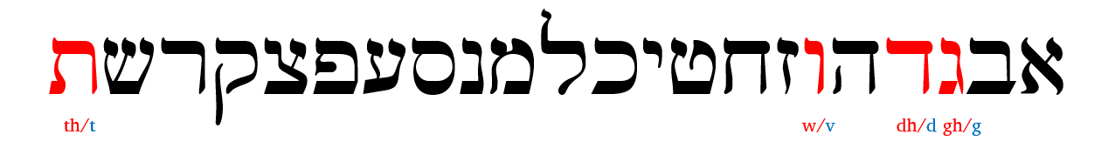

* There are some notable differences between what we might call academic or “seminary[11]” Hebrew and “real-world” Hebrew. Seminary pronunciation is in red above, while Sephardic pronunciation is in blue.
  + Real-world Hebrew is based on Sephardic pronunciation
* We’ve already talked about how only three of the Daghesh Lene letters need to “BucK-uP”
* With “Seminary Hebrew,” the ג without the Daghesh Lene receives something like the GH in “aGHast.” The ד and ת without the Daghesh Lene are closer to the English DH/TH like “this”
* Another difference between Sephardic and Seminary pronunciation is how to pronounce ו
  + In academia, the consonant receives the “w” sound and is called “waw”
  + In most non-academic circles, it receives the “v” sound and is pronounced “vav”
* There are also significant differences in pronouncing vowels, which we will talk about in Lesson 2.
* For the most part, Hebrew GRAMMAR Quest will follow the Sephardic pronunciation
* Lastly, will use “Adonai” or “the LORD” when we encounter the Covenant Name[12]

## Lesson Conclusion and Activities

Congratulations on completing your first lesson!

Now we’ll move into the Activities. This is where you take what you learned above and put it into practice using Anki. For this lesson, we also have a worksheet and an additional writing activity.

### Anki

* Lesson 01 A. Vocab - Learn (or relearn) the Aleph-Bet with Izzy
* Lesson 01 B. Grammar - Identify look-alike Hebrew letters
* Lesson 01 C. Study Verses - we won’t be working on any Study Verses just yet, but we will learn some grammar shorthand that we will use when we get to Lesson 3.

Access Anki using your mobile app, desktop version, or [the web-based version (login may be required)](https://ankiweb.net/decks/)

### Worksheets: Letter Writing

1. Practice writing the letters individually using the [Letter Writing worksheet](https://drive.google.com/file/d/1JcX8kc6e-fKjtzkeE96AwoZFshEpx3ug/view)
   * If you would like some tips on how to write the letters, you can use [this guide](https://drive.google.com/file/d/1cmrCXcafjwvbMNj7GgX7UPMGA0FcwvWN/view?usp=sharing) from Dr. Beckman.
   * As we’ve said before, we strongly encourage everyone to watch (or re-watch) the [*Hebrew Quest* lessons on the Aleph-Bet](https://holylanguage.com/letters.html)
2. Practice writing the entire AlephBet until you can do it FIVE times from memory. This will also be an instruction on the Quest Quiz.

## Ruth Pursuit

* This is a QUEST activity, similar to “bag the letters” from *Hebrew Quest*.
* You can do this activity online using Google Docs or download/print and use physical highlighters.
* Click the link to open a [blank copy of Ruth Chapter 1](https://docs.google.com/document/d/1bcT1J-fcVmD1Zn5Jk2nj0560tEddcgtbYZLkwaVVuyE/copy). You may need to sign in with a Google account.

YOUR QUEST

1. Identify the four guttural letters in Ruth chapter 1(pink)[13]
2. Identify the one half-guttural (red)
3. Identify the six BeGaD KePHaT letters, both with and without the Daghesh Lene, for a total of 12 letters (green)
4. Identify the five final/sofit forms (blue)
5. Identify the 12 remaining consonants not included in the above categories (including both forms of ש)(yellow)
6. Find all examples of the names listed below (grey)
   * Ruth - spelled רוּת; also “and Ruth” - וְרוּת
   * Naomi - spelled נָעֳמִי
   * Bethlehem - spelled בֵּית לֶחֶם , also “from Bethlehem” - מִבֵּית לֶחֶם
     + Our one word “Bethlehem” is two words in Hebrew: בֵּית means “house of” and לֶחֶם means “bread”
   * Moab - spelled מוֹאָב, also “Moabites” מֹאֲבִיּוֹת, and “the Moabitess” הַמּוֹאֲבִיָּה

* Check your results against the [Ruth Pursuit #1 Answer Key](./images/01_Ruth_Pursuit_KEY.pdf)

## Ruth Pursuit Translation Worksheet

* With almost every lesson of Hebrew GRAMMAR Quest, we will be gradually building a translation of Ruth chapter one
* Instead of going sequentially, we will be working to identify concepts
  + We started with the simple words in the previous section
  + Towards the end of the course, you will be translating complex verbs
* We want you to keep track of your progress, because in Unit 4, you will know enough Hebrew to compose your own translation of Ruth 1
* After you finish each Ruth Pursuit, be sure to update your worksheet

RUTH PURSUIT TRANSLATION WORKSHEET INSTRUCTIONS

* Download and open your Hebrew GRAMMAR Quest Checklist if you haven’t already done so
* Find the Ruth 1 Translation tab
* As you identify complete words (not the individual letters), enter the English meaning next to the applicable word
  + For example, next to each occurrence of מוֹאָב, type the word Moab, for רוּת, enter “Ruth” and so forth
  + You might want to make a note of the Lesson # (in this case “1”) in case you need to refer back
  + There is also a column for any notes you wish to make
  + See examples for verse 1 in the worksheet
* Remember to update your translation worksheet after each lesson

## Quest Quiz

Here is our first Quest Quiz. Remember to treat this as a self-assessment. If you do well, you should be ready to progress to Lesson 2. If not, you may need to go back and review some concepts from Lesson 1. This is not for a grade, as there are no grades given in this course.

[Open Quest Quiz #1 in a new window](https://docs.google.com/forms/d/e/1FAIpQLSeqHcE8PvfkOYbTu51cNO8sf-ln6CEnRrcTBUxM0EaeojSSsA/viewform)

# 2 Hebrew Vowels

To comprehend Biblical Hebrew, we must understand how words are formed and pronounced

Even though our goal may not necessarily be to converse in Biblical Hebrew, hearing the sound of the language aids our learning. Vowels are what give a language its distinctive sound. In Hebrew, the same three consonants can change meaning depending on the vowel combination.



As Izzy says in Hebrew Quest, “Vowels are important.” On your screen, you see Genesis 1:9. The black font shows the text with no vowels. Over time, a group known as the Masorites developed the vowel notation we use today. These are the symbols in red. These are usually under, but sometimes in the middle of or over the affected consonant. This vowel system intends to preserve the pronunciation passed down for centuries via the oral tradition. The Hebrew name for these diacritical dots and dashes is *nikudot*. The blue font shows additional cantillation marks, which synagogues use for chanting the verses. These marks also show where the word’s accent is.[14]

**LESSON ITINERARY**

1. Memorize vowels that are not vowel letters
2. Learn vocal Sheva and silent Sheva
3. Memorize the vowel letters
4. Meet “defective” and “plene” spelling
5. Meet Dagesh Lene’s twin, Dagesh Forte
6. Know the rule for a Dagesh Forte
7. Know that the Gutturals and Resh reject Dagesh Forte

**EQUIPMENT CHECK**

Before continuing, can you recite the following groups of letters from memory?

* All twenty-two consonants of the Hebrew Aleph-Bet
* The six BeGaD KePHaT letters
* The five KiMNePaTZ letters
* The four guttural letters and the one sometimes-guttural letter

## First Thought

### הֵמָּה רָאוּ מַעֲשֵׂי יְהוָה

*They have seen the works of Adonai (Psalms 107:24)*

Reflect on the works of HaShem that you have seen.

Listen to this verse in Hebrew, then say it out loud:

Your browser does not support the audio element.

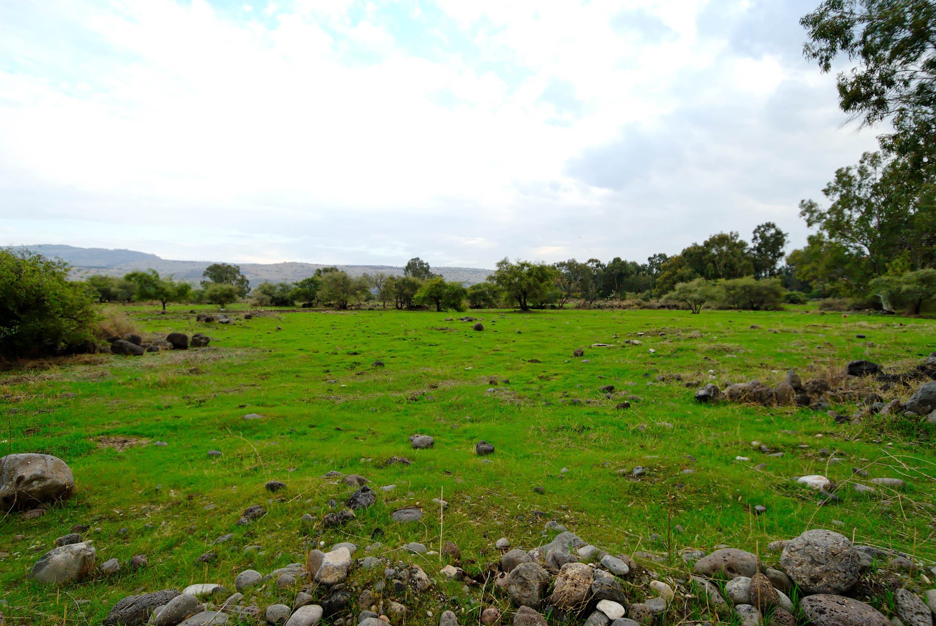

Figure 2.1: Plain of Bethsaida - suggested location where 5000 saw the works of Yeshua (Mark 6). Courtesy of the [Pictorial Library of Bible Lands](https://www.bibleplaces.com)

## 2.1 Vowels that are not vowel letters

### Vowels come in three types: Long, Short, Reduced | Vowels come in five classes: A, E, I, O, U

* Like we memorized the Aleph-bet, we will commit the vowels in the table below to memory
* Study the table below before doing the drills in Anki
  + Knowing the vowel types (Long, Short, Reduced) and classes will make your grammatical life much more comfortable in the future
  + The letter בּ is provided as a placeholder for the long/short vowels; ע represents any Guttural for the reduced vowels, since only Gutturals take the Reduced vowels
* Say the vowel *after* saying the associated consonant[15] So the first vowel example is “qaw” not “awq”.
* Future lessons will explain the difference between Qamets and Qamets Hatuf

Another table to memorize:

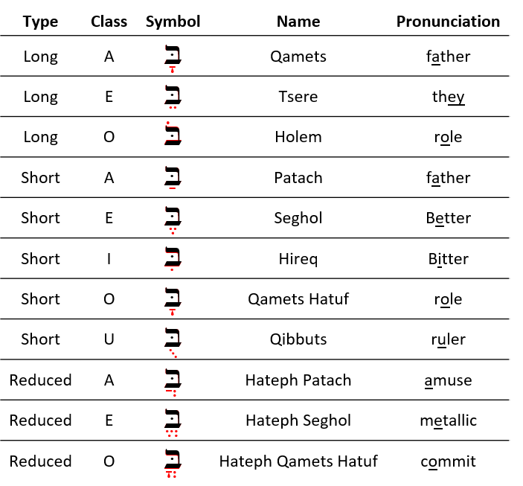

Only **gutturals** take the “Hateph” vowels - to make it easier, we can pronounce all three Hateph vowels like the A in Amuse

Hateph vowels are used because Gutturals reject vocal Sheva

## 2.2 Vocal and Silent Sheva

* The Sheva can be tricky to grasp at first, since vocal and silent Sheva are written the same, but have two very different uses
* Both are written as קְ
  + Both mark the END of a syllable
* VOCAL Sheva[16] is a REDUCED vowel, but does NOT have a vowel Class
  + Only non-gutturals can take a Vocal Sheva
    - Gutturals **reject** the Vocal Sheva and take the Hateph vowels instead
  + Pronounced like the A in Amuse (same as Hateph Patach)
* SILENT Sheva is not a reduced vowel, in fact, it is NOT A VOWEL AT ALL
  + Any letter, including Gutturals can take a Silent Sheva
  + Silent/ No sound
* We will learn how to distinguish between the two kinds of Sheva in the next lesson

|  |  |  |  |  |
| --- | --- | --- | --- | --- |
| Type | Class | Hebrew | Name | Pronunciation |
| Reduced | No Class | ְבּ | Vocal Sheva | amuse |
| Not a Vowel |  | ְבּ | Silent Sheva | No pronunciation |

The Sof Pasuq

* It is worth pointing out that in Hebrew Bibles, we may come across a mark that looks like a super-sized Sheva
* In English, we might say it looks like a giant colon mark (:)
* In Hebrew, this mark is called a Sof Pasuq, and it is used to mark the end of the verse
* Other than this, the mark has no meaning for us whatsoever. You may ignore it when you encounter it.

## 2.3 Vowel letters

### Vowel letters use a consonant plus a nikkud to form a vowel

Another table to memorize:

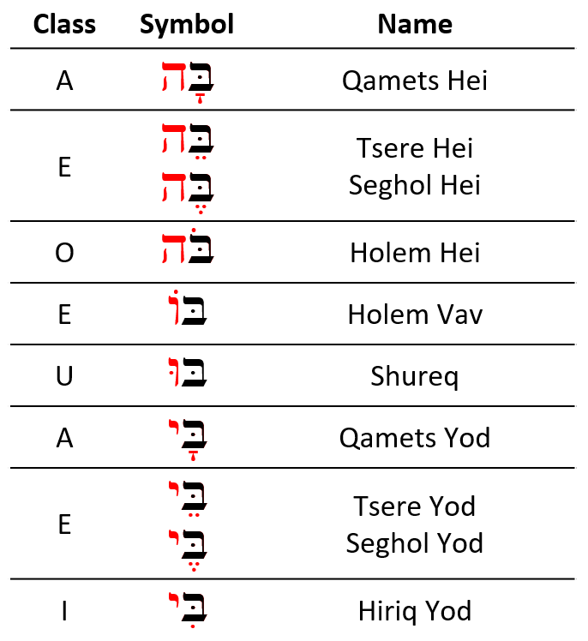

* Shureq is pronounced like Qibbuts (ruler)
* Hireq Yod is pronounced like the i in machine
* All others are pronounced like their non-vowel-letter counterparts
* Yod and Vav vowels - י,ו
  + These are Long Vowels that do not reduce
  + Therefore they are called, “Unchangeable long vowels”[17]
  + These occur in the middle or at the end of a word

If the Yod or Vav has a vowel of it’s own, then the Yod/Vav is acting as a *consonant*, not an irreducible long vowel.

* Hei Vowels - ה
  + Seghol Hei is a short vowel - the other Hei vowels are long
  + Hei vowels **ONLY** occur at the end of a word (often called “word-final hei”)
  + Hei vowels are extremely common in Hebrew

## 2.4 Transliteration Shorthand

* Most Hebrew grammar books include transliteration values
* While learning the transliteration scheme can help in some instances, our general position is that it can be an unnecessary distraction
* Where it can be useful is as shorthand
  + It would get wordy to write “holem vav” repeatedly
  + It’s much less clutter to write the shorthand version based on transliteration: $\hat{O}$
* As we move forward in the course, particularly in unit three, we will be making use of the vowel shorthand listed below

::: {.map. info}

* Short Vowels (no marking): $A$ for Patach, $E$ for Seghol, and so forth for the remaining short vowels
* Long Vowels (bar): $\overset{‾}{A}$ for Qamets, $\overset{‾}{E}$ for Tsere, and $\overset{‾}{O}$ for Holem
* Reduced Vowels (breve): $\breve{A}$ for Hateph Patach, $\breve{E}$ for Hateph Seghol, $\breve{O}$ = Hateph Qamets Hatuf
* Unchangeable Long Vowels (hat): $\hat{E}$ = Tsere+Yod, $\hat{I}$ = Hireq_+Yod; $\hat{O}$ = Holem+Vav; $\hat{U}$ = Shureq
* Additionally, the ending Qamets+He = $\hat{A}$ and Sheva = $ə$

:::

You do NOT need to memorize this. We will review the values as we get into Unit 3.

## 2.5 “Defective” and “plene” spelling

In “defective” spelling, letter vowels can sometimes drop their letter and take on the corresponding non-letter vowel. The meaning of the word doesn’t change.

This is the word for “laws” showing both “plene” spelling (left) and “defective” spelling (right):



* Three vowel letters commonly take “defective” forms[18]
  + Holem-vav can drop the Vav and contract to Holem, as in the example above
  + Hireq-Yod can drop the Yod and contract to Hireq
  + Shuruq can drop the Vav and it’s associated nikkud and contract to Qibbuts

The Qamets-Hei ה ָ sometimes drops the final ה, leaving just the Qamets under the now-final letter.

As you progress, you’ll start to develop a mental checklist when you encounter something that does not seem to follow the normal/regular rules. Asking yourself “Could this be a defective spelling?” will be one of those checklist items.

An unchangeable long vowel written defectively is still an unchangeable long vowel

* A Qibbuts that is *not* defective is a short vowel
* A Qibbuts that is a defective Shureq is an unchangeable long vowel

For now, do not be concerned about the difference. As we progress in the course, you will see this in action.

## 2.6 The Dagesh Forte Doubles the Consonant

Notice the שּׁ in הַשָּׁמַיִם:



* Since שׁ is not a בגד כפת letter, we know this *cannot* be a Dagesh Lene, but it is a Dagesh **Forte**
* The letter with the Dagesh Forte both ends one syllable and begins the next syllable
* If we were to syllabify הַשָּׁמַיִם, it would look something like the bottom line in the picture above (pronounce: hash-sha-mayim)[19]
* A similar word in English might be better = bet | ter
  + If we were to transliterate better into Hebrew hypothetically, it might look like: בּטֶּר*[20]
* Notice the syllable breaks in these words that have a Dagesh Forte: 
* Any consonant (except for Gutturals and Resh) can take a Dagesh Forte, including a בגד כפת letter, which can take either a Dagesh Lene or a Dagesh Forte
  + The “Buck-up” letters will take the **hard** pronunciation regardless of a Dagesh Lene or Dagesh Forte - See the final word אַתָּה in the image above
  + “Any consonant” includes the Vav ו. When a Vav has a Dagesh Forte it looks like this וּ. Does that remind you of anything? Maybe something we just discussed on the previous page?
    - That’s right. A Vav with a Dagesh Forte וּ is identical to a Shurek וּ.
    - It’s surprisingly easy to tell the difference: if there is an additional vowel either under or over the same letter, or if the preceding consonant has a vowel, the letter is a Vav with Dagesh. A Shurek will *never* have a separate vowel following or preceding.

*Advanced tip:* When you see a Dagesh Forte, it often means that another letter has disappeared[21]. We will talk more about this later in the course.

It’s good to think of the Dagesh Forte as the “Doubling Dagesh” since it doubles the consonant and often changes a word’s meaning.

Conversely, we can think of the Dagesh Lene as the “Meaningless Dagesh”, since it does not ever change a word’s meaning

## 2.7 Dagesh Forte Rule

A Dagesh is a Forte if, and only if, it’s preceded by a vowel that is not a Sheva[22]

That’s it. That’s the rule[23].

Quiz yourself with these examples (answers below):

* אַתָּה = Is the Dagesh preceded by a vowel that is not a Sheva?[24]
* בְּרֵאשִׁית = Is the Dagesh preceded by a vowel that is not a Sheva?[25]
* עַל־פְּנֵי = Is the Dagesh preceded by a vowel that is not a Sheva?[26]
* מַבְדִּיל = Is the Dagesh preceded by a vowel that is not a Sheva?[27]
* מִתַּחַת = Is the Dagesh preceded by a vowel that is not a Sheva?[28]

## 2.8 Gutturals and Resh reject Dagesh Forte

* We said in Lesson One that the Gutturals don’t play nice with the other Hebrew Rules, and this rejection of the Dagesh Forte is one of those ways
* A Hebrew collision like this means something has to give. . . and the gutturals tend to get their way.
* It’s like they have a force-field shielding them from other Hebrew grammar rules!



Figure 2.2: That’s no moon. That’s a Guttural!

* A large chunk of any Hebrew grammar course involves learning to resolve these guttural entanglements

MAPPIQ

* You may see הּ. This dot is not a Dagesh, because we just learned that gutturals never take a Dagesh but what is called a Mappiq.
* A word final ה is typically a vowel
* A Mappiq signifies that a word-final ה is a consonant, not a vowel
* We’ll talk more about the mappiq in Lesson 6

## Lesson Conclusion and Activities

Congratulations on completing the vowels lesson. Make sure you memorize the vowel classes, the Dagesh Forte rule, and the guttural behavior.

We’re about halfway through the first stage of the course on Hebrew Grammar Foundations. Keep going! You’re doing great! After you finish all of the activities for this lesson, you can claim the first of our Twelve Tribes Badges.

Take a moment to review the section headings on the left side of the screen before heading on to tackle the activities.

### Anki

* Lesson 02 A. Vocab
* Lesson 02 B. Grammar
* Lesson 02 D. Study Verses
  + Bible verses will arrive next Lesson
  + In this module, we will be learning common Hebrew names.
  + Sound out the words using your knowledge of Hebrew consonants and vowels.
  + As a general hint, with a couple of exceptions, the English names are pretty close to how they sound in Hebrew.

Access Anki using your mobile app, desktop version, or [the web-based version (login may be required)](https://ankiweb.net/decks/)

### Vowel worksheet

* Practice writing the vowels using the [Vowel Writing worksheet/drill](https://drive.google.com/file/d/1ETPKE3u-XGfpNdKmlIr3P_DRbkOOlcI_/copy). See note[29]

## Ruth Pursuit

YOUR QUEST

1. Identify the four UNCHANGEABLE LONG vowels that use YOD in Verse 1 (blue)[30]|
2. Identify the two UNCHANGEABLE LONG vowels that use VAV in Verse 1 (Green)
3. Identify QAMETS HEI in Verse 1. There is a TSERE Hei between Verses 5-10. Can you find it?[31] (Purple)
4. Identify the three LONG vowels in Verse 1 (that are not part of a vowel letter) (pink)|
5. Identify three of the five SHORT vowels in Verse 1 (that are not part of a vowel letter)[32] (red)
6. Five the three REDUCED/HATEPHH vowels, including Hateph Qamets Hatuf[33]. They are in verses 2-4. (grey)
7. One of the more common verbs in the Tanach is וַיֹּאמֶר, which means “(and) he said. * Vav-Patach-**Yod**-Dagesh Forte –וַיּ to start a verb means”And he (did or was something)
   * If we change the second consonant from a Yod to a **Tav**, we get –וָתּ, "and **S**he (did or was something).
   * Thus, וַתֹּאמֶר means “and she said.”
   * Challenge: Find the five instances of וַתֹּאמֶר in Ruth Chapter 1[34] (yellow)

* [Blank copy of Ruth Chapter 1](https://docs.google.com/document/d/1bcT1J-fcVmD1Zn5Jk2nj0560tEddcgtbYZLkwaVVuyE/copy)
* [Ruth Pursuit Answer Key #2](./images/02_Ruth_Pursuit_KEY.pdf)
* Update your Ruth Translation worksheet with וַתֹּאמֶר = “and she said”

## Quest Quiz

[Open Quest Quiz #2 in a new window](https://docs.google.com/forms/d/e/1FAIpQLSeq_9Cy5IlAKDFy8nx9GNC3dfs5l5bJ_iX2FJ0Az7rPKXq5Jw/viewform)

## Claim your Twelve Tribes Badge!

If you have completed **all activities** in Lessons 1 and 2, you may claim the first of our “Twelve Tribes” badges[35].

# 3 Syllabification and Pronunciation

To comprehend Biblical Hebrew, we must know how syllables function

Originally, the Bible and other ancient documents were written without spaces. In addition to vowels, the ancient scribes and readers organically adopted a system of syllables and accents. They knew where one word ended and another began without needing to write it down.

What we call “Hebrew grammar” is truly an exciting journey into the system of spoken and written Hebrew, which had its formation thousands of years ago!

**LESSON ITINERARY**

1. Learn the two basic concepts of Hebrew Syllables
2. Learn the rules and terminology related to Hebrew Word Accents
3. Know the Three Rules for Recognizing Silent Sheva
4. Know the Four Rules for Recognizing Vocal Sheva: Four Rules Gutturals Reject Vocal Sheva
5. Learn the primary Hebrew Diphthong
6. Understand Vowels and Syllable Preference
7. Learn three simple miscellaneous concepts: Qamets and Qamets Hatuf, Furtive Patach Quiescent Alef

**EQUIPMENT CHECK**

Before continuing, can you describe the following concepts?

* The vowels that are not letters, including their type (long, short, reduced) and class (a, e, i, o, u)
* The vowels that are letters, including which are the “irreducible long” type
* The difference between a Dagesh Forte and a Dagesh Lene

Lesson 3 and Lesson 16 are the two most content-heavy lessons in this course. For that reason, it is critical that you have your alephbet and vowels (including the vowel types) memorized.

Assuming you’ve checked your equipment as directed above, and everything is in tip-top shape for your Lesson 3 adventure, take your time. Work through the written material, then do a little Anki work and see if it starts to click.

If not, then come back here and re-read the material again. Then go back to Anki. If you find yourself getting frustrated, take a break, and come back to it later. Continue to work through “the fog.”

You absolutely must have the concepts from this lesson hard-wired before you continue to Lesson 4. The good news is that once you get this lesson down, the ones that follow will be relatively straightforward.

In addition to all of these new concepts, the authors have also seen fit to introduce a full set of vocabulary words AND study verses beginning with Lesson 3. So the overall workload will increase, starting with this lesson.

We’re praying for you in advance as we compile this section! Now, climb the mountain!

## First Thought

### אַשְׁרֵי אָדָם לֹא יַחְשֹׁב יְהוָה לוֹ

*How blessed is the man to whom the LORD does not impute iniquity (Psalms 32:2)*

Thank God for his blessings and meditate upon them.

Listen to this verse in Hebrew, then say it out loud:

Your browser does not support the audio element.



Figure 3.1: Mount of Beatitudes and Sea of Galilee - suggested location of Yeshua’s eight blessings in Matthew 5:3-12. Courtesy of the [Pictorial Library of Bible Lands](https://www.bibleplaces.com)

## 3.1 Hebrew Syllables

There are two basic concepts when it comes to Hebrew Syllables:

1. Every syllable begins with one consonant and has only one vowel
2. There are only open or closed syllables



We see the two basic concepts at play in this simple word (pronounced “da-var” and means word, matter, thing):

* The two syllables each begin with a consonant and have one vowel
  + דָּ starts with the consonant Dalet and has one vowel, Qamets
    - This is also an example of an “open” syllable - open syllables end with a *vowel*, not a consonant
  + בָר starts with the consonant Bet and has one vowel, also a Qamets
    - This is an example of a “closed” syllable - closed syllables end with a *consonant*, not a vowel
* If you need to know how many syllables are in a Hebrew word, count the vowels
  + Remember that vowel letters, such as the Hiriq-Yod, and Diphthongs we will see later in this lesson, count as a single vowel unit

## 3.2 Hebrew Word Accents

* Most frequently, Hebrew words are accented on the last syllable
* If not, then the accent will be on the next-to-last syllable[36]
* Reduced vowels and Sheva never take an accent. If there is a word-final Sheva, the accent will be on the next-to-last syllable

Unlike English, Biblical Hebrew words are never stressed anywhere else[37].



* The word on the left is stressed on the last syllable
* The word on the right (pronounced “SAY-pher” and means book, scroll, or document) is stressed on the next to last syllable
  + Some texts will place a mark over the syllable to be stressed (except when it is on the last syllable)[38]

## 3.3 Tonic, Pretonic, and Propretonic Syllables

* We will encounter specific terms for a syllable’s position respective to the word’s accent
* Let’s use the plural of דָּבָר to illustrate: דְּ ׀ בָ ׀ רִים
  + The **Propretonic** syllable is two (or more) steps away from the accent = דְּ
    - Notice how the vowel changed from the Qamets in דָּבָר to a Vocal Sheva in דְּבָרִים
    - This vowel shortening of the propretonic syllable is called *Propretonic Reduction* and is extremely common in Hebrew
    - Qamets and Tsere will become Sheva (or Hateph Patach/Hateph Seghol)
  + The **Pretonic** Syllable is the syllable immediately before the accented syllable = בָ
  + The **Tonic** syllable is the one with the accent = רִים[39]

## 3.4 Ultima, Penultima, and Antepenultima syllables

Since the accent is not always in a fixed location, we sometimes will use other words that describes a syllable’s position irrespective of the accent.

* *ultima* = the last syllable
* *penultima* = the next-to-last syllable - this is also called the “penult” syllable
* *antepenultima* = the syllable(s) before the *penultima/penult*

## 3.5 Rules for Silent Sheva

Learn the three rules for differentiating a SILENT Sheva from a Vocal Sheva:

### A Sheva is SILENT when the previous vowel is short:



### A Sheva is SILENT when the first of two consecutive Shevas *within a word*:



### A Sheva is SILENT when at the end of a word:

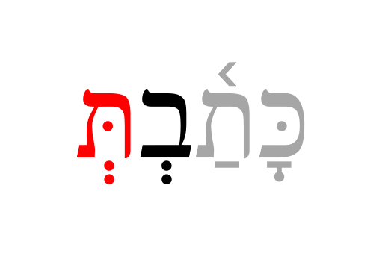 ::: {.map .light} THREE SILENT SHEVA CLUES

1. Previous vowel is short
2. First of two consecutive Sheva in the MIDDLE of a word
3. Word-final :::

## 3.6 Rules for Vocal Sheva

Learn the four rules for differentiating a VOCAL Sheva from a Silent Sheva

### A Sheva is VOCAL when the initial Sheva in a word:



### A Sheva is VOCAL when the second of two consecutive Shevas *within a word*[40]:



### A Sheva is VOCAL when under a Dagesh Forte:



### A Sheva is VOCAL after an unaccented long vowel:



This one may seem random, but it is relatively common with *long* vowels in a propretonic position[41] The word above is not kōṯ-vim but kō-ṯᵉ-vîm.

FOUR VOCAL SHEVA CLUES

1. Word-initial
2. SECOND of two within a word
3. Under a Dagesh Forte
4. After unaccented long vowel

## 3.7 Hebrew Diphthong = Accented Patach-Yod-Hireq



* The diphthong is a single vowel unit, which means it is only one syllable
* We do not pronounce the word on the right above as “BUY-it”, but monosyllabic, more like “BITE”[42]
* The word on the left is not “sh-MAY-im” but it sounds more like “sh-MIME”

Remember “Accent+Patach+Yod+Hireq” as the main Hebrew Diphthong: יִ ַ֫

Qamets-Yod-Vav is another Diphthong that you’ll see in Lesson 9. It’s the pronoun suffix endings for “his” or “him”.

* אֵלָיו (to him) pronounced ’eLAV.
* פָּנָיו (his face) pronounced paNAV

There is scholarly disagreement as to whether (vowel)+Yod are vowel letters or diphthongs. Basics of Biblical Hebrew treats them as vowel letters.

## 3.8 Vowels and Syllable Preference

:: {.box .light} Memorisze this table:

|  |  |  |  |
| --- | --- | --- | --- |
| Syllable | Tonic | Pretonic | Propretonic |
| Open | SHORT | LONG | REDUCED |
| Closed | LONG | SHORT | SHORT |

:::

* Tonic syllables PREFER the listed vowels, but can take any type
* Pretonic syllable REQUIRE the listed vowels
* Propretonic syllables
  + Closed REQUIRES Short
  + Open REQUIRES reducetion from a long vowel to Vocal Sheva (or Hateph if guttural), *except* when there is an unchangeable long vowel
* Go back and look at דָּבָר and דְּבָרִים
  + The vowel preference table explains why the vowel under the Dalet changes from Qamets in the Open/Pretonic to Vocal Sheva (reduced vowel) in the open propretonic when the plural suffix is added
  + This is called “*propretonic reduction*” - you will encounter this topic frequently
  + As we saw with כֹּתְבִים, unchangeable long vowels written “defectively” will not reduce - at their essence, they are still unchangeable

## 3.9 Qamets Hatuf, Furtive Patach, Quiescent Aleph

The next three sections will examine these special situations

## 3.10 Qamets Hatuf

Qamets Hatuf ONLY occurs in a Closed AND Unaccented syllable



* Metheg mark
  + There are many instances where the vowel could be a short Qamets-Hatuf vowel in a closed syllable, or the long Qamets, A-class vowel in an open syllable
  + When this ambiguity occurs, some printings will print a small vertical line called a Meteg בָּֽ.[43] The Meteg tells you the vowel is the **long, a-class**



QAMETS OR QAMETS HATUF

* The A-class is FAR more prevalent
* Nouns such as חָכְמָה that have the pattern +Sheva+Qamets+Hei, *TEND* to be O-class
* You may know a word from vocabulary that has a Holem, such as כֹל.
  + When you encounter that same word in its shortened form, כָל־, the vowel will be shortened O-class
  + This is usually the Construct form, which we will study in Lesson 10.

## 3.11 Furtive Patach

Furtive Patach under final ח or ע is said BEFORE the guttural letter and is not a full vowel



The Furtive Patach is a significant exception to just about everything else we’ve discussed related to vowels and syllabification: * The vowel is pronounced *before* the guttural - so the above word is **Ruach** not “rucha” * The Furtive Patach is not a full vowel and is counted in syllabification

## 3.12 Quiescent Aleph

Quiescent Aleph is silent. It is neither a consonant nor a vowel



* When you see an Aleph with no vowels, it is acting as a silent letter
  + English has all kinds of silent letters, like the ‘p’ in receipt - the Quiescent Aleph works the same way
  + In terms of syllabification, the Aleph is neither a vowel nor a consonant, so it doesn’t count at all - it is just an extra letter

## Lesson Conclusion and Activities

Congratulations on getting this far! We realize that there are a lot of heavy concepts you face in this Lesson.

Some of you may try to read this lesson then do the Anki work (perhaps repeated a few times), and you still aren’t getting it. The Fog isn’t clearing. If this is the case, and you want a more in-depth lecture covering this material, we recommend [Dr. John Beckman’s hour-long YouTube Lecture on lesson 3](https://www.youtube.com/watch?v=AY7KAsD4fZg&feature=youtu.be)

For this lesson, we introduce two new activities that correspond with the official launch of Vocabulary and Study Verses you will see in Anki.

### Introduction to Video Warm-ups

* On the next two pages are videos of the vocabulary words and then the study verses
* Practice speaking the word/verses aloud, following along with Izzy
* You may not know what the words mean yet, and that’s fine (that’s where Anki comes in)
* Consider this some “syllabic stretching” before you do your full Anki workout!

Then after watching these, go ahead and jump into Anki.

* Lesson 03 A. Vocab - This is our first lesson with the Basics of Biblical Hebrew vocabulary list.
* Lesson 03 B. Grammar - This module will reinforce and expand on the Seven Practical Points for this lesson.
* Lesson 03 C. Study Verses
  + This is also the verse lesson using the Basics of Biblical Hebrew study verses.
  + The translation may be difficult at first. It may take you several attempts before you can select Good without using the Hints.
  + Be patient and stick with it - you’ll get it!

## Word Warm-up

[Click to open Word Warm-up video in a new tab](https://youtu.be/h0Ni1_Zya2U)

## Verses Warm-up

* Over the entire 35-lesson course, you will learn to translate almost 500 Hebrew Verses. The most extraordinary journey begins with a single step. You are now about to take that step!

[Click to open Verses Warm-up video in a new tab](https://youtu.be/9IkIvWPArlA)

## Ruth Pursuit

YOUR QUEST

1. Identify all examples of the Tetragrammaton, which we pronounce “Adonai” when we encounter it in Scripture. There are six instances of the Name. Also, שַׁדַּי is another name for God. It means “Almighty.” Find two examples of this name. (Blue)
2. In verse 16, highlight, “עַמֵּךְ עַמִּי וֵאלֹהַיִךְ אֱלֹהָי” in green. This is the famous verse, “your people (will be) my people, and your God, my God.” One of your vocabulary words is אֱלֹהִים. In the last two words of what you just highlighted, you can still see the core portion of אֱלֹהִים present. Begin to notice how Hebrew uses different suffixes to denote “your” and “my.”
3. In verse 1, find one Sheva that begins a word and one Sheva that concludes a word. (Yellow). Which one is a silent Sheva, and which one is the vocal Sheva?
4. Find the Quiescent Aleph in verse 1 (pink)
5. Find the Hebrew words for Elimelech, Machlon, Chilion, and Judah in verses 1-7. Chilion has the prefix “וְ” which means “and.” (gray)
6. For personal reflection, open an English translation side-by-side with your Hebrew version of Ruth 1. Note how the foreigner Ruth uses both אֱלֹהִים and the Tetragrammaton in verses 16 and 17, respectively. Why do you think this might be? Would you say the names are used interchangeably or do you think there is a deeper purpose? May we always seek HIM, just as you have done in this activity!

* [Blank copy of Ruth Chapter 1](https://docs.google.com/document/d/1bcT1J-fcVmD1Zn5Jk2nj0560tEddcgtbYZLkwaVVuyE/copy)
* [Ruth Pursuit Answer Key #3](./images/03_Ruth%20Pursuit%20KEY.pdf)
* Be sure to update your Ruth Pursuit Translation worksheet with this lesson’s words. We encourage you to use “HaShem” or “Adonai” for the Tetragrammaton.

## Quest Quiz

[Open Quest Quiz #3 in a new window](https://docs.google.com/forms/d/e/1FAIpQLSfCy3m3L8z1a5EjEMtEBVWjoci-JvWfYzUVEIpnQHIgGwvu1g/viewform)

# 4 Hebrew Nouns

To comprehend Biblical Hebrew, we must understand how nouns are formed, how they are pluralized, and how to look words up in a dictionary.

Nouns consist of a person, place, thing, or idea and can be singular or plural. Hebrew also introduces the concept of “gender.” This lesson will review aspects of the Hebrew noun with specific attention focused on pluralization rules.

**LESSON ITINERARY**

1. Understand Noun Gender and Number
2. Examine singular noun endings and “endingless” nouns for both Masculine and Feminine nouns
3. Examine endings for plural and dual nouns
4. Identify special dual forms
5. Examine other/irregular Pluralization
6. Describe the Rule of Sheva
7. Define what is meant by “Lexical Form”

EQUIPMENT CHECK

Before continuing, can you describe the following concepts?

* Vowel and syllable preference
* The rules for Silent Sheva and Vocal Sheva

Additionally, starting with this lesson, we will invoke the shorthand we’ve been learning in Anki (e.g., MP = Masculine Plural, FS = Feminine singular).

## First Thought

### רְאֵה לִמַּדְתִּי אֶתְכֶם חֻקִּים וּמִשְׁפָּטִים

*See, I have taught you statutes and judgments (Deuteronomy 4:5)*

Give thanks to God for His Word and ask that you never depart from His commands

Listen to the verse in Hebrew:

Your browser does not support the audio element.



Figure 4.1: Capernaum and Mount of Beatitudes - suggested location of Yeshua’s teachings we call ‘the Sermon on the Mount’ (Matthew 5-7). Courtesy of the [Pictorial Library of Bible Lands](https://www.bibleplaces.com)

## 4.1 Gender and Number

* All Hebrew nouns have Gender and Number
* Gender
  + The “gender” sometimes does, but usually does not, have anything to do with biological gender.
  + סֵ֫פֶר is masculine (M), while תּוֹרָה is feminine (F). There is nothing inherently masculine about books, nor is there anything feminine about laws or instructions
  + The gender of a noun never changes
* Number
  + A noun is either singular (S), plural (P), or less frequently, dual (D)
    - Dual is precisely two of something
    - Apart from the words “pair” or “both”, English doesn’t have too many dual forms
    - In Hebrew, typically paired body parts are in the dual form
  + The number of a noun CAN change
  + A word’s ending indicates the number
* Person
  + In Unit 3 (Verbs), we will introduce the concept of “person”
    - Collectively, when you see “PGN” in grammar, this refers to “person, gender, and number”; e.g., “3MS” means “3rd person, masculine, singular”.

## 4.2 Parsing vs. Inflecting

* When we take a base word and do something with it, such as change its gender or number, we call that *inflecting* the word
* *Parsing* is somewhat of the opposite concept where we take an inflected word and break it down into its base form to determine its meaning
* Reading the Hebrew Bible does not require us to inflect a noun or a verb, but it **does** require us to parse
* When we parse a word, we identify the lexical form, and the inflected person, gender, and number to understand what the word is communicating to us
  + Or, if we don’t know what it means, we have at least identified the lexical form so we can look it up in a dictionary
* Beginning with this lesson, you will see an Anki chapter called Workbook, which will have some activities like parsing

## 4.3 Singular Noun Endings

* Masculine singular (MS)
  + Usually “endingless”
  + Occasionally a MS noun may end in (accented) ה ֶ֫
* Feminine Singular FS: * תּוֹרָה (the Qamets+Hei ending is most typical) * בַּת * תִּפְאֶ֫רֶת (glory) * בְּרִית (covenant) * מַלְכּוּת (kingdom) * אֶ֫רֶץ (land - endingless, but feminine - less common)[44]

Some students fall into a habit of thinking every word-final ה is feminine. Remember ה ֶ֫ is masculine

## 4.4 Plural Noun Endings

For regular nouns, simply remove the singular ending if there is one, and add the plural ending.

* Plural endings:
  + MP: ים ִ e.g., **סוּסִים**
    - דָּבָר becomes **דְּבָרִים**
      * A vowel under a non-Guttural will reduce to Vocal Shewa - דְּבָרִים
      * As we saw in Lesson 3.2, דְּבָרִים changes from דָבָר because an open propretonic syllable prefers a reduced vowel.
    - עָנָן becomes **עֲנָנִים** (clouds)
      * A vowel under a guttural will take a Hateph vowel, usually Hateph Patach - עֲנָנִים
    - כּוֹכָב becomes **כּוֹכָבִים**
      * An irreducible long vowel will not reduce - כּוֹכָבִים
  + FP: וֹת e.g., **מְלָכוֹת** (queens)
    - תּוֹרָה becomes **תּוֹרוֹת**

Under the MP endings above, note the propretonic reduction when the original word is more the one syllable.

## 4.5 Dual Noun Endings

* MD: יִם ַ e.g., סוּסַ֫יִם (two horses)
* FD: יִם ַ e.g., יָדַ֫יִם (two hands) or תַ֫יִם ָ as in תּוֹרָתַ֫יִם (two laws)

Occasionally, we will see the defective spelling of the plural and dual endings: סוּסִם תּוֹרֹת

## 4.6 Special dual forms

* Hebrew has four common words that have the unique dual ending
* These words are usually translated as singular
  + שַׁמַ֫יִם heaven, sky (sometimes “heavens”)
  + מִצְרַ֫יִם Egypt
  + מַ֫יִם water (sometimes “waters”)
  + פָּנִים face

## 4.7 Irregular Pluralization

* Like any language, Hebrew has a handful of irregular nouns
* For example, you won’t find נִשִׁים in a dictionary.
* You need to know the singular form, אִשָּׁה

Memorize these eight most common pairs:

|  |  |  |  |
| --- | --- | --- | --- |
| S | Def | P | Def. |
| אִישׁ | man | אֲנָשִׁים | men |
| אִשָּׁה | woman | נָשִׁים | women |
| עִיר | city | עָרִים | cities |
| אָב | father | אָבוֹת | fathers |
| בַּ֫יִת | house | בָּתִּים | houses |
| בַּת | daughter | בָּנוֹת | daughters |
| בֵּן | son | בָּנִים | sons |
| יוֹם | day | יָמִים | day |

* The plural forms retain the gender of their singular noun
* אָבוֹת is still masculine, and נָשִׁים is still feminine, despite the plural endings.

When you see an *internal* (not word-final) tsere+yod, as in בָּתִּים, the vowel pattern in the ‘original’ word was likely the accented-patach-yod-hiriq diphthong, as in בַּ֫יִת.

The next two categories of irregular words are more straightforward:

### Segholate Nouns follow a standard vowel pattern when pluralizing

* Did you notice that the words דֶּ֫רֶךְ and סֵ֫פֶר have the accent is on the first syllable?
* Many two-syllable words accented on the penult are classified as *Segholate* nouns.
* They get this name because frequently, though not always, there are two Seghol vowels. נַ֫עַר (boy, youth) is a Segholate noun even though it doesn’t have any Seghol vowels.

If a plural word has Vocal Sheva/Hateph under the first consonant and Qamets under the second, with the normal MP or FP ending, the word is likely a Segholate noun.

* מֶ֫לֶךְ to מְלָכִים
* סֵ֫פֶר to סְפָרִים
* נַ֫עַר to נְעָרִים

### Geminate Words take a Daghesh Forte

*Geminate* (from the Latin for “twins”) words appear to have two visible letters (which we call “biconsonantal”), but at one point the second consonant appeared twice. Example עַם (people) was once *עמם. The lexical form drops the extra consonant.

When we pluralize a Geminate word, the “twin” letter “reappears” but as a Daghesh Forte instead of a consonant. So in our example, עַם becomes עַמִּים (peoples).

The reason we don’t have a Daghesh Forte in עַם is that **the last consonant of a word rejects the Daghesh Forte when it has no vowel.**

## 4.8 Rule of Sheva

* Hebrew does not allow two reduced vowels in a row to remain (or “stand”)
  + If you see two Sheva in a row in the text, the first one must be Silent
  + We remember the reduced vowels are *Vocal* Sheva, Hateph Patach, Hateph Seghol, and Hateph Qamets Hatuf
* Sometimes, according to grammar rules, we end up with a scenario where we would have two reduced vowels such as two Vocal Sheva, back to back
* The “Rule of Sheva” defines what happens to resolve: when two reduced vowels occur in a row, the first becomes short
* It is important to recognize when a word has vowels modified because of the Rule of Sheva
  + If we see the combination Hireq+Sheva, the word was *likely* two consecutive Vocal Sheva before the Rule of Sheva was applied
  + If we see a short vowel under a guttural followed by Sheva (or vice-versa) the short vowel was originally the Hateph vowel in the same class as the short vowel

RULE OF SHEVA

|  |  |  |
| --- | --- | --- |
| Type | After Rule of Sheva | Before*[45] |
| Strong | קִטְ[46] | קְטְ* |
| Yod | קִי | קְיְ* |
| Patach/Sheva | עַמְ | עֲמְ* |
| Seghol/Sheva | עֶמְ | עֱמְ* |
| Sheva/Patach | בַּחֲ | בְּחֲ* |
| Sheva/Seghol | בֶּחֱ | בְּחֱ* |

* Note the unique situation above when the second consonant is a Yod; this occurs frequently
* When a prefix is added to אלֹהִים and the Tetragramaton, the vowel changes are irregular:
  + With אלֹהִים the aleph becomes quiescent after a prefix:
    - אלֹהִים + לְ = לֵאלֹהִים
  + With the Tetragramaton, the prefixed letter with take a Patach, with nothing under the Yod:
    - בַיהוָה

You may be wondering why you need to know this

Understanding that a syllable may have “originally” had a reduced vowel is an important clue when it comes to translating and parsing. If you’re ‘foggy’ now, hang in there. It will make sense in a bit!

## 4.9 Lexical Form

The Lexical Form is the dictionary version of the word.

* English examples:
  + “Oxen” may not be its own entry, but you would find it under “ox”
  + You may not find “went,” but you would find “go”
* Hebrew dictionaries (called “Lexicons” in academia) work the same way
  + For nouns, the Lexical Form is the SINGULAR version of the noun
* Below is how to go from a plural noun to the singular, Lexical form (assuming you didn’t already know the singular Lexical Form):
  1. Drop the plural or dual ending
  2. Perhaps add a Feminine Singular ending (usually ה ָ ), or less frequently, ה ֶ for Masculine Singular
  3. For Geiminate nouns, drop the Dagesh Forte when it lacks a vowel
  4. Often change vowels if no singular ending - reduced vowels often become regular vowels but vowel letters do not change

## Word Warm-up

[Click to open Word Warm-up video in a new tab](https://youtu.be/n9HYIqqvA0I)

## Verses Warm-up

[Click to open Verses Warm-up video in a new tab](https://youtu.be/89pLvO3wg6s)

## Anki

* Lesson 04 A. Vocab
* Lesson 04 B. Grammar
* Lesson 04 C. Workbook
  + With Lesson 4, we are gradually increasing the depth of work in Anki
  + The Workbook will have short activities such as translation examples of concepts taught in the lesson and word “parsing”
  + When we parse a Hebrew word, we identify three things:
    - the Person (if applicable), Number and Gender of the word
    - the Lexical form
    - the definition of the original word
  + For example if the instruction is to parse שִׁירִים , we would respond with: “MP שִׁיר Songs”
  + You may not know every word -
    - **That is the point of this exercise!**
    - As you read your Hebrew Bible, you will invariably come across words you don’t know.
    - You will need to be able to break down a word into its Lexical form so you can look it up
    - In the appendix, we have links to some lexicons (dictionaries) you may use with this course. You can download an abridged version [here](./images/BBH_Lexicon.pdf)
  + As we continue to advance, future lessons will incorporate additional aspects into our parsing activities such as verb conjugation.
* Lesson 04 D. Study Verses
  + We will continue with study verses that provide examples of the Lesson’s vocabulary
  + Hints will be provided for less familiar verbs

## Ruth Pursuit

YOUR QUEST

1. Find one regular singular segholate noun in V1. In this verse there is also a segholate noun with a propositional prefix that we haven’t studied yet; this world also takes on vowel changes but we’ll cover that in a few lessons (yellow)
2. Find all words regular masculine plural in the chapter (pink). Some words are prefixed with the definite article, which we will cover in the next lesson. Also find all regular Feminine plural nouns in the chapter (pink). One of the words in verses 2-6 has a MP ending but is actually an irregular FP. Highlight this word in (green).
   * Be sure to research any words you don’t know. HLI has a [lexicon available here.](https://holylanguage.com/resources-dictionaries.php)
3. כַלֹּתֶיהָ is a word meaning her daughters-in-law (in verse 22, this word is in the singular). It comes from a verb meaning “finish” or “end” (we’ll let you ponder that!). Find all four examples of these feminine nouns, including one with the “and” prefix (grey)
4. Find the vocabulary word עִיר. In Ruth 1, it appears as הָעִיר. In the next lesson, we will learn about the prefix ה (blue)

* [Blank copy of Ruth Chapter 1](https://docs.google.com/document/d/1bcT1J-fcVmD1Zn5Jk2nj0560tEddcgtbYZLkwaVVuyE/copy)
* [Ruth Pursuit Answer Key #4](./images/04_Ruth_Pursuit_KEY.pdf)

## Quest Quiz

[Open Quest Quiz #4 in a new window](https://forms.gle/2LCEgvmpHr5mqB5Z6)

# 5 Definite Article and Conjunction Vav

To comprehend Biblical Hebrew, we must be able to identify the definite article and the conjunction Vav whenever we see them in a word.

As we say often, our focus with Hebrew GRAMMAR Quest is not to write or speak Biblical Hebrew but to *read and comprehend* Biblical Hebrew. In this lesson, the sections that deal with meaning are more important than those that deal with the specific spelling[47]

It is unlikely you will ever need to write the article or the conjunction with the correct vowel. We discuss these spelling details because it is important to know how to recognize them in the Bible when you encounter them.

**LESSON ITINERARY**

1. Translate the Vav Conjunction
2. Identify the Vav Conjunction
3. Understand why the Dagesh Forte is your friend
4. Translate the Article
5. Identify the Article
6. Understand the concepts of definiteness and indefiniteness in Hebrew
7. Discuss what makes a noun definite

**EQUIPMENT CHECK**

Before continuing, can you describe the following concepts?

* Identifying the lexical form of a noun
* The “rule of Sheva,” including what happens in different combinations of two contiguous reduced vowels
* How vowels can shift when the number of syllables changes
* The masculine and feminine plural endings

## First Thought

### מִי־מָדַד בְּשָׁעֳלוֹ מַיִם וְשָׁמַיִם

*Who has measured the waters in the hollow of His hand, And marked off the heavens’ (Isaiah 40:12)*

Give thanks to the Creator for the beauty and precision of His creation

Listen to the verse in Hebrew:

Your browser does not support the audio element.



Figure 5.1: Mount of Beatitudes hillside reflecting the beauty of the Galilee region. Courtesy of the [Pictorial Library of Bible Lands](https://www.bibleplaces.com)

## 5.1 Translate the Vav Conjunction

* The Vav conjunction serves *many* different purposes in Hebrew
  + Some of these can be translated into English
  + Other times there is no direct English translation; these uses are more like “stage directions” in a play
* When translating the Vav, we must make sure our translation fits the context
  + Most often, it merely means “and”
  + Other options include: then, and then, but, also, even, together with, that is
  + Occasionally, the best option is to leave it untranslated
    - English does not like to start sentences with “and” or have multiple “and” clauses in a sentence; we call these “run-on sentences”
    - Hebrew LOVES to start sentences with “and” and is just fine with run-on sentences
    - For example, suppose you read and translate the story of David and Goliath in 1 Samuel 17
    - You would discover that nearly every sentence would begin with “and”
      * In English, we would consider these “run-on” sentences.
      * What is exciting about the Hebrew, and this passage in particular, is that the reader can feel the sense of tension and action building in the narrative by the use of the Vav
      * Review [this segment from *Hebrew Quest*](https://youtu.be/oZ1VbPCpMvw?t=729) for additional discussion
* As you advance in Hebrew, you will enjoy seeing how the Bible authors employ the Vav at the beginning of a sentence or clause to evoke different meanings
  + For example, when added to a verb, it usually serves to continue or advance the narrative
    - It can also have a special use of changing the verb’s aspect. We’ll address that in Chapter 17.
  + When added to a non-verb it is often those stage directions we mentioned: a contrast, a scene shift, or a parenthetical comment
* As you are starting out in Hebrew, start your translation of the Vav Conjunction with “And”, but be flexible.
* Another word, such as “but” or “then” might make more sense.
* Many times for smooth English, we will leave the Vav untranslated.

## 5.2 Identify the Vav Conjunction



* The Vav conjunction is usually וְ prefixed to a word
* You will see וּ before במפ - remember “BuMP”- this is the ONLY time a vowel will ever begin a syllable
  + The ב and פ will lose their Dagesh Lene
  + It’s בֵּן, (between), but it’s וּבֵן (and between)
  + The conjunction will also be וּ before a consonant that has a Sheva
* You may see וָ before some accented syllables (remember the Vowel-Syllable preferences)
* Since Vav takes a Vocal Sheva, the Rule of Sheva applies when וְ is prefixed to a word beginning with a reduced vowel (Vocal Sheva or Hateph vowel)
  + As we learned in Lesson 4, the Vav will take the corresponding short vowel

How to tell the difference between the conjunction and words that start with ו?

* ** A Vav or Shureq as the first letter of a word is ALMOST ALWAYS the conjunction Vav.**
* Only 10 words start with Vav, and only two occur more than once
  + וָו means “hook,” and וָוִים means "hooks - occurs 13 times in Exodus 26-38, talking about the hooks for the Tabernacle
  + וַשְׁתִּי - Queen Vashti - occurs only in the book of Esther

## 5.3 Loss of Dagesh Forte

* We’ve been referencing the Dagesh Forte in almost every Lesson of this course, and now we’re about to meet it face to face as we discuss the Hebrew Article
* We like to think of the Dagesh Forte as your friend
* When you see it, it is Hebrew’s way of saying “pay attention; something is different”
* As we’ve discussed, sometimes the Dagesh Forte gets rejected from time to time (everybody say “awwww.”)
* We’ve discussed two of those already, and in this lesson, we’ll add a third
* A SQiN eM LeVY consontant with a Sheva SOMETIMES rejects the Dagesh Forte
  + When this happens, there is NEVER compensatory lengthening
* See table below:

|  |  |  |
| --- | --- | --- |
| Scenario | Reject Dagesh | Compensatory Lengthening |
| Gutturals/Resh | ALWAYS | Sometimes |
| Word-final Dagesh without a Vowel (Lesson 4) | ALWAYS | Sometimes |
| **SQiN eM Levy WITH SHEVA** | SOMETIMES | NEVER |

SQiN eM LeVY Rule

* Please don’t worry if you don’t understand this at first
* When you start to see the SQiN eM LeVY rule in action, it will get easier
* See [this handout](./images/05_sqin_em_levy.pdf) for additional discussion on SQiN eM LeVY consonants

## 5.4 Compensatory Lengthening

* In Compensatory Lengthening, a short vowel *lengthens* to become a long vowel to *compensate* for the loss of a Dagesh Forte (or sometimes a vowel) in the following consonant
  + Patach will lengthen to Qamets
  + Hireq will lengthen to Tsere
  + Qibbuts will lengthen to Holem
* Compensatory Lengthening can occur in ANY letter that precedes a Dagesh Forte-rejecting Guttural or Resh…but it does not *always* occur
* Compensatory Lengthening can also occur in a Quiescent Aleph that rejects a Sheva.
* When SQiN eM LeVY consonants reject the Dagesh, there is NEVER compensatory lengthening.
* Sometimes there is no change to the preceding vowel - this is called “virtual doubling” as discussed above.

## 5.5 Translate the Article

* In English, we have two “Indefinite articles” = “a” or “an”, and one “Definite article” = “the”
* Hebrew just has one article for definiteness (so we just call it the “Article”)
* The Hebrew article has many translations: “the”, “this”, “o” (as in “O king”), “his”, “her”, “my”.
* הַיּוֹם is literally “the day”; however, a better translation is “today”, or sometimes “this day”
* The Hebrew article can make an adjective superlative: הַתּוֹב is literally “the good”, but can mean “the best”.

## 5.6 Identify the Article

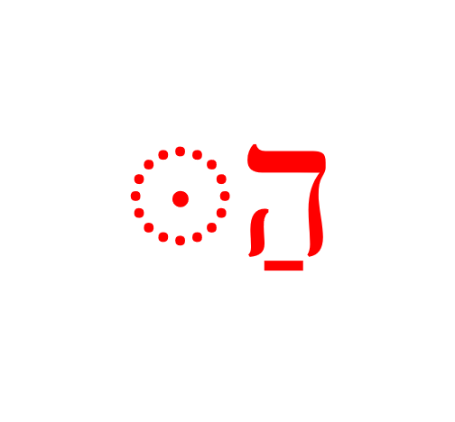

* The usual form is Hei with a Patach and a Dagesh Forte in the next letter (“Hei+Patach+Dagesh”^[By definition, the Dagesh is a Forte as it comes after a vowel that is not a Sheva.)
* As we’ve been saying, some unusual things can happen when the letter following the ה rejects the Dagesh Forte:
  + ּ הַ becomes simply הַ (no Dagesh Forte):
    - Before SQiN eM LeVY with a Sheva
    - Before a ח or another ה (see הֶ note below)- this is called “Virtual Doubling”[48]
  + Becomes הָ (no Dagesh Forte and the Patach lengthens to Qamets):
    - Before א ע ר or הָ֫
    - This is called “Compensatory Lengthening”, and is quite common with these gutturals.
* Becomes הֶ (no Dagesh Forte and a Seghol instead of a Patach):
  + Before accented or unaccented חָ, or unaccented הָ or עָ
* The goal is not to memorize the alternate forms as much as recognize that they exist
* “Hei+Patach+Dagesh” is the form you need to memorize

## 5.7 Hebrew Indefiniteness

Hebrew (and Greek) lacks an indefinite article.

A word without the Article is indefinite.

Occasionally you will see “one” - אַחַת אֶהַר to indicate indefiniteness

## 5.8 Other Hebrew Definiteness

* The Article is not the only way Hebrew indicates definiteness
* An individual’s name and most proper nouns are definite by definition.
  + דָּוִד is definite (we will never see: *הַדָּוִד)
  + On the other hand names of people groups and some geographic features often take the article. הַיַּרְדֵּן= the Jordan River.
* A word with a pronominal suffix is definite, since the suffix indicates possession, and possession is definite[49].
* A word in its construct state is definite when the last word in the construct chain is definite[50].

## Lesson Conclusion and Activities

You made it through another lesson! Way to go! Even though we only studied two concepts - the word for “and” and the word for “the”, these concepts may not be as straightforward as we might have thought.

You may be noticing how each new lesson builds upon the previous ones. If something isn’t entirely making sense, or if you find yourself asking, “why in the world do I need to know this?” just be patient, and it should start to come together in a lesson or two. Now might also be a good time to look back and see how far you have come in just five lessons.

As far as activities, we have the warm-up videos, Anki, the Ruth Pursuit and the Quest Quiz. When you finish all of that, we have our second Twelve Tribes Badge you can claim.

Take your time and let the simple, but not so simple, concepts in this chapter sink in. You’re about half-way through “non-verbs” portion of the course. Lessons 6-10 will be continuing to build out sentences with prepositions, adjectives, and pronouns. Then we’ll take a little bit of a break with numbers in Lesson 11 before we move on to verbs.

Keep with it; you’re doing great!

## Word Warm-up

[Click to open Word Warm-up video in a new tab](https://youtu.be/fYwaA5f-XGc)

## Verses Warm-up

[Click to open Verses Warm-up video in a new tab](https://youtu.be/Fa0KEAh_I84)

## Anki

* Lesson 05 A. Vocab
* Lesson 05 B. Grammar
* Lesson 05 C. Workbook
  + In this activity, we will have very short passages of scripture that illustrate the definite article and the Vav conjunction.
  + Make sure you look up any words you do not know. See the appendix for links to some lexicons (dictionaries) you may use with this course. You can download an abridged version [here](./images/BBH_Lexicon.pdf).
* Lesson 05 D. Verses

## Ruth Pursuit

YOUR QUEST

1. Find five examples of the conjunction vav: וְ (note the Vocal Sheva) (Yellow)
2. find five examples of the standard definite article ּ הַ (Green)
3. Find the first three examples of “Compensatory Lengthening” of the definite article. There is one example of “Virtual Doubling” of the definite article in verses 10-15. Can you find it?(Light Blue)
4. הִנֵה is a widespread Biblical expression that means, “look!” or “behold.” Find the one example of הִנֵה in Ruth 1. (Pink)
5. Find all examples of אִישׁ (man), and אִשָּׁה, wife/woman. (grey)
   * In verses 1 and 2, note that אִשְׁתּוֹ has a pronominal suffix, so the word means “his wife.” Words that normally end with a ה tend to lose the ה when suffixes are added. We’ll study more about pronominal suffixes in Lessons 9 and 19.
   * In verses 12 and 13, note that לְאִישׁ has a prepositional prefix mean “to” or “for.” We will learn about prepositions in the next lesson.
6. Find the vocabulary word כֹּה. It appears once with the Vav conjunction and once without. (red)

* [Blank copy of Ruth 1](https://drive.google.com/file/d/1qcfTKAlTJGChC2eYCMhSbY2w-ibzCcDV/view?usp=sharing)
* [Ruth Pursuit Answer Key #05](./images/05_Ruth_Pursuit_KEY.pdf)
* Update your Ruth Pursuit Translation worksheet.

## Quest Quiz

[Open Quest Quiz #05 in a new window](https://forms.gle/NsrAS9XKMbtLToW1A)

## Claim your next Twelve Tribes Badge!

Check to be sure you have completed **all activities** through this lesson, then fill out the form below.

[Check to be sure you have completed all ACTIVities here](https://forms.gle/vgjsvL4QNMXzkcAE6), complete the certification below, and your badge will be on its way!

# 6 Hebrew Prepositions

To comprehend Biblical Hebrew, we must be able to identify prepositions as we read the Text.

Prepositions give us space and context. Prepositions are on almost every page as the authors seek to communicate this context to us. Furthermore, there is one Hebrew word, מִן, that is classified as a preposition, but, depending on the context, can convey a wide array of meanings.

**LESSON ITINERARY**

1. Recognize that a Nun with Silent Sheva becomes a Dagesh Forte
2. Describe Independent and Maqqef prepositions
3. Define Inseparable prepositions
4. Identify when a word with an inseparable preposition also has the definite article
5. Understand how מִן is constructed
6. Define how מִן is used
7. Identify the Definite Direct Object (DDO) marker

**EQUIPMENT CHECK**

Before continuing, can you describe the following concepts?

* The construction of the definite article, including what happens when the Dagesh Forte is rejected
* The construction of the Vav conjunction
* How Hebrew handles indefinite words

## First Thought

### בְּיוֹם צָרָתִי אֲדֹנָי דָּרָשְׁתִּי

*In the day of my trouble I sought the Lord (Psalms 77:3)*

Meditate and celebrate that the Lord is in the midst of our troubles.

Listen to the verse in Hebrew:

Your browser does not support the audio element.

The בּ in בְּיוֹם is an example of an “inseparable preposition” that means “in.” We will study various types of prepositions in this lesson.

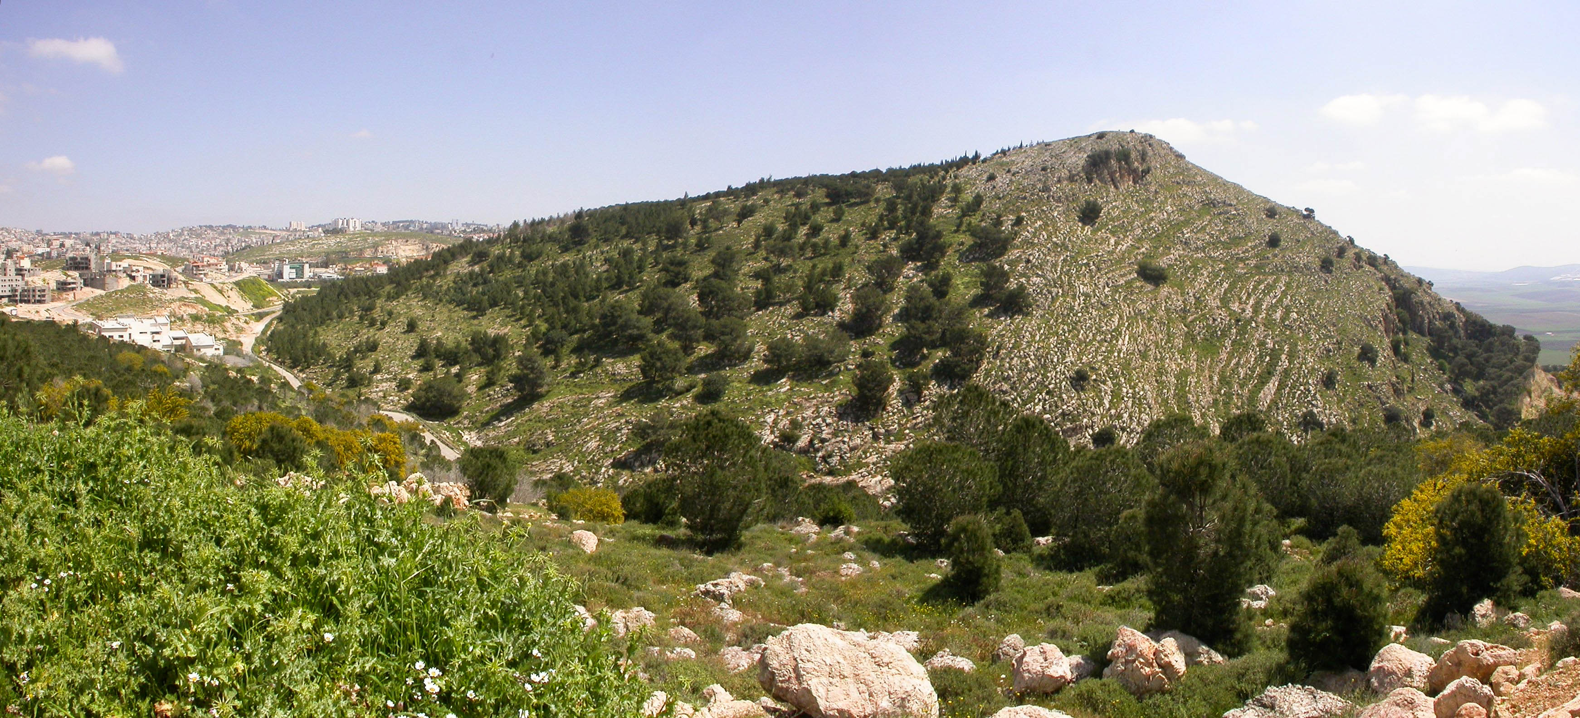

Figure 6.1: Mt. Precipice in Nazareth - suggested location of Luke 4:29 when the townsfolk took Yeshua ‘up’ the mountain, wanting to throw Him ‘from’ the cliff, ‘down upon’ the rocks, ‘into’ the valley below. Again, He prevailed in His day of trouble. Courtesy of the [Pictorial Library of Bible Lands](https://www.bibleplaces.com)

## 6.1 Nun with Silent Sheva Becomes Dagesh Forte



* Nun is considered a “weak letter”
* One aspect of weak letters is that they disappear from a word under specific scenarios
* One such scenario is when the nun appears with a SILENT Sheva נְ (or no vowel at all)
* When then nun drops, whenever possible, it will be replaced with a Dagesh Forte
* The technical term for this is called “assimilation”
  + So grammarians say, “the נ has assimilated into a Dagesh Forte”
* To get back to the original/lexical form, we would substitute the Dagesh Forte for the Nun+Sheva

ASSIMILATED NUN

A Dagesh Forte frequently indicates an assimilated נ

* When the Dagesh Forte is rejected, we have lost our big clue that a letter like נ has gone missing
  + Occasionally, but not always, we will have Compensatory Lengthening to help us out
* Recall the three scenarios where the Dagesh Forte may be rejected:

|  |  |  |
| --- | --- | --- |
| Scenario | Reject Dagesh | Compensatory Lengthening |
| Gutturals/Resh | ALWAYS | Sometimes |
| Word-final Dagesh without a Vowel (Lesson 4) | ALWAYS | Sometimes |
| SQiN eM Levy WITH SHEVA | SOMETIMES | NEVER |

## 6.2 Independent and Maqqef prepositions

* In Hebrew, there are three different types of Hebrew prepositions: independent, Maqqef, and inseparable.
* An *independent preposition* is a separate word with a space before it and after it
  + The preposition comes first, followed by its object (just like English). E.g., תַּחַת אֹתוֹ (under it)
* *Maqqef* is a mark like the English hyphen
  + The two marks are nearly identical in meaning and appearance except the Hebrew Maqqef is raised ־ whereas the English is middle -
  + Like the hyphen used to join two English words, the Maqqef lets us know that two Hebrew words are closely connected grammatically
* In a *Maqqef preposition*, the Maqqef connects a preposition to its object
* Again, the preposition comes first: עַל־מֶלֶךְ
  + English prepositions are NOT written this way; we would never see “on-a-king.”
* One notable aspect about the Maqqef is that the first word (to the left of the Maqqef) loses its accent
  + As a result, the vowel that loses its accent may change

The same preposition may be written both with and without the Maqqef

* The meaning does not change
* עַל מֶלֶךְ means the same as עַל־מֶלֶךְ

## 6.3 Inseparable prepositions

* Like וְ for the word “and,” an inseparable preposition is a one-letter prefix affixed to its object
* Three Hebrew prepositions are **ALWAYS** written this way, usually with a Vocal Sheva under the prepositional letter:
  + בְּ - in, at, with, by, against
    - בְּמֶ֫לֶךְ
    - With a king
  + כְּ - as, like, according to
    - כְּמֶ֫לֶךְ
    - Like a king
  + לּ - to, toward, for
    - לְמֶ֫לֶךְ
    - To/towards a king

A mnemonic to remember these three inseparable prepositions is “BucKLe”

The first word of the Bible contains an inseparable preposition: בְּרֵאשִׁית = “In (the) beginning”

* In the lexical form of these prepositions, there is a Vocal Sheva vowel under the “buckle” consonant
* If there is a Sheva or Hateph vowel in the next letter, the Rule of Sheva come into play (see Lesson 4)
  + Before another Vocal Sheva, the preposition usually takes a Hireq
  + Before a Guttural with a Hateph vowel, the preposition takes the corresponding short vowel
  + Note the names of God again receive special treatment: לֵאלֹהִים and לַיהוָה

## 6.4 The Article and Inseparable Prepositions

ARTICLE WITH INSEPARABLE PREPOSITION

The one-letter preposition replaces the ה of the article. The vowel under the preposition and the Dagesh Forte (if it is there) are your clues that the word is definite.

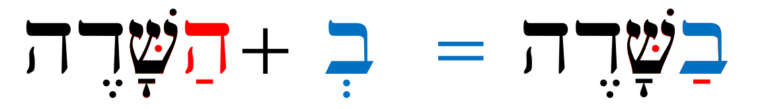

* We have learned previously that some letters reject the Dagesh Forte, which robs us of a clue
* Below is how we can tell whether there is the article with a preposition in the absence of a Dagesh
  + NO ARTICLE if there is a Sheva under the preposition - the article never takes a Sheva
  + NO ARTICLE if the short vowel under the preposition can be explained by the Rules of Sheva:
    - אֲנָשִׁים + לְ = לַאֲנָשִׁים - for men, (not ‘for the men’)
  + ARTICLE if vowel under the preposition is not Sheva and can NOT be explained by the Rule of Sheva:
    - לַהֵיכָל = for THE temple

## 6.5 The flexible מִן: construction

* There is one preposition that is unique: מִן
  + It can be a Maqqef preposition, as in: מִן־זָהָב
  + It can also be an inseparable preposition: מִזָּהָב.
  + Both examples above literally mean “from gold.”
* Note the spelling of the inseparable preposition:

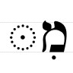 * When we see Mem+Hireq+Dagesh, we know it is מִן written as an inseparable preposition * As we know well by know, the Gutturals and Resh reject the Dagesh Forte: * א צ ה ר have compensatory lengthening so the Hireq becomes Tsere. * ח has virtual doubling, which as we remember means “virtually no doubling” in that the vowel under the מ remains a Hireq * SQiN eM LeVY with a Sheva may reject the Dagesh - as we know, there will never be any Compensatory Lengthening * So when we see מִקְ, מִיְ or Mem+Hireq followed by any other SQiN eM LeVY letter and there is no Dagesh Forte, we need to say to ourselves, “I don’t see a Dagesh Forte, but wait. That’s a SQiN eM LeVY letter, so this may still be מִן.”

## 6.6 The Article and מִן

Unlike the regular “BucKLe” inseparable prepositions, the ה of the article is always RETAINED with מִן

* מֶהָאָ֫רֶץ = from the land.

## 6.7 The flexible מִן: meanings

* מִן occurs 7,592 times in the Bible, so it is important to study its multiple uses
* The most direct meaning is “from” - מֵהָאָ֫רֶץ from the land
* מִן can also have comparative (think “bigger”) and superlative (think “biggest”) meanings depending on the context
  + טוֹבָה חָכְמָה מִזָּהָב = wisdom is better *than* gold
  + קָשָׁה הָעֲבֹדָה מֵהָאֲנָשִׁים = the work is *too* difficult *for* the men
  + עָרוּם מִכֹּל חַיַּת הַשָֹּדֶה ּ = the *most* clever living thing *of all* the field
* There is also a use called “partive” that denotes a portion or part of something else:
  + מֵהָאֲנָשִׁים may mean “*some* *of* the men” (lit. from the men)
* Other uses: ‘because’, ‘by’, ‘without’, ‘even’, ‘namely’.
* This is a word that takes practice to appreciate the various nuanced meanings
* As you are starting out in Hebrew, when you see מִן, start your translation with “from…”, but don’t be surprised if “from” does not make sense
* For example, if our translation is something like, “good the wisdom from the gold,” we know that doesn’t make sense
  + We need to remember the comparative or supurlative uses
  + “*Better* is wisdom *than* gold”

## 6.8 The Definite Direct Object marker

* Hebrew has an untranslated word that is often used to mark a direct object that is definite
* It is often abbreviated DDO (Definite Direct Object) marker
* Spelling:
  + תֵא (independent)
  + תֶא־ (Maqqef)
* The challenge can be that this is the same spelling as the preposition “with.”
* As both the DDO and preposition can take pronominal suffixes, we will save a discussion of differentiating between the two words for Lesson 9

We see the DDO twice in the first verse of the Bible:

בְּרֵאשִׁית בָּרָא אֱלֹהִים *אֵת* הַשָּׁמַיִם *וְאֵת* הָאָרֶץ

## Review and Activities

How are you feeling so far? Is any component of “the fog” refusing to dissipate? Keep sticking with Anki and try to do your reviews at least once daily.

To help with this, we’ve gone a little bit lighter on the Grammar cards and the Ruth Pursuit for Lesson 6. While there are some differences, prepositions are used much the same way in Hebrew as they are in English. There is no sense in creating a lot of busy work.

We would recommend using the time between now and starting Lesson 7 to get caught up and make sure the new concepts start to take hold. You might notice the intensity pick up starting with the next lesson as we get into some ways Hebrew handles adjectives and pronouns. Until then, enjoy learning some more of God’s work with Izzy in the Word warm-up, Verse warm-up, and Anki.

### Anki

* Lesson 06 A. Vocab
* Lesson 06 B. Grammar
* Lesson 06 C. Workbook
  + In this activity, we will have very short passages of scripture that illustrate prepositions.
  + Make sure you look up any words you do not know. See the appendix for links to some lexicons (dictionaries) you may use with this course. You can download an abridged version [here](./images/BBH_Lexicon.pdf).
* Lesson 06 D. Verses

## Word Warm-up

[Click to open Word Warm-up video in a new tab](https://youtu.be/P-oZ1J6ZyBc)

## Verses Warm-up

[Click to open Verses Warm-up video in a new tab](https://youtube.com/embed/z4QY0pMdPsA)

## Ruth Pursuit

YOUR QUEST

1. Highlight the following words that begin with the inseparable pronouns and provide a definition (Yellow)
   * בָּאָרֶץ
   * בַדֶּרֶךְ
   * לְבֵית
   * לִי
2. Find examples of מִן (there is one Maqqef and the rest are inseparable) - translate the Maqqef phrase (look up the object of the מִן preposition in a lexicon if needed) (Green)
3. Find one example of the DDO (Maqqef) (Blue)
4. Find Lesson 6 vocabulary words:
   * עַד
   * אַחֲרֵי (note: In Ruth 1, one instance of word also has a מִן prefix (inseparable form) as well as a pronominal suffix, which we will study in Lesson 9)
   * כָּל־(Pink)

* [Blank copy of Ruth 1](https://drive.google.com/file/d/1qcfTKAlTJGChC2eYCMhSbY2w-ibzCcDV/view?usp=sharing)
* [Ruth Pursuit Answer Key #6](./images/06_Ruth_Pursuit_KEY.pdf)

## Quest Quiz

[Open Quest Quiz #6 in a new window](https://forms.gle/oeB8E6K4y4mTjPWGA)

# 7 Hebrew Adjectives

To comprehend Biblical Hebrew, we must be able to identify and translate an adjective based on its usage, gender, and number

**LESSON ITINERARY**

1. Understand how an adjective relates to the noun it is modifying
2. Define and identify Substantival se
3. Define and identify Attributive use
4. Define and identify Predicative use
5. Determine the appropriate adjectival use in a passage
6. Define the function of the Mappiq and differentiate it from Daghesh marks
7. Recognize the Directional Ending and differentiate it from the vowel ה ָ

EQUIPMENT CHECK

Before continuing, can you describe the following concepts?

* Inseparable prepositions with and without the definite article
* Construction and meaning of מִן, including assimilation of the נ

## First Thought

### אֶת־הַכֹּל עָשָׂה יָפֶה בְעִתּוֹ

*He has made everything appropriate (beautiful) in its time. (Ecclesiastes 3:11)*

Offer a word of gratitude that HaShem has made you beautiful!

יָפֶה is an example of predicate adjective use, which we will study in this lesson.

Listen to the verse in Hebrew:

Your browser does not support the audio element.

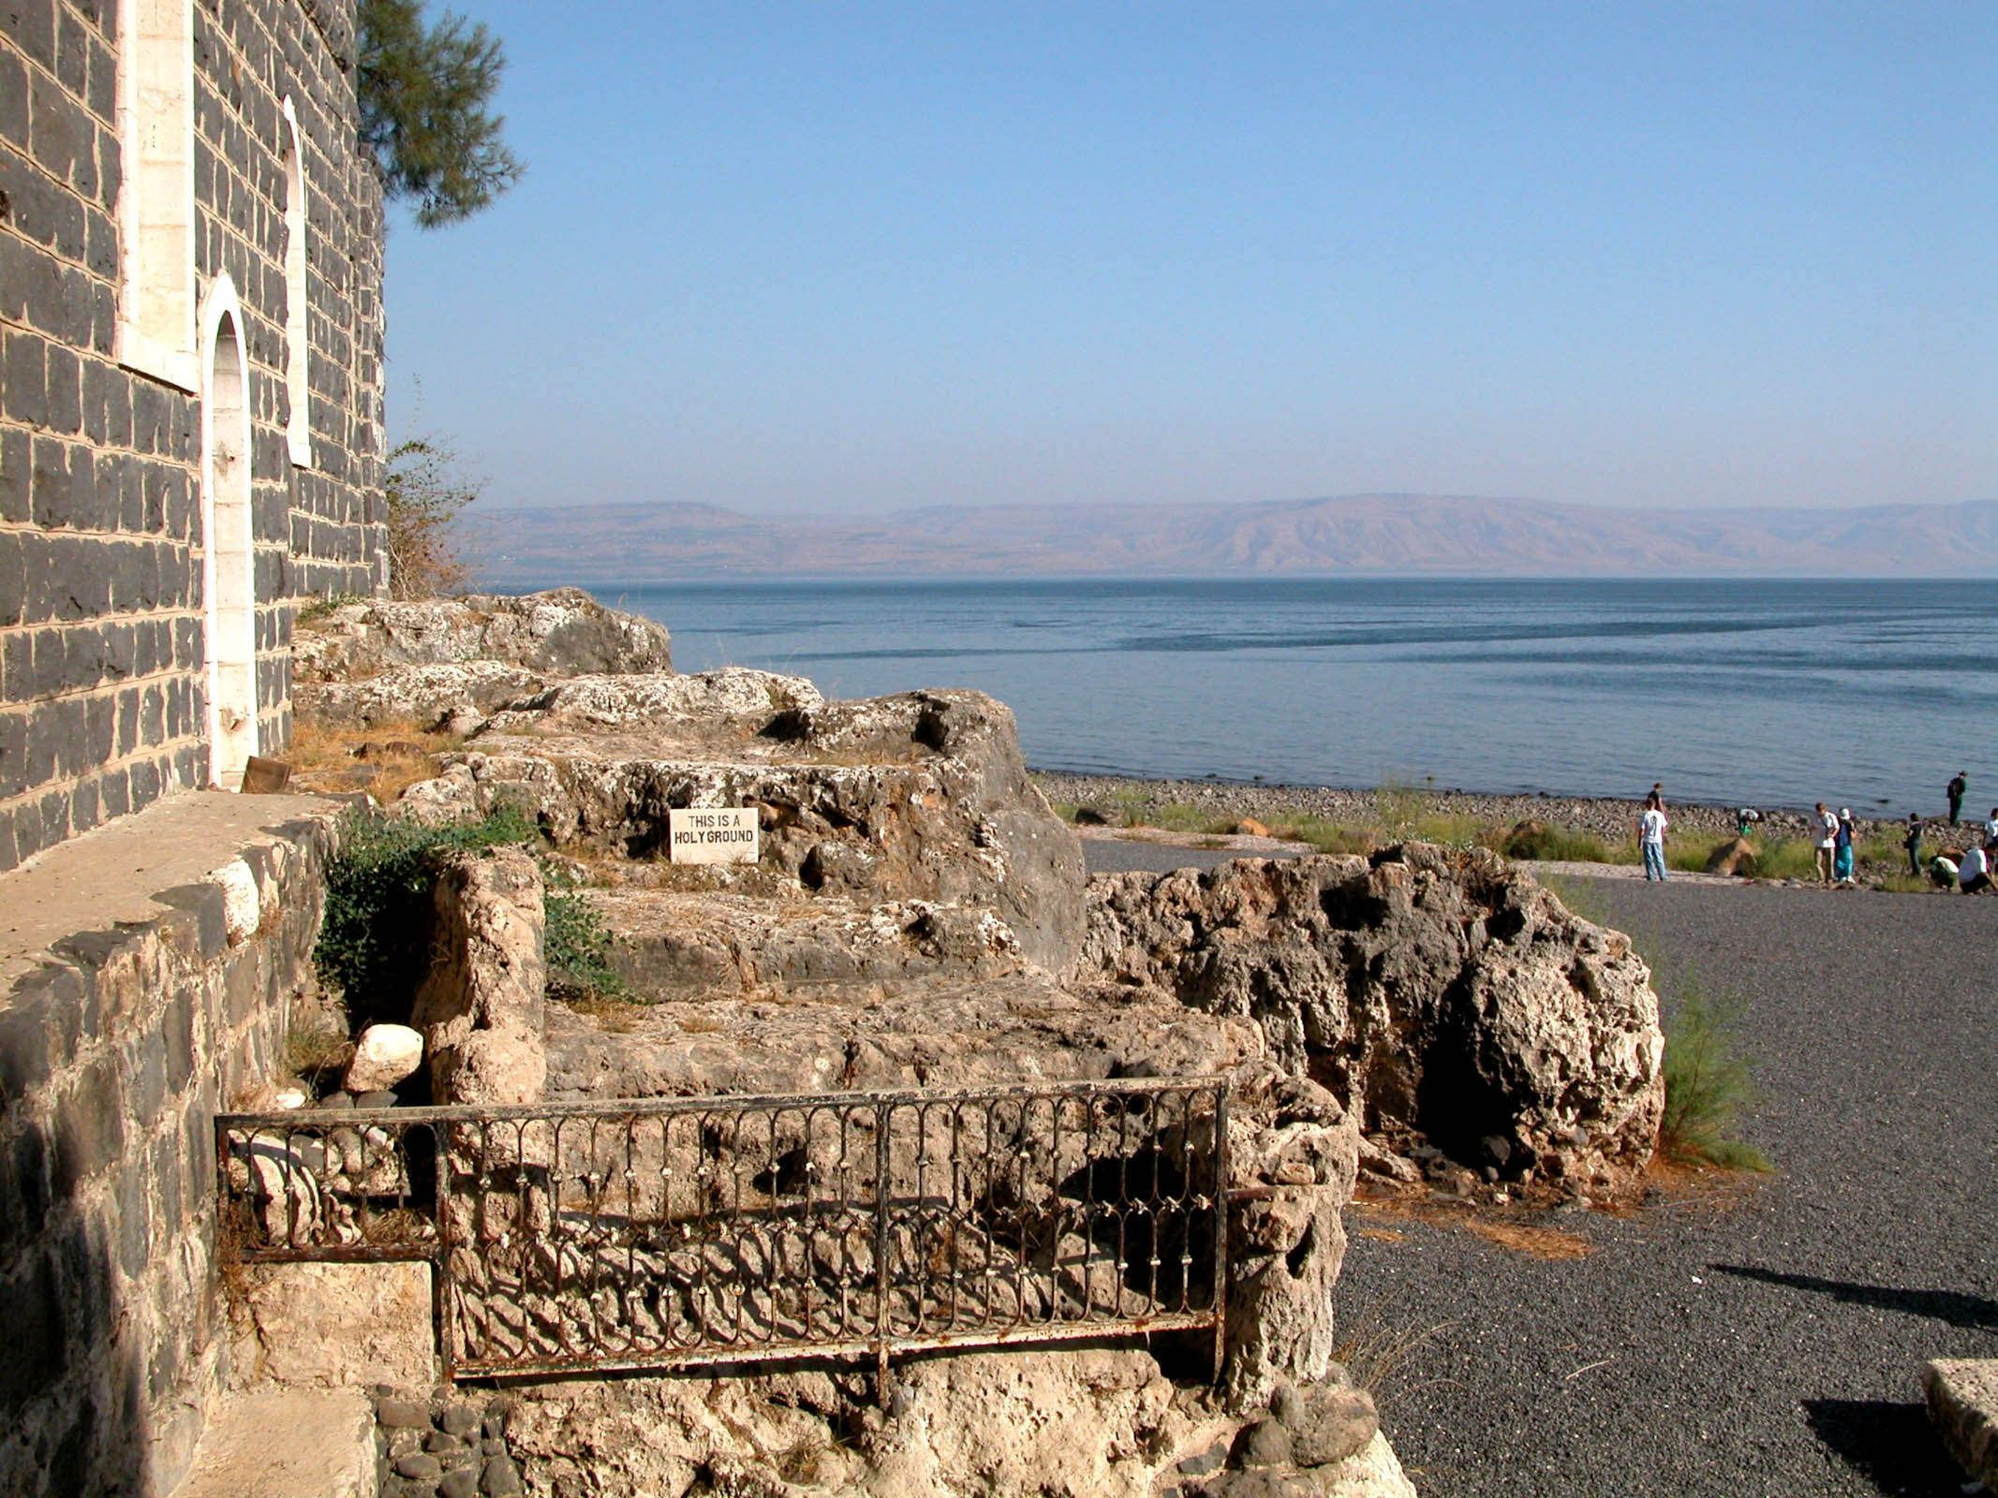

Figure 7.1: Tabgha - suggested location of Yeshua’s restoration (making beautiful) of Shimon Kefa (Peter) on the beach in John 21, following Peter’s denial of Yeshua a few days earlier. Courtesy of the [Pictorial Library of Bible Lands](https://www.bibleplaces.com)

## 7.1 Inflecting Adjectives

Adjective inflection is relatively straight-forward.

We will use the paradigm word טוֹב to illustrate

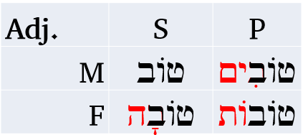

1. An adjective is either masculine or feminine
2. An adjective is either singular or plural (dual nouns take plural adjectives)
3. An adjective will match the gender and number of the noun that it modifies or for which it substitutes
   * Note that for irregular nouns, the adjective will not necessarily match the exact ending
   * נָשִׁים טוֹבוֹת - even though “נָשִׁים” has the irregular -im ending, the adjective טוֹבוֹת remains the regular feminine plural
4. An adjectives will use expected endings

Unlike nouns, adjectives can inflect across genders in order to match the respective gender of the noun.

The Lexical Form of an adjective is the MS. MS is usually endingless, but can be Seghol+Hei as in יָפֶה, which is MS for pleasing, beautiful.

Note that unlike טוֹב, most adjectives undergo vowel changes when the inflectional endings are added. The good news is you already know what to do. Adjectives follow the same rules as nouns.

## 7.2 Substantival Use

In the Substantival use, the adjective acts as a noun. We could say the “Substantiv Substitutes” for a noun.

Perhaps an obvious example of this from pop culture is the film, “The Good, The Bad, and The Ugly.” The three words, “good”, “bad” and “ugly” are adjectives being used as nouns. In a sense the noun is implied. It could be the “good ones” or the “bad man”.

The Substantival use in Hebrew is relatively easy to identify. You will see an adjective but there will be no related noun that matches in gender and number.

הַטּוֹבָה - “the good” (feminine singular something). So depending on the context it could be “the good woman”, or a feminine object like “the good Torah.”

In substantival use, the adjective never directly modifies a noun.

## 7.3 Attributive Use

The Attributive use is usually what we think of with respect to adjectives. The adjective modifies and describes a noun. “The good book” is an example of the Attributive use.

Hebrew makes it much easier to identify the Attributive use. The adjective MUST come AFTER the noun it modifies, and it MUST match in definiteness - meaning either both the noun and the adjective have the definite article or they both will not have the article.

* הָאִשָּׁה הָטּוֹבָה - the good woman
* אִשָּׁה טוֹבָה - a good woman (or “the woman is good”-predicate use; see next section)

**A**ttributive **A**fter noun, **A**rticle **A**grees

## 7.4 Predicative Use

The Predicative use (often called the predicate use) asserts something about the noun. The noun is the subject and the adjective is the predicate of the sentence: “The book is good.”

The Predicative use is more flexible than the Attributive, in that the adjective can be either before or after the noun. One way to differentiate it from the Attributive use is the Predicative use WILL NOT have the Article.

All of the options below can mean “the woman is good”:

* טוֹבָה הָאִשָּׁה
* הָאִשָּׁה טוֹבָה
* טוֹבָה אִשָּׁה
* אִשָּׁה טוֹבָה (or “attributative”)

As this illustrates, the only time there can be any ambiguity between Attributive and Predicative is when the adjective follows the noun and both are indefinite. In these situations, we need to let context determine the use.

**P**redicative de**P**rived of the article; **P**erhaps **P**rior

## 7.5 Adjective Use Summary

Here is a decision tree:

* Is the adjective modifying a noun?
  + No - *Substantival*
  + Yes - does the adjective have the article?
    - Yes - *Attributive* (Predicate dePrived of Article)
    - No - is the adjective before the noun?
      * Yes - *Predicate* (Attributive Always After)
      * No - Potentially ambiguous when both noun and following adjective are indefinite: Predicate or Attributive depending on context

## 7.6 The Mappiq

The Mappiq is a mark that looks exactly like a Daghesh, but it ONLY is found in a word-final Hei (a Hei that is the final letter of a word).

It is virtually impossible to confuse a Daghesh and a Mappiq because ה can never take a Daghesh.

A word-final ה is always a vowel unless it has a mappiq (הּ).

The mappiq is a sign that the breathy sound of the consonantal hei should be accentuated slightly.

At the end of a word:

* ה ָ - “aaw”(long A sound)
* הּ ָ - “ahh”(breathy)

## 7.7 The Directional Ending

We’ve studied the fact that the ה ָ is the Feminine Singular ending. We now need to refine this definition slightly.

* An ACCENTED ה ָ is the FS ending
* However, an UNACCENTED ה ָ is known as a “directional ending”
* The directional ending is used to indicate motion towards or to, whatever the noun is
  + אַ֫רְצָה - to/toward a land
  + הָעִ֫ירָה - to/toward the city

Note that אֶל־הָאָ֫רֶץ and אַ֫רְצָה are essentially synonymous.

אָנֹכִי אֵרֵד עִמְּךָ מִצְרַ֫יְמָה

*I will go down with you to Egypt (Gen 46:4)*

## Word Warm-up

[Click to open Word Warm-up video in a new tab](https://youtu.be/8GIYqACoOcQ)

## Verses Warm-up

[Click to open Verses Warm-up video in a new tab](https://youtu.be/s0JvZ9z0jAg)

## Anki

* Lesson 07 A. Vocab
* Lesson 07 B. Grammar
* Lesson 07 C. Workbook
  + In this activity, we will have very short passages of scripture that illustrate adjectives, including examples of attributive and predicate use
  + Be sure to look up any words you do not know.
* Lesson 07 D. Verses

## Ruth Pursuit

YOUR QUEST

Curiously, there are a lack of adjectives in Ruth 1. There are participles, which are verbal adjectives we will study in Lesson 22.

1. There are several mappiq marks that should be relatively easy for you to locate (yellow)
2. Vocabulary words (green)
   1. Find the Hebrew word for “name”, that you learned in the Lesson 3 Vocab. Frequently, the word has the Vav conjunction.
   2. Find the word for “very”
   3. Find the word for “daughters” - it occurs with a pronominal suffix, and means “my daughters”
   4. Find the phrase joined with a Maqqef that means “to the land (of)”
3. Other words (pink)
   1. Towards the end of the chapter, Naomi says "don’t call me Naomi (pleasant) call me ‘Mara’ (bitter). Find the word for Bitter. It occurs twice in two different forms.
   2. Find the word for Orpah
   3. רֵיקָם is a word that means “empty”. It occurs 16x, and almost always with the sense of sending someone away empty-handed.[51]. In Ruth 1, Naomi said she left full but was sent back empty. Find the one example of this word near the end of the chapter.

* [Blank copy of Ruth 1](https://drive.google.com/file/d/1qcfTKAlTJGChC2eYCMhSbY2w-ibzCcDV/view?usp=sharing)
* [Ruth Pursuit Answer Key #8](./images/08_Ruth_Pursuit_KEY.pdf)
* Don’t forget to update your Ruth Pursuit Translation worksheet with new words identified through lesson 7.

## Quest Quiz

[Open Quest Quiz #07 in a new window](https://forms.gle/uYiUgRBWeRJikaR57)

## Claim your next Twelve Tribes Badge!

Check to be sure you have have completed **all activities** through this lesson, then fill out the form below.

[Check the requirements here](https://docs.google.com/spreadsheets/d/1t0C7JlygyUqgF_aQWbhq7h3s_VDn0VuvISJn5mp-LdE/edit?usp=sharing), then complete the certification and claim your badge below:

# 8 Hebrew Pronouns

To comprehend Biblical Hebrew, we must be able to identify pronouns with gender, number and person

Pronouns are essentially a language’s shorthand so we don’t have to keep repeating nouns (because saying all of those nouns over and over can really wear you down).

As such, this is an important topic that will take two lessons (8 and 9). If you want to understand what you’re reading, you will need a firm grasp of pronouns to help decipher what is happening in the narrative.

**LESSON ITINERARY**

1. Define the phrase “independent personal pronoun”
2. Identify and define Hebrew’s relative pronoun
3. Identify Hebrew’s interrogative pronouns
4. Distinguish the interrogative particle from the definite article
5. Identify and translate the near and far demonstratives
6. Detect demonstrative adjective use
7. Detect demonstrative pronoun use

EQUIPMENT CHECK

Before continuing, can you describe the following concepts?

* Define and translate substantival, attributive, and predicate adjectives (at a summary level)
* How Hebrew inflects adjectives, so we can identify Gender and Number
* The directional ending as compared with the FS ending

## First Thought

### זֶה הַדֶּרֶךְ לְכוּ בוֹ

*This is the way, walk in it (Isaiah 30:21)*

Pray that you continually walk in His way, not your own way

Listen to the verse in Hebrew:

Your browser does not support the audio element.

The first word in above passage is an example of a “demonstrative pronoun”. The first two words are translated, “this is the way”. Contrast “this is the way” with the phrase “this way.” “This way” would be written הַדֶּרֶךְ הַזֶּה. “This way” is an example of a “demonstrative adjective.” We’ll learn about demonstratives in this lesson.



Figure 8.1: Sea of Galilee and Plain of Gennesaret. Yeshua likely walked this way through the valley below on His way from Nazareth to Capernaum (a town on the coastline, roughly in the center of the picture above). Courtesy of the [Pictorial Library of Bible Lands](https://www.bibleplaces.com)

## 8.1 Independent Personal Pronoun

Independent personal pronouns are *always* subjects, meaning they are equivalent to I, you, she, he, it and they in English (NOT me, my, her, him, his)

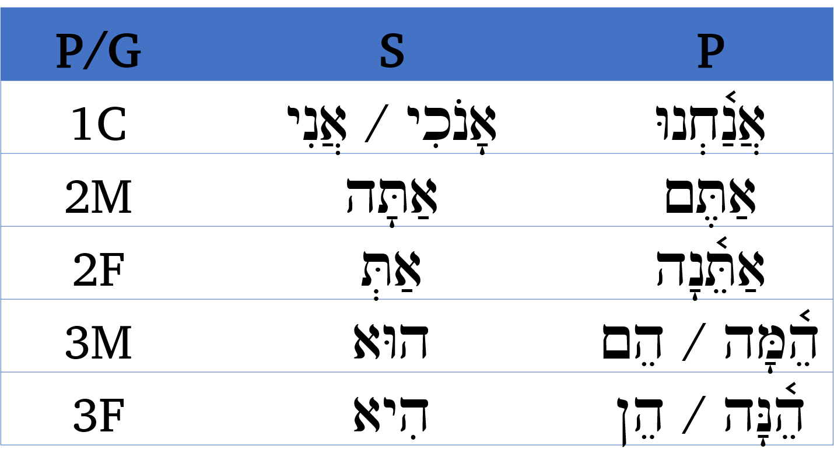

You will work to memorize these in Anki.

Notes:

* This is the first time we are officially using all three elements of Person, Gender and Number. 3MS is shorthand for Person = 3rd Person, Gender = Masculine, Number=Singular
* For 1st person, Hebrew, like English, does not distinguish between gender in the first person. A woman says “I” and a man says “I”
  + אָנֹכִי is considered more formal or emphatic. It is often translated, “I, myself”
* Note the following memory aids:
  + All 1st person pronouns begin with אנ
  + All 2 begin with accented אַתּ֫ - note the Daghesh Forte
  + All 3 begin with accented ה֫
  + All MP end with either מָה or ם. Think “monks” since men are monks
  + All FP end with either נָה or ן. Think “nuns” since women are nuns
  + Who is he? He is she.
* Do not confuse אַתָּה (you 2MS) with עַתָּה (now)

## 8.2 Relative Pronoun אֲשֶׁר

* Hebrew has one general-purpose relative pronoun
* אֲשֶׁר is a vocabulary word for this lesson
* This word does not inflect/the spelling never changes
* It can refer to people (who) or things (that), subjectively (who) or objectively (whom)

Example Deuteronomy 1:1

אֵלֶּה הַדְּבָרִים *אֲשֶׁר* דִּבֶּר מֹשֶׁה

*These are the words that Moses spoke*

## 8.3 Interrogative Pronoun

* מִי = who (“Who, me?”)
* מָה = what (think of your mom questioning you, “What, ma?”)
  + Can also be written as Maqqef - note the vowel shortens מַה־
* לָמָה = why
  + Remember the familiar verse “אֵלִ֣י אֵ֖לִי לָמָ֣ה עֲזַבְתָּ֑נִי” - My God, my God, WHY have you forsaken me?

Usually these words will appear at the beginning of a clause

## 8.4 Interrogative Particle הֲ

English has a question mark at the end of a sentence. Hebrew has what is called an interrogative particle at the BEGINNING of a sentence that asks a yes/no question.

Questions that ask who? what? or why? will use the interrogative pronouns.

### Interrogative Particle vs Definite Article

In most cases you will not have trouble differentiating the Article from the Interrogative Particle. Below are potential sources of ambiguity:

* 1st word of a clause before חָ֫,חָ, הָ, עָ = both are הֶ
* 1st word of a clause before ה, ח without Qamets or SQiN eM LeVY with Sheva = both are הַ
* In these situations, you guessed it, you will need to let context determine whether a question is being asked.
* With lots of reading practice, this will get easier.
* Additionally, the Definite Article is about **300X more common**.

## 8.5 Near and Far Demonstratives

In English, the near demonstratives are this and these. The far demonstratives are that and those. Think of “this right here” and “those, over there”.

Hebrew has three words to indicate nearness. We already learned the words to indicate distance - they are the same as the subject pronouns.

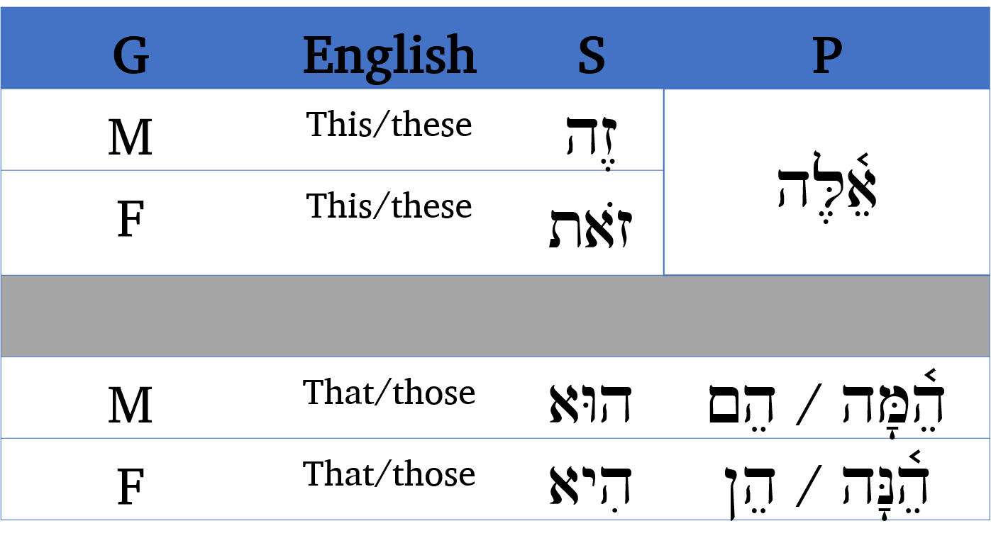

## 8.6 Demonstrative Adjective

Demonstratives act as adjectives or as pronouns.

A demonstrative adjective modifies a noun just as an attributive adjective does. These daughters.

The behavior is a lot like the Attributive use:

* Always comes after the noun (Dem Adjective Always After)
* Always has the article (Dem. Adjective Always Article)
* Always matches in Gender and Number
  + הָאִשָּׁה הַזֹּאת = this woman (FS)
  + הָאֲנָשִׁים הָהֵם = those men (MP)

Mnemonic:

Demonstrative Adjective Always After noun, Always has Article

## 8.7 Demonstrative Pronoun

A demonstrative pronoun takes the place of a noun as the subject of a clause. This is her daughter.

The behavior is a lot like the Predicative use:

* Always comes before the noun (Pronoun Perpetually Precedes)
* Does NOT have the article (Pronoun dePrived of article)
* Matches Gender and Number
  + זֹאת הַמַּלְכָּה = this is the queen (FS)
  + זֶה הַמֶּ֫לֶךְ = this is the king (MS)

Mnemonic:

Demonstrative Pronoun Perpetually Precedes, Perpetually dePrived of article

## Conclusion and Intro to Activities

Your mission for the next two lessons is to focus on building your pronoun vocabulary. You may notice more Anki words than usual to learn but most of these are short (and for next lesson, the pronouns will mostly be two letters each). After you finish the stack in Anki we have two pronoun worksheets for you to test your memory.

It is important to know the gender, number, and where necessary the person of each. Also the concept of multiple ways to say “you” can be confusing to the English speaker. It’s important to give the PGN, for example אַתֵּ֫נָה means “you (2FP).”

If you can picture yourself hiking the trails of Israel, Lessons 8, 9, and 10 may represent some hills where you may need to push a little bit extra. Then we’ll get a bit of a breather with Lessons 11 and 12 before ramping up again with Qal Verbs. Keep at it! You’re doing awesome!

## Word Warm-up

[Click to open Word Warm-up video in a new tab](https://youtu.be/kNfZ8BblobA)

## Verses Warm-up

[Click to open Verses Warm-up video in a new tab](https://youtu.be/XXn6G8EWmn0)

## Anki

* Lesson 08 A. Vocab
* Lesson 08 B. Grammar
* Lesson 08 C. Workbook
  + In this activity, we will have very short passages of scripture that illustrate pronouns
* Lesson 08 D. Verses

## Worksheets: Pronouns

We have two worksheets for this lesson. Make sure you do the Anki work first, before tackling these worksheets.

While our focus is on reading Hebrew, pronouns are so prevalent that it’s highly beneficial to commit them to memory. Review the column on the right, then cover it up and try to complete the remaining columns by memory (right to left).

1. [Subject Personal Pronouns](./images/08_subject_paradigm.pdf)
2. [Demonstrative Pronouns](./images/08_demonstrative_paradigm.pdf)

## Ruth Pursuit

YOUR QUEST

Just as the vocabulary for Lessons 8 and 9 are a bit longer, so too are the Ruth Pursuit exercises. There are 33 total “finds” in Ruth Pursuit #8 and 34 in Ruth Pursuit #9. Be patient and you’ll find them all!

1. Pronoun Vocabulary (yellow)
   1. The relative pronoun meaning “who, whom, that, which” and the related pronoun meaning “as, when”
   2. Independent Pronouns: I, he, she, them, they you (may have prepositional prefix)
2. Interrogative (green)
   1. Interrogative pronouns from Lesson 8 vocabulary
   2. The idiom הַעוֹד־לִי, means “have I yet?” or “do I have?”
   3. Other uses of the interrogative particle
3. Other vocabulary (blue)
   1. because/for/if
   2. also/even
   3. Therefore (also has interrogative particle)
4. Find one near demonstrative pronoun (also has interrogative particle) (Pink)
   * Translate the demonstrative

* [Blank copy of Ruth 1](https://drive.google.com/file/d/1qcfTKAlTJGChC2eYCMhSbY2w-ibzCcDV/view?usp=sharing)
* [Ruth Pursuit Answer Key #8](./images/08_Ruth_Pursuit_KEY.pdf)

## Quest Quiz

[Open Quest Quiz #8 in a new window](https://forms.gle/Ew13bcUBZM8T7ck86)

# 9 Hebrew Pronominal Suffixes

To comprehend Biblical Hebrew, we must be able to translate a noun or preposition with a pronominal suffix

In this lesson, we continue the important discussion on pronouns. In Lesson 9, we focus on an aspect of pronouns we don’t have in English - pronominal suffixes.

**LESSON ITINERARY**

1. Understand the meaning of pronominal suffixes
2. Define Type 1 vs Type 2 suffixes
3. Differentiate Type 1 from Type 2
4. Identify the Lexical Form of a Noun with a Type 1 Suffix
5. Identify the Lexical Form of a Noun with a Type 2 Suffix
6. Recognize unusual changes with pronominal suffixes
7. Identify look-alike words involving pronominal suffixes

EQUIPMENT CHECK

Before continuing, can you describe the following concepts?

* Independent personal pronouns (memorized)
* The difference between the definite article and the interrogative particle
* Hebrew demonstratives

## First Thought

### וַיֹּאמְרוּ שָׁאוֹל שָׁאַל־הָאִישׁ לָנוּ וּלְמוֹלַדְתֵּנוּ

*This man heavily questioned us and our kindred. (Genesis 43:7)*

In addition to offering up our petitions, let us be sure to listen for God’s questions. What is He asking you (or asking of you) today? Take a moment.

Listen to the verse in Hebrew:

Your browser does not support the audio element.



Figure 9.1: Banias waterfall. Region of Caesarea Philippi where Yeshua asked his talmidim a very important question, ‘who do YOU say that I am?’. With our choices, we have the opportunity to answer this same question practically every moment of every day. See Matthew 16:13-17. Courtesy of the [Pictorial Library of Bible Lands](https://www.bibleplaces.com)

## 9.1 Meaning

Hebrew has another type of pronoun in addition to stand-alone words. In Lesson 6, we talked about “inseparable prepositions”, which are one-letter prefixes to words. Pronominal suffixes work similarly, except as the name “suffix” implies, these go on the back of words instead of the front.

* On a noun, a pronominal suffix indicates the one who owns or is related to the noun: His books / her houses / their house / our father
* On a preposition, the suffix indicates the object: to her / with them / behind him / in front of it
* Verbs also take pronominal suffixes, which will indicate the verb’s object. We will study these in Lesson 19.

Pronominal suffixes have *gender*, *number*, and *person*.

* Whereas independent personal pronouns were always “subject” pronouns (e.g., I, she, he, it and they), pronominal suffixes are always “object” or “possessive” pronouns (e.g., me, my, her, him, them, theirs).
* “You” can be an ambiguous term in English, not only with number and gender but also, “you” can be either a subject or object. Hebrew has distinct ways of saying 2MS, 2FS, 2MP, and 2FP, as well as different forms for subject and object.

## 9.2 Type 1 vs Type 2 Suffixes

Pronominal suffixes are further divided into two types.

* **Type 1** suffixes go on **SINGULAR** nouns[52]
  + Keep in mind there are both plural and singular Type 1 suffixes for use on singular nouns
  + Multiple people can have ownership of a single object
  + In English we would say “his house” and “their house”
* **Type 2** suffixes go on **PLURAL** nouns
  + Similar to above, there are both singular and plural type 2 suffixes for use on plural nouns
  + “his houses” as well as “their houses”
* Type on a preposition means nothing in terms of translation; each preposition will only take one class or the other

## 9.3 Singular Suffixes

While Type 1 and Type 2 suffixes have distinctives, there are also some commonalities with singular suffixes of both types.

Below are the singular suffixes. You will use Anki to commit these to memory.

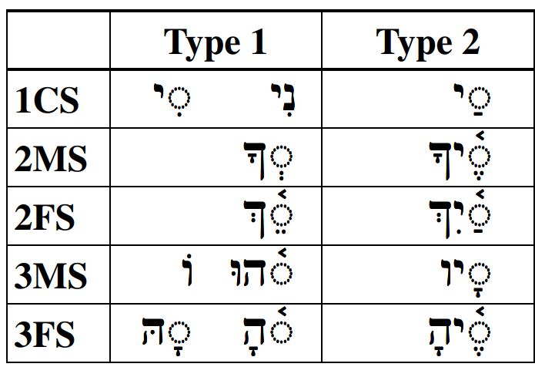

* 1CS end with י
* 2MS/2FS end with ך
* Not all 3M/3F have ה but every ה is 3M/3F

## 9.4 Plural Suffixes

Below are the plural suffixes: 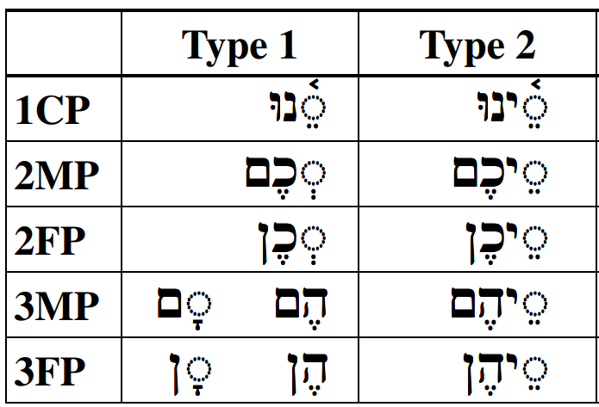

* 1CP ends with נוּ
* 2MP/2FP have כ
* Not all 3M/3F have ה but every ה is 3M/3F
* 2MP/3MP has מָה or ם (‘monks’)
* 2FP/3FP has נָה or ן (‘nuns’)

## 9.5 Distinguish Type 1 from Type 2

Look at the chart below with the two types side-by-side.

Type 2 **always** contains vowel + yod, but **not** hiriq + yod  
Type 1 **never** contains yod, *unless* it’s hiriq+yod

This simple rule, plus the tips on the previous pages about patterns in gender and number, should make it easier to identify the pronominal suffix.

When you encounter a word with a suffix, always start by asking “is there a vowel + yod, that is not hiriq + yod?”

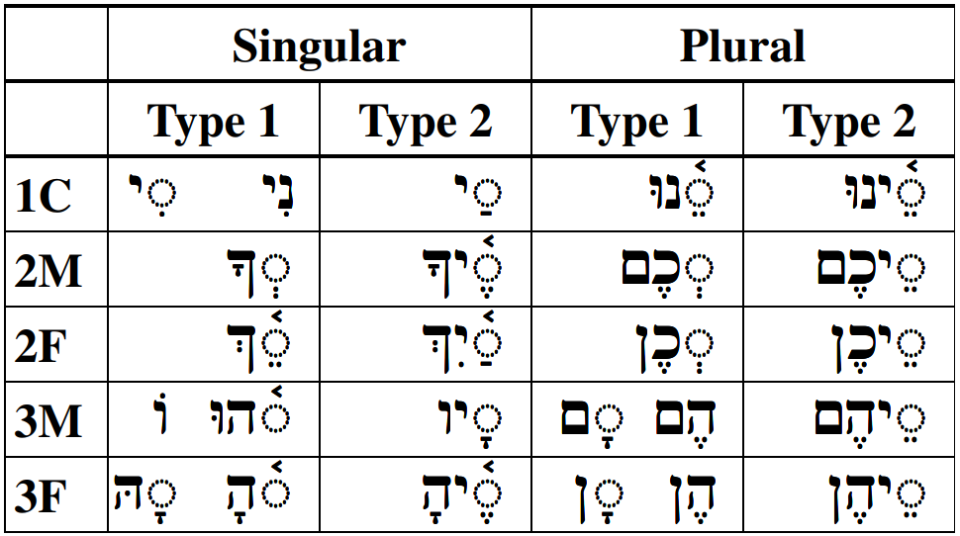

## 9.6 Lexical Form with Type 1

Part of learning to read Biblical Hebrew is assembling a set of skills that make it easier to navigate when you encounter an unfamiliar word in the Text. A noun is more likely to be unfamiliar to you than a preposition so we’ll focus on that. Below is a procedure you may follow that should help with this. The steps for a Type 1 suffix are on this page and the steps for Type 2 are on the next page.

1. Remove the pronominal suffix
2. Remembering that type one suffixes can *only* go with SINGULAR nouns, the next step is to fix the singular ending as needed
   * If the remaining word ends with a ת, it is likely Feminine. Replace ת ַ or ת ָ with ה ָ (usually)
   * If the remaining word does not end with a ת, it is likely masculine. Most often, masculine words are endingless but sometimes you may need to add the masculine singular ending ה ֶ
3. If there is a tsere + yod in the middle of the word, replace with the diphthong יִ ַ֫
4. Change other vowels as needed according to the vowel preference table we studied several lessons ago.

Here is Dr. Beckman’s example of the four steps using five example words with Type 1 suffixes. Note that words do not always need all four steps.

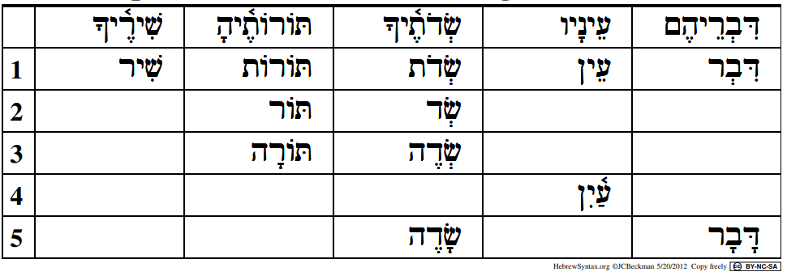

## 9.7 Lexical Form with Type 2

1. Remove the pronominal suffix
2. Remembering that type 2 suffixes can *only* go with PLURAL nouns, but the Lexical Form is going to be the SINGLULAR, the next step is to fix the singular ending as needed. Remove the וֹת ending if there is one. Keep in mind that the word could exhibit defective spelling as with שְֹדֹת below.
3. Add the appropirate singular ending, if needed
   * If the word ended with a וֹת, it is Feminine. Replace with ה ָ (usually)
   * If the remaining word does not end with וֹת, it is likely masculine. Most often, masculine words are endingless but sometimes you may need to add the masculine singular ending ה ֶ
4. If there is a tsere + yod in the middle of the word, replace with the diphthong יִ ַ֫
5. Change other vowels as needed according to the vowel preference table we studied several lessons ago.

Here is Dr. Beckman’s example of the five steps. Note that words do not always need all five steps.

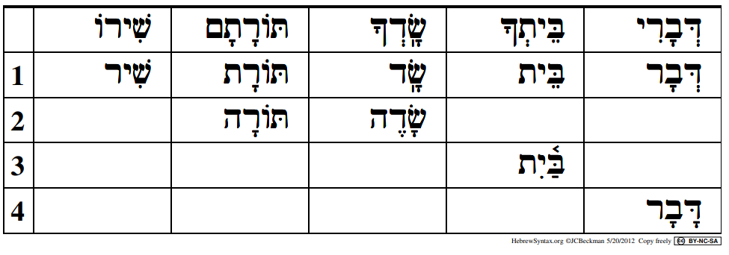

The changes to the base words are due to the words being in **construct** form. We will study more about this in Lesson 10.

## 9.8 Unexpected changes

Two of the prepositions we studied in Lesson 6 undergo some irregular changes you will encounter as you read the Bible.

* כְּ (like, as) and מִן (from, etc.) often insert an extra מוֹ or מּ in some forms
  + Like you (2MS): כָּמ֫וֹךָ
  + From you (2MS): מִמְּךָ
* אָח adds a hireq + yod before all type 1 suffixes
  + My brother (1CS): אָחִי
  + Our Brother (1CP): אָחִינוּ

The rule still applies:

Type 2 **always** begins with vowel + yod, but **not** hiriq + yod

## 9.9 Look-alike words: אֵת as “with” or as Definite Direct Object (DDO) marker

* As we learned previously, אֵת can mean either the DDO or the preposition “with”. They are spelled the same way and either form can take a pronominal suffix.
* אֵת with a regular Type 1 pronominal suffix is the DDO, when the א has a vowel-marked as אֹ or אֶ
  + 3MS: אֹתוֹ
  + 2FP: אֶתְכֶן
* When then author intends to communicate the preposition with, as in “with him”, the א will take a Hireq in all forms
  + With me (1CS): אִתִּי
  + With them (3FP): אִתָּן

## 9.10 Look-alike words: עִם, “with”, or עַם, “people”

These two words frequently take pronouns. It could be easy to get them confused. The trick is to pay close attention to the vowel under the ע.

* עִם , with, will always have Ayin+Hireq, whereas עַם, people, will always have Ayin+Patach
  + With Me (1CS): עִמִּי
  + My People (1CS): עַמִּי
  + With them (3MP): עִמָּם
  + Their people (3MP): עַמָּם

## 9.11 Look-alike words: אֵל, “God”, or אֶל, “to”

This one is *slightly* easier.

* אֵלִי, my God is the only form of אֶל that appears with a pronominal suffix in the Bible
* to me (1CS) is: אֶלַי - Patach under the ל

Although אֵל may not appear with a suffix apart from this one time, אֱלֹהִ֑ים can, and in the Torah, frequently does take suffixes. The words pairs below are close but not equivalent.

* אֱלֹהֶ֑יךָ = your God (See Deuteronomy 6:5)
* אֵלֶ֫יךָ = to you (2MS)
* אֱלֹהִ֑ים = God, gods
* אֲלֵיהֶם = to them (3MP)
* אֱלֹהֵֽינוּ = our God (Exodus 3:18)
* אֵלֵ֫ינוּ = to us (1CP)
* אֱלֹהָֽי = my gods (Genesis 31:30)
* אֵלֶ֫יהַ = to her/it (3FS)

## Word Warm-up

[Click to open Word Warm-up video in a new tab](https://youtu.be/IGxobVIxYkY)

## Word Warm-up: pronominal suffixes

We have created a special Word Warm-up for the pronominal suffixes.

[Click to open Word Warm-up video in a new tab](https://youtu.be/zk-v6XSY6Pg)

## Verses Warm-up

[Click to open Verses Warm-up video in a new tab](https://youtu.be/8Y7XdOBkWWo)

## Anki

* Lesson 09 A. Vocab
* Lesson 09 B. Grammar
* Lesson 09 C. Workbook
* Lesson 09 D. Verses

## Worksheets: Pronominal Suffixes

After you have done your Anki work, we have an additional worksheet to help you drill your pronominal suffixes. As with previous worksheets, study, then cover-up the first column on the right and see if you can complete the remainder of the worksheet by memory.

[Pronominal Suffix](./images/09_pronominal_suffix_paradigm.pdf)

## Ruth Pursuit

YOUR QUEST

1. Identify words with pronominal suffixes affixed to the following familial nouns (yellow)
   * sons
   * children
   * people (be mindful of the difference between people and with)
   * daughters
   * God/gods (be mindful of the difference between God and to them.)
   * mother-in-law לַחֲמוֹתָהּ
   * widow יְבִמְתֵּךְ (we are excluding “his wife”, “her daughters-in-law”, and “her husband” since you found those in previous lessons!)
2. Identify words with pronominal suffixes affixed to the following other nouns (green)
   * voice
3. Identify words with pronominal suffixes affixed to the following prepositions (pink)
   * between
   * with
   * in
   * to
   * about
4. Identify the vocabulary word for “food” or “bread” that is NOT part of a city’s name (blue)

You may see other words with pronominal suffixes. These are likely verbs that we will cover in Lesson 19.

* [Blank copy of Ruth 1](https://drive.google.com/file/d/1qcfTKAlTJGChC2eYCMhSbY2w-ibzCcDV/view?usp=sharing)
* [Ruth Pursuit Answer Key #09](./images/09_Ruth_Pursuit_KEY.pdf)[53]

## Quest Quiz

Open Quest Quiz #9 in a new window

# 10 Hebrew Construct Chain

To comprehend Biblical Hebrew, we must be able to identify words in the construct state.

You might be surprised to learn that you are already familiar with at least one Hebrew Construct chain.

בֵּית לֶחֶם, the word you probably know as “Bethlehem”, literally means “house of bread” and is a Hebrew construct chain. The first thing you might notice is that בַּ֫יִת, the word for “house”, is spelled a little differently. The reason for this is that בֵּית is in what we call a “construct” form or state.

* בַּ֫יִת means “house”, and is said to be in “absolute” form
* בֵּית means “house of”, and is said to be in “construct” form

In this lesson, we will discuss the parameters of a Hebrew construct chain. Keep in mind that we do not need to spell the construct state for a given noun. Our primary goal is to *recognize* it and translate it adequately when we read our Bibles.

**LESSON ITINERARY**

1. Describe what is meant by the term “construct chain”
2. Define a Hebrew construct chain
3. Review and identify what makes a word definite
4. Determine the definiteness of a chain
5. Differentiate between absolute state and construct state words

**EQUIPMENT CHECK**

Before continuing, can you describe the following concepts?

* The pronominal suffixes (you have them memorized)
* Define Type 1 vs Type 2 suffixes

## First Thought

### בְּצֶדֶק כָּל־אִמְרֵי־פִי

*All the utterances of my mouth are in righteousness (Proverbs 8:8)*

Listen to the verse in Hebrew:

Your browser does not support the audio element.

כָּל־אִמְרֵי־פִי “all *of* the utturances *of* my mouth” is a construct chain.

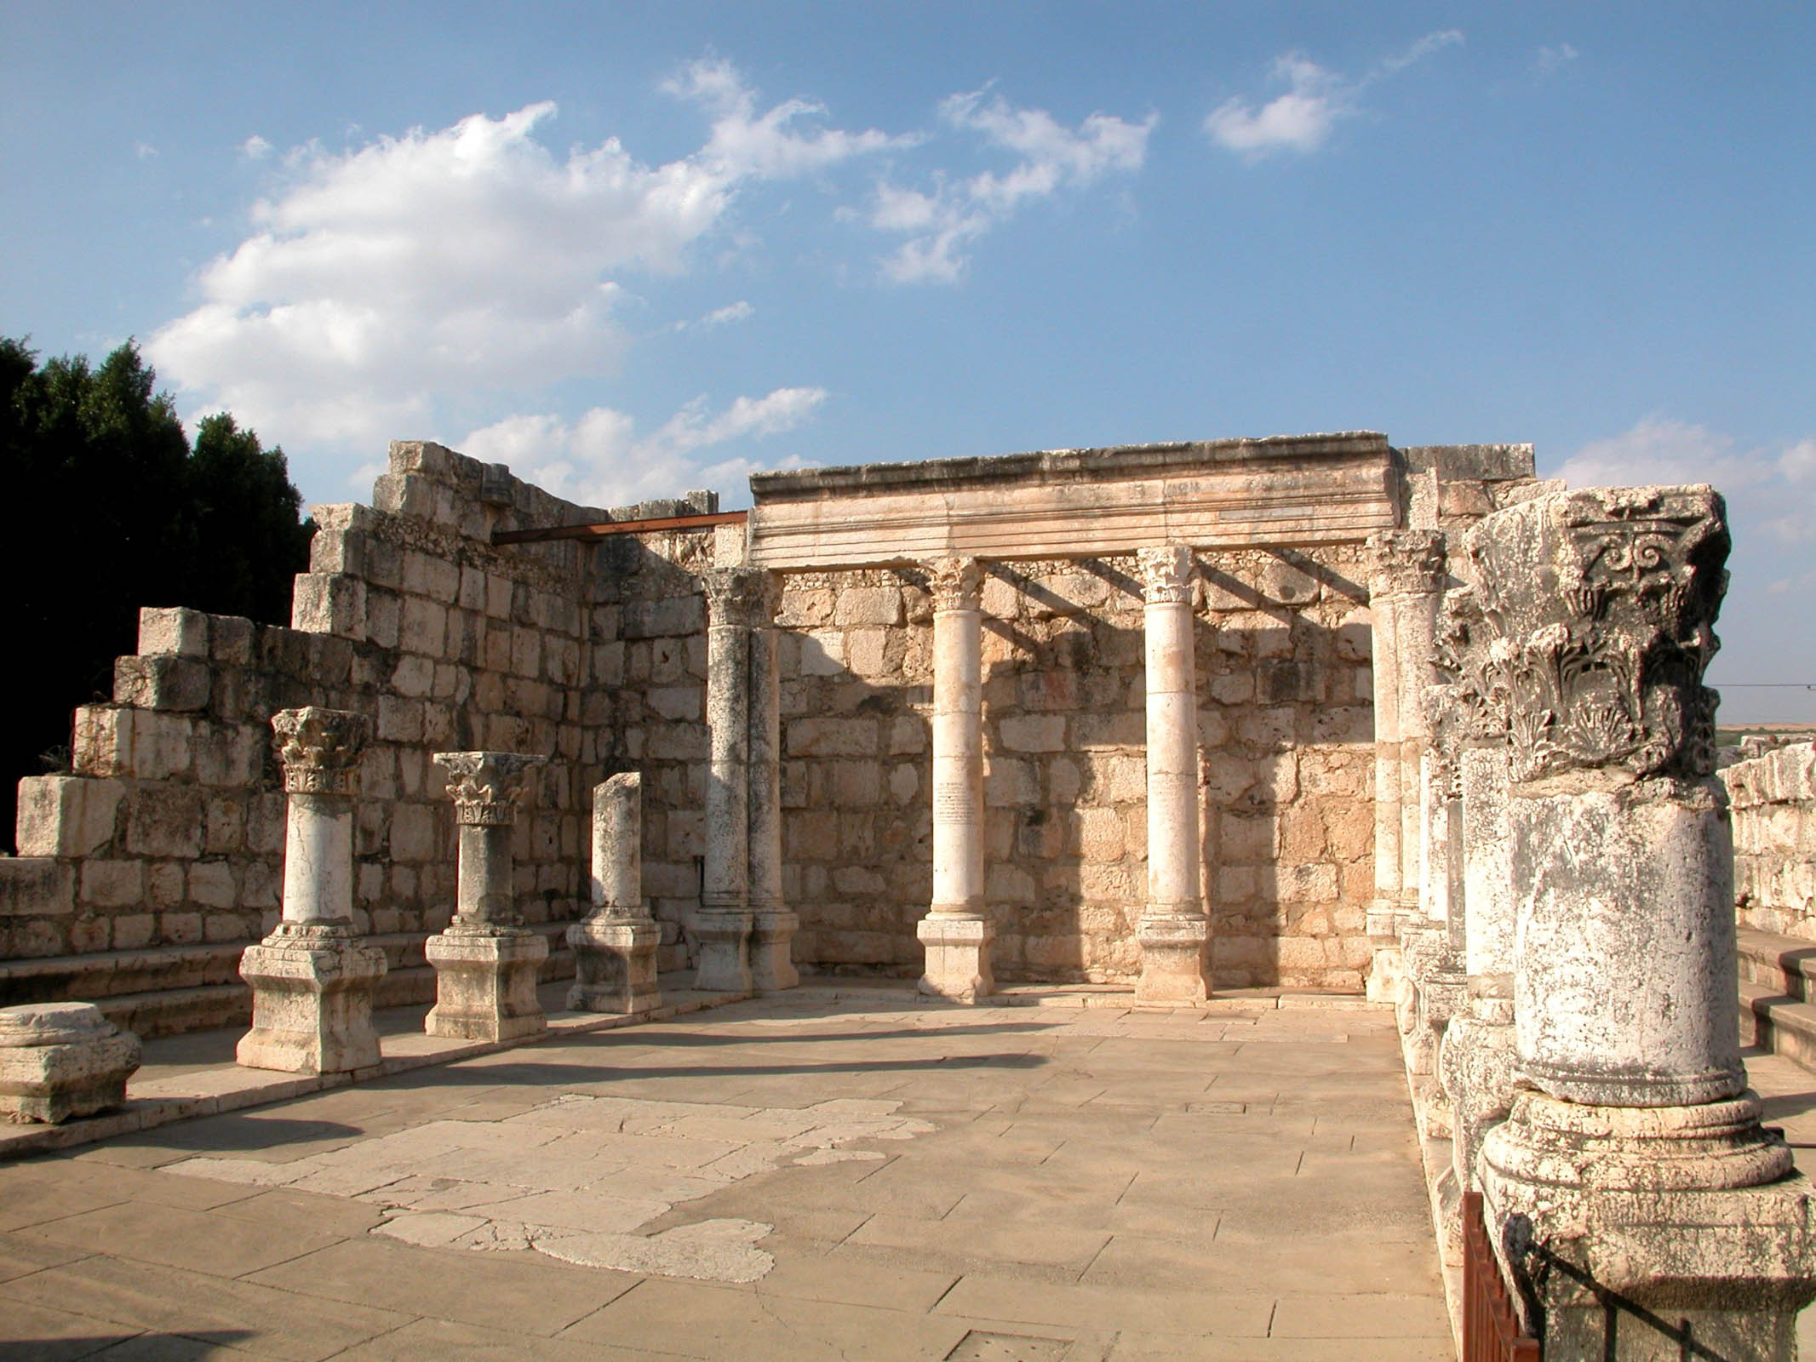

Figure 10.1: Capernaum synagogue. Although this structure was built after the time of Yeshua, archeologists are convinced the current building rests on the foundation of an earlier synagogue. This synagogue was the probable location where Yeshua taught in righteousness as recorded in Mark 1:21-28, Luke 4:31-37, and John 6:59. Courtesy of the [Pictorial Library of Bible Lands](https://www.bibleplaces.com)

## 10.1 What is a Construct Chain?

A construct chain consists of at least two nouns linked together.

The first important thing to know about a Hebrew construct chain is this:

The very last noun in the chain is said to be in the “absolute state”. All words in the chain before the absolute noun are said to be in “construct state.”

* Back to בֵּית לֶחֶם, “house of bread”
  + “bread” would be in the absolute state
  + “house of” is in the construct state
  + The entire phrase, with one and only one absolute noun and one or more construct nouns, would be called a “construct chain.”

The purpose of the chain is to describe the **first** *noun* in the chain.

* It might be reasonable to think that the chain would be describing the noun in the absolute state, but that is not the case.
* In בֵּית לֶחֶם, we are describing the house, not the bread
* Note that we said the first NOUN in the chain
  + If there were a substantival adjective as the first word, e.g. “wise of heart”, the chain is describing “heart” not “wise”.
  + A chain describes the first NOUN in the chain, not necessarily the first word in the chain.

In English, we would typically add the word “of” after each word in the construct state.  
* We could say “the king’s son” or the “son of the king,” and both would mean the same thing * Translating a construct word as “of” is a *starting point* and not a hard-and-fast requirement

Just like we may add 's, Hebrew has different spelling for nouns in construct. The absolute noun is the “normal” spelling and meaning.

## 10.2 What makes a construct chain

What makes a Hebrew construct chain different is that nothing else comes between the words of the chain.

* In English, we could add an adjective like “the servant of the *wicked* son of the king.”
* In Hebrew, any adjectives must come after the whole chain.
* A literal translation would look like: “servant of son of the king the wicked.”
* To resolve, we would need to go back and determine which word the adjective modifies by matching the gender and number.
* In the example above, there is ambiguity. Without more context, it is impossible to determine which of the three men is the wicked one.
* Translating is more straightforward when the nouns in the construct chain are of a mixed number or gender.
  + For example: “the wife of David the strong the smart, the beautiful.”
    - If “strong” and “beautiful” were FS then we know they are referring to David’s wife.
    - If “smart” was MS, we know it is referring to David.
    - The sentence translation would be clear: “The strong and beautiful wife of smart David.”

## 10.3 Review: what makes a word definite

Construct Chains have strict rules regarding definiteness, so now would be a good time to refresh our list of what makes a noun definite in light of this lesson and Lesson 9.

A word is definite if it:

* Has the article - הַמֶּלֶךְ
* Has a pronominal suffix - מַלְכִּי
* Is a proper noun - דָּוִיד
* Is in a construct chain where the last, absolute, word is definite - בֶּן הַמֶּלֶךְ = THE son of the king

This brings us to a critical concept about construct chains:

Nouns in construct state NEVER take the article.

Even though a noun in construct may not have the definite article, it is deemed definite when the last word (the absolute noun) is definite. We explain more on the next page.

## 10.4 The Absolute noun establishes the definiteness of a chain

A construct chain is either entirely definite, or entirely indefinite and it is the last, absolute, word that defines whether the chain is definite or indefinite.

* בֶּן הַמֶּלֶךְ = the son of the king
* בֶּן מֶלֶךְ = a son of a king

A construct chain cannot mix definite and indefinite.

You will never see “a son of the king” or “the son of a king” in a construct chain. It’s only one or the other.

There are examples in the Bible of mixing definiteness and indefiniteness but these are not done using construct chains[54].

## 10.5 How to Recognize a Construct Chain

The following are characteristics of nouns in the construct state:

* Never an article
* Never a pronominal suffix
* Never a unaccented long vowel unless it is a vowel letter
  + We will see Tsere-yod and Holem-Vav
  + We will not see Holem, Qamets, or Tsere
  + We will see *accented* long vowels in the penult[55] - סֵ֫פֶר
* No diphthong (will see Tsere+Yod or Holem-Vav)
* May have a reduced vowel in the penult
* Noun endings may change (next page)
* Two nouns connected by maqqef is a construct chain
  + כְּבוֹד־יְהוָה = The glory of the LORD

A good rule:

Long vowel, not accented, not a vowel letter = absolute

## 10.6 Identifying Construct state by Noun Endings

Nouns in construct often sometimes (but will not always) change endings. The table below shows the Absolute ending and then the difference in the Construct form.

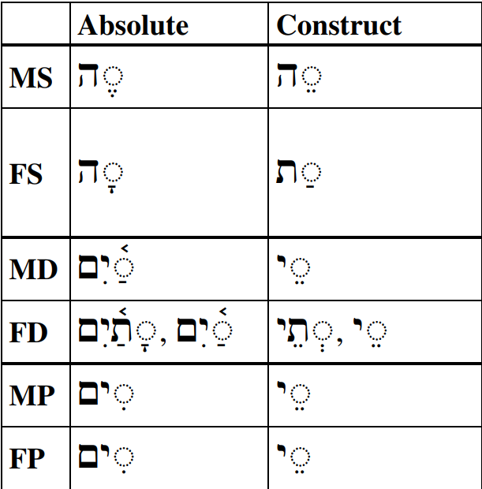 Other nouns may not change endings but will exhibit a loss of long vowels as discussed in the previous section.

Word-final Tsere+Yod is diagnostic of Plural and Dual construct forms

## 10.7 Construct Chain Summary

* Remember the rules for what makes a noun definite. This will help you determine whether the entire construct chain is definite or indefinite (for it can only be entirely definite or entirely indefinite)
  + “THE son of the queen” OR “A son of a queen”
* All words except for the last are in the “construct state”
  + No article or pronominal suffix
  + Long vowels are limited
    - (“Long vowel, not a vowel letter = Absolute” - Dr. Beckman)
  + No diphthong
  + Review ending changes chart
    - Tsere+yod is a very common ending for a masculine plural construct noun
  + A reduced vowel in the penult is usually construct - נְבִיא
  + Noun with Maqqef is construct - בֶּן־

There are four extremely common constructs in the Bible so we must be able to recognize them. These will be reviewed in Anki.

* כָּל־ - all of
* אֲבִי־ = father of
* אֲחִי־ = brother of
* אֵ֫שֶׁת־ = wife of

## Word Warm-up

[Click to open Word Warm-up video in a new tab](https://youtu.be/1bvZ74a1SYU)

## Verses Warm-up

[Click to open Verses Warm-up video in a new tab](https://youtu.be/1JWesFEa2_c)

## Anki

* Lesson 10 A. Vocab
* Lesson 10 B. Grammar
* Lesson 10 C. Workbook
* Lesson 10 D. Verses

## Worksheets: Construct Identification

This attachment has a list of words, some are in absolute and some are in construct. See if you can determine the differences[56].

[Construct Practice](./images/10_construct_practice.pdf)

This next attachment is not really a worksheet but is a summary of common construct vocabulary that occurs in the Bible for your review.

[Construct Vocabulary](./images/10_construct_vocab.pdf)

## Ruth Pursuit

YOUR QUEST

1. Find the following construct nouns:
   * days of (yellow)
   * field(s) of (green)
   * two of (blue)
     + two construct M שְׁנֵי
     + two construct F שְׁתֵּי
   * house of (pink)
2. Find the following vocabulary words (gray)
   * Again
   * Death
   * Loyalty

As always, words may have prefixes or suffixes. Try to identify whether the construct is definite or indefinite based on the absolute noun.

* [Blank copy of Ruth 1](https://drive.google.com/file/d/1qcfTKAlTJGChC2eYCMhSbY2w-ibzCcDV/view?usp=sharing)
* [Ruth Pursuit Answer Key #10](./images/10_Ruth_Pursuit_KEY.pdf)

## Quest Quiz #10

[Open Quest Quiz #10 in a new window](https://forms.gle/ST6XfCvKRXHRfxfVA)

## Claim your next Twelve Tribes Badge!

Check to be sure you have have completed **all activities** through this lesson, then fill out the form below.

[Check the requirements here](https://docs.google.com/spreadsheets/d/1t0C7JlygyUqgF_aQWbhq7h3s_VDn0VuvISJn5mp-LdE/edit?usp=sharing), then complete the certification and claim your badge below:

# 11 Hebrew Numerals

To comprehend Biblical Hebrew, we must be able to figure out numbers, with or without a dictionary, when we encounter them in the Bible

You have worked very hard on the first ten lessons! Way to go! While a discussion on numbers and counting is often interweaved in a discussion with the Aleph-Bet, the authors of Basics of Biblical Hebrew, wisely in our opinion, strategically placed a necessary but lighter discussion on numerals right here in Lesson 11. We are emerging from what may be a lot of foggy concepts with all of the noun, pronoun, and adjective concepts in lessons 4-10 (particularly Lessons 8-10). The bulk of the work in Lesson 11 will be in Anki learning numbers from *Hebrew Quest*.

For the next 25 lessons, we will focus on the Hebrew verbal system and – the entire point of this course – reading and understanding Scripture.

Enjoy this brief lesson on numbers!

**LESSON ITINERARY**

1. The Biblical text always spells out numbers
2. Notes and footnotes use symbols for numbers
3. Be Familiar with Hebrew Ordinal Numbers - First through Tenth
4. Hebrew Cardinal Numbers
5. Digits 1 and 2 match the gender of the noun
6. Digits 3-10 take the opposite gender of the noun
7. Learn the Cardinal Numbers Above 10

**EQUIPMENT CHECK**

Before continuing, can you describe the following concepts?

* The difference between construct and absolute states

## First Thought

Give Him praise that you are among those counted as His talmidim (disciples)!

(Joshua 4:2 NASB) Take for yourselves twelve men from the people  
קְחוּ לָכֶם מִן־הָעָם שְׁנֵים עָשָׂר אֲנָשִׁים

Listen to the verse in Hebrew:

Your browser does not support the audio element.

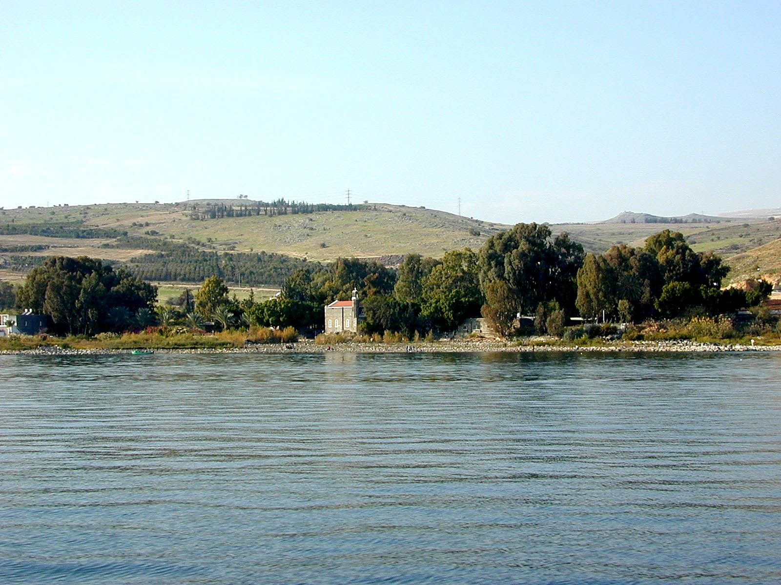

Figure 11.1: Tabgha, traditional location of the calling of the twelve disciples (). Courtesy of the [Pictorial Library of Bible Lands](https://www.bibleplaces.com)

## 11.1 The Biblical text always spells out numbers

There is not a lot of elaboration needed except to note that this is the case. You will not see “1”, “200”, or “969”, either in modern symbols or in Rabbinic symbols (using the Aleph-bet) in the Hebrew text.

כָּל־יְמֵי מְתוּשֶׁלַח **תֵּשַׁע וְשִׁשִּׁים שָׁנָה וּתְשַׁע**

“all the days of Methuselah (were) **nine and sixty years (i.e 960) and nine (i.e. 969)**.”

## 11.2 Notes and footnotes use symbols for numbers

You may come across a system of counting that uses numerical values for each of the Hebrew letters. The term for this is “gemetria”. Gemetria is interesting and the Rabbis have a lot of fun with comparing words that have identical numerical values, but it won’t be a focus of this course.

* א ב ג ד ה ו ז ח ת represent 1-9
* י כ ל מ נ ס ע פ צ represent 10-90 by tens
  + So to say 33, would be 30 and 3 = לג or often ל״ג, with the ״ indicating that this is not a real word
* ק ר ש ת are 100, 200, 300, and 400, then we go to the sofit forms ך ם ן ף ץ for 500-900
* In some reckonings, a series of dots or diamonds above the letters, or ’ is used for numbers above 999. For example, 1000 is ’א

Below is Genesis 1:1.

* בראשית פרק א means “Genesis Chapter 1”
* Next, note the diminished א indicating “1” for the first verse

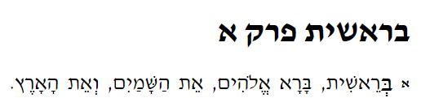

## 11.3 Hebrew Ordinal Numbers

* Ordinal numbers denote order. first, second, third
* In Hebrew, these are attributive adjectives. As such, they follow the noun and match in gender, number and definiteness (Attributive Always After, Always Agree).
  + יוֹם רִאשׁוֹן or הַיּוֹם הָרִאשׁוֹן = first day or the first day
* Ordinal numbers end in Hireq-Yod (M) or Hireq-Yod_Tav (F)
  + שְׁלִישִׁי and שְׁלִישִׁית mean ‘third’
* To denote the 11th position or higher, we would use cardinal numbers
  + We are dependent on the context of the passage to indicate whether the number is cardinal or ordinal
  + בִּשְׁנַת הָאַרְבָּעִים = in the year of the forty = in the 40th year

We encourage you to learn the “days of the week” song with Izzy in the video below.

### Hebrew Quest Ordinal Numbers Video

[Open video in new window](https://www.youtube.com/embed/MlfwNNuWgto?t=2545)

## 11.4 Cardinal Numbers 1-10

* The numeral one is an attributive adjective - it follows its noun and agrees in gender, number, and definiteness
  + As we mentioned previously, it is sometimes used as an indefinite article
  + אִישׁ אֵחָד = one man = a man
* Two through Ten are nouns
  + They have both masculine and feminine forms
  + They have absolute and construct forms
* Higher numbers are nouns with no specific gender

### Digits 1 and 2 match the gender of the noun

For example:

* בֵּן אֶחָד = one son
* בַּת אַחַת = one daughter

### Digits 3-10 take the opposite gender of the noun

Additionally, they are “singular” even though the noun is plural.

For example:

* שְׁלֹשָׁה בָּנִים = three sons
* שְׁלֹשׁ בָּנוֹת = three daughters

The technical term for this is “chiastic concord” (you don’t need to know this)

## 11.5 Cardinal Numbers Above 10

* 11-19
  + 11-12 match gender, 13-19 swap
    - 11 אַחַד אָשָֹר
    - 13 שְׁלֹשָׁה אָשָֹר
* Decades 30 through 90 are spelled as masculine plural of the corresponding 3-9 number
  + 3 = שָׁלֹשׁ
  + 30 = שְׁלֹשִׁים
* 20 is a bit unusual
  + The word for two is שְׁנַיִם (male) and שְׁתַּיִם (female)
  + Since these words already have a non-singular ending, Hebrew uses the masculine plural of ten
  + עֶשֶׂר is 10
  + עֶשְׂרִים is 20
* 100 is מֵאָה
* 200 is מָאתַיִם, the plural of 100
* 300 is שְׁלֹשׁ מֵאוֹת (“three one hundred” and so forth up to 1000)

## 11.6 Conclusion

This chapter omits many details about numbers and counting. We aimed to provide an introduction so that you will have basic familiarity when you encounter numbers in the Bible.

If you are interested in going a little deeper, we encourage you to view the complete [Hebrew Quest segment on numerals](https://holylanguage.com/grammar-1.php).

For Hebrew GRAMMAR Quest, it is sufficient for you to learn the Ordinals 1-10, and the Cardinals 1-10, then 20-100 by 10s, and 1000.

There is no quiz and no Anki Workbook for this lesson.

You are at an exciting point in the course. Next week we get into Hebrew Verbs, where your understanding of Hebrew Scripture will start to move into high gear!

### Anki

* Lesson 11 A. Vocab
  + The vocab work will be a little bit longer than in a usual lesson.
    - We will have the normal set of words from Basics of Biblical Hebrew
    - We will also incorporate the numerals cards from Hebrew Quest
* Lesson 11 B. Grammar
* Lesson 11 C. Study Verses - Note: there is no Workbook component to this lesson.

## Word Warm-up

[Click to open Word Warm-up video in a new tab](https://youtu.be/3OuD2Snu-Uk)

## x Verses Warm-up`

Click to open Verses Warm-up video in a new tab

## Ruth Pursuit

YOUR QUEST

1. Find the following numbers:
   * one (yellow)
   * second (green)
   * ten (pink)
2. Find the following vocabulary words (blue)
   * there
   * night

* [Blank copy of Ruth 1](https://drive.google.com/file/d/1qcfTKAlTJGChC2eYCMhSbY2w-ibzCcDV/view?usp=sharing)
* [Ruth Pursuit Answer Key #11](./images/11_Ruth_Pursuit_KEY.pdf)

# Introduction to Unit 3

This unit represents a pivot point in this course. From now through the end of the course, we will be focusing on verbs. In Unit 3 we will be spending our time learning what is called the Qal verb stem in depth. Then in Unit 4 we will learn the six so-called “derived” stems.

We wanted to let you know of some changes:

1. Vowel Shorthand
2. Cantillation marks added to Study Verses
3. Changes to Hebrew GRAMMAR Quest for Units 3 and 4
   1. No more quizzes!
   2. Cantilation marks added to study verses
   3. OPTIONAL *Hebrew Quest* Study Passage Translation

## 11.7 Vowel Transliteration/Shorthand

* Way back in Chapters 1 and 2, *Basics of Biblical Hebrew* taught transliteration for both consonants and vowels
* At the time you studied these lessons, we omitted this discussion. For Hebrew GRAMMAR Quest, we want to get you into the actual Hebrew text, not rely on a transliteration
* The transliteration shorthand used does turn out to be valuable as we progress in the derived verb stems
  + It allows us to create mathematical-style formulas which are much easier to remember than writing and reading everything in long-form. Compare:
    - “The stem vowel is Hireq + Yod and the preformative vowel is Hateph Qamets Hatuf”, with “ $V_{S}=\hat{I}$ and $V_{P}=\breve{O}$”
* Below is the vowel shorthand we will use:

|  |  |  |  |  |  |
| --- | --- | --- | --- | --- | --- |
| Type / Class | A | E | I | O | U |
| Short (plain) | בַ[57]> | בֶ | בִ | בָ | בֻ |
| Long (bar) | ב $=\overset{‾}{A}$ ֲ | ב $=\overset{‾}{E}$ ֵ |  | ב $=\overset{‾}{O}$ ֹ |  |
| Reduced (breve) | ב $=\breve{A}$ | ב $\breve{E}$ ֱ |  | ב $=\breve{O}$ ֳ |  |
| Letters (hat)[58] |  |  | בִי | וֹ | וּ |

* Finally, we will use $:$ for Sheva (silent or vocal)
* As we remember, the ה vowel letters are only used at the end of words, so they would never be the $V_{P}$ or the $V_{S}$

## 11.8 Word Initial Combinations

* A Hebrew strong verb conjugation, regardless of stem, can usually be identified based on its initial combination of consonants, vowels, and from time-to-time, the presence of a Daghesh Forte
* For example, in Lesson 15, we will learn the “Imperfect Preformatives”
  + The 3ms and 3mp strong forms will always have:
    - Preformative consonant = Yod
    - $V_{P}$ = Hireq, and
    - $V_{1}$ = Silent Sheva
  + We can shorten this by saying $Pre_{QI}=$ יִקְ, where ק represents $R_{1}$ of any strong verb

## 11.9 Changes for Unit 3: No more quizzes!

The purpose of the quizzes in Units 1 and 2 was to provide a checkpoint for students before proceeding to the next lesson. If you have reached this point in the course, you are a veteran at this now. The workload in other areas of the course is steadily increasing, and of course the Anki reviews are growing (so be sure to keep up with daily reviews!). We can now dispense with the quizzes and leave it up to your judgment as to whether you are ready to proceed with the next lesson.

## Changes for Unit 3: Cantillation Marks added to Study Verses

Way back in Lesson 2, we also referenced additional marking called cantillation marks. These are the marks in addition to vowels and consonants we sometimes see in Hebrew. Here is an example from Genesis: 

Up until now, we have been using a simple accent mark whenever a Hebrew word has an accent on the second to last syllable. For example, נֶ֫גֶב. While the Lessons and other materials will continue to use these simple accents, from now on, we will graduate to using the full set of Hebrew accents in our Study Verses and Workbook exercises. Why do this?

When you read from a Tanach, you are much more likely to encounter the complete set of Hebrew accent marks. So part of becoming more comfortable with the Hebrew Bible must include a basic familiarity with these additional marks.

Things to keep in mind:

* There are over 20 different cantilation marks. We won’t go into what each one means, but there are plenty of resources on the Internet if you are interested in digging deeper
* If you see a mark that is not a vowel you recognize (such as an upside-down wishbone) or in the wrong place (such as a dot above a consonant instead of inside or below) it is a cantillation mark
* Remember that a syllable can have only one vowel
* Most often there is only one cantillation mark per word - where you see the mark is where the accent goes
* Occasionally you will see a mark near the front or middle of the word and a mark near the end of a word. The first mark is a secondary accent. Remember, a primary Hebrew accent can ONLY be on the LAST or SECOND-TO-LAST syllable
* The vertical line | that can appear between two words can be ignored
* When in doubt, listen to Izzy’s audio carefully as he reads each verse, to determine where the accent goes

Trying to read with these marks can be visually distracting and overwhelming at first, but with practice you will get used to them. They are part of the rich tradition of Biblical Hebrew that has been passed down to us from many centuries ago.

## Changes for Unit 3: OPTIONAL Hebrew Quest Study Passage Translation

For those who seek more opportunities for additional Hebrew Bible reading and translating activity, we present the Hebrew Quest Study Passages. Whether you have already completed *Hebrew Quest* or not, this activity is sure to significantly expand your Hebrew reading skills.  
You will be asked to read through the passage on your own, looking up any words you don’t know, to then compose a translation. You will then watch the applicable video from *Hebrew Quest* where Izzy reads and breaks down the passage.

Completion of this activity may require a significant time investment to complete. Therefore, completion of the Hebrew Quest Study Passage Track is not required to earn any Hebrew GRAMMAR Quest Badges, Certificates, or the Graduation Diploma.

We will start off slowly with the verses from the Proverbs study. Then we will go in *Hebrew Quest* order, beginning with Genesis 1 (*Hebrew Quest* Lesson 17) through 1 Kings 18 (*Hebrew Quest* Lesson 40).

Here is what we want you to do in these Study Passages activities:

1. Download or print the applicable study passage document
2. Translate verse by verse
   1. First see how much you can do without a reference
   2. Then look up any words you don’t know in a lexicon
3. Watch the *Hebrew Quest* video where Izzy reads and breaks down the passage, often with spiritual insights. Izzy intentionally speaks very slowly so you may wish to increase the speed of the YouTube video
4. Compare your translation from step 2 with Izzy’s explanation on the video? How did you do? Can you see how much you are learning?

## Keep going!

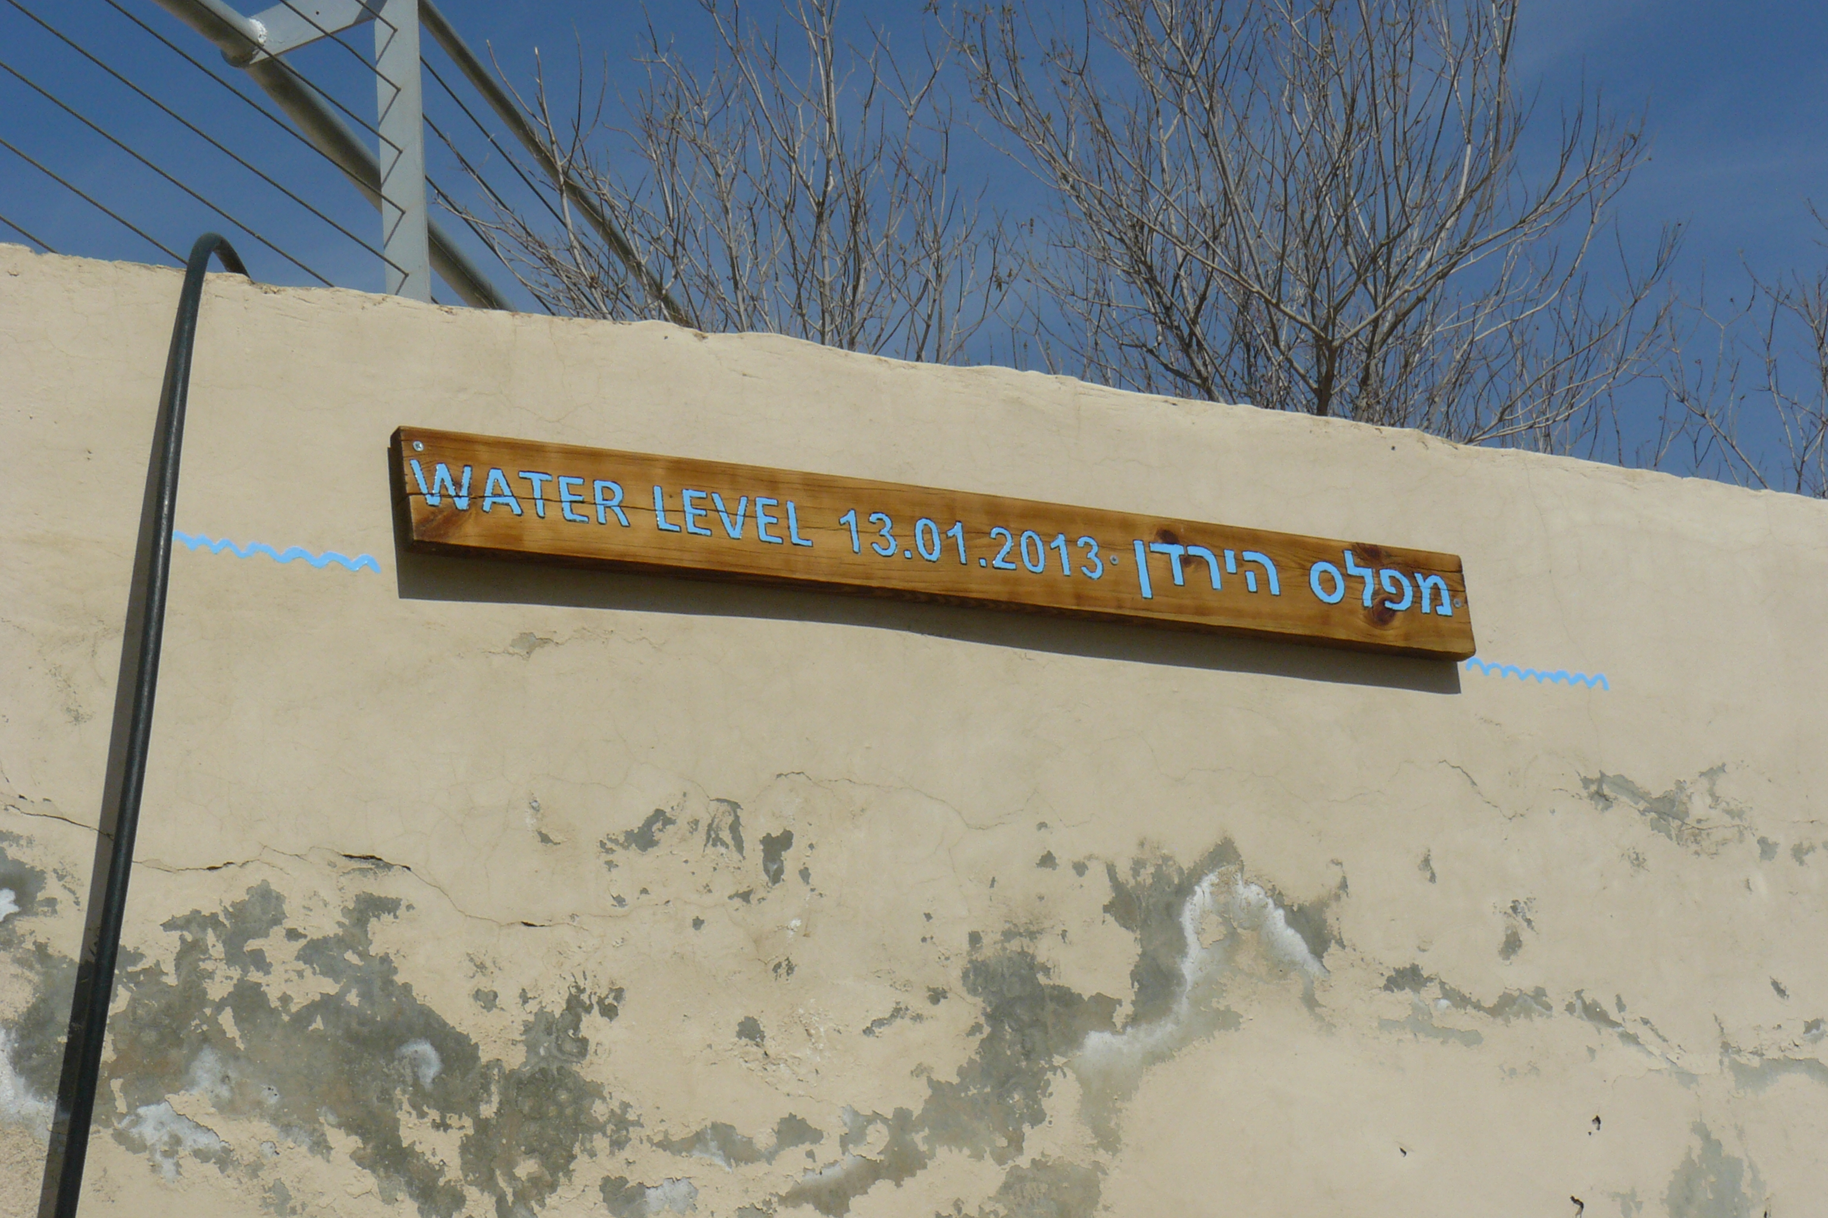

Figure 11.2: Jordan River High Water Sign. The sign says ‘Level of the Jordan.’ Photo by Chris Flanagan, taken 2/12/2013.

* The photo above is of the Jordan River baptismal area in Israel near Jericho - it was taken less than a month after flooding of the area
* Lessons 13-16 could be considered the “high-water mark” of the course
* There will be a lot of details to digest as we talk about the two most critical verb forms in the Bible, the Qal Perfect and the Qal Imperfect
* It’s important that you master the material in these four chapters - this will make the rest of the course much smoother
* The high water will start to recede a little starting with Lesson 17
* For the most part, the rest of the course from 17-35 will be building off of what we learned in Chapters 13-16
* Hang in there and keep going! Slow and steady wins your Hebrew race!

Now, let’s get to Hebrew Verbs!

# 12 Introduction to Hebrew Verbs

Hebrew is a verbal, action-oriented language. Now that we have concluded our discussion on nouns, pronouns, adjectives and prepositions, the remainder of the course will focus on verbs. Around 70% of Hebrew verbs are in what is called the Qal stem so we will spend Lessons 13-22 learning that stem inside and out. Our quest is to translate accurately. To do this we must be able to identify the root, stem, conjugation, person, gender, and number of verbs. This Lesson will provide a brief introduction on the verb system as a whole and learn some overall conventions.

LESSON ITINERARY

1. The Verbal Root
2. Preformatives and Sufformatives
3. Verbal Vowels
4. The Seven Hebrew Verb Stems
5. Person, Gender, Number
6. The Eight Basic Hebrew Verb Conjugations
7. Finite and Non-Finite Conjugations
8. Parsing Conventions
9. Strong and Weak Verbs

EQUIPMENT CHECK

Before continuing, have you completed all requirements for your certificate for Lessons 1-11?

## First Thought

### וְהֽוּא־הָלַ֤ךְ בַּמִּדְבָּר֙ דֶּ֣רֶךְ י֔וֹם

*But he himself went a day’s journey into the wilderness . . . (1 Kings 19:4)*

As we begin a long stretch in Hebrew Verbs, with what ultimately is the remainder of this course, at times you may feel as exhausted, dry, and isolated as if you were were Elijah (the subject of 1 Kings 19:4) driven into the wilderness.

It is these times where we must depend on God, and it is times like these where God can pour into us and prepare us for our next adventure. Moses, Elijah, John the Immerser, and several others all had their time in the Wilderness that God used to mold them as servant-leaders. Of course we can point to Yeshua himself and his time in the wilderness at the beginning of his ministry. Embrace the wilderness!

Listen to the verse in Hebrew:

Your browser does not support the audio element.

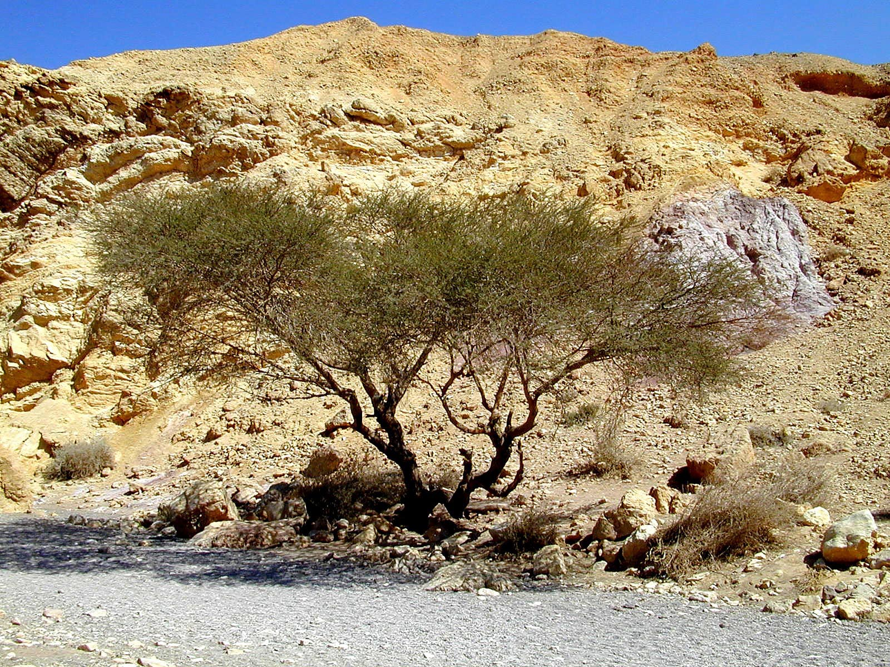

Figure 12.1: Acacia tree in Red Canyon. Courtesy of the [Pictorial Library of Bible Lands](https://www.bibleplaces.com)

## 12.1 The Verbal Root

* A *Root* is the set of consonants on which a verb (and often nouns) are based
* The majority of verbs have three *root consonants* from which the other words are derived.



## 12.2 Person, Gender, Number

* Hebrew verbs do what is called “inflecting” for person, gender and number
  + Inflecting can be any combination of the following are added to the verbal root
    - Spelling/vowel patterns
    - Preformatives (verbal prefixes)
    - Sufformatives
* The person, gender and number refers to the *subject* of the verb.
  + Pronominal suffixes are used to denote the object of the verb. We will study these in Lesson 19.
* Person, Gender, and Number are as we learned with nouns
  + “Common” gender is for verb forms that could be either M or F; In Hebrew, as in English, the words for “I” and “we” are Common (i.e. there is not a masculine form of “I” and a separate feminine form of “I”)
  + Person
    - 1st person is the speaker - “I/we sat”
    - 2nd person is the person being spoken to - “you sat”
    - 3rd person is anyone else - “he/she/it/they sat”
  + Number is singular or plural - there are no dual verb forms

When parsing, it is standard to use parsing code “3ms” to mean “third person, masculine, singular”.

## 12.3 Verb nomenclature

* As a convention, many Hebrew grammars label the three root letters , , and [59].
* For the verb מָלַכְתִּי (I was king):
  + The *root* is מלך (no vowels)
    - = מ
    - = ל
    - = ך[60]
* Also important to know is the *Lexical Form*
  + The *lexical form* is how you would look the word in a dictionary.
  + The lexical form for verbs is almost always the Qal Perfect 3rd Person Masculine Singular: מָלַךְ

## 12.4 Preformatives, Sufformatives, Prefixes, and Suffixes

* While many dictionaries would consider “preformative” synonymous with “prefix” and “sufformative” synonymous with “suffix”, Hebrew grammars often use the terms “preformative” and “sufformative” exclusively for verbs
* A verbal *preformative* (if any) goes before $R_{1}$ and a *sufformative* (if any) goes after $R_{3}$
* Any *prefix* such as the interogative particle, or (commonly) the conjunction vav, goes *before* the preformative
* Any *suffix*, such as a pronominal suffix, goes *after* the sufformative
* For the verb קָטַ֫לְתִּי, the sufformative is תִּי and there is no preformative (and no prefix or suffix)
* For the verb יִקְטְלוּ, the preformative is יִ , and the sufformative is וּ
* For the verb יִקְטְל֫וּהָ, the preformative is יִ, the sufformative is וּ, and the pronominal suffix is הָ

## 12.5 Verbal Vowels

* Being able to identify a verbal vowel’s position will turn out to be important in identifying the Verbal Root and the Stem
* Similar to our shorthand for the root consonants, we use $V_{P}$- the vowel with the preformative, $V_{1}$ and $V_{2}$- the vowels with $R_{1}$ and $R_{2}$, and $V_{S}$, which is what is called the **stem** vowel
  + The $V_{S}$ is usually $V_{2}$ but this is not a constant. Sometimes it can be $V_{1}$. We’ll discuss this more in the next lesson
  + The vowel associated with $R_{3}$ turns out to be less important so we do not need to identify this
* For the verb יִקְטְל֫וּהָ, the $V_{P}$ is hireq; $V_{1}$ is Silent Sheva; and, $V_{2}$/ $V_{S}$ are Vocal Sheva
  + While we have said Silent Sheva is technically not a vowel, it is occupying the vowel position of $R_{1}$- so for this purpose it is ok to say $V_{1}= :$

## 12.6 The Seven Hebrew Verb Stems

* The verb **stem** affects the meaning of the verb itself
* At a basic level, the stem provides the *type of action* (simple, causative, intensive) and the *voice* (active or passive)
* The *Qal* stem is the basic or simple verb stem. All other stems are derived from Qal

1. *Qal* - Active (versus passive) voice and a simple type of action (without nuance) - “he broke the vase”
   * Parsing code: Q
2. *Niphal* - Passive or reflexive voice with a simple action - “the vase was broken”
   * Interestingly in English, many translations of Niphal verbs are still active voice
   * For example, a fair translation of “he was seen” might be “he appeared”
   * Parsing code: N
3. *Piel* - Active/intensive - “he smashed the vase”
   * Parsing code: D (the Piel paradigm has a Daghesh Forte in $R_{2}$- the D stands for “doubling Daghesh”)
4. *Pual* - Passive/intensive - “the vase was shattered”
   * Parsing code: Dp (passive of the Piel (D))
5. *Hiphil* - Active/Causative - “he caused the vase to be broken”
   * Parsing code: H
6. *Hophal* - Passive/Causative - “the vase was caused to be broken”
   * Parsing code: Hp (passive of the Hiphil (H))
7. *Hitpael* - Reflexive/Intensive - “he caused himself to be holy”
   * Parsing code: tD (very similar to Piel (D) and has a ת in every preformative form)

We’ll explain the “Parsing codes” in a few sections

## 12.7 The Seven Stems: Summary Table

* There is scholarly debate about the table below
  + Hebrew verbs can have any one of several nuanced meanings depending on the context
  + The table provides a good starting place but it is not the “final word” on verb stems
  + We will discuss these nuances as we introduce each stems

|  |  |  |  |
| --- | --- | --- | --- |
|  | Active Voice | Passive Voice | Reflexive Voice |
| Simple Action | Qal | Niphal | (Niphal) |
| Cause a State | Piel | Pual | Hitpael |
| Cause an Action | Hiphil | Hophal |  |

## 12.8 The Eight Basic Conjugations

* While the Stem provides the overall meaning, the *conjugation* provides additional descriptive information needed for translation
* Strictly speaking, Hebrew does not have past, present, future, tense, like English does
* Instead, the easiest way of thinking about it is that Hebrew has complete vs incomplete action

1. The *Perfect* conjugation describes completed action, whether in the past, present, or future
   * Most often we translate this as English past tense - “She went”
   * Verbs that describe a state of being as will an action that is completed in the future will be in the Perfect Parsing code: P
2. The *Imperfect* conjugation describes an incomplete action, whether in the past, present, or future
   * Most often, we translate this as English future tense - “She will go”
   * Verbs that describe a process (that is not completed) or incomplete action even if in the past will tend to be in the Imperfect
   * Parsing code: I
3. The *Imperative* 2nd person Volitional - a command: “Go!”
   * Parsing code: M
4. The *Cohortative* 1st Person Volitional - wish, purpose: “I should go”[61].
   * Parsing code: C
5. The *Jussive* 3rd Person Volitional - conjugation is similar to the Imperative - “He should go.”
   * Parsing code: J
6. The *Infinitive Construct* Verbal Noun - “to go”, or a verbal noun as in, “going”
   * Parsing code: ∞
7. The *Infinitive Absolute* Verbal Noun - special uses, less common and has no direct equivalent in English
   * Parsing code: A
8. The *Participle* - Verbal adjective - “runner” “one who runs”
   * Parsing code: Pt

Vav prefix

* Some grammars identify three other forms, each with a Vav prefix, as additional conjugations/tenses:
  + Perfect + Vav
  + Imperfect + Vav
  + Imperfect Vav Consecutive
* We will discuss these forms further in Lesson 17

## 12.9 Finite vs Non-Finite Conjugations

* *FINITE* verbs have “person”
  + Perfect, Imperfect, Imperative, Cohortative, Jussive
* *NON-FINITE* verbs do NOT have “person”
  + Infinitive Construct, Infinitive Absolute, Participle
  + Only Participles have Gender and Number

## 12.10 Parsing

* Parsing is the process of breaking down a verb into its component parts
* The following should be included when parsing a verb (as applicable):
  + Stem
  + Conjugation
  + Person (only for finite)
  + Gender (except for Infinitive forms)
  + Number (except for Infinitive forms)
  + Either the *Root* form or the *Lexical* form
    - We’ve already mentioned the *root* - these are the three root letters without vowels
    - *Lexical* form for verbs is similar to non-verbs in that it is the most common inflected form
    - For verbs, the lexical form is usually the Qal Perfect 3ms (or QP3ms)
      * Only if $R_{2}$ is a vowel, the Lexical form is the Q∞ form
    - For parsing in this course, the Anki exercises will prompt for the *Root*

## 12.11 Parsing Codes

As it would get cumbersome to consistently write the full descriptions, such as “Hitpael Cohortative Third Person, Masculine Plural”, many Hebrew grammarians use what is called “parsing code.”

Unfortunately the nomenclature for morphology is not standardized. We will be using Dr. John Beckman’s code as he has applied it to “Basics of Biblical Hebrew”. His shorthand for the above, would be “tDC3mp”. For comparison, Logos software’s code would be “VgI3MS-C”.

We do not have very many writing assignments in Hebrew GRAMMAR Quest; but, when we do have worksheets, feel free to use Parsing Code (or not!).

To get the Infinity ∞ symbol on a desktop/laptop keyboard, use the combination alt+236.

## 12.12 Strong and Weak Verbs

As we get into each stem, there will be separate chapters devoted to strong and week verbs; therefore, it might be good for you to know what we mean by these terms.

* Each conjugation will have a basic paradigm that directs vowels, accents, preformatives and sufformatives for each PGN
* Strong verbs will follow the paradigm, while weak verbs will have one or more weak letters that result in some deviation from the paradigm
  + To put another way, strong verbs are “regular” and weak verbs are “irregular”
* The next page lists some of the major weak categories

## 12.13 Weak Verb Classes

A weak verb has a root consonant that causes it to deviate from the strong-verb paradigm

* A verb may have one such letter that causes deviation in one stem or conjugations but not in others
  + ר is only weak in forms that try to put a Dagesh Forte in it
  + 1נ wants to assimilate whenever it has a Silent Sheva
    - Because this never happens to $R_{1}$ in the Qal Perfect, 1נ is strong in the Qal Perfect
    - We will learn this will happen in the imperfect, so 1נ is weak in that conjugation
* We classify weak verbs by their problem letter
  + 3נ means that $R_{3}$ is נ, as in זקן
  + 3ת means that $R_{3}$ is ת, as in ברת
  + 1G means that $R_{1}$ is a guttural, as in אמר
  + 2G means that $R_{2}$ is a guttural, as in בחר
  + We can’t simply say “3G” for any $R_{3}$ guttural because it turns out that א and ה each behave differently:
    - 3עח means that $R_{3}$ is ע or ח, as in מנע לקח
    - 3א means that $R_{3}$ is א, as in מצא
    - 3ה means that $R_{3}$ is the vowel Qamets+Hei, as in בנה
  + Geminate - $R_{2}$ = $R_{3}$ סבב
  + Biconsonantal (also called Hollow) - $R_{2}$ is a vowel letter בוֹא שִׁים* קוּם*
  + Doubly Weak is any combination of two (or three) weak letters, as in עַלָה
* The good news is when Hebrew verbs are weak, the behavior is usually predictable
* In fact, you have already learned almost every behavior change we will encounter with weak verbs
  + For example, you already know that Gutturals reject Vocal Sheva and the Daghesh Forte
  + It will just be a matter of applying that which you already know to a new area
* Weak verbs may take a little more thought, but overall they are nothing to be concerned about
* The better you know your *vocabulary* and the *strong* verb paradigms, the easier the *weak* verbs will be

## 12.14 Hebrew GRAMMAR Quest is a Quest for RECOGNITION NOT RECALL

* Our overall goal for this course is **RECOGNITION, NOT RECALL**.
  + Older Hebrew Grammars focused on memorizing dozens of verb paradigm charts
  + Students had to memorize many different stems, conjugations, as well as strong and weak verb paradigms in those conjugations.
* In this course, you will memorize only a handful of paradigms in the Qal Stem
* From here we will be on a quest for pattern recognition
* Think of it like this: instead of taking a traditional approach to learning a language by brute-force, rote memorization, we are going to take more of a mathematical approach
  + A mathematician doesn’t brute-force memorize the solution to every possible problem
  + She or he uses a series of formulas and plugs the specifics into the most appropriate formula for the situation
  + For example, consider the formula for the area of a square : $Area=S^{2}$- the length of one of its sides multiplied by itself
  + Studying Hebrew the old way would require you to memorize the areas of hundreds of different squares
  + It is much simpler to memorize the formula, then when you encounter a square that has a side $s$ = 5, you can use the formula: $5^{2}$ to get the answer of $Area=25$
* You will begin to see things in a special $formulafont$- we will use $thisfont$ when there are consistent patterns
  + For example, whenever you see $Pre=$, this tells you that the verb has a specific combination of prefixes/preformative letters, vowels, and possibly Dagesh Forte marks that are characteristic of that verb class

::: {.box .map} WHERE WE ARE HEADING

When we get to the end of the course, we’re going to have built a Stem Comparison Table that looks like this:

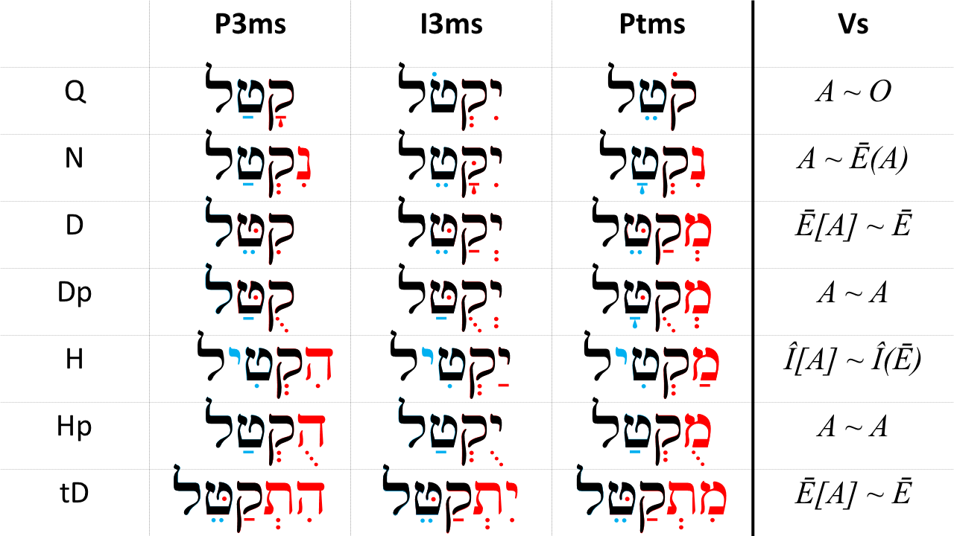

* The marks in RED are the distinctive $Pre$ patterns for the strong verbs in that stem/conjugation
* The vowels in BLUE and the “formula” in the last column are the $V_{S}$ patterns for that stem/conjugation
* You do not need to do anything with this table right now - we only want to show you how this relatively simple series of patterns will help you unlock the meaning of the Bible

## 12.15 A note on the paradigm strong verb קטל

* Hebrew grammars for the past several centuries have used the verb קטל as what is called the “paradigm verb”
* It is meant to represent *ANY* strong verb
* What makes קטל awkward is the word means “to kill”
* As we go through this course, remember that the actual translation of קטל is not material to our purposes
* In this respect, it is similar to a math formula like we mentioned above
  + In $a^{2}+b^{2}=c^{2}$, the letters “a”, “b”, and “c” have no direct, literal meaning
  + They are meant to represent the lengths of any three sides of a right triangle
* We encourage you to think of קטל the same way - they are just variable or placeholder letters that are part of a formula with a larger purpose than the direct, literal meaning

That’s enough for this introduction to Hebrew verbs. Let’s get to the exercises!

## Word Warm-up

[Click to open Word Warm-up video in a new tab](https://youtu.be/MGk-CGqJwUY)

## Verses Warm-up

Note: See Unit 3 Introduction for a discussion of the cantillation accent marks you see on the video. [Click to open Verses Warm-up video in a new tab](https://youtu.be/AS03bG1xjBE)

## Anki

* Lesson 12 A. Vocab
* Lesson 12 B. Grammar
* Lesson 12 C. Workbook
* Lesson 12 D. Study Verses

## Ruth Pursuit

YOUR QUEST

Find the following miscellaneous words:

* <span class="he">בְּמֵעַי</span> - "in my belly/womb" (yellow)  
* <span class="he">תִקְוָה</span> - "hope." (green)  
 * The Israeli national anthem is called <span class="he">הַתִּקְוָה</span>.   
 * [Watch the _Hebrew Quest_ Lesson on "HaTiqvah"](https://holylanguage.com/hebrew-history-8.php){target="_blank"}  
* <span class="he">בִּתְחִלַּת</span> - "in the beginning" (pink)  
* <span class="he">קְצִיר</span> - "harvest of" (blue)  
* Vocabulary word for "no, not" (immediate and specific prohibition) - gray

* [Blank copy of Ruth 1](https://docs.google.com/document/d/1bcT1J-fcVmD1Zn5Jk2nj0560tEddcgtbYZLkwaVVuyE/copy)
* [Ruth Pursuit Answer Key #12](./images/12_Ruth_Pursuit_KEY.pdf)

## OPTIONAL: *Hebrew Quest* Study Passage Track: Proverbs Study #1-4

[Blank copy of Proverbs #1-4](https://docs.google.com/document/d/1r7-fkkTsioVcMIxxtw3AP5ukrK6QH-8QjtoTtsd_-4U/copy)

YOUR HEBREW QUEST!

1. BEFORE WATCHING THE VIDEO, read through the passage on your own straight through one time - pick up as much as you can. [Blank copy of Proverbs #1-4](https://docs.google.com/document/d/1r7-fkkTsioVcMIxxtw3AP5ukrK6QH-8QjtoTtsd_-4U/copy)
2. Now re-read the passage critically
   1. Highlight any words you do not know and look them up in a [lexicon](https://holylanguage.com/resources-dictionaries.php)
   2. Sketch out a translation - there is a blank line between each verse
3. Now, using your marked-up copy of the passage, watch Izzy’s *Hebrew Quest* videos (video opens in a new tab)
   1. [Proverbs #1](https://holylanguage.com/proverbs-1.php)
   2. [Proverbs #2](https://holylanguage.com/proverbs-2.php)
   3. [Proverbs #3](https://holylanguage.com/proverbs-3.php)
   4. [Proverbs #4](https://holylanguage.com/proverbs-4.php)
4. After the video, assess your translation. How close was it?
5. How did the Ruach HaQodesh speak to you through the passage?

# 13 Qal Perfect - Strong Verbs

To comprehend Biblical Hebrew, we must be able to translate Qal verbs, which are over 2/3 of all verbs in the Bible

While our focus is not on writing Biblical Hebrew, you do need to be able to write the details on the Qal strong verb paradigm. This will make it easier to recognize Qal weak and non-Qal verbs.

LESSON ITINERARY

1. Qal is simple action, active voice; Perfect is completed action or state
2. Components of the Qal Perfect Strong Paradigm
   1. $V_{S}$ is accented in Finite verbs
   2. A Sheva precedes a Finite verb sufformative
   3. The Perfect Sufformatives
   4. The Qal Perfect Vowels
3. Building the Qal Perfect Paradigm
4. Deviations from the Strong Paradigm

EQUIPMENT CHECK

Before continuing, make sure you understand the $R_{n}$ and the $V_{n}$ nomenclature, including $V_{S}$

## First Thought

### לֹא־שָׁמְר֤וּ אֲבוֹתֵ֙ינוּ֙ אֶת־דְּבַ֣ר יְהוָ֔ה

*Our fathers did not keep the word of Adonai (2 Chronicles 34:21)*

שָׁמַר means guard or keep, in the sense of obey. It is a verb that occurs frequently in the Hebrew Bible. In לֹא־שָׁמְרוּ, the word לֹא serves to negate the verb it preceedes. Literally this might be “not they kept”, but in English we would say “they did not keep”.

Everyday, and frequently throughout each day, we have two choices. We can keep His word or we can ignore His word. Let us strive to have it be said of all of us, שָׁמְרוּ אֶת־דְּבַר יְהוָה , “they KEPT the word of Adonai.”

Listen to the verse in Hebrew:

Your browser does not support the audio element.

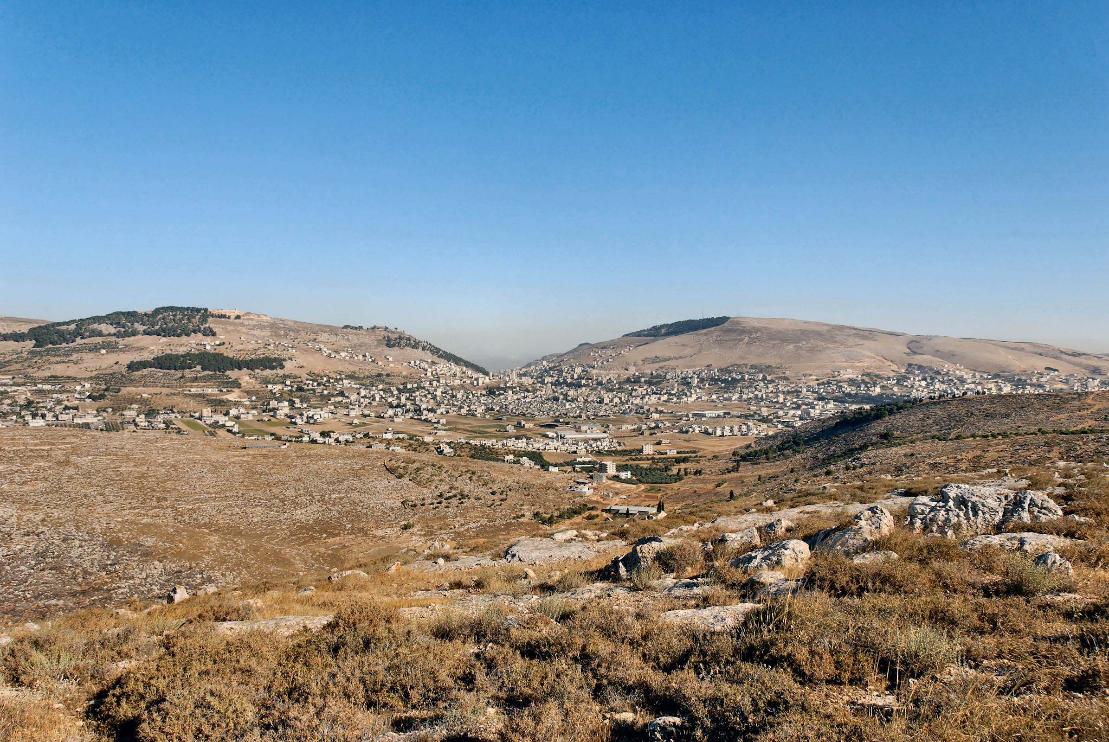

Figure 13.1: Mt Gerezim, Shechem, Mt. Ebal from east. In Deuteronomy 11, Moses instructs that when Israel enters the land, she is to read the blessings from Mt. Gerezim and the curses from not following His word from Mt. Ebal. Today, Shechem is also known as the Arab city of Nablus. Courtesy of the [Pictorial Library of Bible Lands](https://www.bibleplaces.com)

## 13.1 Qal is Simple action, Active voice

|  |  |  |  |
| --- | --- | --- | --- |
|  | Active Voice | Passive Voice | Reflexive Voice |
| Simple Action | **QAL** | Niphal | (Niphal) |
| Intensive | Piel | Pual | Hitpael |
| Cause an Action | Hiphil | Hophal |  |

* Remember this table is very high-level and perhaps over-simplified; but, it is a good starting place for understanding the meaning each stem
* Qal is the primary Hebrew stem
* The other six major stems are said to be “derived” from the Qal stem, hence the name “derived stems”

## 13.2 Perfect is completed action or a state as a whole

* In translating, we will most often use the simple English past tense: she had studied
* Other appropriate translations depending on the context
  + Present perfect: she has studied
  + Past perfect: she had studied
  + Future perfect: she will have studied
    - In other words, saying “Perfect = past” and “Imperfect = future” is an oversimplification
* Stative verbs describe a state of being are also Perfect
  + English present is often a better translation: She is wise, she knows, she loves
  + English past might also be appropriate: she was wise
  + In a few sections, we will learn that in Hebrew, stative verbs are sometimes spelled differently

The Hebrew perfect describes an action or a state of being as a whole, not as a process

* I.e. “she was studying” is an incomplete process, but “she had studied” is completed action

## 13.3 Components of the Qal Perfect Strong Paradigm

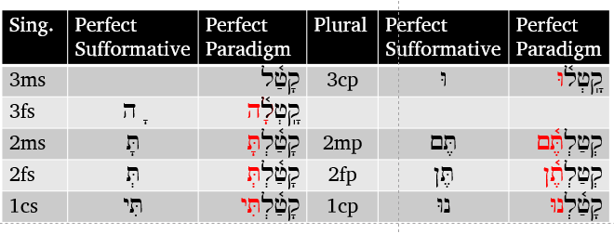

The next few sections go into detail of building the paradigm.

## 13.4 The Perfect Sufformatives

The table below shows the perfect sufformatives in the middle column. The 1st and 2nd Person forms are similar to the respective pronominal suffix.

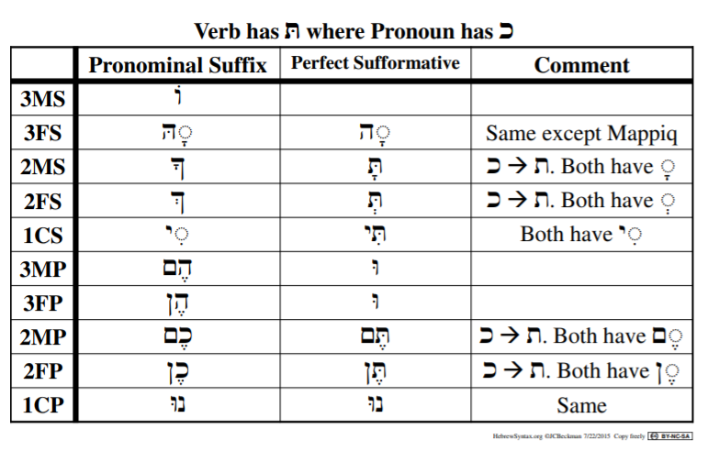

Notes:

* 3MS has no Perfect sufformative
  + so the steps such as adding a sheva before a perfect sufformative" do not apply to 3ms
* Since 3mp and 3fp are the same, we simply say “3cp” - Third person, common, plural
* Good news: these sufformatives REMAIN THE SAME throughout all seven Perfect conjugations

## 13.5 Qal Perfect Vowels: $V_{1}$ is almost always Qamets

* $V_{1}$ is almost always Qamets
* As we learned way back in this course, an unaccented long vowel in an open propretonic syllable, will undergo propretonic reduction
  + When this happens, you will see a Vocal Sheva, but you will be able to deduce that $V_{1}$ used to be a long vowel - and if it’s a Qal verb, you’ll know it used to be a Qamets

HGQ SHORTHAND: $B$ = Strong Form Distinctive “B”eginning

* Each of the stems/conjugations has a distinctive combination of consonants, vowels, and occasionally Daghesh Forte marks the first one or two syllables of a given verb
  + This serves to make the strong form of the verb easy to differentiate from the other stems
  + We will call this a “Distinctive Beginning” which we will combine with parsing code
* ק represents any strong letter in $R_{1}$
* $B_{QP}=$ קָ, means the Distinctve “B”eginning of a Qal Perfect verb is no prefix/preformative and a Qamets in $V_{1}$

## 13.6 Qal Perfect Vowels: $V_{2}$ prefers patach

* $V_{2}$ prefers patach
* For strong verbs, $V_{S}=V_{2}$
  + So we could either say “ $V_{S}$ for Qal Perfect Strong equals Patach”
  + Or we could use formula shorthand and say $V_{S}Q=A$, since “A” without
* In 3cp and 3fs, the Sheva of the perfect sufformative goes in $V_{2}$
  + Some stative verbs can also take a Tsere or Holem in $V_{2}$

HGQ SHORTHAND: $V_{S}=$ Formulas for Stem Vowels

* As we progress through the verbs, each major stem will end up with a formula that looks something like this:
$$V_{S_{H}}=Î[A]∼Î(Ē)$$

* This may be utter gibberish to you right now, but as we get into Unit 4, this formula (in combination with the $B$ pattern for the conjugation’s Distinctive Beginning) will save you hours of paradigm memorization of the derived stems
* You will only need to memorize the Qal paradigms, then apply this formula for the other stems
* So let’s start to build this formula for the Qal:

$$V_{S_{Q}}=A∼$$

* In the formula, $A$ refers to Patach - you may need to review the Vowel shorthand in the Unit 3 Introduction * This formula is telling you that the Stem Vowel of the Perfect Conjugation is Patach * The $V_{S}$ can change based on other grammar rules, but if you are looking at a Qal Perfect verb, the $V_{S}$ is *or was* a Patach * The *Imperfect* Stem Vowel will be to the right of the $∼$ mark - we’ll get to this in Lesson 15

## 13.7 $V_{S}$ is accented in Finite verbs

* As we introduced in Lesson 12, verbs that have “person” designation are called Finite verbs
  + Perfect, Imperfect, Imperative, Cohortative, Jussive are FINITE
  + Infinitive Construct, Infinitive Absolute, Participle are NON-FINITE, because they do not have “person”
* The $V_{S}$ is accented in Finite verbs, when possible
  + As we said in the previous lesson, $V_{S}$ usually = $V_{2}$- in קָטַל $V_{S}$ = patach
    - If $R_{2}$ is a vowel letter, then $V_{S}$ = $V_{1}$- in קוּם $V_{S}$ = shuruq
    - If $R_{2}$ disappears, then $V_{S}$ = $V_{1}$- in קָם $V_{S}$ = Qamets
* Exceptions where we accent after $V_{S}$:
  + $V_{S}$ is a Sheva or Hateph vowel - Sheva/reduced vowels *never* take an accent
    - In the Perfect, we will see this in Qal Perfect 3fs and Qal Perfect 3cp
  + The verb has a “heavy sufformative”
    - A heavy sufformative pulls the accent
    - There are two heavy sufformatives in the Perfect
      * 2mp - תֶּ֫ם and 2fp - תֶּ֫ן
  + The verb has a pronominal suffix
  + $V_{S}$ is not one of the final two syllables

## 13.8 A Sheva precedes a Finite Sufformative

The Sheva is rejected in the following circumstances:

* A Sheva does not replace an unchangeable long vowel
* A Sheva does not replace $V_{1}$ of the Qal Perfect (and only the Qal Perfect)
* When $R_{3}$ is א, the א quiesces (generally resulting in Compensatory Lengthening of $V_{2}$)

If the sufformative has a בגדכפת letter (usually ת), that letter will take a Daghesh Lene

## 13.9 Building the Qal Perfect Strong Paradigm

Our general philosophy is to prepare you to read Hebrew. While it is unlikely you will ever need to “inflect קתל into the Qal Perfect 2fs”, understanding how we build the paradigm will not only prepare you to identify verbs in the Bible, it will prepare you do spot when deviations occur.

Study the graphic and the steps below carefully. It may seem confusing at first but, with practice, you’ll get it. You’ll note that the steps work backwards from left to right



1. Add the perfect sufformatives (13.4)
2. Put a Sheva before the sufformative (13.7)
   * 3fs/3cp - the Sheva can’t go under $R_{3}$ because $R_{3}$ already has a vowel
     + A consonant can’t have more than one vowel
     + For these forms, the Sheva goes under $R_{2}$
3. Add Dagesh Lene to תּ that comes after any Sheva
   * all 2nd person forms and 1cs
4. $V_{S}$ is PATACH in the Qal Perfect Strong paradigm (13.5)
   * UNLESS $V_{2}$ is already a sheva from step two
5. Accent $V_{S}$ (unless there is one of the exceptions listed in 13.6)
6. $V_{1}$ is QAMETS (13.5)
   * 2mp/2fp - the Qamets is then reduced to a Vocal Sheva because of propretonic reduction
7. OPTIONAL - Add a metheg mark to $V_{1}$ 3fs/3cp
   * The metheg can denote that the vowel is Qamets followed by a vocal Sheva and not Qamets Hatuf followed by a Silent Sheva
   * The Hebrew Bible does not do this

## 13.10 Hearing the Qal Perfect Strong Paradigm

Below is the complete paradigm. Be sure to listen to Izzy read the forms with the paradigm verb, קתל and take note of pronunciation and accents.

Qal Perfect Strong (Singular) read by Izzy

Your browser does not support the audio element.



Qal Perfect Strong Paradigm from *Hebrew Quest* Chapter 14

Your browser does not support the audio element.

## Worksheet: Qal Perfect Strong Paradigm

We are going to go a little out of order. Normally, we save all of the activities for the end of the lesson, but here, we want you to pause and complete the [Qal Perfect Strong Paradigm](./images/13_qal_perfect_strong_paradigm.pdf).

Complete the paradigm from memory at least once, then return here and continue in the guidebook.

We know you’re tempted to keep on clicking to read the pages that follow. Resist!

Doing the worksheet now will maximize your learning time - in other words, the material that follows in this lesson will make more sense to you if you have the paradigm in your short-term memory.

## 13.11 Qal Perfect Strong Examples

* יָדַ֥ע
  + No Preformative + No sufformative = **P3ms**
  + $V_{2}$ = ַ and $V_{1}$ is ָ = **QP**
    - $V_{2}$ can be ◌ָ also
  + This combination of Preformatives, sufformatives, and vowels can only be Qal Perfect 3MS (QP3ms) - he knows
  + As we said in the introduction to Unit 3, you will start to see the cantillation marks in words and passages. If you don’t recognize a mark as a vowel, it is a cantillation mark.
* שָׁמְר֤וּ
  + No preformative + וּ sufformative = **P3cp**
  + $V_{2}$ = ְ and $V_{1}$ is ָ = **QP**.
    - $V_{2}$ is Sheva, but we know that the Perfect sufformative is preceded by a Sheva whenever possible. In the P3cp and P3fs, the sheva of the sufformative displaces $V_{2}$. If we know our vocab, we also know that the Lexical form is שָׁמַר.
  + שָׁמְר֤וּ is Qal Perfect 3cp (QP3cp) - they guarded/observed
* As we will learn in Unit 4, when there are no other signs of a different stem we can default to Qal, since Qal is the most common
* As with זָכָ֑רְתְּ, there are times where $V_{2}$ is Qamets instead of Patach - these are just spelling variants that occur over the many hundreds of years the Tanach was written. There is nothing otherwise to suggest that these are not Qal verbs

## 13.12 Deviations from the Paradigm

* As we talked about in Lesson 12, what makes a verb “weak” versus “strong” is when one or more letters cause a deviation from the strong verb paradigm.
* While the bulk of the discussion on weak verbs will be in Lesson 14, there are three weak forms we will introduce here.
  + Words where $R_{3}$ = נ, which we abbreviate as 3נ or sometimes III-נ
  + Words where $R_{3}$ = ת, called 3ת or III-ת
  + Stative verbs where $V_{2}$ is not always Pathach
* Studying these now will demonstrate how you can use your knowledge of the Perfect Strong paradigm to determine the stem and conjugation of weak verbs.

In most cases, you already know the behaviors of “weak” letters!

While “stative” verbs may be a new concept, we have already discussed the tendency of ת and נ to assimilate under certain circumstances. This is exactly what is happening when we encounter 3ת and 3נ verbs.

## 13.13 3נ and 3ת Verbs

* We mentioned above how a Sheva will be placed before a Finite sufformative (if possible)
* When ת and נ have a Silent Sheva, each may assimilate depending on the letter that follows
  + In other words, the verb will lose $R_{3}$ and a Daghesh Forte will be placed into the first letter of the sufformative
  + An $R_{3}$ of ת with a Silent Sheva will only assimilate when the sufformative begins with ת
    - Not כָּרַ֫תְתָּ*[62] but כָּרַ֫תָּ
    - Not כְּרַתְתֶּם*, but כְּרַתֶּ֫ם
    - IMPORTANT: Note how the Daghesh in the ת shifts from a Lene to a Forte (because the Daghesh is now preceded by a vowel that is not a Sheva)
      * This is your cue that something has changed, usually that a letter is missing
      * In theory, the root could be either כרן or כרת, but you already know כרת from your vocabulary work (and there is no verb root כרן)
  + An $R_{3}$ of נ with a Silent Sheva will tend to assimilate to either נ or ת
    - נַתַן is an extremely common 3נ verb meaning “to give”
    - Not נָתַ֫נְנוּ*, but נָתַ֫נּוּ
    - Not נָתַ֫נְתָּ*, but נָתַ֫תָּ

## 13.14 Stative Verbs MAY have a different $V_{S}$

* Stative verbs describe a state of being, such as “wise”, “old”, or even “dead”
* The $V_{S}$ may change in some forms
  + There is what is called a “Patach Stative”, that prefers $V_{S}$ of (wait for it…) Patach
    - Since Qal Perfect *already* prefers a $V_{S}$ of Patach, there is no visible change
    - Patach Stative has a different $V_{S}$ in the Imperfect conjugiation
    - גָּדַ֫ל, “he is great” is an example - this word maintains the Perfect Strong paradigm all the way through
  + Tsere Stative has $V_{S}$ of Tsere in the P3ms ONLY
    - כָּבֵ֫ד = “he is honored”
    - All other PGN follow the Perfect Strong
  + Holem Stative has $V_{S}$ of Holem in P3ms, P2ms, and P1cp
    - Holem Statives are relatively rare and do not even appear in the Bible as P2fs or any of the plural forms other than P1cp
    - יַכֹ֫ל = “he is able to”
    - קָטֹ֫נְתִּי = “I am small”
      * Note the נְ DOES NOT assimilate - Hebrew likes to keep you guessing!
      * While we could ask, “Why didn’t this assimilate?”, this is not going to be very productive or satisfying in the long run.
      * When you see only $R_{1}$ and $R_{2}$, and then a Daghesh Forte in the next consonant, it’s better to ask “did $R_{3}$ assimilate?”

## Word Warm-up

[Click to open Word Warm-up video in a new tab](https://youtu.be/PuYs3ZTVXVg)

## Verses Warm-up

[Click to open Verses Warm-up video in a new tab](https://youtu.be/kgMX1hbnbSE)

## Anki

* Lesson 13 A. Vocab
* Lesson 13 B. Grammar
* Lesson 13 C. Workbook
  + The verb parsing exercises are taking directly from the Study Verses
  + As we will learn next week, “weak” verbs are a lot more common than “strong” verbs
  + Even though we will formally study weak verbs in Lesson 14, you should be able to use your knowledge of $V_{1}$ and the Perfect preformatives, to determine the parsing solution
    - Of course, we’ve only studied the Qal Perfect!
    - When you encounter a “weak” verb, such as מָלְאָ֥ה, which is 3א, or יָדָ֔עוּ, which is 3עח (A ח or ע as $R_{3}$), try to see what changes occur (based on what you already know about Gutturals)
* Lesson 13 D. Study Verses

## Ruth Pursuit

YOUR QUEST:

1. Identify and translate the following Qal Perfect Strong Verbs:
   * פקד QP3ms (yellow)
   * זקן QP1cs (green)
     + What is unique about this verb?
   * ילד QP1cs (gray)
   * דבק QP3fs (blue)
     + Hint: See [page 65 of this dictionary](https://holylanguage.com/resources/Pocket-Hebrew-Dictionary-Feyerabend.pdf)
2. Identify and translate מלא FS (adjective)(pink)

* [Blank copy of Ruth 1](https://docs.google.com/document/d/1bcT1J-fcVmD1Zn5Jk2nj0560tEddcgtbYZLkwaVVuyE/copy)
* [Ruth Pursuit Answer Key #13](./images/13_Ruth_Pursuit_KEY.pdf)

## X Claim your next Twelve Tribes Badge!

Check to be sure you have have completed all activities through this lesson, then fill out the form below.

Check to be sure you have completed all ACTIVities here, complete the certification below, and your badge will be on its way!

## OPTIONAL: *Hebrew Quest* Study Passage: Proverbs #5-7

YOUR HEBREW QUEST:

1. BEFORE WATCHING THE VIDEO, read through the passage on your own straight through one time - pick up as much as you can - [Blank copy of the Proverbs studied in sessions 5-7.](https://docs.google.com/document/d/15D5W-prZoVTGEFa9QzuBCnfW4kQnwXT4TBNYNPhcRW8/copy)
2. Now re-read the passage critically
   1. Highlight any words you do not know and look them up in a [lexicon](https://holylanguage.com/resources-dictionaries.php)
   2. Sketch out a translation - there is a blank line between each verse
3. Now, using your marked-up copy of the passage, watch Izzy’s *Hebrew Quest* videos (video opens in a new tab)
   1. [Proverbs #5](https://holylanguage.com/proverbs-5.php)
   2. [Proverbs #6](https://holylanguage.com/proverbs-6.php)
   3. [Proverbs #7](https://holylanguage.com/proverbs-7.php)
4. After the video, assess your translation. How close was it?
5. How did the Ruach HaQodesh speak to you through the passage?

# 14 Qal Perfect - Weak Verbs

A weak verb is defined as one with one or more letters that cause the word to deviate from the strong verb pattern.

In the Bible, weak verbs are much more common than strong verbs. Rather than memorizing all of the differences, we will study the changes caused by weak letters. By understanding these changes, we can work “backwards” to identify the strong verb’s pattern. This will enable us to correctly determine a weak verb’s stem and conjugation so we can translate it accurately.

LESSON ITINERARY

1. 3נ and 3ת assimilate
2. 1G, 2G reject Vocal Sheva
3. 2fs form of 3ע/ח is irregular
4. 3א usually quiesces
5. $R_{3}$ in 3ה is a vowel not a consonant
6. Gemininate and Biconsonantal often have only two root letters visible
7. Clues for your Qal Perfect Quest

EQUIPMENT CHECK

Before continuing, can you describe the following concepts?

* You must have the Qal Perfect Strong Paradigm memorized!

## First Thought

### בָ֤אָה נַחֲלָתֵ֙נוּ֙ אֵלֵ֔ינוּ מֵעֵ֥בֶר הַיַּרְדֵּ֖ן מִזְרָֽחָה׃

*our inheritance has fallen to us on this side of the Jordan toward the east (Numbers 32:19)*

Numbers 32 begins, “The Reubenites and Gadites, who had very large herds and flocks, saw that the lands of Jazer and Gilead were suitable for livestock.” They followed their eyes, which saw profit. The fact that they took the easy path caused tension between the tribes, and students of history know that these lands were often easily invaded. The lesson for us is to make we are seeking what the Lord wants for us and not our own desires.

Listen to the verse in Hebrew:

Your browser does not support the audio element.

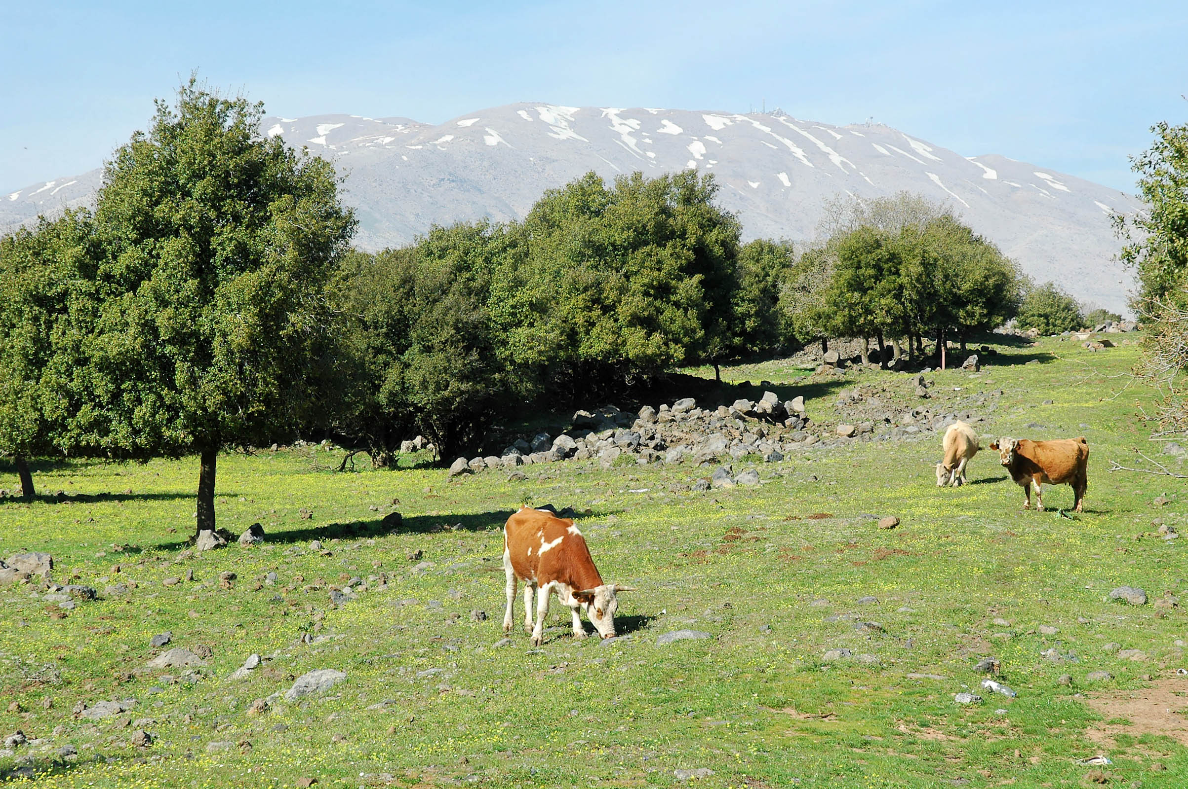

Figure 14.1: Cows of Bashan with Mount Hermon. Courtesy of the [Pictorial Library of Bible Lands](https://www.bibleplaces.com)



## 14.1 Review

* Strong verbs follow the קטל strong-verb paradigm
* A weak verb has one or more root consonants that cause a spelling change when compared to the strong
* Depending on the change, a verb may be strong in one conjugation but weak in another
  + For example, Resh is only weak in forms that try to put a Daghesh Forte in it
    - The Piel stem has a Daghesh Forte in $R_{2}$, but the Qal does not
    - Therefore, a stem with a Resh (or a guttural) in $R_{2}$ is weak in the Piel, but Resh is not weak in the Qal
* Weak verbs are classified by their problematic root letter

## 14.2 3נ and 3ת with Silent Sheva Assimilate to Dagesh

* A Tav with a Sheva assimilates to another Tav only
  + It becomes a Dagesh Forte in the following Tav
  + This occurs in all Qal Perfect 2nd person forms as well as 1cs
  + NOT כָּרַתְתָּ, BUT כָּרַתָּ
* A Nun with a Silent Sheva assimilates to anything
  + It becomes a Daghesh Forte in the next letter
  + This occurs in all Qal Perfect 1st and 2nd Person forms
    - NOT נַתַ֫נְתָּ, BUT נַתַ֫תָּ
    - NOT נָתַנְנוּ, BUT נַתַ֫נּוֹ
* The Daghesh 2MS ending is usually a Lene, but in these examples, each becomes a Forte (Why?[63])

## 14.3 Review of Guttural Principles

1. Gutturals and Resh reject Dagesh Forte, often resulting in compensatory Lengthening:
   * From ִ TO ֵ
   * From ַ TO ָ
   * From ֻ TO ֹ
2. Gutturals Take Hateph Vowels instead of Vocal Sheva
   * Usually Hateph Patach, sometimes Hateph Seghol, rarely Hateph Qamets Hatuf
   * This can affect the preceding vowel, as well as the vowel associated with the guttural:
     + NOT עְמַדְתֶּם, BUT עֲמַדְתֶּם

* Gutturals prefer Patach
  + NOT יִשְׁלֹח, BUT יִשְׁלַח

## 14.4 1G, 2G

* The Guttural will take Hateph Patach instead of Vocal Sheva
* 1G - affects QP2mp and QP2fs
  + NOT עְמַדְתֶּם, BUT עֲמַדְתֶּם
  + Otherwise, $V_{1}=\overset{‾}{A}$ as is diagnostic of the QP conjugation
* 2G - affects QP3fs, QP2fs, QP3cp
  + NOT בָּחְרוּ, BUT בָּהֲרוּ
  + In 2G, $V_{1}=\overset{‾}{A}$ (unless reduced in 2mp/2fp) as is diagnostic of the QP conjugation

To get back to the strong verb paradigm, substitute Sheva for the Hateph vowels

## 14.5 3-ע/ח

* Because different $R_{3}$ gutturals behave in different ways, we are unable to simply say “3G”
  + 3 ע/ח is discussed below
  + א 3 and 3 ה will be discussed in separate sections
* 3 ע/ח: We said earlier that the Gutturals reject VOCAL sheva but the Sheva in the 2nd (except 2fs) and 1st person forms is SILENT so it stays
  + שָׁמַ֫עְתָּ
* For reasons scholars don’t fully understand, the 2fs form is irregular.
  + The 3rd ע or ח takes a Patach instead of a Sheva:
    - שָׁמַ֫עַתְּ
  + The Dagesh is a LENE despite the preceding vowel
  + It is not necessary to memorize this oddity
* In all 3G, $V_{1}=\overset{‾}{A}$ (unless reduced in 2mp/2fp) as is diagnostic of the QP conjugation - in other words, no matter what happens to $V_{S}$, you will usually be able to diagnose Qal Perfect by the regular Qamets in $V_{1}$

## 14.6 א3

* Aleph quiesces with Silent Shewa
  + Occasionally, it also quiesces with Hateph vowels (i.e. Vocal Sheva)
  + Usually there is Compensatory Lengthening (CL)
  + $V_{2}=\overset{‾}{A}$ (Qamets) unless reduced by the perfect sufformative
  + QP2ms: NOT מָצַ֫אְתָּ, BUT מָצָ֫עתָ
  + QP3ms, the Aleph is already quiescent (CL): NOT מָצַא, BUT מָצָא
  + בגד כפת have Dagesh Lene only if not after a vowel
    - In other words, the Quiscent Aleph is ignored
    - Note how the 2fs forms drops the Dagesh Lene and final Silent Sheva if a vowel is before the בגד כפת:
    - NOT מָצַאְתְּ, BUT מָצָאת
* As mentioned, in 3G, $V_{1}=\overset{‾}{A}$ (unless reduced in 2mp/2fp) as is diagnostic of the QP conjugation - (are you beginning to see the pattern?)

## 14.7 יָרֵא is 3א AND Tsere Stative

* $V_{S}=\overset{‾}{E}$ unless reduced (P3fs, P3cp)
* Most Tsere statives have $\overset{‾}{E}$ only in the 3ms - ירא is irregular

## 14.8 3ה

* 3ה verbs are in a unique class
* $R_{3}$ is not a consonant; in fact there is no $R_{3}$ consonant
* 3ה verbs only have two root consonants, $R_{1}$ and $R_{2}$- the final slot is taken up by the vowel letter ה ָ

Historically, third ה verbs used to be 3-י. In some conjugations, the Yod “reappears.”

* $V_{2}$ of 3H verbs follow a unique pattern:
  + IF there is no sufformative THEN add the vowel ה ָ in the Perfect
  + IF the sufformative starts with a vowel, THEN the vowel of the sufformative is $V_{2}$
  + IF the sufformative starts with a consonant, THEN $V_{2}$ is +Yod
    - The specific depends on the stem - for the QP $V_{2}=\hat{I}$ (Hireq+Yod)
* Additionally, to avoid ambiguity with the P3ms, the P3fs sufformative becomes תָה
* With all these changes, the $V_{1}=\overset{‾}{A}$ (unless reduced in 2mp/2fp) diagnostic of QP does not change

## 14.9 Doubly Weak

* Doubly weak verbs have two (or all three[64])
* Most frequently, it will be a 3ה verb with a 1G or 2G
* These verbs have an additional step to scavenger hunt our way back to the Strong Verb Paradigm but overall, these are not difficult
* We simply need to combine the 1G/2G aspects of the hateph vowel instead of a sheva with the 3ה endings we studied in the previous section

## 14.10 הָיָה

* This is a very common verb meaning “to be”
* As you can see, it is both 1G and 3ה
* It follows the 3ה endings we discussed above
* $V_{1}$ is הֱ in 2mp and 2fp
  + הֱיִיתֶם and הֱיִיתֵן
  + The first Yod is $R_{2}$
  + The second is $V_{2}=\hat{I}$ (Hireq Yod)

## 14.11 Geminate

* In Geminate verbs, $R_3 = $R_{2}$
* No Hebrew words have $R_{1}=R_{2}$- this will prove to be important later in the course
* Frequently, $R_{2}$ assimilates into its twin $R_{3}$
  + $R_{3}$ will then take a Dagesh Forte, unless it is the final consonant in a word
  + 3rd person forms will have both
    - סַב or סָבַב
  + When there is assimilation, the accent tries to shift to $V_{1}$ since that is the new Stem Vowel
    - The accent must be on the last two syllables
    - The heavy sufformatives (2mp and 2fp) continue to take the accent
  + $V_{2}=\hat{O}$ before sufformative that starts with a consonant
* Review the table below, noting $V_{1}$ and accent changes:

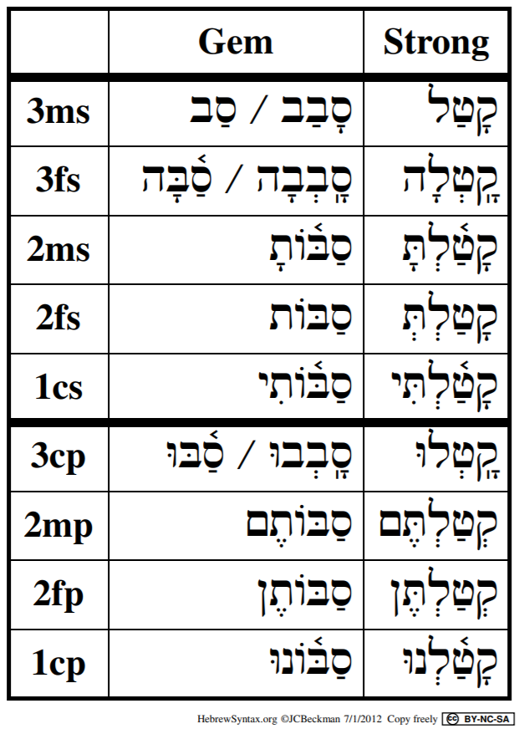

Figure 14.2: Qal Perfect: Geminate/Strong Paradigms

Although they can be troublesome, Geminate verbs are relatively infrequent, so the changes in the table above needn’t distract you from your verb parsing quest! You will learn the major geminate verbs in your vocabulary. To start with, here are a few of the most common:

* סָבַב, to surround
* שָׁלַל, to plunder
* אָרַר, to curse
* תָמַמ, to finish

## 14.12 Biconsonantal

* Biconsonantal have two root consonants, $R_{1}$ and $R_{3}$
* What appears to be $R_{2}$ is actually an unchangable long vowel, Holem+Vav, Shuruq, or Hireq+Yod
  + This vowel is called the **LEXICAL VOWEL**
  + It will be important to memorize the Lexical Vowel
    - For example, NOT קִים, NOT קוֹם, BUT קוּם
  + The word with the Lexical Vowel is the Lexical Form (the version that is in the dictionary)
  + This is an exception to the QP3ms = Lexical Form guideline
* $V_{S}$ and its accent move to $V_{1}$ and do not reduce
  + $V_{S}$ lengthens in 3rd person

Review the table below, noting $V_{1}$ and accent changes:

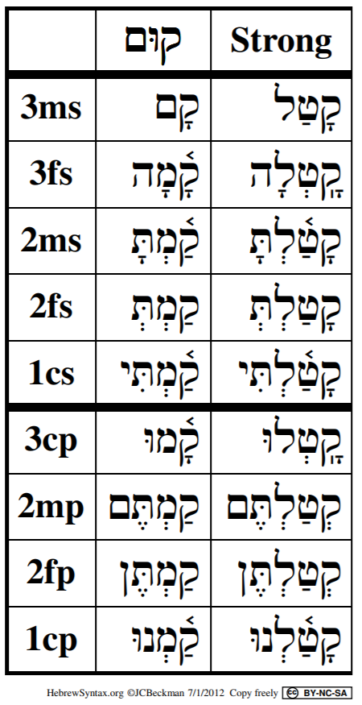

Figure 14.3: Qal Perfect: Biconsonantal/Strong Paradigms

## 14.13 םוּת is Biconsonantal and Stative

* Recognize Biconsonantal by the accent and missing root consonant
* $V_{S}$ and accent moved to $V_{1}$
* Tsere stem vowel in 3rd person
* In the perfect, only occurs in 3rd person and 1cp
* Compare םוּת and קוּם in the table below: 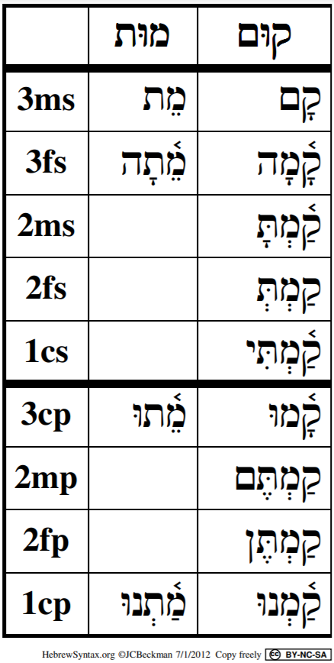

## 14.14 Qal Perfect Quest Clues

1. No preformative
2. Perfect sufformative
3. $V_{1}\overset{‾}{A}$ (Qamets)
   * Reduced if 2mp/2fp
   * $A$ (Patach) if Biconsonantal or Geminate 1st or 2nd Person
   * (*reduced if pronominal suffix - Lesson 19*)

## 14.15 Clues for Qal Perfect Special Situations

Commit the 3ה clues to memory. Geminate and Biconsonantal are much less frequent.

* Missing a Root Consonant?
  + If $V_{1}$ is accented, it is biconsonantal or geminate
  + 1st or 2nd person: look at the vowel before the sufformative
    - י ִ = 3ה
    - וֹ ּ = GEMINATE
    - ְ = BICONSONANTAL
    - תּ ַ (where Tav is the sufformative) = 3נ/ת
    - נּוּ ַ in the 1cp = 3נ
  + 3rd Person
    - Dagesh Forte in what looks like $R_{2}$ = GEMINATE
    - $V_{1}$ is accented and no Dagesh in $R_{2}$ = BICONSONANTAL
    - $V_{2}$ accented as usual = 3ה

## Word Warm-up

[Click to open Word Warm-up video in a new tab](https://youtu.be/eoDmrjNixN4)

## Verses Warm-up

[Click to open Verses Warm-up video in a new tab](https://youtu.be/8MouGMH5bCQ)

## Anki

* Lesson 14 A. Vocab
* Lesson 14 B. Grammar
* Lesson 14 C. Workbook
* Lesson 14 D. Study Verses

unless there is something unique to point out, we will omit the Anki section from the Hebrew GRAMMAR Quest Guidebook going foward. You know the drill! Be sure to do the four Anki levels after each Lesson.

## Ruth Pursuit

YOUR QUEST

Identify and translate the Qal Perfect Weak Verbs below. All verbal roots are vocabulary words from Lesson 12 or Lesson 14.

1. שׁמע QP3fs
2. היה QP3fs
3. עשה QP2mp
4. אמר QP1cs
5. יצא QP3fs - why is this verb 3fs?
6. שׁוּב QP3fs X2
7. הלך QP1cs
8. ענה QP3ms 9 בוֹא QP3cp

* [Blank copy of Ruth 1](https://docs.google.com/document/d/1bcT1J-fcVmD1Zn5Jk2nj0560tEddcgtbYZLkwaVVuyE/copy)
* [Ruth Pursuit Answer Key #14](./images/14_Ruth_Pursuit_KEY.pdf)

## X Quest Quiz

Open Quest Quiz #xx in a new window

## OPTIONAL: *Hebrew Quest* Study Passage: Proverbs #8-10

YOUR HEBREW QUEST:

1. BEFORE WATCHING THE VIDEO, read through the passage on your own straight through one time - pick up as much as you can. [Blank copy of the Proverbs studied in sessions 5-7.](https://docs.google.com/document/d/15D5W-prZoVTGEFa9QzuBCnfW4kQnwXT4TBNYNPhcRW8/copy)
2. Now re-read the passage critically
   1. Highlight any words you do not know and look them up in a [lexicon](https://holylanguage.com/resources-dictionaries.php)
   2. Sketch out a translation - there is a blank line between each verse
3. Now, using your marked-up copy of the passage, watch Izzy’s *Hebrew Quest* videos (video opens in a new tab)
   1. [Proverbs #8](https://holylanguage.com/proverbs-8.php)
   2. [Proverbs #9](https://holylanguage.com/proverbs-9.php)
   3. [Proverbs #10](https://holylanguage.com/proverbs-10.php)
4. After the video, assess your translation. How close was it?
5. How did the Ruach HaQodesh speak to you through the passage?

# 15 Qal Imperfect - Strong Verbs

To comprehend Biblical Hebrew, we must be able to parse and translate Qal imperfect verbs

In a few lessons, we will learn about the Vav Conjunction. The Vav Conjunction + the Qal imperfect is the most frequent verb form in the Hebrew Bible, so understanding the imperfect is essential. Like the Qal Perfect Strong paradigm, we must have robotic-like recall of the Qal Imperfect Strong Paradigm.

וַיֹּאמֶר אֱלֹהִים יְהִי אוֹר וַיְהִי־אוֹר׃

You might recognize this from Genesis 1:3 - “And God said, let there be light; and there was light.” There are three verbs in this short sentence and all three are Qal Imperfect.

LESSON ITINERARY

1. Imperfect is future, modal, or imperfective
2. Components of the Qal Imperfect Strong Paradigm
   1. The Imperfect Preformatives and Sufformatives
   2. The Qal Imerfect Vowels
3. Building the Qal Imerfect Paradigm
4. Deviations from the Strong Paradigm
5. Negative Commands

EQUIPMENT CHECK

Before continuing, can you describe the following concepts?

The Qal Perfect Strong Paradigm, from memory

## First Thought

### יִ֝שְׁמֹ֗ר כָּל־אָרְחֹתָֽי׃

*He watches all my paths (Job 33:11)*

There’s a story of a small child who was beginning to understand the implications of God’s power. “Do you mean God is watching everything I do?”, the child asked with mounting fear. Her father quickly replied, “God loves you so much, He can’t take His eyes of you.”

Let that sink in as you study Biblical Hebrew.

Listen to the verse in Hebrew:

Your browser does not support the audio element.

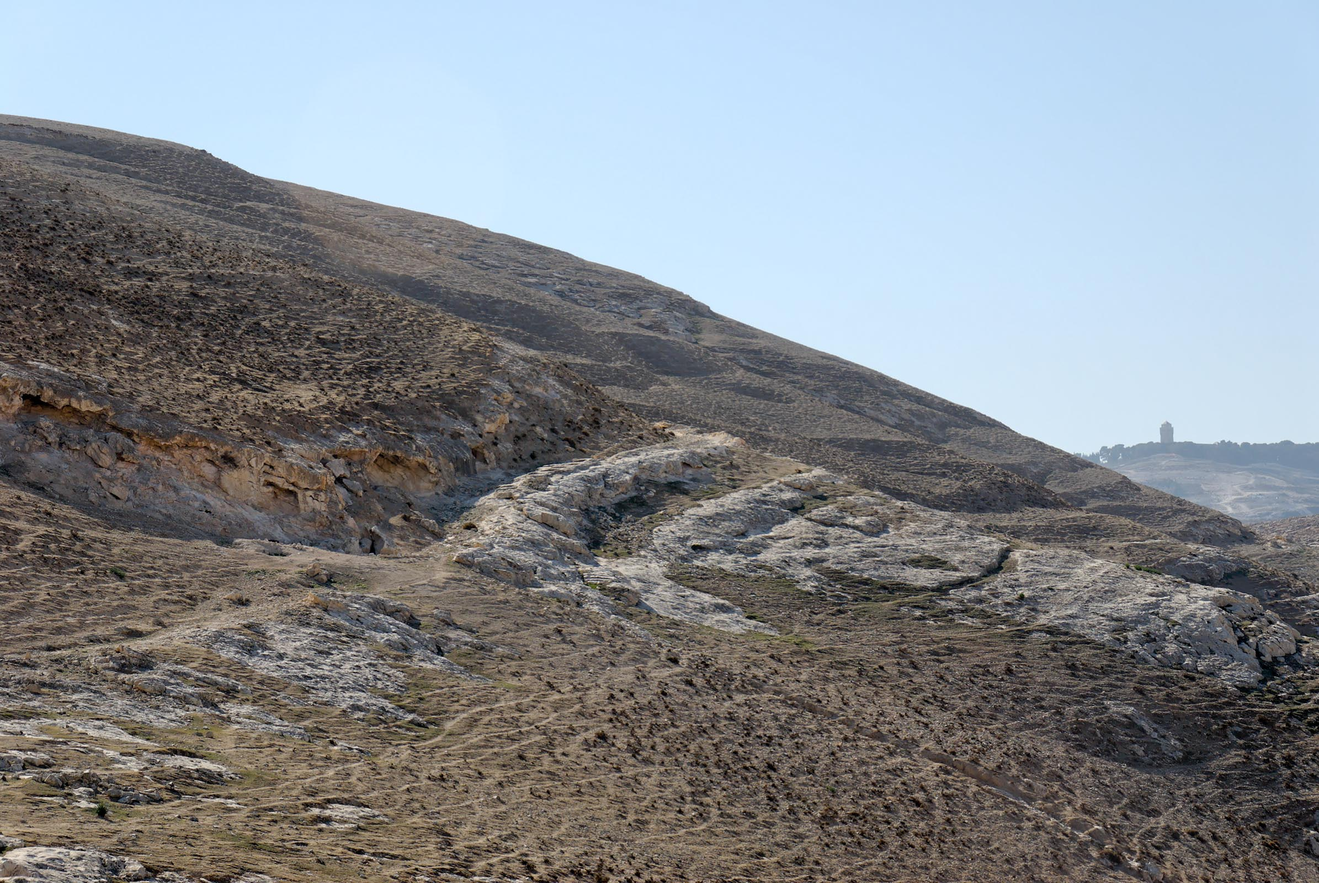

Figure 15.1: Ascent of Adummim Roman road remains - this was the main route from Jericho to Jerusalem in antiquity. It was notoriously trecharous, both in terms of physical exertion, rising 3500 feet in just 15 miles, as well as in terms of physical safety. This latter aspect provided the geographical context of Yeshua’s story of the Good Samaritan in Luke 17. Courtesy of the [Pictorial Library of Bible Lands](https://www.bibleplaces.com)

## 15.1 Translating the Imperfect

* The Imperfect has many potential translations
* Watch to see whether the imperfect verb begins a clause as this is a clue
* When the Imperfect does not begin a clause . . .
  + future, “I will run”
  + imperfective, “I am running” or “I was running”
* When the Imperfect begins a clause (and does not have a Vav Consecutive prefix[65] . . .
  + modal, cohortative: “I should run” or “I might run” or “let us run”
  + modal, jussive: “may he run”
  + We will study the modal forms in greater detail in Lesson 18
* When the imperfect is preceded by לֹא or אַל it is a negative command
  + We’ll have more to say about this towards the end of the lesson

## 15.2 The Imperfect Always has a Preformative

* All stems have the same set of preformatives
* The Imperfect is called the Prefix Conjugation
* י for 3ms, 3mp
* א for 1cs
* נ for 1cp
* תּ for everywhere else (3fs,3fp, 2ms, 2fs, 2mp, 2fp)

## 15.3 Qal Imperfect Vowels

Qal Imperfect strong verbs have a diagnostic $V_{P}$ + $V_{1}$ combination

* All QI strong verbs except 1cs begin with Hireq+Silent Shewa
  + ְ יִ for 3ms, 3mp
  + ְ נִ for 1cp
  + ְ תִּ for all others except 1cs
* 1cs begins with Aleph+Seghol+Silent Sheva **ְ אֶ**\*
* The vowels behave as if they were from the Rule of Sheva (they aren’t)

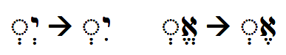

## 15.4 Imperfect Sufformatives

* Of the singular forms, only 2fs has a sufformative
  + It is **י ִ**\*
  + The **ְ תִּ**\* preformative with the **י ִ**\* sufformative is diagnostic of the QI2fs
* Of the plural forms, only 1cp does NOT have a sufformative
  + 2mp/3mp sufformative - **וּ**\*
    - Occasionally, there may be what is called a Paragogic Nun, as in **וּן**\*
    - The ן sometimes causes the shuruk to shorten to a Qubbutz
    - In other words, you may see **יִקְטְלוּ**\* or **יִקְטְלוּן**\* or **יִקְטְלֻן**\*. All three words are QI3mp
  + 2fp/3fp sufformative - **נָה**\*
  + You’ll note that QI2fp and QI3fp are identical. Context will determine whether the verb is being used in the 3rd person or the 2nd person. These forms are relatively infrequent.
* There are no “heavy sufformatives” in the Imperfect
  + In fact, the two we studied previously (2mp and 2fp) are the only ones
* The Imperfect is a Finite verb so a Sheva prefers to go before a finite verb sufformative

Now we’re ready to put all this together and learn the Qal Imperfect Strong Paradigm, the samw way we built the Qal Perfect Strong Paradigm!

## 15.5 Building the Qal Imperfect Strong Paradigm

Study the graphic and the steps below carefully. It may seem confusing at first but, with practice, you’ll get it. You’ll note that the steps work backwards from left to right.

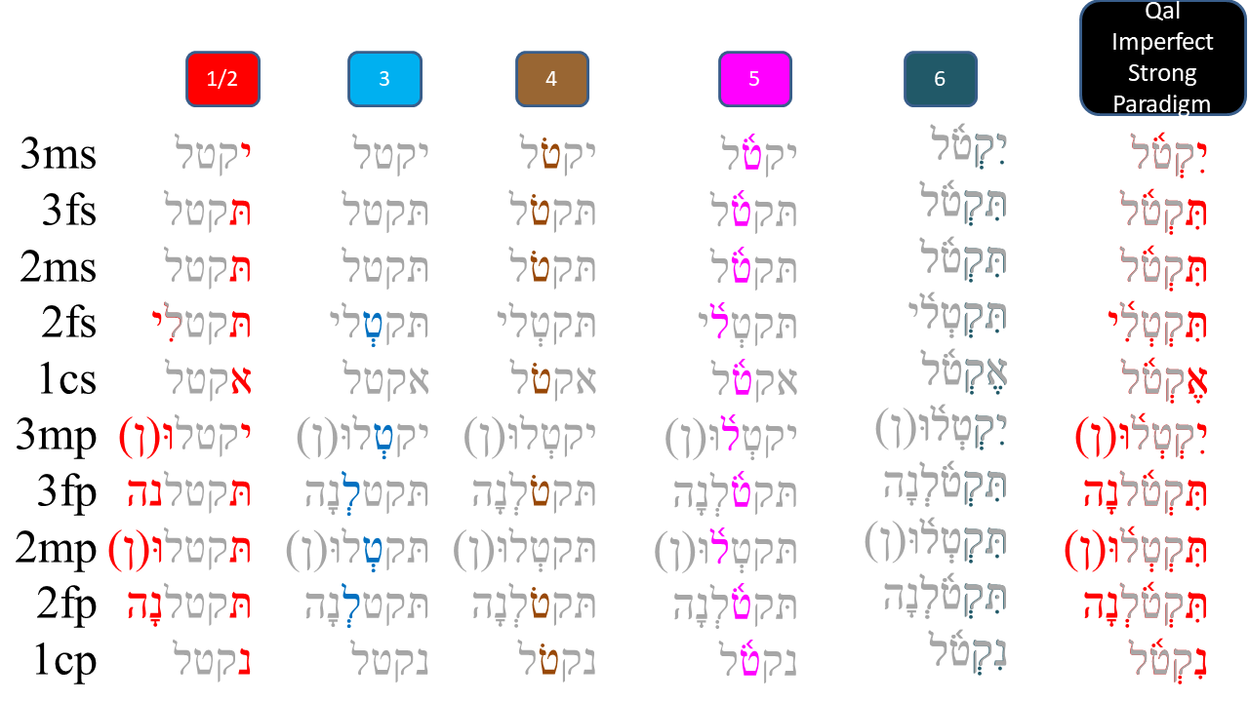

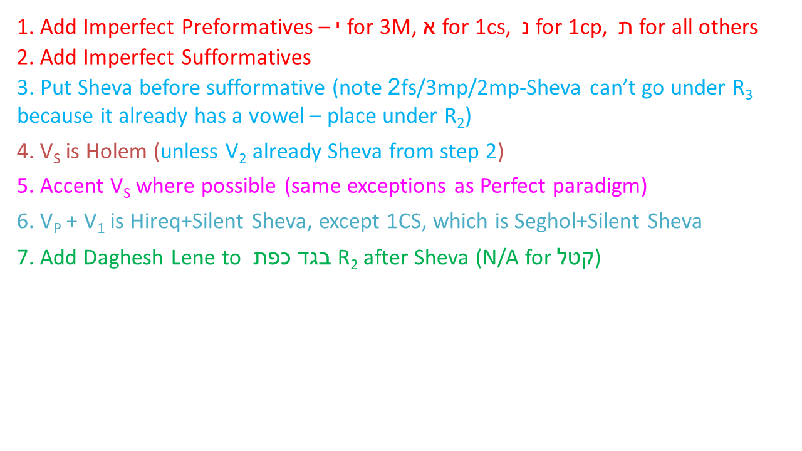

## 15.6 Hearing the Qal Imperfect Strong Paradigm

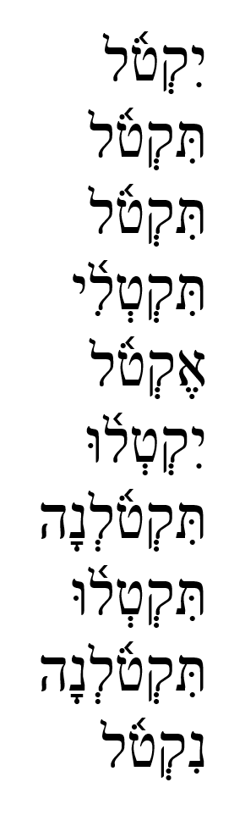

Qal Imperfect Strong (Singular) read by Izzy

Your browser does not support the audio element.

Qal Imperfect Strong (Plural) read by Izzy

Your browser does not support the audio element.

## Worksheets: Qal Imperfect Strong Paradigm

As with Lesson 13 we want you to pause here and do the [Qal Imperfect Strong Paradigm](./images/15_qal_imperfect_strong_paradigm.pdf).

Complete the paradigm from memory at least once, then return here and continue in the guidebook.

Doing the worksheet now will maximize your learning time - in other words, the material that follows in this lesson will make more sense to you if you have the paradigm in your short-term memory.

## 15.7 Qal Imperfect Strong Examples

* **תִּזְכְּר֔וּ**\*
  + Preformative: Tav+Hireq+Sheva = QI2xx or QI3Fx
  + Sufformative: Shuruq = I2mp or I3mp
  + Together: QI2mp
  + You will remember
* **יִכְתֹּ֤ב**\*
  + Preformative: Yod+Hireq+Sheva = QI3mx
  + Sufformative: none = QIxxS or QI1CP
  + Together: QI3ms
  + He will write
* **תִשְׁבַּ֤ת** *
  + Preformative: Tav+Hireq+Sheva = QI2xx or QI3Fx
  + Sufformative: none = QIxxS or QI1CP
  + Together: QI3fs or QI2fs - context will determine which one
  + Context: **לָ֣מָּה תִשְׁבַּ֤ת הַמְּלָאכָה֙**\* = Lit: why she will stop, the work" or “Why should the work stop” = the verb is modifying “the work” which is a feminine noun.
  + QI3fs

## 15.8 Deviations from the Paradigm

* All stative verbs have $V_{S}$ of Pathach (QI strong paradigm $V_{S}$ is Holem)
  + This is true in all PGN except where $V_{S}$ has been replaced by a Sheva (in step 3 of the workflow)
  + **יִגְדַּל**\* = he/it will be great or let him/it be great
* 3נ assimilates to a consonant as usual when the sufformative starts with a consonant
  + This happens in the QI(2/3)Pfp
  + **תִּשְׁכֹּנָּה**\* = you (fp)/they (f) will dwell
  + Since $V_{1}$ is a Sheva in the imperfect, 1נ verbs will be affected by this (Lesson 16)

## 15.9 Translating Negative Commands

* An imperfect form that is preceded by a negation is a negative imperative
  + Hebrew has an imperative form (Lesson 18), but this form is not used for negative commends
  + Hebrew has two primary words for negative commands: לֹא and אַל
  + לֹא + imperfect is for permanent prohibitions
    - לֹא תִּרְצָח Thou shalt not murder (Ex 20:13)
  + + jussive (closely related to imperfect) is usually a temporary or circumstantial prohibition
    - אַל־ת־ִשְׁמְעוּ אֶל־דִּבְרֵי נְבִיאֵיצֶם Do not listen to the words of your prophets (Jer 27:16)
    - Jeremiah is not saying don’t EVER listen to ANY prophets, but in this circumstance, they were listening to FALSE prophets. That is what Jeremiah is prohibiting.

## Word Warm-up

[Click to open Word Warm-up video in a new tab](https://youtu.be/IA1LEEbvOKw)

## Verses Warm-up

[Click to open Verses Warm-up video in a new tab](https://youtu.be/fellWe2bUt8)

## Worksheets: Qal Imperfect Strong Paradigm

Complete the paradigm from memory at least once, then return here and continue in the guidebook.

[Qal Imperfect Strong Paradigm](15_qal_imperfect_strong_paradigm.pdf)

## Ruth Pursuit

YOUR QUEST

Identify and translate the Qal Verbs below.

* היה QP1cs
* גדל QI3mp
* [Blank copy of Ruth 1](https://docs.google.com/document/d/1bcT1J-fcVmD1Zn5Jk2nj0560tEddcgtbYZLkwaVVuyE/copy)
* [Ruth Pursuit Answer Key #15](./images/15_Ruth_Pursuit_KEY.pdf)

## X Quest Quiz

Open Quest Quiz #xx in a new window

## OPTIONAL: *Hebrew Quest* Study Passage: Proverbs #11-14

YOUR HEBREW QUEST:

1. BEFORE WATCHING THE VIDEO, read through the passage on your own straight through one time - pick up as much as you can. [Blank copy of Proverbs #11-14(<https://docs.google.com/document/d/1E1Qbbx3tHw8pOfMSGwQHwD406eHIMd1O5lAS_tDWllE/copy>){target="_blank"}
2. Now re-read the passage critically
   1. Highlight any words you do not know and look them up in a [lexicon](https://holylanguage.com/resources-dictionaries.php)
   2. Parse as many verbs as you can
   3. Sketch out a translation - there is a blank line between each verse
3. Next, using your marked-up copy of the passage, watch Izzy’s *Hebrew Quest* videos (video opens in a new tab)
   1. [Proverbs #11](https://holylanguage.com/proverbs-11.php)
   2. [Proverbs #12](https://holylanguage.com/proverbs-12.php)
   3. [Proverbs #13](https://holylanguage.com/proverbs-13.php)
   4. [Proverbs #14](https://holylanguage.com/proverbs-14.php)
4. After the video, assess your translation. How close was it?
5. How did the Ruach HaQodesh speak to you through the passage?

# 16 Qal Imperfect Weak

This is a critical and dense chapter - lots of details…

Almost every weak verb type experiences some change in the Imperfect

LESSON ITINERARY

1. Work though the various weak verb forms in the Qal Imperfect

EQUIPMENT CHECK

Before continuing, can you describe the following concepts?

* The Qal Imperfect Strong Paradigm must be memorized

## First Thought

### וְעֵינֵיכֶ֖ם תִּרְאֶ֑ינָה

*Your eyes will see (Malachi 1:5)*

Listen to the verse in Hebrew:

Your browser does not support the audio element.



Figure 16.1: Jezreel Valley from Mount Carmel panorama. Courtesy of the [Pictorial Library of Bible Lands](https://www.bibleplaces.com)

## 16.1 Our Quest

As we progress through the material in this chapter, our quest is to learn how the weak verbs behave so we can work our way back to the Qal Imperfect Strong Verb indicators

* $Pre =$ יִק

$V_{S}=O$

ְ

## 16.2 2G

* Reject Daghesh Forte = no effect in QI)
* $V_{2}$ will be a Hateph Vowel instead of Vocal Sheva
* Prefer Patach so $V_{S}=A$ instead of $O$ (unless reduced)

Although $V_{S}=A$, 2G verbs are easily recognized as Qal Imperfect when $Pre =$ ְ יִ

|  |  |  |
| --- | --- | --- |
|  | 2G | Strong |
| 3ms | יִבְחַר | יִקְטֹל |
| 3mp | יִבְחֲרוּ | יִקְטְלוּ |

## 16.3 3חע

* Silent Sheva at $V_{3}$ remains
* Prefer $V_{S}=A$

Although $V_{S}=A$, 3חע verbs are easily recognized as Qal Imperfect when $Pre =$ ְ יִ

|  |  |  |
| --- | --- | --- |
|  | 3חע | Strong |
| 3ms | יִשְׁלַח | יִקְטֹל |
| 3mp | יִשְׁלְחוּ | יִקְטְלוּ |

## 16.4 3א

* While 3חע prefer $V_{S}=A$, 3א prefer $V_{S}=\overset{‾}{A}$ primarily
  + $E$ in 3/2fp
  + Occasionally, will see $\overset{‾}{E}$ also
* 3א quiesces with Silent Sheva (and sometimes with vocal)

Although $V_{S}$ can vary, 3א verbs are easily recognized as Qal Imperfect when $Pre =$ ְ יִ

|  |  |  |
| --- | --- | --- |
|  | 3א | Strong |
| 3ms | יִמְצָא | יִקְטֹל |
| 3mp | יִמְצְאוּ | יִקְטְלוּ |

## 16.5 3ה

* 3ה have two root consonants plus a ה vowel
* $V_{2}$ for 3ה verbs
  + IF $Suf$ starts with a vowel, THEN $Suf=V_{2}$
    - QI3cp - יִבְנוּ
    - QP3cp - בָּנוּ
  + IF $Suf$ starts with a consonant, THEN $V_{2} =$ vowel + י
    - QI(3/2)fp - תִּבְנֶ֫ינָה
    - QI2ms - בָּנִ֫יתָ
  + IF there is no $Suf$, THEN $V_{2} =$ ה vowel:
    - QP3ms: בָּנָה
    - QI3ms: יִבְנֶה

Despite the endings, 3ה verbs are easily recognized as Qal Imperfect when $Pre =$ ְ יִ

|  |  |  |
| --- | --- | --- |
|  | 3ה | Strong |
| 3ms | יִבְנֶה | יִקְטֹל |
| 3mp | יִבְנוּ | יִקְטְלוּ |

## 16.6 1G

* Remember the Rule of Sheva that prevents two contiguous Vocal Sheva/Hateph Vowels
  + NOT יְקְ, BUT יִקְ
  + Whenever we see the $Pre =$ ְ יִ of the Qal Imperfect, think “Rule of Sheva”[66]
* The 1G will reject the Vocal Shewa in favor of a Hateph Vowel

To identify QI from a 1G verb:

* Turn יַחֲ or יֶחֱ back to יִקְ
* Turn יֶהֶזְ or יַחַלְ back to יִקְטְ

|  |  |  |  |
| --- | --- | --- | --- |
|  | חזק ׀ חלף | Strong |  |
| 3ms | יַחֲלֹף | יֶחֱזַק | יִקְטֹל |
| 3mp | יַחַלְפוּ | יֶחֶזְקוּ | יִקְטְלוּ |

## 16.7 1א “Angry Baker”

* There is a special class of 1א verbs that are irregular ONLY in the QI
* They are given the mnemonic “angry baker”:
  + "I said אמר
  + I want אטה you
  + To eat אכל what
  + I bake אפה , or
  + I *may* sieze אחז you[67], and you
  + will perish אבד."
* $V_{P}=O$ and the $R_{1}$ אקִֶֻסצֶס. (uusually $V_{S}=A$)
  + QI1cs: NOT אֹא, BUT אֹ

|  |  |  |
| --- | --- | --- |
|  | 1א | Angry 1א |
| 3ms | יֶאֱסֹף | יֹאמַר |
| 1cs | אֶאֱסֹף | אֹמַר |
| 3mp | יַאַסְפוּ | יֹאמְרוּ |

You saw this already with an earlier Ruth Pursuit. וַתֹּאמֶר is an “angry baker” verb.

## 16.8 Geminate

* Geminate Lose $R_{2}$- Dagesh Forte in remaining twin letter (unless word-final or guttural letter)
  + In alternate forms, the Dagesh appears in $R_{1}$ and $V_{P}=I$ (see table below)
* Imperfect Preformatives/Sufformatives remain
* $V_{S}$ and Accent shift to $V_{1}$
* Connecting vowel before a sufformative that starts with a consonant
  + QP2fp - סַבּוֹתֶן
  + QI2fp - תְּסֻבֶּ֫ינָה

Recognizing the Imperfect preformatives/sufformatives and Geminate vocabulary knowledge will help you recognize QI for Geminate verbs

|  |  |  |  |
| --- | --- | --- | --- |
|  | Gem | Gem (alt) | Strong |
| 3ms | יַסֹב | יִסֹּב | יִקְטֹל |
| 3mp | יַסֹ֫בּוּ | יִסֹּּבּוּ | יִקְטְלוּ |

## 16.9 Biconsonantal

* $Pre =$ י

$V_{S}$ ַ
* and accent move to $R_{1}$
* The Lexical Vowel REMAINS, though sometimes it is defective
  + יָקוּם
  + יָקֻם

The retention of the Lexical Vowel, $V_{P}=\overset{‾}{A}$, and the Imperfect preformative/sufformative will indicate QI of a Biconsonantal verb

|  |  |  |
| --- | --- | --- |
|  | קוּם | Strong |
| 3ms | יָקוּם | יִקְטֹל |
| 3mp | יָק֫וּמוּ | יִקְטְלוּ |

## 16.10 1-Yod

* ALWAYS drops 1-yod $R_{1}$
  + $V_{P}=\overset{‾}{E}$ or $V_{P}=\hat{I}$ (Hireq+Yod)
  + $V_{S}=\overset{‾}{E}$ or $V_{S}=A$
  + See examples

|  |  |  |  |
| --- | --- | --- | --- |
|  | ירשׁ | ישׁב | Strong |
| 3ms | יֵשֵׁב | יִירַשׁ | יִקְטֹל |
| 3mp | יֵשְׁבוּ | יִירְשׁוּ | יִקְטְלוּ |

* When $V_{P}=\hat{I}$, you can visualize the remnants of the QI Strong $Pre$ as well as the 1st yod
* When $V_{P}=\overset{‾}{E}$, you will need to recognize the Imperfect pre/sufformatives and your knowledge of vocabulary[68]

## 16.11 הלך

* הלך is an irregular verb that acts like 1-Yod in the Qal Imperfect
* The ה drops and $V_{P}=\overset{‾}{E}$
 $V_{S}=\overset{‾}{E}(A)$

 + The (A) means in the Feminine Plural forms, we will see Patach instead of Tsere
  + This will be common notation in Unit 4

|  |  |  |  |
| --- | --- | --- | --- |
|  | הלך | ישׁב | Strong |
| 3ms | יֵשֵׁב | יֵלֵךְ | יִקְטֹל |
| 3mp | יֵשְׁבוּ | יֵלְכוּ | יִקְטְלוּ |

## 16.12 יכל takes $V_{P}=\overset{‾}{U}$

|  |  |  |  |
| --- | --- | --- | --- |
|  | יכל | ישׁב | Strong |
| 3ms | יֵשֵׁב | יוּכַל | יִקְטֹל |
| 3mp | יֵשְׁבוּ | יוּכְלוּ | יִקְטְלוּ |

## 16.13 1נ Assimilates with Silent Sheva

* If guttural or Resh after the נ, the נ usually remains
* Dagesh Forte in $R_{2}$ when נ assimilates
  + SQiN eM LeVY + Sheva may drop the Dagesh

To get back to QI Strong paradigm, remove the Dagesh Forte and add נְ

|  |  |  |
| --- | --- | --- |
|  | 1נ | Strong |
| 3ms | יִפֹּל | יִקְטֹל |
| 3mp | יִפְּלוּ | יִקְטְלוּ |

## 16.14 לקח

* Just as הלך thinks it’s 1י, לקח thinks it’s 1נ
* Note ק is SQiN eM LeVY

|  |  |  |  |
| --- | --- | --- | --- |
|  | 1נ | לקח | Strong |
| 3ms | יִפֹּל | יִקַּח | יִקְטֹל |
| 3mp | יִפְּלוּ | יִקְחוּ | יִקְטְלוּ |

## 16.15 Doubly Weak

* As with the Qal Perfect, there is nothing overly complex about Imperfect Doubly Weak Verbs
* Simply address each weakness and work your way back to the strong form
* Note עשֹה in the table below
  + 1G affects $V_{P}$ and $V_{1}$
  + 3ה affects $V_{2}$

|  |  |  |  |
| --- | --- | --- | --- |
|  | 3ה | עסֹה | 1G |
| 3ms | יִבְנֶה | יַעֲשֶֹה | יַחֲלֹף |
| 3mp | יִבְנוּ | יַעֲשֹוּ | יַחַלְפוּ |

## 16.16 נתן is 1נ and 3נ

* 1n assimilates as usual
* 3n assimilates as usual
* Result is only ONE root letter!
  + But fortunately, this only occurs in QIfp forms

נתן is extremely common - it is important to study these changes

|  |  |  |  |
| --- | --- | --- | --- |
|  | נתנ | 1נ | Strong |
| 3ms | יִפֹּל | יִתֵּן | יִקְטֹל |
| 3mp | יִפְּלוּ | יִתְּנוּ | יִקְטְלוּ |
| 3fp | תִּפֹּ֫לְנָה | תִּתֵּ֫נָּה | תִּקְטְלוּ |

## 16.17 ראה vs. ירא

* ירא is 1-yod and 3-aleph
  + $V_{P}=\hat{I}$ like 1י
  + 3א quiesces with Sheva (FP forms)
* ראה is 2-guttural and 3-hei
  + Follows normal 3ה patterns - no $R_{3}$

|  |  |  |
| --- | --- | --- |
|  | ירא | ראה |
| 3ms | יִרְאֶה | יִירָא |
| 3mp | יִירְאוּ | יִרְאוּ |

## 16.18 Qal Imperfect Weak Summary

This is the densest chapter in *Basics of Biblical Hebrew*, and also one of the most important.

Once you get comfortable with the changes in this chapter, the rest of the course WILL get easier.

Take your time working through the Anki activities and be sure you keep up with your reviews each day. What may seem foggy now will begin to make sense soon!

Overall the Qal Imperfect is relatively easy to recognize with the distinctive preformatives.

## Word Warm-up

[Click to open Word Warm-up video in a new tab](https://youtu.be/AVjuXDd5BbI)

## Verses Warm-up

[Click to open Verses Warm-up video in a new tab](https://youtu.be/z6AvUVjwSzo)

## Ruth Pursuit

YOUR QUEST

Identify and translate the Qal Verbs below. Be sure to look up any unfamiliar words. (Hint: most of these verbs come from Ruth’s famous oath of loyalty.)

* נתן QI3ms
* שׁוּב QI1cp
* הלך QI2fp
* הלך QI2fs
* הלך QI1cs
* לין QI2fs
* לין QI1cs
* םוּת QI2fs
* מוּת QI1cs
* עשֹה QI3ms
* קתא QI2fp
* [Blank copy of Ruth 1](https://docs.google.com/document/d/1bcT1J-fcVmD1Zn5Jk2nj0560tEddcgtbYZLkwaVVuyE/copy)
* [Ruth Pursuit Answer Key #16](./images/16_Ruth_Pursuit_KEY.pdf)

## X Quest Quiz

Open Quest Quiz #xx in a new window

## X Claim your next Twelve Tribes Badge!

Check to be sure you have have completed all activities through this lesson, then fill out the form below.

Check to be sure you have completed all ACTIVities here, complete the certification below, and your badge will be on its way!

## OPTIONAL: *Hebrew Quest* Study Passage: Proverbs #15-17

YOUR HEBREW QUEST:

1. Read through the passage - [Blank copy of Proberbs #15-17](https://docs.google.com/document/d/1ZuH8tOF8VEtLYCvAexzt0oScAKlfVEkSecPQ-ZjfuhM/copy)
2. Now re-read the passage critically, highlighting ([lexicon here](https://holylanguage.com/resources-dictionaries.php) and translating (you will need to parse verbs to translate)
3. Next, using your marked-up copy of the passage, watch Izzy’s *Hebrew Quest* videos (video opens in a new tab)
   1. [Proverbs #15](https://holylanguage.com/proverbs-15.php)
   2. [Proverbs #16](https://holylanguage.com/proverbs-16.php)
   3. [Proverbs #17](https://holylanguage.com/proverbs-17.php)
4. After the video, assess your translation. How close was it?
5. How did the Ruach HaQodesh speak to you through the passage?

# 17 Vav Consecutive

Way back from Lesson 2 of *Hebrew Quest*, there was a vocabulary word that illustrates the Vav Consecutive: **וּכְתַטְתָּם***. The initial ו means “and”, so this one word is translated “AND you will write them”. It also has a grammatical purpose of changing the verb’s meaning from a past tense to a future tense.* ***כָּתַטְתָּ*** means “you (ms) wrote” (perfect), but putting a ו as prefix changed the meaning to “and you will write” (imperfect). We’ll learn more about these changes in this Lesson.

The terminology on this topic is a bit fluid. The term “Waw Consecutive” is significantly more prevalent than “Vav Consecutive”, so we will stick with the seminary style phrasing for this chapter.

|  |  |  |  |
| --- | --- | --- | --- |
| Hebrew | Description | Also known as | Shorthand |
| **וְקָטַל**\* | Qal Perfect + ו | Weqatal | QP + |
| **וְיִקְטֹל**\* | Qal Imperfect + ו | Weyiqtol | QP + |
| **וְקָטַל**\* | Qal Perfect Waw Consecutive | Weqatal | QPwc |
| **יַיִּקְטֹל**\* | Qal Imperfect Waw Consecutive | Wayyiqtol | QIwc |

**LESSON ITINERARY**

1. learning_objective_1
2. learning_objective_2
3. learning_objective_3
4. learning_objective_4
5. learning_objective_5
6. learning_objective_6
7. learning_objective_7

**EQUIPMENT CHECK**

Before continuing, can you describe the following concepts?

## First Thought

### וַיַּשְׁכִּ֣מוּ בַבֹּ֔קֶר וַיַּֽעֲל֥וּ אֶל־רֹאשׁ־הָהָ֖ר

*In the morning, however, they rose up early and went up to the ridge of the hill country (Numbers 14:40)*

The conjunction ו is a powerful linguistic tool in Scripture. Later in this Lesson, we will study Genesis 1:1-5 from *Hebrew Quest*. Verse 2 begins with the conjunction prefixed to a noun, while verses 3-5 each begin with what is called the “Waw-Conjunction”, which is to say the Vav is prefixed to a verb.

Like the dawning of a new day, after you complete this lesson, a majority the verb forms that appear in the Hebrew Scriptures will be opened to you. We hope you are as excited about taking this new step into a larger world as we are excited for you!

Listen to the verse in Hebrew:

Your browser does not support the audio element.

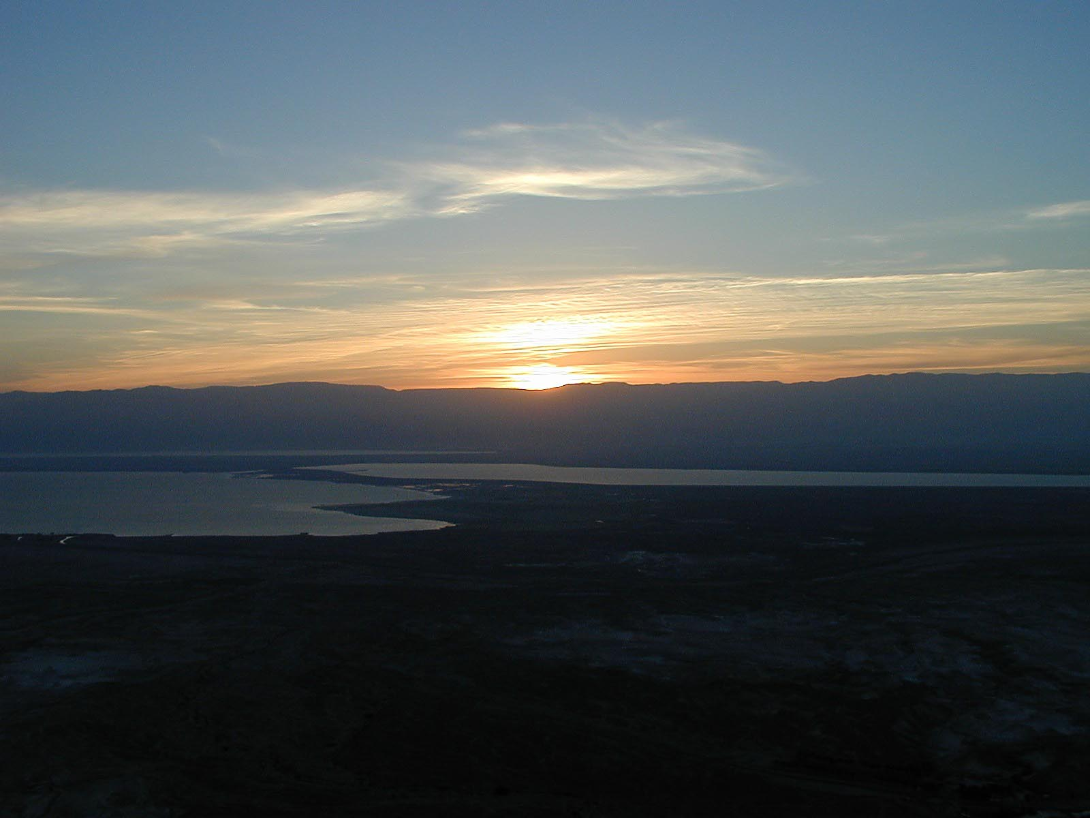

Figure 17.1: Masada sunrise over Dead Sea. Courtesy of the [Pictorial Library of Bible Lands](https://www.bibleplaces.com)

## 17.1 Review of the Conjunction Vav

* Usually spelled **וְ**\*
  + Spelled **וּ**\* before פ, מ, ב, or Sheva I* Rule of Sheva can create **וִי** *or the “hateph copy-cat”,****וַעֲ***

## 17.2 Perfect + וְ: Spelling

* Always first letter
* Accent shift to ultima in 2ms and 1cs

|  |  |  |
| --- | --- | --- |
|  | QP | + ו |
| 3ms | קָטַל | וְקָטַל |
| 1cs | קָטַ֫לְתִּי | וְקָטַלְתִּ֫י |
| 3cp | קָטְלוּ | וְקָטְ֫לוּ |

## 17.3 Perfect + וְ: Translating

* Parsing code: Pwc (Perfect Waw Consecutive)
* Often used for the next event in a future narrative
* Usually translated as IMPERFECT
  + Future: And I will study
  + Modal: And I would/could/should study
  + Imperfective: Amd I am/was/will be studying
* After an imperative, usually translate as another imperative:
  + Go and study!
* Can be translated as the normal perfect (past tense)
  + Parsing code in this case would be the perfect code “+ ו”, as in QP3ms + ו
  + The accent MAY be a clue
    - **וְשָׁמַרְתִּ֫י**\* = QPwc1cs - and I will guarded
    - **וְשָׁמַ֫רְתִּי**\* = QP1cs + ו - and I guarded
  + Context is a better guide

## 17.4 Imperfect + וְ: Spelling

* Always first letter
* Usually spelled וְ
  + On the Perfect, there is no difference between the spelling of the Conjunction and the Waw Consecutive - both are, וְ
  + On the Imperfect, the CONJUNCTION is spelled, וְ
  + The Imperfect Waw CONSECUTIVE is spelled, וַיִּ

|  |  |  |
| --- | --- | --- |
|  | QI | + ו |
| 3ms | יִקְטֹל | וְיִקְטֹל |
| 1cs | אֶקְטֹל | וְאֶקְטֹל |
| 3cp | יִקְטְלוּ | וְיִקְטְלוּ |

## 17.5 Imperfect with Vav often indicates purpose

* Instead of “and”, translate, “so that…may”
  + “Shall I go call a Hebrew nurse SO THAT she MAY nurse the child for you?” (Ex 2:7)
  + “Let’s make a tower…SO THAT we MAY make a name for ourselves.” (Gen 11:4)
* Regular imperfect translations are possible (same as Pwc)

## 17.6 Imperfect Waw Consecutive: Spelling (Strong)

* Vav + Patach + Dagesh Forte
  + Similar to the independent preposition with the definite article
* In the 1cs form, the Aleph preformative rejects the Dagesh, resulting in Compensatory Lengthening

|  |  |  |
| --- | --- | --- |
|  | QI | QIwc |
| 3ms | יִקְטֹל | וַיִּקְטֹל |
| 1cs | אֶקְטֹל | וָאֶקְטֹל |
| 3cp | יִקְטְלוּ | וַיִּקְטְלוּ |

## 17.7 Imperfect Waw Consecutive: Spelling (Weak)

* 3ה verbs drop the suffix
* Biconsonantal verbs change
* Some other verbs change stem vowel to Seghol

|  |  |  |
| --- | --- | --- |
| 3ms | QI | QIwc |
| 3ה | יִבְנֶה | וַיִּבֶן |
| Bicons | יָקוּם | וַיָּקָם |
| Seghol | יֹאמַר | וַיֹּ֫אמֶר |

## 17.8 Imperfect Waw Consecutive: Translation

### Usually translate Iwc as PAST TENSE

* Often used for the next event in a past-time narrative
* Uses the opposite form from what we might expect:
  + Iwc in a PAST narrative
  + Pwc in a FUTURE narrative
* He did X (the first verb will be P), and then he did Y (next verb is Iwc), and then he did Z (Iwc)
* He will do X (first verb is I), then he will do Y (next verb is Pwc)

## 17.9 Summary

* Iwc is most common **וַיִּקְטֹל**\*
* Pwc is next **וְקָטֹל**\*
* P+ו and I+ו are relatively uncommon

## Word Warm-up

[Click to open Word Warm-up video in a new tab](https://youtu.be/_usEc7vYIXI)

## Verses Warm-up

[Click to open Verses Warm-up video in a new tab](https://youtu.be/mfNf7nNcRPA)

## Worksheets: Qal Vav-Consecutive Paradigms

[Qal Vav-consecutive Paradigms](17_qal_waw-consecutive_paradigms.pdf)

## Ruth Pursuit

YOUR QUEST

1. Identify and translate the Qal Vav Consecutive Verbs below from verses 1-5. Be sure to look up any unfamiliar words.
   * היה QIwc3ms x2
   * הלך QIwc3ms
   * בוא QIwc3mp
   * היה QIwc3mp
   * מות QIwc3ms
   * נשׂא QIwc3mp
   * ישׁב QIwc3mp
   * מות QIwc3mp
2. Identify, parse, and translate all remaining Qal Vav Consecutive verbs in verses 6-22.
   * There is one QPwc and the rest are QIwc.
   * As needed, break down the preformatives and sufformatives to identify the lexical form in order to look up its meaning.
   * For completeness, we will note the instances of וַתֹּאמֶר in gray on the answer key.

* [Blank copy of Ruth 1](https://drive.google.com/file/d/1qcfTKAlTJGChC2eYCMhSbY2w-ibzCcDV/view?usp=sharing)
* [Ruth Pursuit Answer Key #17](./images/17_Ruth_Pursuit_KEY.pdf)

## Hebrew Quest Study Passage: Genesis 1:1-5

[Blank copy of Genesis 1:1-5](https://docs.google.com/document/d/1FIQAtWfWlrWmzX5pKR6esRLzJKFdv5Szx3mb5_zWwLg/edit?usp=sharing)

1. Read through the passage straight through
2. Now re-read the passage critically, highlighting ([lexicon here](https://holylanguage.com/resources-dictionaries.php) and translating (you will need to parse verbs to translate) 3.[Watch Izzy’s *Hebrew Quest* video (video opens in a new tab)](https://holylanguage.com/genesis-1.php)
3. After the video, assess your translation. How close was it?
4. How did the Ruach HaQodesh speak to you through the passage?

Optionally, you may complete the passage memorization in Memrise [here](https://app.memrise.com/course/5406435/hebrew-quest-lessons-1-to-40/17/garden/learn/?source_element=level_details_session&source_screen=level_details).

## X Quest Quiz

Open Quest Quiz #xx in a new window

## X Claim your next Twelve Tribes Badge!

Check to be sure you have have completed **all activities** through this lesson, then fill out the form below.

Check to be sure you have completed all ACTIVities here, complete the certification below, and your badge will be on its way!

# 18 Qal Imperative

Lesson 18 marks the start of the second semester of a traditional first year Hebrew Course. In other words, congratulations! You are halfway through the course!

Many students believe the second half of the course is easier than the first half. Likely this is because, the foundational work is behind us and reading the Bible, while not yet fluid, is definitely becoming more enjoyable.

We have covered the two major uses of the Qal stem: the Perfect and Imperfect (including the Waw-Consecutive). For the remainder of Unit 3 we will round out our study of Qal Verbs with the Volitional forms (Lesson 18), the Infinitive forms (Lessons 20 and 21), and the Participle forms (Lesson 22).

Keep going!

**LESSON ITINERARY**

1. 2nd Person Imperative
2. 1st Person Cohortative
3. 3rd Person Jussive
4. Negative Commands do not use the Imperative
5. Complications

**EQUIPMENT CHECK**

Before continuing, can you describe the following concepts?

* The Qal Imperfect Strong form
* The Rule of Sheva

## First Thought

### וְעַתָּ֣ה יִשְׂרָאֵ֗ל שְׁמַ֤ע אֶל־הַֽחֻקִּים֙ וְאֶל־הַמִּשְׁפָּטִ֔ים אֲשֶׁ֧ר אָֽנֹכִ֛י מְלַמֵּ֥ד אֶתְכֶ֖ם לַעֲשׂ֑וֹת

*Now, O Israel, listen to the statutes and the judgments which I am teaching you to perform (Deuteronomy 4:1)*

The *Hebrew Quest* Study Passage for this lesson is the Shema, from Deuteronomy 6. Yeshua quoted it as the “greatest commandment.” The Shema reminds us that we study Hebrew so that we may draw closer to Him and love Him with all that we are.

Listen to the verse in Hebrew:

Your browser does not support the audio element.

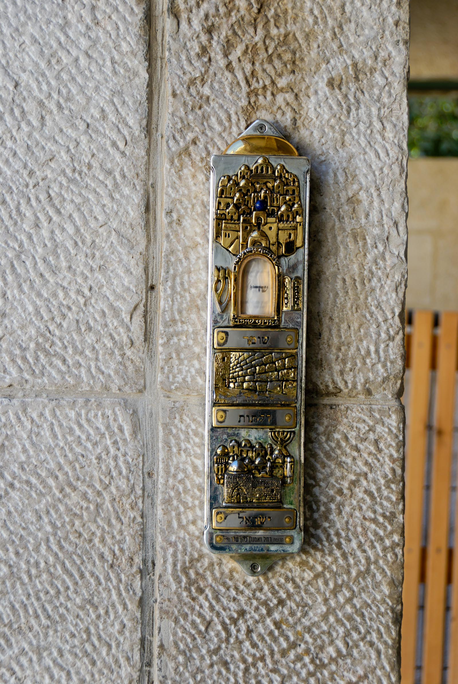

Figure 18.1: Mezuzah near Western Wall. Inside a Mezuzah is a small section of scripture, frequently Deuteronomy 6. Courtesy of the [Pictorial Library of Bible Lands](https://www.bibleplaces.com)

## 18.1 Volitional Forms Introduction

* Volitional conjugations express someone’s will (their volition)
  + Command or permission
  + Wish or desire
  + Purpose
  + Occasionally, used to indicate a result (even if the result was not intended)
* The most common volitional form is the Imperative (Parsing code: M)
  + “Study!”
  + 2nd person
* The Jussive (J) is the 3rd person volitional form
  + “May he study” or “she should study”
  + 2nd person jussives exists
* The Cohortative (C) is the 1st person volitional form
  + “Let us study”
  + “I shall run!”

## 18.2 Negative Commands use the Jussive or the Imperfect

* Negative commands never use the imperative
* לֹא + imperfect
  + Absolute, permanent, blanket prohibition
  + You shall not murder (Ex 20:13)
* אַל + jussive or cohortative
  + Immediate, circumstance-specific prohibition
  + “Do not listen to your prophets!” (Jer 27:9)
  + In this context, Jeremiah is prohibiting the people from listening to FALSE, misguided prophets, not a blanket prohibition of ANY and ALL prophets
  + 2nd person jussives are used for negative commands

## 18.3 The Imperative is the Imperfect withoug the Imperfect Preformative

* Apply Rule of Sheva to 2fs and 2mp

|  |  |  |
| --- | --- | --- |
|  | QI | QM |
| 2ms | תִּקְטֹל | קְטֹל |
| 2fs | תִּקְטְלִי | קִטְלִי |
| 2mp | תִּקְטְלוּ | קִטְלוּ |
| 2fp | תִּקְטֹ֫לְנָה | קְטֹ֫לְנָה |

* Rule of Sheva - 2mp is NOT קְטְלוּ, BUT קִטְלוּ

## 18.4 Identifying QM

1. Lacks I preformative
2. Retains I sufformative (or no sufformative)
3. $V_{1}$ IS or WAS reduced
   * Rule of Sheva in 2fs/2mp
4. Imperfect $V_{S}$

## 18.5 נָה can follow volitional verbs

* נָה may be independent or joined by maqqef
* Scholars debate what this means, or whether it means anything
* “Please” or “now” have been suggested
* May leave it untranslated depending on the context

נָה only follows volitional verbs. This helps with parsing.

## 18.6 Distinguishing QM2ms, QI3ms, and QP3ms

|  |  |  |  |
| --- | --- | --- | --- |
|  | QI3ms | QM2ms | QP3ms |
| Spell | תִּקְטֹל | קְטֹל | קָטַל |
| $V_{1}$ | ְ | ְ | ָ |
| $V_{2}$ | ֹ | ֹ | ַ |

## 18.7 Paragogic ה

* Paragogic ה on M2ms 311x[69].
  + קְטֹל or קָטְלָה (Qamets Hatuf) - QM2ms with paragogic ה OR pronominal suffix (Lesson 19) prefers Qamets Hatuf
  + NEVER directional ה on verbs

## 18.8 3ה Verbs

3rd ה verbs undergo the usual changes we have been studying. Now, we are adding a new (vowel) + ה ending for the Imperative:

* No sufformative = Add ה vowel letter
  + Perfect - ה ָ
  + Imperfect - ה ֶ
  + Imperative - ה ֵ
* If sufformative starts with vowel, use that for $V_{2}$
* If sufformative starts with consonant, add Yod vowel letter
  + Perfect - י ִ
  + Imperfect/Imperative - י ֶ

## 18.9 1נ and 1י

* 1י drops in the QM
* 1נ *sometimes* drops in the QM
  + For example, נסע, נתן do; נפל does not
* These have the Imperfect $V_{S}$, unless it has reduced

|  |  |  |  |
| --- | --- | --- | --- |
|  | QI2ms | QM2ms | QM2mp |
| ישׁב | תֵּשֵׁב | שֵׁב | שְׁבוּ |
| ירשׁ | תִּירַשׁ | רַשׁ | רְשׁוּ |
| נסע | תִּסַּע | סַע | סְאוּ |
| נתן | תִּתֵּן | תֵּן | תְּנוּ |
| נפה | תִּפֹּל | נְפֹל | נִפְלוּ |

## 18.10 Biconsonantal and Geminate

* Like 1נ and 1י above, if missing $R_{1}$ or $R_{2}$, keep Imperfect $V_{S}$ instead of reducing $V_{1}$

|  |  |  |
| --- | --- | --- |
| Verb | QI2ms | QM2ms |
| קוֹם | תָּקוֹם | קוֹם |
| שִׁים | תָּשִׁים | שִׁים |
| בוֹא | תָּבוֹא | בּוֹא |
| סבב | תָּסֹב | סֹב |
| תמם | תֵּתַם | תַּם |

## 18.11 QP3ms and QP2ms

* These are going to be more challenging
* QP doesn’t drop $R_{1}$ when weak, whereas QI/QM do

|  |  |  |
| --- | --- | --- |
| Type | QP3ms | QM2ms |
| Strong | קָטַל | קְטֹל |
| 1י | יָשַׁב | שֵׁב |
| 1נ | נָסע | סַע |
| 3ה | בָּנָה | בְּנֵה |
| Bicons. | קָם | קוּם |

## 18.12 QP3mp and QP2mp

|  |  |  |
| --- | --- | --- |
| Type | QP3mp | QM2mp |
| Strong | קָטְלוּ | קִטְלוּ |
| 1י | יָשְׁבוּ | שְׁבוּ |
| 1נ | נָסְעוּ | סְעוּ |
| 3ה | בָּנוּ | בְּנוּ |
| Bicons. | קָ֫מ | ק֫וּמוּ |

## 18.13 Cohortative and Jussive

* These are more nuanced conjugations
* They are usually spelled exactly like the imperfect
* If context suggests volitional and it’s the first word in its clause then parse as Cohortative (C) if 1st person, or Jussive (J) if 3rd (or sometimes 2nd) person
* The Cohortative usually (but not always) ends in **ה ָ**\*
  + **אֶקְטְלָה**\* = QC1cs

## 18.14 Some weak verbs often shorten the Jussive singular

|  |  |  |  |
| --- | --- | --- | --- |
| Type | QI3ms | QJ3ms | Translation |
| 3ה | יִבְנֶה | יִבֶן | Let him build |
| Bicons. | יָשִֹים | יָשֵֹׁם | Let him put |
| Bicons. | יָשׁוּב | יָשֹׁב | Let him return |

## Word Warm-up

[Click to open Word Warm-up video in a new tab](https://youtu.be/Ycsb8GLkFRA)

## Verses Warm-up

[Click to open Verses Warm-up video in a new tab](https://youtu.be/3mMX0zLi0cU)

## Worksheets: Qal Volitional Forms

Qal Volitional Forms

[Name of worksheet](18_qal_volitive_paradigm.pdf)

## Ruth Pursuit

YOUR QUEST

1. Identify, parse, and translate eight Qal Imperatives
2. Identify, parse, and translate the one 3rd person Jussive
3. Identify, parse, and translate the two negated commands

* [Blank copy of Ruth 1](https://drive.google.com/file/d/1qcfTKAlTJGChC2eYCMhSbY2w-ibzCcDV/view?usp=sharing)
* [Ruth Pursuit Answer Key #18](./images/18_Ruth_Pursuit_KEY.pdf)

## Hebrew Quest Study Passage: The Shema

[Blank copy of The Shema](https://docs.google.com/document/d/1YOCp_Jm-FlLlRlTNHJN1hjNPb0Yh_7xzWDQQFqZ8-6w/edit?usp=sharing)

1. Read through the passage straight through
2. Now re-read the passage critically, highlighting ([lexicon here](https://holylanguage.com/resources-dictionaries.php) and translating (you will need to parse verbs to translate) 3.[Watch Izzy’s *Hebrew Quest* video (video opens in a new tab)](https://holylanguage.com/deuteronomy-6.php)
3. After the video, assess your translation. How close was it?
4. How did the Ruach HaQodesh speak to you through the passage?

Optionally, you may complete the passage memorization in Memrise [here](https://app.memrise.com/course/5406435/hebrew-quest-lessons-1-to-40/28/garden/learn/?source_element=level_details_session&source_screen=level_details).

## X Quest Quiz

Open Quest Quiz #xx in a new window

## X Claim your next Twelve Tribes Badge!

Check to be sure you have have completed all activities through this lesson, then fill out the form below.

Check to be sure you have completed all ACTIVities here, complete the certification below, and your badge will be on its way!

# 19 Pronominal Suffixes on Verbs

There is good news and bad news with pronominal suffixes. The good news is that, in almost every case, you already know the suffixes and how they are used. These are the same ones from Lesson 9. In fact, Verbs ONLY use the “Type 1” suffixes.

The more challenging aspects can include significant spelling and accent changes, which result in a few forms that are identical. For these we can only depend on context to help us translate correctly.

One of the first vocabulary words in *Hebrew Quest* was **וּכְתַטְתָּם**\*. We mentioned in Lesson 17 how this word has the Vav Consecutive (AND you will write them). It also has a 3mp pronominal suffix (and you will write THEM).

**LESSON ITINERARY**

1. learning_objective_1
2. learning_objective_2
3. learning_objective_3
4. learning_objective_4
5. learning_objective_5
6. learning_objective_6
7. learning_objective_7

**EQUIPMENT CHECK**

Before continuing, can you describe the following concepts?

## X First Thought

### X אֲנִֽי־קְרָאתִ֣יךָ כִֽי־תַעֲנֵ֣נִי אֵ֑ל הַֽט־אָזְנְךָ֥ לִ֝֗י שְׁמַ֣ע אִמְרָתִֽי׃

*I have called upon You, for You will answer me, O God; Incline Your ear to me, hear my speech. (Psalms 17:6)*

Imagine walking along a path like the one below on a day Yeshua taught in this very area. What would you be thinking and feeling?

* Would you be giddy, as if if you got special access to a famous entertainer or dignitary? Would you try to get His autograph or a selfie with Him?
* Would you be skeptical, wondering whether this Yeshua you have heard about is really “all that”? In the back of your mind, would you even be questioning whether He is a fraud?
* Would He be just another voice with a platform like all the people with thousands of followers on YouTube today?
* Or, would you know there is something special about Him? Would you have realized that Yeshua is God, come to bridge the divide between you and the Father?

Be honest.

Meditate on that as you work through this lesson and, especially, as you study the “Avinu” in the *Hebrew Quest* Study Passage.

Listen to the verse in Hebrew:

Your browser does not support the audio element.

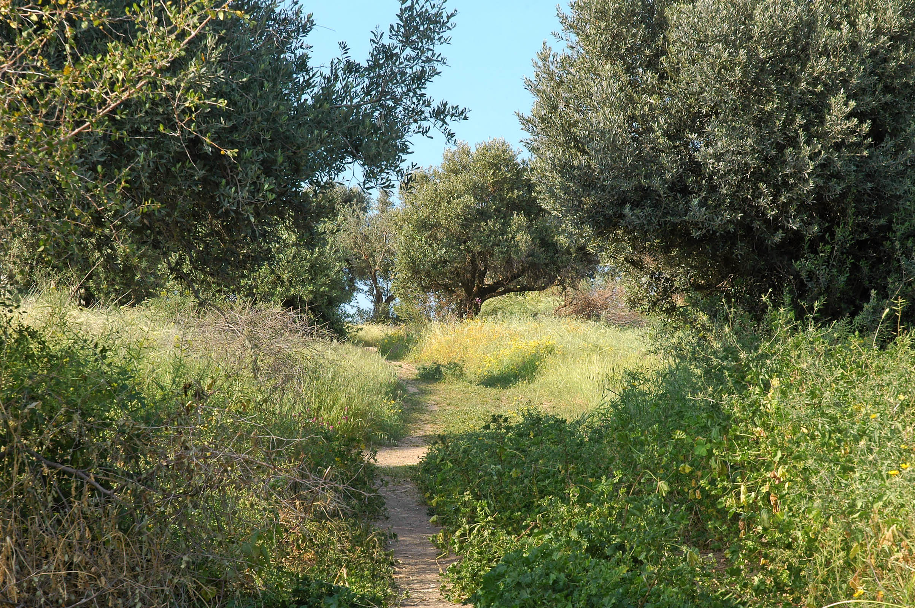

Figure 19.1: Mount of Beatitudes path through olive grove - suggested location of Yeshua’s teachings we call ‘the Sermon on the Mount’ (Matthew 5-7). Courtesy of the [Pictorial Library of Bible Lands](https://www.bibleplaces.com)



## 19.1 Hebrew Direct Object Pronouns

* We learned in Lesson 9 that Hebrew has a Definite Direct Object marker **אֵת**\* that takes pronominal suffixes
  + For example, **אֹתִי**\* is “me” and **אֹתְךָ**\* is “you (ms)”
* Hebrew also attaches pronominal suffixes to verbs
  + **אֲכָלוֹ**\* - “he ate IT”

## 19.2 Verbs use Type 1 Suffixes

* This is good news as you will be able to recognize the suffix immediately (provided you have memorized them from Lesson 9!).
* The 1cp pronominal suffix is **נוּ**\*, which is the same as the P1cp sufformative
  + The preceding vowel can help in most cases:
    - If sheva, it’s P1cp
    - If vowel, then pronominal suffix

## 19.3 QP Vowel Changes

* Accent shifts to sufformative
* $V_{1}$ reduces
* $V_{S}$ is LONG in the 3rd person (usually reduces in 3cp)
* 2fs and 1cs are identical
* QP2fp - [70]

|  |  |  |
| --- | --- | --- |
|  | QP | QP + Pron. |
| 3ms | קָטַל | קְטָל |
| 3fs | קָטְלָה | קְטָלַ֫ת |
| 2ms | קָטַ֫לְתָּ | קְטַלְתּ֫ |
| 2fs | קָטַלְתְּ | קְטַלְתִּ֫י |
| 1cs | קָטַ֫לְתִּי | קְטַלְתִּ֫י |
| 3cp | קָטְלוּ | קְטָל֫וּ |
| 2mp | קְטַלְתֶּם | קְטַלְתּ֫וּ |
| 1cp | קָטַ֫לְנוּ | קְטַלְנ֫וּ |

## 19.4 QI Vowel Changes

* Imperfect $V_{S}$ reduces before a pronominal suffix, unless:
  + If $V_{S}$ is Patach, THEN it lengthens to Qamets
* QI3fp/QM2fp - $∄$

|  |  |  |
| --- | --- | --- |
|  | QI | QI + Pron. |
| 3ms | יִקְטֹל | יִקְטְל |
| 3fs | תִּקְטֹל | תִּקְטְל |
| 2ms | תִּקְטֹל | תִּקְטְל |
| 2fs | תִּקְטְלִי | תִּקְטְלִי |
| 1cs | אֶקְטֹל | אֶקְטְל |
| 3mp | יִקְטְלוּ | יִקְטְלוּ |
| 2mp | תִּקְטְלוּ | תִּקְטְלוּ |
| 1cp | נִקְטֹל | נִקְטְל |

## 19.5 QM Vowel Changes

* QM2ms is Qamets Hatuf + Silent Sheva
* QM2fs/QM2fp - $∄$

|  |  |  |
| --- | --- | --- |
|  | QM | QM + Pron. |
| 2ms | קְטֹל | קָטְל |
| 2mp | קִטְוּ | קִטְלוּ or קִטְלֻ |

## 19.6 Imperative/Perfect Ambiguity when normal Imperative $V_{S}=A$

* With a pronominal suffix, Imperative $V_{S}$ lengthens to Qamets instead of reducing
  + Stative, 2G, and 3G verbs do this
* QM2ms+suffix looks like QP3ms+suffix
* QM2mp+suffix looks like QP3cp+suffix
* Context will determine whether the verb is directed TO someone (2nd person) or is ABOUT someone (3rd)

|  |  |  |
| --- | --- | --- |
| QP/suf | QM/Suf $V_{S}=A$ | QM/Suf $V_{S}=O$ |
| קְטָל | קְטָל | קָטְל |
| יְטָלוּ | יְטָלוּ | קִטְלוּ or קִטְלֻ |

## 19.7 X Verb Stem Table

## 19.8 X Meanings

## 19.9 X Strong Word-initial Combinations

## 19.10 X Strong Stem Vowels

## 19.11 X : what to memorize

## 19.12 X Perfect Strong

|  |  |  |  |
| --- | --- | --- | --- |
| Sing | Paradigm | Plural | Paradigm |
| 3ms | ***** | 3cp | ***** |
| 3fs | ***** |  |  |
| 2ms | ***** | 2mp | ***** |
| 2fs | ***** | 2fp | ***** |
| 1cs | ***** | 1cp | ***** |

X Perfect Strong from *Hebrew Quest* Chapter 15

Your browser does not support the audio element.

## 19.13 X Imperfect Strong

|  |  |  |  |
| --- | --- | --- | --- |
| Sing | Paradigm | Plural | Paradigm |
| 3ms | ***** | 3mp | ***** |
| 3fs | ***** | 3fp | ***** |
| 2ms | ***** | 2mp | ***** |
| 2fs | ***** | 2fp | ***** |
| 1cs | ***** | 1cp | ***** |

X Imperfect Strong from *Hebrew Quest* Chapter 15

Your browser does not support the audio element.

## 19.14 X Imperative Strong

|  |  |  |  |
| --- | --- | --- | --- |
| Sing | Paradigm | Plural | Paradigm |
| 2ms | ***** | 2mp | ***** |
| 2fs | ***** | 2fp | ***** |

## 19.15 X Infinitives Strong

|  |  |
| --- | --- |
| Type | Paradigm |
| ∞ | ***** |
| A | ***** |

## 19.16 X Participle Strong

|  |  |  |  |
| --- | --- | --- | --- |
| Sing | Paradigm | Plural | Paradigm |
| ms | ***** | mp | ***** |
| fs | ***** | fp | ***** |

## 19.17 X Parsing Examples

* Word:

$WI=$

$Sufformative=$

$Root=$

$V_{S}=$
  + *****
  + Result:
* Word:

$WI=$

$Sufformative=$

$Root=$

$V_{S}=$
  + *****
  + Result:
* Word:

$WI=$

$Sufformative=$

$Root=$

$V_{S}=$
  + *****
  + Result:

## Word Warm-up

[Click to open Word Warm-up video in a new tab](https://youtu.be/VnY-EzVTywk)

## Verses Warm-up

[Click to open Verses Warm-up video in a new tab](https://youtu.be/tY9vx7ZRSwQ)

## Ruth Pursuit

Most verbal pronominal suffixes in Ruth 1 are on Qal Infinitive Construct conjugations. We will study these in lesson 20. Therefore, there is is no Ruth Pursuit for lesson 19.

## Hebrew Quest Study Passage: Matthew 6

[Blank copy of Matthew 6](https://docs.google.com/document/d/1ICe0FEaE8wRBuKGR4q34drqfEIxQDG_9NRwa-n3Wgd8/edit?usp=sharing)

1. Read through the passage straight through
2. Now re-read the passage critically, highlighting ([lexicon here](https://holylanguage.com/resources-dictionaries.php) and translating (you will need to parse verbs to translate) 3.[Watch Izzy’s *Hebrew Quest* video (video opens in a new tab)](https://holylanguage.com/matthew-6.php)
3. After the video, assess your translation. How close was it?
4. How did the Ruach HaQodesh speak to you through the passage?

Optionally, you may complete the passage memorization in Memrise [here](https://app.memrise.com/course/5406435/hebrew-quest-lessons-1-to-40/28/garden/learn/?source_element=level_details_session&source_screen=level_details).

## X Quest Quiz

Open Quest Quiz #xx in a new window

## X Claim your next Twelve Tribes Badge!

Check to be sure you have have completed **all activities** through this lesson, then fill out the form below.

Check to be sure you have completed all ACTIVities here, complete the certification below, and your badge will be on its way!

# 20 Qal Infinitive Construct

Infinitive constructs are verbal nouns.

There is a unique aspect that makes identifying and parsing the ∞[71] super easy (but you’ll have to read on!)

**LESSON ITINERARY**

1. Spelling of the Infinitive Construct
2. Translating the Infinitive Construct
3. Negating the Infinitive Construct

## First Thought

### וְשָׁ֣מַרְתָּ֔ אֶת־מִצְוֺ֖ת יְהוָ֣ה אֱלֹהֶ֑יךָ לָלֶ֥כֶת בִּדְרָכָ֖יו וּלְיִרְאָ֥ה אֹתֽוֹ׃

*Therefore, you shall keep the commandments of Adonai your God, to walk in His ways and to fear Him. (Deuteronomy 8:6)*

It is easy to follow Adoni’s commandments when they align with our desires. When they do not align is when we face a more difficult decision: to follow in HIS ways or to continue in OUR ways. In our Study Passage for this lesson, we will read the story of when Adonai commanded Abraham to sacrifice Isaac. This passage is as beautiful as it is troubling. How could Adonai ask such a thing? How could Abraham willing obey so easily? What is Adonai trying to teach us? What would I do if God asked a difficult task of me?

Ponder these things as you work through this Lesson and the study passage.

Listen to the verse in Hebrew:

Your browser does not support the audio element.



Figure 20.1: Western Wall plaza and Dome of the Rock with snow. The Temple Mount, specifically the rock enshrined by Islam’s Dome of the Rock, is the traditional location of Abraham’s near-sacrifice of Isaac described in Genesis 22. Courtesy of the [Pictorial Library of Bible Lands](https://www.bibleplaces.com)

## 20.1 Two types of Infinitives

* Infinitive Construct - Parsing Code: ∞
* Infinitive Absolute (Lesson 21) - Parsing Code: A
* The Infinitives do NOT inflect for person, number, or gender
* Parsing is straightforward - Stem + Conjugation
  + Q∞
  + QA (Lesson 21)
* Prefixes
  + The ∞ can also take prepositional prefixes (which we will discuss a little bit later) or pronominal suffix
  + The A NEVER takes a prefix or suffix

## 20.2 Q∞ Spelling

* For most verbs: **קְתֹל**\*
  + 1G reduces as expected: **אֱמֹר**\*
  + 3ח/ע can take a furtive patach, which is ignored when parsing: **שְׁלֹחַ**\*

“uh-oh” is the sound a Q∞ (or QM2ms) strong verb makes

## 20.3 3ה Endings

* As expected, when a 3ה verb has no sufformative, a vowel is added
* For the ∞, this ending is **וֹת**\*
  + The **וֹת**\* remains when a pronominal suffix is added
  + Note: in this use, **וֹת**\* is not the FP ending - it would be incorrect to say “Q∞fp.” ∞ verbs are never inflected for person, gender, or number.

|  |  |
| --- | --- |
|  | Hebrew |
| P | בָּנָה |
| I | יִבְנֶה |
| M | בְּנֵה |
| ∞ | בְּנוֹת |

Memorize the 3ה endings as they will make parsing easier

::: {.box .caution} * **ּבָנוֹת**\* is spelled with a Qamets and means “daughters” * בְּנוֹת is reduced and means “to build, building”

## 20.4 1י and 1נ Spelling

* Usually, but not always, drop the 1-yod/nun
* When dropped, add a final **ת**\*, and change the vowels so that it looks like a Segholate noun
* **הלך**\* as always thinks it’s a 1-yod

|  |  |  |
| --- | --- | --- |
| Root | Keep | Drop |
| נסע | נְסֹעַ | סַ֫עַת |
| נגע | נְגֹת | גַּ֫עַת |
| נתן | נְתֹן | תֵּת |
| הלך | $∄$ | לֶ֫כֶת |

**נתנ**\* is tricky *and common*

Memorize **תֵּת**\* as Q∞ of נתן

## 20.5 Biconsonantal

* An easy one, as long as you’ve memorized your vocab!
* The Q∞ of biconsonantal verbs is simply the lexical form
  + **שׁוּב**\*
  + **מוּת**\*
  + **בּוֹא**\*
  + **בּוֹשׁ**\*
  + **דִּין**\*
  + **בִּין**\*

## 20.6 Q∞ often is identical to QM2ms

* As one is finite and the other is non-finite, the context should be obvious as to whether one person is giving a command to another person
* Some verbs that lose the Imperfect $V_{S}=O$ in the QM, RETAIN $V_{S}=O$ in the Q∞
* 3ה verbs have different word-final ה vowels as mentioned previously

## 20.7 ∞ take Type 1 Pronominal Suffixes

* Q∞ and QM2ms with pronominal suffix are usually the same
* Both shift vowels with $V_{1} =$ Qamets Hatuf if pronominal suffix
* Nun-type suffixes ONLY occur with imperfects and imperatives

|  |  |
| --- | --- |
| No suffix | With Suffix |
| קְטֹל | קָטְל |

|  |  |
| --- | --- |
| Suffix PGN | With Suffix |
| 3ms | קָטְלוֹ |
| 1cs | קָטְלִי |
| 3mp | קָטְלָם |
| 1cp | קָתְלֵ֫נוּ |

When affixed to an ∞ verb, the suffix can be the SUBJECT as well as the object.

## 20.8 Most ∞ have a prefixed preposition

* There are 6595 ∞ in the Bible
  + Only 896 do not have a prefixed preposition
  + 68% have **ל**\*

Since only ∞ and Participle can have a prefixed preposition, identifying and parsing the ∞ is usually easy!

## 20.9 Meaning of ∞

* Often used as a verbal noun - “to hear” or “hearing”
  + In English, “to hear”, “to speak”, or “to be” are examples of “infinitive” verbs.
* ∞ plus prefix **ל**\*
  + Try “to x” or “by xing”
  + Sometimes indicates purpose or result: IN ORDER TO SEE the nakedness of the land = **לִרְאוֹת**\*
  + Something imminent: The sun was ABOUT TO SET = **לָבוֹא**\*
  + Verbal noun: It is good TO PRAISE Adonai = **לְהֹדוֹת**\*
  + Verbal Noun: Obey BY WALKING in His ways = **לָלֶכֶת**\*
* ∞ plus prefix **ב**\* or **כ**\* is often temporal
  + Often included with **וַיְהִי**\* or **וְהָיָה**\*
  + Past time: WHEN Israel DWELT = **וַיְהִי בִּשְׁכֹּן יִשְֹרָאֵל**\*
  + Future time: WHEN YOU CROSS = **וְהָיָה בְּעָבְרְכֶם**\*

## 20.10 Negating the Infinitive

* The negative particles **אַל** * and **לֹא** * are not used to negate the ∞
* **בִּלְתִּי** * and **לְבִלְתִּי**\* are used
* There is no difference in meaning between the two words, but **לְבִלְתִּי**\* is more frequent
* Not to do all my commandments (Lev 26:15) = **לְבִלְתִּי עֲשׂוֹת אֶת־כָּל־מִצְוֺתַי**\*

## Word Warm-up

[Click to open Word Warm-up video in a new tab](https://youtu.be/wrlzC0OAxoc)

## Verses Warm-up

[Click to open Verses Warm-up video in a new tab](https://youtu.be/9eYgruFN7bM)

## Ruth Pursuit

YOUR QUEST

1. Identify, parse, and translate the eleven Q∞
   * Identify pronominal suffixes in the parsing, when present
   * All but two of these have prepositional prefixes
2. Identify the Lesson 20 vocabulary word that negates an Infinitive (blue)

* [Blank copy of Ruth 1](https://drive.google.com/file/d/1qcfTKAlTJGChC2eYCMhSbY2w-ibzCcDV/view?usp=sharing)
* [Ruth Pursuit Answer Key #20](./images/20_Ruth_Pursuit_KEY.pdf)

## Hebrew Quest Study Passage: Genesis 22:1-19

[Blank copy of Genesis 22:1-19](https://docs.google.com/document/d/1zpIOg9zyDv_qPK9f69QexbIlBhH6wKO74YkPz3xpurI/edit?usp=sharing)

1. Read through the passage straight through
2. Now re-read the passage critically, highlighting ([lexicon here](https://holylanguage.com/resources-dictionaries.php) and translating (you will need to parse verbs to translate) 3.[Watch Izzy’s *Hebrew Quest* video (video opens in a new tab)](https://holylanguage.com/genesis-22.php)
3. After the video, assess your translation. How close was it?
4. How did the Ruach HaQodesh speak to you through the passage?

Optionally, you may complete the passage memorization in Memrise [here](https://app.memrise.com/course/5406435/hebrew-quest-lessons-1-to-40/28/garden/learn/?source_element=level_details_session&source_screen=level_details).

## X Quest Quiz

Open Quest Quiz #xx in a new window

## X Claim your next Twelve Tribes Badge!

Check to be sure you have have completed **all activities** through this lesson, then fill out the form below.

Check to be sure you have completed all ACTIVities here, complete the certification below, and your badge will be on its way!

# 21 Qal Infinitive Absolute

Say something general bridging the desired outcome above with the learning objectives below

**LESSON ITINERARY**

1. Strong and weak verb spelling
2. Meaning
3. Compare Infinitve Construct with Infinitive absolute
4. The articles יֵשׁ and אֵין

**EQUIPMENT CHECK**

Before continuing, can you describe the following concepts?

* The spelling and meaning of Qal Infinitive Construct

## First Thought

### אָנֹכִ֗י אֵרֵ֤ד עִמְּךָ֙ מִצְרַ֔יְמָה וְאָנֹכִ֖י אַֽעַלְךָ֣ גַם־עָלֹ֑ה

*"I will go down with you to Egypt, and I will also surely bring you up again (Genesis 46:4)*

Our *Hebrew Quest* Study Passage for this Lesson is the Pristly Blessing from Numbers 6, which begins, “the LORD bless you and keep you…”. The LORD kept his promises to keep Israel when the nation was in Egypt. This Lesson’s grammar subject is the Infinitive Absolute. This has no direct equivalent in English. In Hebrew, it is often used to emphasize another verb. When this happens, the verb being emphasized will be repeated, but in the Infinitive Absolute form. In, **אַעַלְךָ גַם־עָלֹה**\*, the literal translation might be “I will bring you up again bringing up”, but what it means is “I will SURELY bring you up again,” as if to say, “Don’t worry! I am definitely bringing up out of Egypt. In fact, there is zero chance I will not bring you up!”

This is a great picture of what the LORD means when He says He will “keep” us!

Listen to the verse in Hebrew:

Your browser does not support the audio element.

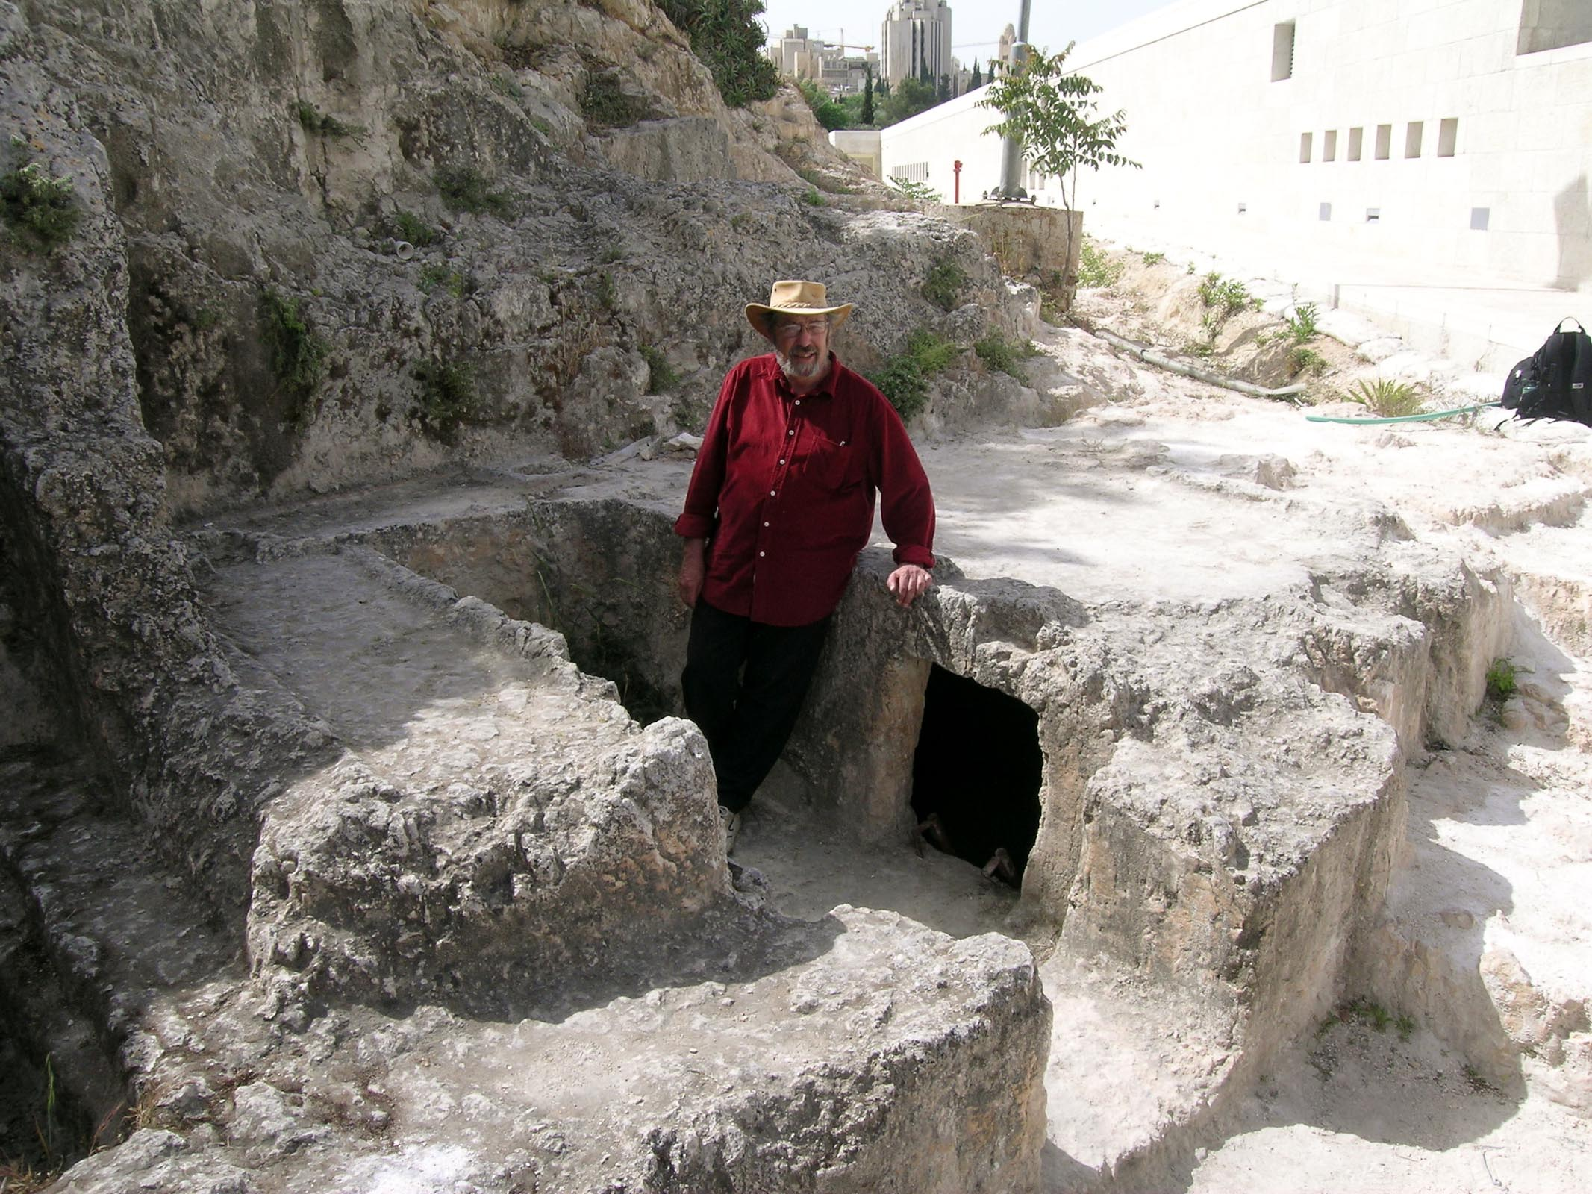

Figure 21.1: Ketef Hinnom with archeologist Gabriel Barkay. In 1979, Barkay’s team found two tiny silver scrolls, inscribed with portions of the Priestly Blessing from Numbers 6 and apparently once used as amulets, in this burial chamber in Jerusalem. They contain what may be the oldest surviving texts from the Hebrew Bible, dating from the First Temple period, making the find one of the most significant Biblical discoveries ever made. Courtesy of the [Pictorial Library of Bible Lands](https://www.bibleplaces.com)

## 21.1 QA

* Spelling
  + Has a distinctive $V_{2}=\hat{O}$ (Holem+Vav)
  + **קָטוֹל**\* or **קָטֹל**\* (defective spelling)
  + If the Q∞ was “uh-oh”, then the QA is “ah-oh”
  + Most weak verbs follow the “ah-oh” pattern
    - 3ע/ח verbs will take a Furtive Patach under $R_{3}$, but this affects pronunciation only (not parsing or translation)
    - 3ה verbs can appear in two forms
      * Holem+Hei = **עָשׂה** *
      * Holem+Vav with no Hei = **עָשׂוֹ**\*
    - Biconsonantal verbs, including I- and U-class typically take the Holem+Vav/Holem $V_{S}$
      * **קוֹם** * or **שׂוֹם**\*
      * O-class look the same in QA/Q∞/QM2ms = **בּוֹא** *
        + Sometimes QA is defective = **בֹּא**\*
    - Geminate verbs retain all three letters with $V_{2}=\hat{O}$- **סָבוֹב**\*
* Parsing (parsing code: A)
  + Never inflects for person, number, or gender
  + Never has a pronominal suffix
  + Never has a prefixed preposition

## 21.2 3ה endings

|  |  |
| --- | --- |
|  | Hebrew |
| P | בָּנָה |
| I | יִבְנֶה |
| M | בְּנֵה |
| ∞ | בְּנוֹת |
| A | בָנֹה or בָנוֹ |

## 21.3 Meaning of Infinitive Absolute

* Emphasize a finite verb from the same root - the Infinitive Absolute form may appear before or after the finite verb
  + In terms of certainty
    - 2 Kings 1:16: **מוֹת תָּמוּת**\* = you will surely die (lit: dying you will die)
    - A mnemonic might be: “there is ABSOLUTE certainty you will die!”
  + In terms of extent
    - Judges 1:28: **וְהוֹרֵישׁ לֹא הוֹרִישׁוֹ**\* = he did not completely drive him out (note these verbs are Hiphil, not Qal, hence no “ah-oh”)
* Substitute for another verb conjugation
  + Often imperative - Deuteronomy 5:12: **שָׁמוֹר אֶת־יוֹם הַשַּׁבָּת**\* = Observe Shabbat!
* Ongoing action, often contemporaneous with another action
  + 2 Sam 15:30: **וְעָלוּ עָלֹה וּבָכֹה**\* = they went up, weeping as they went (lit: they went up, going up and weeping)

## 21.4 Infinitive Construct vs Infinitive Absolute

|  |  |  |
| --- | --- | --- |
|  | ∞ | A |
| PGN | No PGN | No PGN |
| Paradigm | **קְטֹל**\* | **קָטוֹל**\* |
| Sound | uh-oh | ah-oh |
| 1י and 1נ | Drop | Never Drop |
| 3ה | use **וֹת**\* | 3ה use **ה ֹ** * or **וֹ**\* |
| Bicons | use Lexical $V_{S}$ | use **וֹ**\* |
| Pron. suffix | Yes | Never |
| Preposition prefix | Usually | Never |
| Meaning | purpose/result | emphasize certainty |
| English equivalent | Verbal noun “to do” or “doing” | No direct equivalent |

## 21.5 **יֵשׁ** * and **אֵין** *

* These are particles that expresses the existence or non-existence of something or someone
  + Mnemonics:
    - יֵשׁ sounds like “yes” as in “yes there are”
    - אֵין sounds like “ain’t” as in “ain’t nothing or nobody”
* Do not inflect for gender or number
  + אֵין could mean “there is not” or “there are not”
* When prefixed with **לְ**\*, indicates possession or non-possession
  + We saw this way back in the Lesson 3 Study Verses
  + Genesis 44:20 - **יֶשׁ־לָנוּ אָב זָקֵן**\* = we have an elderly father (lit: there is to us a father old)
* Pronominal suffixes occur on יֵשׁ only 9 times, compared with 104 times on אֵין
  + 2 Kings 17:34: **אֵינָם יְרֵאִים**\* = they do not fear

## Word Warm-up

[Click to open Word Warm-up video in a new tab](https://youtu.be/UWb_3JSv-mk)

## Verses Warm-up

[Click to open Verses Warm-up video in a new tab](https://youtu.be/4-EL_lcP2xU)

## Ruth Pursuit

YOUR QUEST

There are no Qal Infinitive Absolutes in Ruth 1 (if you find one, let us know!)

1. Identify the particle affirming the existence of someone or something (yellow)
2. Identify the Lesson 21 vocabulary word for “faminine” (green)
3. A vocabulary verb for this lesson was נוּחַ. Identify the FS noun in Ruth 1 that is derived from this verb. (blue)

* [Blank copy of Ruth 1](https://drive.google.com/file/d/1qcfTKAlTJGChC2eYCMhSbY2w-ibzCcDV/copy)
* [Ruth Pursuit Answer Key #21](./images/21_Ruth_Pursuit_KEY.pdf)

## Hebrew Quest Study Passage: Numbers 6: Priestly Blessing

[Blank copy of Numbers 6](https://docs.google.com/document/d/159LEzKxPYHjxibJ3VZylYLbZ_It9zwYZyAg_iotZIwM/copy)

1. Read through the passage straight through
2. Now re-read the passage critically, highlighting ([lexicon here](https://holylanguage.com/resources-dictionaries.php) and translating (you will need to parse verbs to translate) 3.[Watch Izzy’s *Hebrew Quest* video (video opens in a new tab)](https://holylanguage.com/numbers-6.php)
3. After the video, assess your translation. How close was it?
4. How did the Ruach HaQodesh speak to you through the passage?

Optionally, you may complete the passage memorization in Memrise [here](https://app.memrise.com/course/5406435/hebrew-quest-lessons-1-to-40/28/garden/learn/?source_element=level_details_session&source_screen=level_details).

## X Quest Quiz

Open Quest Quiz #xx in a new window

## X Claim your next Twelve Tribes Badge!

Check to be sure you have have completed **all activities** through this lesson, then fill out the form below.

Check to be sure you have completed all ACTIVities here, complete the certification below, and your badge will be on its way!

# 22 Qal Participle

To comprehend Biblical Hebrew, we must be able to . . .

Say something general bridging the desired outcome above with the learning objectives below

**LESSON ITINERARY**

1. learning_objective_1
2. learning_objective_2
3. learning_objective_3
4. learning_objective_4
5. learning_objective_5
6. learning_objective_6
7. learning_objective_7

**EQUIPMENT CHECK**

Before continuing, can you describe the following concepts?

## First Thought

### וְיִבְטְח֣וּ בְ֭ךָ יוֹדְעֵ֣י שְׁמֶ֑ךָ כִּ֤י לֹֽא־עָזַ֖בְתָּ דֹרְשֶׁ֣יךָ יְהוָֽה׃

*And those who know Your name will put their trust in You, For You, O LORD, have not forsaken those who seek You. (Psalms 9:11)*

Our *Hebrew Quest* study passage for this lesson is Matthew 13 and the parable of the sower. Yeshua clarifies that the “good soil” is someone who hears the word, understands it, and then does something with it. In contrast the soil among the thorns is someone who hears the word but doesn’t fully trust in Adonai or his promises, like the promise not to forsake us in Psalms 9:11.

It’s become a cliche for teachers to ask, “which of the four soils are you?” In truth for most of us, our lives at some point have reflected each of four soils. So the better question to ask might be:

“Today, in the next 1440 minutes, how can I make sure that I am the ‘good soil’, trusting in Adonai, and producing a yield for the Kingdom?”

Listen to the verse in Hebrew:

Your browser does not support the audio element.

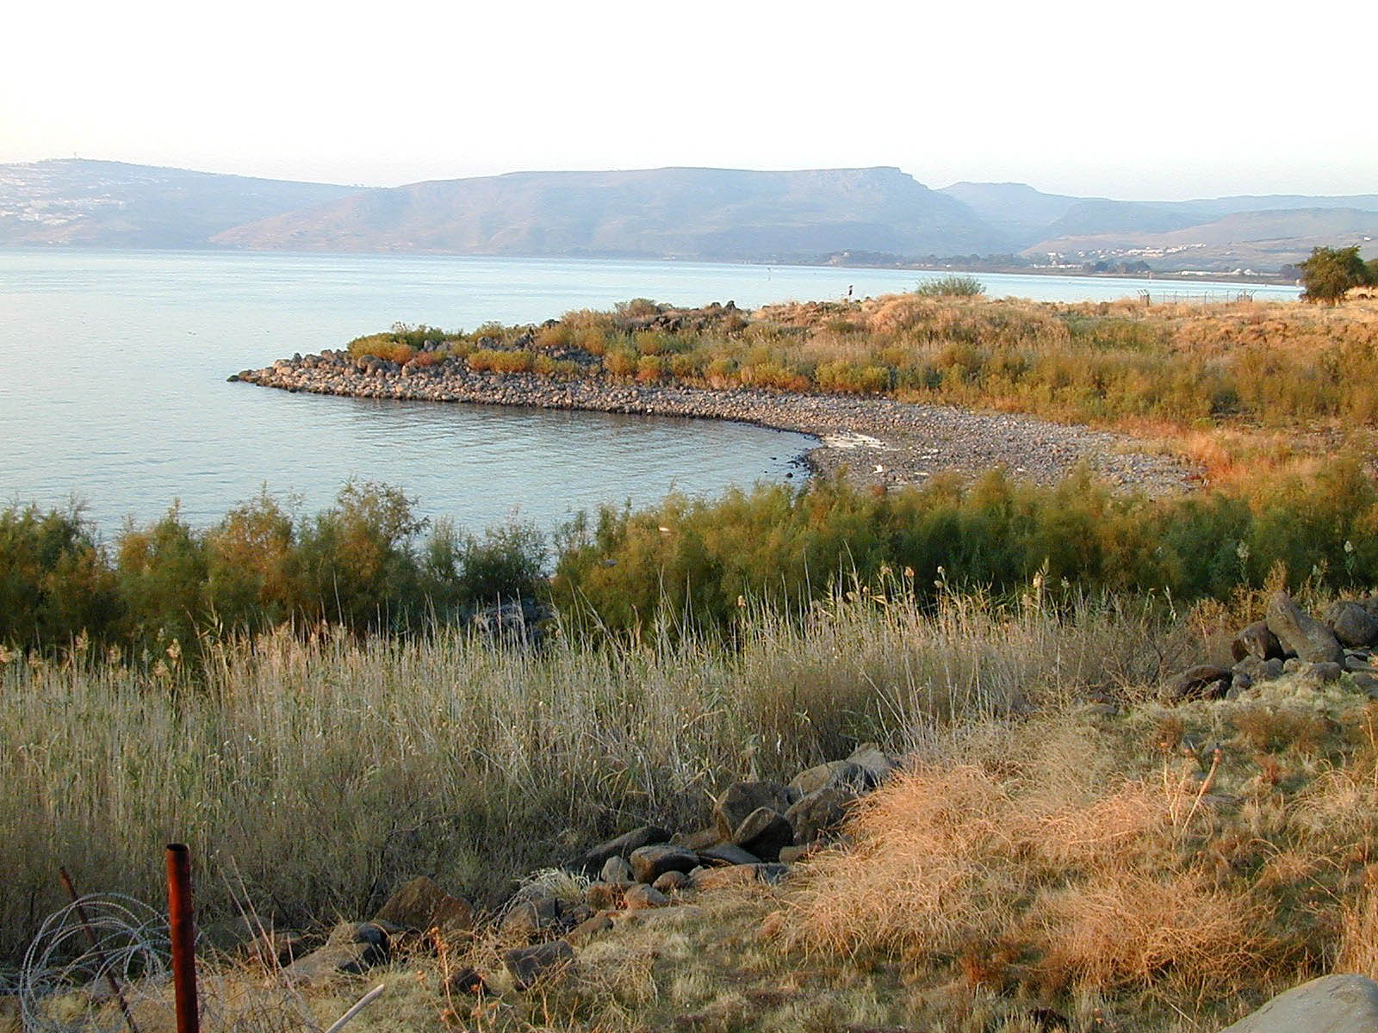

Figure 22.1: Cove of the Sower from east - suggested location of Yeshua’s teaching we call ‘The Parable of the Sower’ (Matthew 13). The acoustic properties of this region have been analyzed, with results indicating a person could be in a boat a few feet from the shore and, using a normal speaking voice, easily be heard by ‘large crowds’ scattered several hundred feet up the embankment. Courtesy of the [Pictorial Library of Bible Lands](https://www.bibleplaces.com)

## 22.1 Participles are Verbal Adjectives

* Participles are non-finite because they do not have 1st, 2nd, or 3rd person
* Since Participles are adjectives, the DO inflect for gender and number
  + They use the same adjectival endings we learned many lessons ago: MS, FS, MP, FP
  + They are used like adjectives
    - attributive: I saw running water
      * Match the noun in gender, number, and definitness
      * Attributive Always After (the noun), Article Always Agrees (with definiteness of noun)
    - predicative: The water is running
      * Matches the subject in gender and number, but not definiteness
      * Predicate dePrived of the Article, Perhaps Precedes (the noun)
    - substantival: running is good exercise
      * Has the gender and number of the noun it is replacing
* The Qal (and only the Qal) stem has both active and passive particles
  + Active:
    - Parsing code QPtms - Qal Participle masculine singular (no need to say “active”)
    - “He who blesses”
    - Every Qpt can be identified by $V_{1}=\hat{O}$ (defective Holem is more common than plene Holem+Vav
      * Exception: biconsonantals have $V_{1}=\overset{‾}{A}$ (Qamets)
  + Passive:
    - Parsing code QPpMS - Qal Passive Participle Masculine Singular (important to denote “passive”)
    - “Blessed are you”

## 22.2 Qal Participle

* Participles use adjective endings and can appear in Absolute or Construct forms
* Active
  + $V_{1}=\overset{‾}{O}$ defective: Holem (more common than plene Holem+Vav)
  + $V_{2}$ reduces before adjective endings
  + The QPtFS “T” form is more common
* Passive:
  + Every QPp as $V_{2}=\hat{U}$ plene: Shureq (more common than defective Qibbuts)
  + Since $V_{2}=\hat{x}$ it can’t reduce; therefore $V_{1}$ will reduce before adjective endings
  + No FS "T form

|  |  |  |
| --- | --- | --- |
| Abs | Con |  |
| QPtMS | קֹטֵל | קֹטֵל |
| QPtFS | קֹטֶ֫לֶת or קֹטְלָה | קֹטְלַת |
| QPtMP | קֹטְלִים | קֹטְלֵי |
| QPtFp | קֹטְלוֹת | קֹטְלוֹת |
|  |  |  |
| QPpMS | קָטוּל | קְטוּל |
| QPpFS | קְטוּלָה | קְטוַּת |
| QPpMP | קְטוּלִים | קְטוּלֵי |
| QPpFP | קְטוּלוֹת | קְטוּלוֹת |

## 22.3 Prefixes and Suffixes

* Like any adjective, the conjunction, the definite article, the interrogative article, and prepositions can be added to Participles
  + Infinitive constructs and participles are the only verb conjugations that can take a prefixed preposition
* Type 1 pronominal suffixes may be added to singular participles
* Type 2 pronominal suffixes may be added to plural participles

## 22.4 Biconsonantal

* QPt $V_{1}=\overset{‾}{A}$ (Qamets) - always - DOES NOT REDUCE
  + Irregular: **מוּת**\* becomes **מֵת**\* in Qpt
* QPp $V_{1}=\hat{U}$ or the lexical vowel $\hat{I}$ (Hireq+Yod)
* Ambiguities
  + **קָם**\* - QP3ms, QPtMS
  + **בּוֹא**\* - QM2ms, Q∞, QA
  + **קָמָה**\* is QPtFS, but **קָ֫מָה**\* (note accent) is QP3fs

## 22.5 3ה were originally 3י

* The Yod reappears as $R_{3}$ in all forms of the QPp (and the non “T” form of QPtFS)

### We can now complete our 3ה $V_{2}$ table

* If no sufformative, use:

|  |  |
| --- | --- |
| Conj. | Hebrew |
| P | בָּנָה |
| I and Pp | יִבְנֶה |
| M | בְּנֵה |
| ∞ | בְּנוֹת |
| A | בָנֹה or בָנוֹ |
| QPp | בָנוּי |

* If sufformatives begins with a vowel, use the sufformative vowel as $V_{2}$
* If sufformative begins with a consonant
  + Perfect $V_{2}$- Hireq+Yod
  + Imperfect $V_{2}$- Seghol+Yod

## 22.6 Stem Comparison Table

* Now that we have concluded our discussion on the Qal stem, take a moment to review this table showing the Perfect 3ms, the Imperfect 3ms, and the Participle ms strong verb forms
* Take note of the $Pre$ patterns in red and the $V_{S}$ in blue
  + When you are able to work your way back to the $Pre$ pattern of the Strong verb means you will correctly identify the stem and conjugation most of the time
* The last column indicates the $V_{S}$ pattern for perfects on the left, and Imperfects/Imperatives/Infinitives on the right.
* We will update this table as we conclude each additional stem in Unit 4

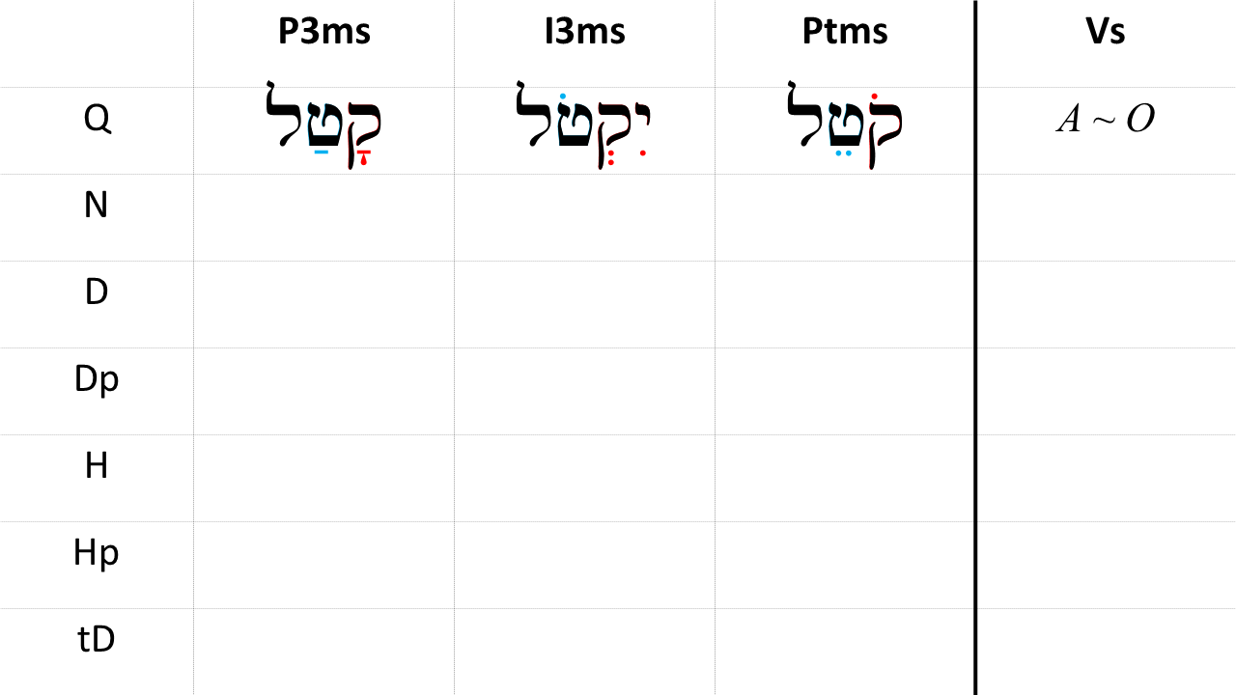

## Word Warm-up

[Click to open Word Warm-up video in a new tab](https://youtu.be/6inZWylM5U8)

## Verses Warm-up

[Click to open Verses Warm-up video in a new tab](https://youtu.be/uCkJD0fhT74)

## Worksheets: All Qal Paradigms

The attached worksheet has all of the Qal strong forms we have studied in Lessons 13-22. Side 1 has placeholders while side 2 has the קטל paradigm verb. Complete either side of the worksheet until you can complete one entire column without looking at the answer column on the right.

[All Qal paradigms worksheet](22_qal_paradigms_strong_verbs.pdf)

## Ruth Pursuit

YOUR QUEST

Identify the one Participle in Ruth 1. You might recall that we discussed this word in the Lesson 4 Ruth Pursuit.

* [Blank copy of Ruth 1](https://drive.google.com/file/d/1qcfTKAlTJGChC2eYCMhSbY2w-ibzCcDV/view?usp=sharing)
* [Ruth Pursuit Answer Key #22](./images/22_Ruth_Pursuit_KEY.pdf)

## Hebrew Quest Study Passage: Matthew 13

[Blank copy of Matthew 13](https://docs.google.com/document/d/1rl--X01fxApzUiadlxg68F6qVcx_nEsYlJP5LCGSsxo/edit?usp=sharing)

1. Read through the passage straight through
2. Now re-read the passage critically, highlighting ([lexicon here](https://holylanguage.com/resources-dictionaries.php) and translating (you will need to parse verbs to translate)
3. Watch Izzy’s *Hebrew Quest* video (video opens in a new tab)
   * [Part 1](https://holylanguage.com/matthew-13.1.php)
   * [Part 2](https://holylanguage.com/matthew-13.2.php)
4. After the video, assess your translation. How close was it?
5. How did the Ruach HaQodesh speak to you through the passage?

Optionally, you may complete the passage memorization in Memrise [here](https://app.memrise.com/course/5406435/hebrew-quest-lessons-1-to-40/28/garden/learn/?source_element=level_details_session&source_screen=level_details).

## X Quest Quiz

Open Quest Quiz #xx in a new window

## X Claim your next Twelve Tribes Badge!

Check to be sure you have have completed **all activities** through this lesson, then fill out the form below.

Check to be sure you have completed all ACTIVities here, complete the certification below, and your badge will be on its way!

# 23 Hebrew Syntax

To comprehend Biblical Hebrew, we must be able to understand how words in our Bible work together to communicate meaning. We call this “syntax”.

This lesson serves as a bridge between the discussions on the Qal verb forms (Lessons 13-22) and the derived stems (Lessons 24-35).

In a way, this could be the most exciting Lesson of Hebrew GRAMMAR Quest because, here, you will begin to put all that information you learned over the past 22 lessons to work in better understanding how the Bible communicates to us. With this knowledge, we can begin to think critically in our evaluation of differences in translation and the validity of arguments we read in commentaries.

**LESSON ITINERARY**

1. Understand the significance of word order upon translation
2. Describe the nuances of translation based upon word order and whether or not a verb has the ו prefix
3. Translate conditional and volitional phrases

**EQUIPMENT CHECK**

Before continuing, can you describe the following concepts?

* A foundation of the Qal conjugations

## First Thought

### עַתָּה יָדַעְתִּי כִּי־גָדוֹל יְהוָה מִכָּל־הָאֱלֹהִים

*Now I know that the LORD is greater than all the Gods (Exodus 18:11)*

-brief meditation-

Listen to the verse in Hebrew:

Your browser does not support the audio element.



Figure 23.1: Statue of Elijah on Mount Carmel. This statue commemorates the events in 1 Kings 18 and the showdown between Elijah and our God, and the priests of Baal (one of whom is depicted at the bottom of the sculpture), and their God. Our God proved He was greater. Courtesy of the [Pictorial Library of Bible Lands](https://www.bibleplaces.com)

## 23.1 Clause versus Sentence

* A clause has a subject and a predicate.
  + The simplest clause in Scripture is “Yeshua (subject) wept (predicate)”
* An *independent* clause, such as “Yeshua wept” can be a complete sentence
* A sentence can have more than one clause
  + Now after the death of His servant Moses, the LORD spoke to Joshua son of Nun, Moses’ assistant, saying, “Moses My servant is dead.” (Joshua 1:1)
  + There are three clauses in the one sentence
* Hebrew will frequently start a clause with ו
* We’ve used the terms “word-initial” and “word-final” throughout this course. Now we will use “clause-initial” to reference the first word in a clause
* ו is frequently clause-initial

## 23.2 Word order

Normal Hebrew word order is Verb - Subject - Object. We can abbreviate this V-S-O (of course in Hebrew, this goes from right-to-left).

* וַיִּזְכֹּר אֱלֹהִים אֶת־נֹחַ
  + *And God Remembered Noah (Gen 8:1)*
* וַיַּחֲלֹם יוֹסֵף חֲלוֹם
  + *And (Then) Joseph dreamed a dream (Gen 37:5)*
* וַיִּקְרָא מֹשֶׁה אֶל־כָּל־יִשְׂרָאֵל
  + *Then (and) Moses summoned all Israel (Ex 24:16)*

Since we say that V-S-O is the “normal” word order, whenever we encounter a clause that is **NOT** V-S-O, we want to take note as to what is going on. Below is an example of S-V-O used to emphasize the subject, Adonai.

* *יְהוָה* יִמְלֹךְ לְעֹלָם וָעֶד
  + *Adonai* shall reign forever and ever (Ex 15:18)

Hebrew also can have O-V-S, particularly in poetry.

English standard word order is S-V-O, so this is the way we would translate regardless of the Hebrew word order.

## 23.3 Perfect Syntax

The Perfect *without* the ו consecutive is **NOT NORMALLY** the first word in a clause

* אַחַר הַדְּבָרִים הָאֵלֶּה *הָיָה* דְבַר־יְהוָה אֶל־אַבְרָם
  + After these things the word of the LORD *CAME* to Abram (Gen 15:1)
* וְהִנֵּה *נָפְלוּ* אֲבוֹתֵינוּ בֶּחָרֶב
  + For behold, our fathers *FELL* by the sword (2 Chr 29:9)
* בְּרֵאשִׁית *בָּרָא* אֱלֹהִים אֵת הַשָּׁמַיִם וְאֵת הָאָרֶץ
  + In the beginning, God *CREATED* the heavens and the earth (Gen 1:1

However, the Perfect *WITH* the ו consecutive, is **ALWAYS** the first word in a clause

* *וַיֹּאוְאָהַבְתָּ* אֵת יְהוָה אֱלֹהֶיךָ
  + *And you will love* Adonai your God (Deut 6:5)
* *וְזָכַרְתִּי* אֶת־בְּרִיתִי
  + *And I will remember* my covenant (Gen 9:15)

As we remember from Lesson 17, whenever we have the Perfect conjugation with the Vav, we translate it imperfectively.

## 23.4 Imperfect Syntax

Similar to Perfect, the Imperfect *without* the ו consecutive is **NOT NORMALLY** the first word in a clause. Below is an “S-V-O” verse we looked at earlier

* יְהוָה *יִמְלֹךְ* לְעֹלָם וָעֶד
  + Adonai *shall reign* forever and ever (Ex 15:18)

The consecutive Imperfect is the first word in a clause. This is the most common form in Hebrew narrative.

* *וַיֹּאמֶר* הַנָּחָשׁ אֶל־הָאִשָּׁה
  + The serpent *said* to the woman (Gen 3:4)

The volitional imperfects (Cohortative and Jussive, without the Vav consecutive) are normally the first word in the clause.

* *נַעֲשֶׂה* אָדָם בְּצַלְמֵנוּ
  + *Let us make* man in our image

You already know how the verbs in each of these uses are formed because they all use the Imperfect paradigm. The key to accurate translation is word order and whether or not there is the ו consecutive prefix.

## 23.5 Volitional Syntax

Hebrew likes to link multiple verbs together. Word order can be a big clue in translating volitional clauses.

* Multiple Imperatives (M+M) in succession:
  + *עֲלֵה* *וּקְבֹר* אֶת־אָבִיךָ
  + *Go up* and bury your father (Gen 50:6)
  + This verse would be sequential - go up and (then you can) bury your father
  + Context may indicate a consequential translation - do this, **so that** you do that
* An Imperative followed by Perfect with Vav Consecutive (M + Pwc)
  + *לֵךְ* *וְאָמַרְתָּ* אֶל־עַבְדִּי
  + *Go and say* to my servant (2 Sam 7:5)
  + The perfect verb acts as if it were a second imperative (“Go and say”, not “go and you will say”)
* Imperative followed by an Imperfect or Cohortative (M+I or M+C) to create a purpose or result. “So that…”
  + *רְדוּ*־שָׁמָּה *וְשִׁבְרוּ*־לָנוּ מִשָּׁם *וְנִחְיֶה*
  + *Go down* there and *buy grain* for us from there *so that we might live*

## 23.6 Conditional Phrases

A conditional phrase is made up of two clauses. You might want to think of this as an “if-then” statement. The first gives the “if” condition, and the second states the “then” consequence if the condition is met[72]

* וַיֹּאמֶר אֵלֶיהָ בָּרָק *אִם*־תֵּלְכִי עִמִּי *וְהָלָכְתִּי* *וְאִם*־לֹא תֵלְכִי עִמִּי לֹא אֵלֵךְ
  + Then Barak said to her, “*If* you will go with me, *then I will go*; but *if* you will not go with me, (*then*) I will not go.” (Judg 4:8)

The Hebrew word אִם is most frequently, but not always, used for the first clause. The second clause often, but not always begins with וְ

## 23.7 Disjunctive Vav

In this course, we have talked about the CONjunctive Vav. This is a Vav that is prefixed to a verb and serves to link the narrative and move it forward in some fashion.

When a Vav is prefixed to a non-verb, it is called a DISjunctive Vav. As the name implies, it indicate some kind of break or tangent in the narrative. There are four major ways a disjunctive Vav is used as illustrated by the verses below.

* *וְהֵם* לֹא יָדְעוּ כִּי שֹׁמֵעַ יוֹסֵף כִּי הַמֵּלִיץ בֵּינֹתָם
  + *(Now) They* did not know, however, that Joseph understood, for there was an interpreter between them (Gen 42:23)
  + Parenthetical use: וְהֵם
  + A parenthetical comment to explain why Joseph’s brothers believed they could speak freely
* וַיְהִי כְּהַיּוֹם הַזֶּה וַיָּבֹא הַבַּיְתָה לַעֲשׂוֹת מְלַאכְתּוֹ *וְאֵין* אִישׁ מֵאַנְשֵׁי הַבַּיִת שָׁם בַּבָּיִת
  + Now it happened one day that he went into the house to do his work, *and none* of the men of the household was there inside (Gen 39:11)
  + Circumstantial use: וְאֵין
  + A break in the narrative, in this case, to provide important information to set up the circumstances of the attempted seduction and subsequent imprisonment of Joseph
* וַיִּשַׁע יְהוָה אֶל־הֶבֶל וְאֶל־מִנְחָתוֹ׃ *וְאֶל*־קַיִן וְאֶל־מִנְחָתוֹ לֹא שָׁעָה
  + And Adonai had regard for Abel and for his offering; *but for* Cain and for his offering He had no regard (Gen 4:4b-5a)
  + Contrastive use: וְאֶל
  + Often translated “but”
  + This contrasts Adonai’s reponse to the two men’s offerings
* *וְהַנָּחָשׁ* הָיָה עָרוּם מִכֹּל חַיַּת הַשָּׂדֶה אֲשֶׁר עָשָׂה יְהוָה אֱלֹהִים
  + *Now the serpent* was more crafty than any beast of the field which the LORD God had made (Gen 3:11)
  + Introductory use: וְהַנָּחָשׁ
  + A new theme or idea; sometimes an entirely new narrative
  + In this example, we move from the creation narrative to the temptation narrative

## 23.8 Adverbs

* *עַתָּה* יָדַעְתִּי כִּי־יְרֵא אֱלֹהִים אַתָּה
  + *Now* I know that you fear God (Gen 22:12)
  + Adverb of Time: עַתָּה
* *וַיָּשֶׂם* שָׁם אֶת־הָאָדָם אֲשֶׁר יָצָר
  + *and there* He placed the man whom He had formed (Gen 2:8)
  + Adverb of Place: שָׁם
* עֵינַי *תָּמִיד* אֶל־יְהוָה
  + My eyes are *continually* toward the LORD (Ps 25:15)
  + Adverb of Degree: תָּמִיד
* וַיָּבֹא אֲלֵיהֶם יְהוֹשֻׁעַ *פִּתְאֹם*
  + So Joshua came upon them *suddenly* (Josh 10:9)
  + Adverb of Manner: פִּתְאֹם
* Adverbs are most frequently at the end of a clause.
* As the above examples illustrate, this is not a hard-and-fast-rule

## Word Warm-up

Click to open Word Warm-up video in a new tab

## Verses Warm-up

Click to open Verses Warm-up video in a new tab

## Ruth Pursuit

::: {.box .map}

There is no formal quest for this lesson, but consider the following points based on the material in Lesson 23:

* Note the Disjunctive Vav in Ruth 1:2. Note how the main narrative does not continue but pauses to let us know the names of the people involved. This is supplemental, background information.
* The Conjunctive Vav in Ruth 1:7 serves to begin a more detailed, focused narrative account of Naomi’s return
* Note how the Disjunctive Vav in the final clause of 1:14 - Vav + non-verb (subject) + predicate - introduces a CONTRAST of Ruth’s attitude of clinging, signaling deep loyalty and attachment to Naomi (see the דבק + בְּ note in Lesson 13 answer key), compared to Orpah’s goodbye kiss
* In 1:16, כִּי introduces a subordinate clause that has an explanatory function. “Ruth tells Naomi to stop urging her to go back, because she has determined that she will follow Naomi wherever her mother-in-law goes.”[73]
* 1:17 has what some scholars refer to as an “oath formula”. כֹּה gives the punishment for breaking the promise, and כִּי gives the condition. The specifics appear to be implied rather than stated, which makes a literal translation awkward and any other translation someone speculative and dependent on what the translator believes is the context. NET renders the first clause as “The LORD will punish me severely.”
  + Other oaths of this type appear in 1 Samuel 14:44, 1 Samuel 20:13, 2 Samuel 3:9, 1 Kings 2:23, and 1 Kings 19:2
* In 1:20, כִּי introduces a subordinate clause that has an explanatory function. Naomi is elaborating on why she wants a new name.
* We have noted that most Hebrew clauses begin with a verb, but 1:21 begins with “I”. Naomi is drawing attention to her condition - full when she left, but now returning empty. Curiously, Ruth evidently counts for nothing. Naomi’s attitude will definitely change by the end of the book!
  + Also note in 1:21 the Disjunctive Vav clauses, “And Adonai” followed by “And Shaddai.” Chisholm notes that the use may be “semi-poetic”: “Adonai has testified about me; Shaddai has afflicted me”[74].
* Finally the Iwc in 1:22 begins a summarizing, concluding statement bringing the “first act” of the drama to a close.

## Hebrew Quest Study Passage: Psalm 19

[Blank copy of Psalm 19](https://docs.google.com/document/d/1jyLXPdhaGYbyBmc6dZ2XJX1QrYDGgRpWtE6Yuho8B1k/edit?usp=sharing)

* DO: File | Make a copy to store in your local Google Drive so you can highlight and edit
* DON’T: Request Edit Access

1. BEFORE WATCHING THE VIDEO, read through the passage on your own straight through one time - pick up as much as you can
2. Now re-read the passage critically
   1. Highlight any words you do not know and look them up in a [lexicon](https://holylanguage.com/resources-dictionaries.php)
   2. Parse as many verbs as you can
   3. Sketch out a translation - there is a blank line between each verse
3. Now, using your marked-up copy of the passage, [watch Izzy’s *Hebrew Quest* video (video opens in a new tab)](https://holylanguage.com/psalm-19.php)
4. After the video, assess your translation. How close was it.
5. How did the Ruach HaQodesh speak to you through the passage.

Optionally, as we discussed in Lesson 17, you may complete the passage memorization in the separate Anki deck, or in Memrise [here](https://app.memrise.com/course/5406435/hebrew-quest-lessons-1-to-40/26/garden/learn/?source_element=level_details_session&source_screen=level_details).

# Introduction to Unit 4

Congratulations! You now have the heaviest work of a first-year Hebrew grammar course behind you. From here on out, we will be studying the six major derived Hebrew Verb stems: Niphal, Piel, Pual, Hiphil, Hophal and Hitpael.

The reason we spent so much time on the Qal stem is not only because it’s the most frequently occurring stem, but everything from this point forward is based on what you learned in Unit 3. This means, for the most part, the Lessons that follow will be shorter and much more methodical.

Summaries of each of the derived stems will consist of the overall diagnostic features. It is THESE features that should be memorized, not the numerous paradigms.

## Lessons 24-35

Each stem will have two lessons:

* Lesson 1/2 (even number) - The “Strong” Verb paradigm
  + The meaning of the Stem
  + The spelling of the stem
    - Word-initial Prefix/Preformative combinations
    - $V_{S}$ formulas to help you “diagnose” the stem when you encounter it in the Bible
  + Complete forms of each conjugation using the קטל paradigm verb
    - The Perfect and Imperfect forms will have the Audio from Chapter 15 of *Hebrew Quest*
    - The Anki deck will have exercises to help you with paradigm identification
    - Each lesson will have a worksheet for you to practice the paradigm
    - From here on out, identification of patterns is more important than memorization of paradigms
* Lesson 2/2 (odd number) - Weak verb deviations
  + Spelling changes within caused by the behaviors of gutturals and other weak letters, Geminate verbs, Biconsonantal verbs, and other irregular verbs
  + Most of the time, you already know the concepts
    - For example, in some forms of the Niphal Strong paradigm, $R_{1}$ takes a Dagesh Forte
    - You already know that if $R_{1}$ is a guttural or Resh, $R_{1}$ will reject the Dagesh Forte and often (but not always), there will be Compensatory Lengthening

## Ruth Pursuits

There are only a handful of non-Qal verbs in Ruth 1, so you will only see the Ruth Pursuit activities in the following Lessons:

* Lesson 25 - Niphal
* Lesson 27 - Piel
* Lesson 31 - Hiphil
* Lesson 35 - Hitpael

## 23.9 Review: Vowel and Consonant Shorthand

* To reduce clutter and redundancy, the following chapters will make extensive use of the “Vowel Shorthand” we discussed in the Unit 3 Introduction - be sure you are comfortable with this nomenclature
* $V_{P}$ is the vowel that is affixed to the verb’s preformative, if there is one
* $R_{1}$ is root consonant #1 and $V_{1}$ is that consonant’s vowel
* $R_{2}$ is root consonant #2 and $V_{2}$ is that consonant’s vowel
* $R_{3}$ is root consonant #3 (we do not use $V_{3}$).

## 23.10 Review: Stem Vowel is the Vowel with the 2nd Root Consonant

* $V_{S}$ is the “Stem Vowel”, this is *usually $V_{2}$*
  + If the first consonant is lost, $V_{S}$ is still the vowel with the second root consonant
    - In **שֵׁב**\*, $V_{S}=V_{2}=\overset{‾}{E}$- (Long E - Tsere)
  + For biconsonantal verbs, $V_{S}$ is between the consonants
    - In **קָם**\*, $V_{S}=\overset{‾}{A}$ (Long A - Qamets)
    - In **יַקוּם**\*, $V_{S}=\overset{‾}{U}$ (Long U - Shureq)

## 23.11 Stem Vowel Pattern Nomenclature

* The derived stems tend to be much more consistent with their application of stem vowels
* We will use a code to memorize the stem vowels for non-Qal Strong verbs
* For example, the stem vowel code is
$$V_{S_{N}}=A∼\overset{‾}{E}(A)$$

* V_{S_N}$ means the Stem Vowel for the Niphal. The final letter is the stem’s parsing code.
* Everything to the LEFT of the tilde, $∼$, is the PERFECT
* Everything to the RIGHT of the tilde is the IMPERFECT and related forms, Jussive, Cohortative, Imperative and Infinitive Construct
* Any exceptions are inside ()
  + Imperfect form exceptions apply to the Feminine Plural
    - Therefore $(A)$ in the formula means the Stem Vowel in the Imperfect FP, the Jussive FP and the Imperative FP is Short A - Patach
  + Perfect exceptions will tend to apply to the 2nd and 1st person forms
  + Niphal does not have any Perfect exceptions

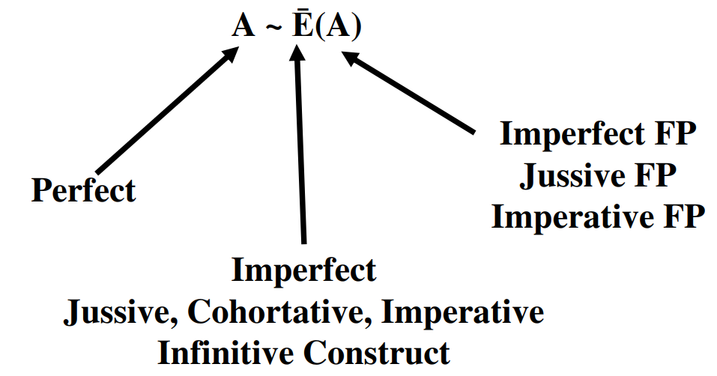

## 23.12 Review: Sheva before Finite Verb Endings

* Finite Verbs have Person (1st, 2nd, 3rd)
  + Thus the Finite verb conjugations are: Perfect, Imperfect, Imperative, Jussive, Cohortative
  + The non-Finite conjugations are: Infinitive Construct, Infinitve Absolute, Participle
* A sheva goes before a Finite Verb ending
  + This means the $V_{S}$ will REDUCE if the sufformative begins with a VOWEL
  + An exception to the above is that Unchangeable vowel letters do not reduce, so they do NOT take a Sheva
* The Adjective Endings do NOT take a Sheva - since Participles use adjective endings, they do not take a Sheva
  + One exception: if the Participle $V_{S}=\overset{‾}{E}$, then it REDUCES
    - Qal Active: קֹטֵל (QPTms) becomes קֹטְלִים (QPTmp)
    - Piel: מְקַתֵּל (DPtms) becomes מְקַטְּלוֹת (DPtfp)

# 24 The Niphal Stem - Strong Verbs

The Niphal stem occurs 4,138 times in the Bible.

* P - 1,426
* I - 1,544
* M - 118
* I∞ - 205
* A - 37
* Pt - 808

LESSON ITINERARY

1. The meaning of the Niphal stem
2. $Pre$ combinations diagnostic of the Niphal Stem
3. Niphal Stem Vowels
4. What to Memorize

EQUIPMENT CHECK

Before continuing, can you describe the following concepts?

* You must have all of the Qal strong verb paradigms committed to memory: Perfect, Imperfect, Imperative, Infinitive Construct, Infinitive Absolute, and Particle
* Review the $V_{S}=$ nomenclature from the Unit 4 Introduction
* Review the $Pre=$ nomenclature from the Unit 3 Introduction

## First Thought

### וּמִן־הַגָּדִ֡י נִבְדְּל֣וּ אֶל־דָּוִיד֩ לַמְצַ֨ד מִדְבָּ֜רָה

*From the Gadites there came over to David in the stronghold in the wilderness (1 Chronicles 12:9)*

En Gedi, pictured below, is a well-watered oasis in an otherwise dry and dusty part of Israel adjacent to the Dead Sea. Similarly, our walk with Yeshua (and indeed, our study of Hebrew!) can sometimes leave us feeling dry and dehyrdated. Just as David had a retreat at En Gedi, it is important for us to remain connected to our source of Living Water as we go through life’s journeys.

Listen to the verse in Hebrew:

Your browser does not support the audio element.



Figure 24.1: Ibex drinking from Nahal David at En Gedi. En Gedi is the suggested location of the ‘desert stronghold’ referenced in 1 Chronicles. Courtesy of the [Pictorial Library of Bible Lands](https://www.bibleplaces.com)

## 24.1 Niphal Verb Stem Table

|  |  |  |  |
| --- | --- | --- | --- |
|  | Active Voice | Passive Voice | Reflexive Voice |
| Simple Action | Qal | *NIPHAL* | *NIPHAL* |
| Cause a State | Piel | Pual | Hitpael |
| Cause an Action | Hiphil | Hophal |  |

* Reminders:
  + The table gives broad generalization; many verbs do not fit neatly into the table’s definitions
  + Use a lexicon/dictionary to check the meanings in different stems
  + Few verbs occur in all stems - there are many Niphal verbs that NEVER occur in Qal
* Lesson 25 will have a list of the most frequent Niphal verbs

## 24.2 Niphal Meanings

* Simple action with either a passive or reflexive voice
* שָׁמַע
  + Qal - He heard
  + Niphal - He was heard (passive), or he heard himself (reflexive)
* Some English translations do not overtly seem passive or reflexive
  + אמן - Niphal - to be reliable, faithful, trustworthy
  + לחם - Niphal - to fight, do battle with

## 24.3 Parsing Clues - *Pre*: the נ prefix is added to EVERY conjugation

* For ease of reference, we are going to use the label $Pre$ for any diagnostic combination of word-initial consonants (prefix or root letters), vowels, and Dagesh Fortes (as applicable)
  + ק is used as a placeholder to represent $R_1% of any strong verb

Memorize these three $Pre$ formulas and the conjugations in which they are used:

* Perfect, Participle, some Infinitive Absolute: $Pre=$ נִקְ
* Imperfect: $Pre=$ יִקָּ - and so forth for the other Imperfect forms
  + Imperfect 1cs: $Pre=$ אֶקָּ (like the Qal) OR אִקָּ
* Imperative/∞/some Infinitive Absolute: $Pre=$ הִקָּ
* The נ prefix is added to every form of every conjugation
  + In the NP, NPt and in one form of the NA, the נ appears
  + In the NI, NM, N∞, and the other form of the NA, the נ is *assimilated into a Daghesh Forte* in $R_{1}$
* Niphal Strong $V_{P}=I$ ALWAYS

## 24.4 Parsing Clues - $V_{S}=A∼\overset{‾}{E}(A)$

Memorize the $V_{S}$ formulas for each stem

* NP = $A$  
* NP/NI/N∞ = $\bar E$ ($A$ for Feminine Plural forms)  
* NA (and A for all derived stems) = $\bar E$ (usually)  
* NPt (and Pt for all derived stems) = the P3ms $V_S$, _lengthened if possible_

* Perfect $V_{S}=A$, so NP3ms = נִקְתַל
* Imperfect/Imperative/∞ (except FP) $V_{S}=\overset{‾}{E}$, so יִקָּטֵל
* Imperfect/Imperative/∞ FP $V_{S}=(A)$, so תִּקָּטַ֫לְנָה
* Infinitive Absolute $V_{S}=\overset{‾}{E}$ (usually)
  + In the QA, $V_{S}=\hat{O}$- ALWAYS
  + Some forms of Niphal also have $V_{S}=\hat{O}$- וֹ- can be written defectively
  + The Niphal absolute only occurs 37 times total
* Niphal Participle $V_{S}=$ Lengthened P3ms
  + If $V_{S}$ is already long, the Participle is the same as the Perfect 3ms
  + Since the Niphal Perfect 3ms $V_{S}=A$, the Niphal Participle $V_{S}=\overset{‾}{A}$
    - NP3ms = נִקְטַל
    - NptMS = נִקְטָל
  + $V_{S}$ does NOT reduce in the NPt, which distinguishes Np3fs from NPtfs
    - נִקְטָלָה is NPtfs because $V_{S}$ is long
    - נִקְתְלָה is NP3fs because $V_{S}$ is reduced
  + Other stems reduce only if $V_{S}$ is $\overset{‾}{E}$ (Tsere)
    - Qal Active, Piel and Hitpael

## What to memorize for all Derived Stems

* Meaning of $V_{S}$ pattern
$$V_{S}=Perfect[2/1person]∼Imperfect(ImperfectFP)$$

* Always a Sheva before finite verb endings (unless $\overset{‾}{E}$ (Tsere))
* Participle $V_{S}$ = P3ms $V_{S}$ lengthened if possible (unless $\overset{‾}{E}$ (Tsere))
* Infinitive Absolute $V_{S}=\overset{‾}{E}$
  + Except: $V_{S}=\hat{O}$ for QA and some NA
* Everything else uses Imperfect $V_{S}$
  + Imperative, Jussive, Cohortative, ∞

## 24.5 What to memorize for Niphal

* The Three $Pre$ Sequences
  + $Pre_{NP,NPt}=$ ְנִק
    - Also one form of NA
  + $Pre_{NI3m}=$ יַקְ - and so forth for the other Imperfect forms
  + $Pre_{NM/N∞}= $מַקְ
    - Also one form of NA
* The Niphal $V_{S}$ formula and what it means

$V_{S}=A∼\overset{‾}{E}(A)$

## 24.6 Paradigm: Niphal Perfect Strong

YOU DO NOT NEED TO MEMORIZE THE NON-QAL PARADIGMS

* The paradigms are presented so that you may see and hear each form
* With your knowledge of the Qal paradigms, you should be able to write the non-Qal paradigms from principles listed on the previous sections
* In the Perfect the נ of the Niphal is WRITTEN

|  |  |  |  |
| --- | --- | --- | --- |
| Sing | Paradigm | Plural | Paradigm |
| 3ms | נִקְטַל | 3cp | נִקְטְלוּ |
| 3fs | נִקְטְלָה |  |  |
| 2ms | נִקְטַ֫לְתָּ | 2mp | נִקְטַלְתֶּם |
| 2fs | נִקְטַלְתְּ | 2fp | נִקְטַלְתֶּן |
| 1cs | נִקְטַ֫לְתִּי | 1cp | נִקְטַ֫לְנוּ |

X Perfect Strong from *Hebrew Quest* Chapter 15

Your browser does not support the audio element.

## 24.7 Paradigm: Niphal Imperfect Strong

* In the Imperfect, the נ of the Niphal is ASSIMILATED

|  |  |  |  |
| --- | --- | --- | --- |
| Sing | Paradigm | Plural | Paradigm |
| 3ms | יִקָּטֵל | 3mp | יִקָּֽטְלוּ |
| 3fs | תִּקָּטֵל | 3fp | תִּקָּטַ֫לְנָה |
| 2ms | תִּקָּטֵל | 2mp | תִּקָּֽטְלוּ |
| 2fs | תִּקָּטְלִי | 2fp | תִּקָּטַ֫לְנָה |
| 1cs | אֶקָּטֵל | 1cp | נִקָּטֵל |

Imperfect Strong from *Hebrew Quest* Chapter 15

Your browser does not support the audio element.

## 24.8 Paradigm: Niphal Imperative Strong

* In the Imperative, the נ of the Niphal is ASSIMILATED
* You can tell an Imperative from an Imperfect by the הִ, which is not an Imperfect preformative

|  |  |  |  |
| --- | --- | --- | --- |
| Sing | Paradigm | Plural | Paradigm |
| 2ms | הִקָּטֵל | 2mp | הִקָּֽטְלוּ |
| 2fs | הִקָּֽטְלִי | 2fp | הִקָּטַ֫לְנָה |

* The translation value of the Niphal Imperative will often lose the passive nuance as in הִשָּׁמֶר לְךָ פֶּן־תִּשְׁכַּח אֶת־יְהוָה “take heed to yourself lest you forget the Lord” (Deut 6:12).
* Frequently, the 2ms Imperative appears with an ה ָ ending

Advance Notice:

Hiphil Perfect verbs also have $Pre=$ הִקְ, but Hiphil non-Perfect verbs have $Pre=$ הַקְ. As long as you are able to distinguish a perfect from a non-perfect form, the הִ prefix will pose little difficulty. ## Paradigm: Niphal Infinitives Strong

* In one form of the Infinitive Absolute, the נ of the Niphal is WRITTEN
* In the other form of the Infinitive Absolute, the נ of the Niphal is ASSIMILATED

|  |  |
| --- | --- |
| Type | Paradigm |
| ∞ | הִקָּטֵל |
| A | נִקְטוֹל |
| A | הִקָּטוֹל |

* There is no specific pattern regarding when one of the two absolute forms is used versus the other

### Derived Stem Infinitive Absolute $V_{S}=\overset{‾}{E}$ (usually)

* In the QA, $V_{S}=\hat{O}$- ALWAYS
* Some forms of Niphal also have $V_{S}=\hat{O}$
  + $\hat{O}$ וֹ can be written defectively as ֹ

## 24.9 Paradigm: Niphal Participle Strong

* In the Participle, the נ of the Niphal is WRITTEN

|  |  |  |  |
| --- | --- | --- | --- |
| Sing | Paradigm | Plural | Paradigm |
| ms | נִקְטָל | mp | נִקְטָלִים |
| fs | נִקְטֶ֫לֶת | fp | נִקְטָלוֹת |

* Note $V_{S}=\overset{‾}{A}$, which is the lengthened $V_{S}$ of NP3ms

### Derived Stem Participle $V_{S}=$ the P3ms Vowel, lengthened if possible (usually)

* In Niphal, the Perfect 3ms $V_{S}=A$- using the above rule, the Niphal Participle $V_{S}=\overset{‾}{A}$
* For the Piel, the Perfect 3ms $V_{S}=\overset{‾}{E}$. Since $\overset{‾}{E}$ is already long, the Piel Participle is also $\overset{‾}{E}$

Three Exceptions:

* QPt = $\overset{‾}{E}$
* QPp = $\overset{‾}{U}$
* The Alternate FS “T-form” = ת ֶ ֶ

## 24.10 Participle Prefixes in the Derived Stems

All of the Participles besides Qal have a distinctive prefix. Being able to identify this prefix will make identifying the various Participle stems straightforward.

|  |  |
| --- | --- |
| Stem | Prefix |
| NIPHAL | נִ |
| Piel | מְ |
| Pual | מְ |
| Hiphil | ַמ |
| Hophal (u-class) | מֻ |
| Hophal (o-class) | ָמ |
| Hithpael | תִמְ |

## 24.11 Forms with Identical Spelling

* NP3fs and NPtfs - נִקְטְלָה
* NI2ms and N∞ - הִקָּטֵל
* As one form is finite and the other is non-finite, the context should immediately resolve any potential ambiguity

## 24.12 Easily Confused Forms

* נִקְטַל - NP3ms
* נִקְטֹל - QI1cp (only biconsonantal forms would ever take a holem stem vowel (defective of Holem Vav) in the Niphal )
* נִקְטָל - Nptms

## 24.13 Niphal Parsing Examples

* Word: נִכְרָֽת
  + Context: וְזֶ֖רַע רְשָׁעִ֣ים נִכְרָֽת
  + $Pre=$ נִכ

$Suf=$ ְ
  + n/a
  + $Root=$ כרת
  + $V_{S}=\overset{‾}{A}$-
    - The $V_{S}$ lengthening is unusual, but we have seen this with other Perfect and Imperfect verbs in the Qal section[75]
    - When the $Pre$ and $Suf$ are unambiguous, you can ignore the $V_{S}$
  + Result: NP3ms, he will be cut off
* Word: וְאִכָּבְדָ֤ה
  + Context: וְאִכָּבְדָ֤ה בְּפַרְעֹה

$Pre=$ ֙
  + אִכָּ- Niphal Imperfect 1cs + ו
  + $Suf=$ דָה
    - Our first thought might P3fs or 3fs pronominal suffix, but neither of these fit the context
    - Remember from Lesson 18 that often, the Cohortative appears with an ה ָ ending, but in this passage, “I will be honored in/through Pharaoh” seems to fit better than “Let me be honored through Pharaoh.” This is likely just a spelling variant[76]</small
    - External references tend to parse this as NI1cs
  + $Root=$ כבד to be heavy/weighty/glorified
  + $V_{S}=$ silent sheva (reduced)
  + Result: N(I/C)1cs; Imperative: I will be honored or Cohortative: let me be honored
* Word: נִגְרַזְתִּי֮
  + Context: נִגְרַזְתִּי֮ מִנֶּ֪גֶד עֵ֫ינֶ֥יך

$Pre=$ ָ
  + נִג

$Suf=$ ְ
  + תִי
  + $Root=$ גרז
  + $V_{S}=$ רַ
  + Result: NP1cs - I am cut off (from before your eyes)
  + More than anything else, this word highlights the importance of being able to differentiate the root from the $Pre$ and $Suf$. For example, if one thought the root was נגר, the translation would be very much incorrect. גרז only appears once, here in Psalms 31:23

## 24.14 Stem Comparison Table

* We can now update our Stem Comparison table to include Niphal
* Take note of the $Pre$ patterns in red and the $V_{S}$ in blue
  + When you are able to work your way back to the $Pre$ pattern of the Strong verb means you will correctly identify the stem and conjugation most of the time

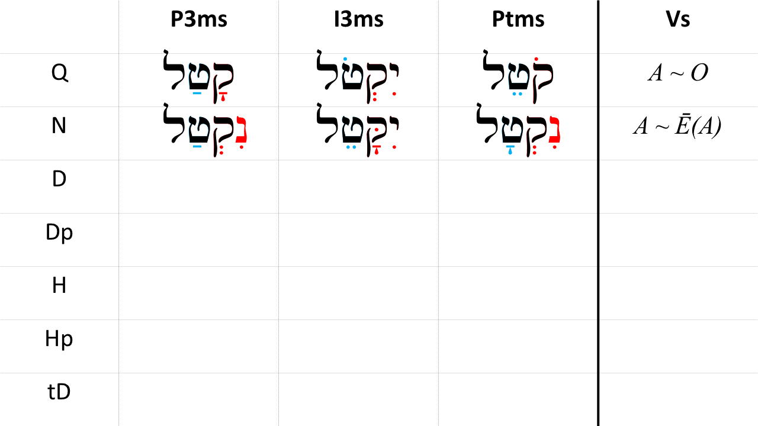

## Word Warm-up

[Click to open Word Warm-up video in a new tab](https://youtu.be/WYDdz_zrwSw)

## Verses Warm-up

[Click to open Verses Warm-up video in a new tab](https://youtu.be/jEQ6P2xIDEo)

## Worksheets: Niphal Strong Paradigm

Use your knowledge of the $Pre$, $Suf$, and $V_{S}$ of the Niphal, complete the worksheet until you can do it once through correctly.

Again, you do NOT need to have the Niphal paradigms memorized (although that may eventually happen naturally!).

[Niphal Strong Paradigm](24_niphal_strong_paradigms.pdf)

## Hebrew Quest Study Passage: Numbers 15

[Blank copy of Numbers 15](https://docs.google.com/document/d/19Tug4LR7twlNvMA0Gad_JKFsQNm5qugtzEqP_ET8_78/view?usp=sharing)

1. Read through the passage straight through
2. Now re-read the passage critically, highlighting ([lexicon here](https://holylanguage.com/resources-dictionaries.php) and translating (you will need to parse verbs to translate) 3.[Watch Izzy’s *Hebrew Quest* video (video opens in a new tab)](https://holylanguage.com/numbers-15.php)
3. After the video, assess your translation. How close was it?
   * You may wish to check your parsing and translation [here](https://scholarsgateway.com/search/WLC-ESV/Numbers/15)
   * Check the “verbs” box to highlight all of the verbs in the passage, then hover over each verb for parsing information
4. How did the Ruach HaQodesh speak to you through the passage?
5. Complete associated Memrise module [here](https://app.memrise.com/course/5406435/hebrew-quest-lessons-1-to-40/28/garden/learn/?source_element=level_details_session&source_screen=level_details).

# 25 The Niphal Stem - Weak Verbs

Now that we have learned the basic groundrules for the Niphal stem in Lesson 24, we now turn our attention to the spelling changes caused by verbs with one or more weak letters. In all stems, weak verbs tend to be much more prevalent, but it is easier to start with the strong verb patterns, then “manage by exception” when it comes to the corresponding weak verbs.

LESSON ITINERARY

1. 1-Guttural Take Hateph Vowels, which changes $V_{P}$
2. 1-Guttural/Resh Compensatory Lengthening
3. 1-Yod Becomes וֹ or וָּ
4. 1-Nun with Silent Sheva Assimilates
5. 3-Aleph Changes $V_{S}$
6. 3-Hei Endings

**EQUIPMENT CHECK**

Before continuing, can you describe the following concepts from Lesson 24?

* The Niphal $Pre$ sequences
* The Niphal $V_{S}$ formula
* What to Memorize for Derived Stems

## First Thought

### וְקָרְא֥וּ לָהֶ֛ם עַם־הַקֹּ֖דֶשׁ גְּאוּלֵ֣י יְהוָ֑ה וְלָךְ֙ יִקָּרֵ֣א דְרוּשָׁ֔ה עִ֖יר לֹ֥א נֶעֱזָֽבָה׃

*And they will call them, “The holy people, The redeemed of Adonai”; And you will be called, “Sought out, a city not forsaken.” (Isaiah 62:12)*

We are called “Redeemed of Adonai.” Let that sink in. Each new day offers us a chance to reflect on what it means to be redeemed and live our lives accordingly.

Listen to the verse in Hebrew:

Your browser does not support the audio element.



Figure 25.1: Sunrise over Mount of Olives. Courtesy of the [Pictorial Library of Bible Lands](https://www.bibleplaces.com)

## 25.1 A weak consonant affects the vowels that touch it

* A weak $R_{1}$ affects $V_{P}$ and $V_{1}$ (but NOT $V_{S}$)
* A weak $R_{2}$ affects $V_{S}$ and $V_{1}$ (but NOT $V_{P}$)
* A weak $R_{3}$ affects $V_{S}$ and sufformative (but NOT $V_{1}$ or $V_{P}$)

## 25.2 1-Guttural

* Guttural takes Hateph Vowel instead of Sheva
  + Remember the Rule of Sheva - “Hateph Copy Cat”
  + Whichever Hatef vowel is under the guttural, the Niphal prefix will take the corresponding short Vowel
    - Strong - נִקְ
    - 1G - נַעֲ or נֶאֱ
  + If $R_{2}$ has a sheva, then $R_{1}$ lengthens from Hateph to it’s corresponding short vowel
    - 1G -נֶאֶמְ
* Guttural and Resh reject Dagesh Forte
  + Strong - הִקָּ
  + 1G/1R - יֵעָ

## 25.3 1-Yod

* Most 1-Yod verbs were originally 1-Vav
* In some forms, the “original Vav” reappears
* 1-Yod shifts to Holem Vav when $Pre$ = נִקְ
  + Perfect - NOT *נִיְשַׁב, but נוֹשַׁב
  + Participle - NOT *נִיְשָׁב, but נוֹשָׁב
* 1-Yod shifts to consonantal Vav when $Pre=$ יִקָּ (or similar)
  + Imperfect - NOT *יִיָּשֶׁב, but יִוָּשֶׁב
    - Imperfect 1C is ALWAYS אִ, NOT *אֶ if 1-Yod
  + Imperative - NOT *הִיָּשֵׁב, but הִוָּשֵׁב

If you see what looks like a “1-Vav” verb, parse it as 1-Yod

## 25.4 1-Nun with Silent Sheva Assimilates

* When Niphal $Pre=$ נִקְ:
  + NP3ms - NOT *נִנְצַל but נִצַּל
  + NPtMS - NOT *נִנְטָל but נִצָּל

## 25.5 3-Aleph Changes $V_{S}$

You can usually parse a 3-Aleph verb based on the preformative alone

* For 3-Aleph, there is a unique Niphal $V_{S}$ formula

$$V_{S}=\overset{‾}{A}(\overset{‾}{E})∼\overset{‾}{E}(E)$$

* Don’t memorize the changed pattern, since you can still parse based on the preformative $\overset{‾}{A}(\overset{‾}{E})$* means: $\overset{‾}{A}$* (Qamets) in the NP 3rd person, (reduced except in 3ms) $(\overset{‾}{E})$* (Tsere) in the NP 1st and 2nd person * NPt is still the P3ms $V_{S}$ lengthened $\overset{‾}{A}$* is already a long vowel * So 3-Aleph NP3ms and NPtMS have the same spelling * נִמְצָא is NP3ms or NPtMS

## 25.6 3-Hei Verbs Follow the same general principles

To review:

* 3-ה verbs have two root consonants, not three
* 3-ה verbs add a vowel after $R_{2}$

1. If the sufformative begins with a vowel, the sufformative vowel goes after $R_{2}$
   * NP3cp - NOT *נִבְנָהוּ, but נִבְנוּ
   * Ni2fs - NOT *תִּבָּנָהִי, but תִּבָּנִי
2. If the sufformative begins with a consonant, (vowel)+Yod goes between $R_{2}$ and the sufformative
   * NP2ms - NOT *נִבְנָהתָ, but נִבְנֵ֫יתַ (Tsere+Yod for Perfect in the PASSIVE stems: Niphal, Pual, Hophal)
   * Ni3fp - NOT *תִּבָּנָהנָה, but תִּבָּנֶ֫ינָה (Seghol+Yod for Imperfect and IMperative)
   * Hireq+Yod for Perfect in the NON-PASSIVE stems: Qal, Piel, Hiphil, Hitpael)
3. If NO sufformative or pronominal suffix, add 3-Hei ending after $R_{2}$
   * NP3ms נִבְנָה (Qamets-Hei for Perfect)
   * QI3ms יִבְנֶה (Seghol+Hei for Imperfect, Participle)
   * NI3ms יִבָּנֶה (note the Dagesh Forte in $R_{1}$ is how you distinguish from QI3ms)
   * NM2ms הִבָּנֵה (Tsere+Hei for Imperative, some Absolute)
   * QJ3ms יִ֫בֶן (No ending for Iwc or Jussive)
4. Perfect 3fs uses sufformative תָה to distinguish from P3ms
   * NP3ms - נִבְנָה
   * NP3fs - נִבְנְתָה

## 25.7 What to Memorize for Niphal Weak

Think your way through the weak verb $Pre$ to get back to the Niphal Strong $Pre$

* 1G - $Pre$ נַעֲ or נֶאֱ or נֶאֶמְ is the same as strong $Pre$ נִקְ
* 1G/R - $Pre=$ הֵרָ is the same as strong $Pre=$ הִקָּ
* 1Y - $Pre=$ נוֹ is the same as strong $Pre=$ נִקְ
* 1N - $Pre=$ ָנִתּ is the same as strong $Pre=$ נִקְתַ

Also:

* Verbs that look “1-Vav” are actually 1-Yod - יִוָּשֵׁב
* Memorize the list of 3-ה verb endings:

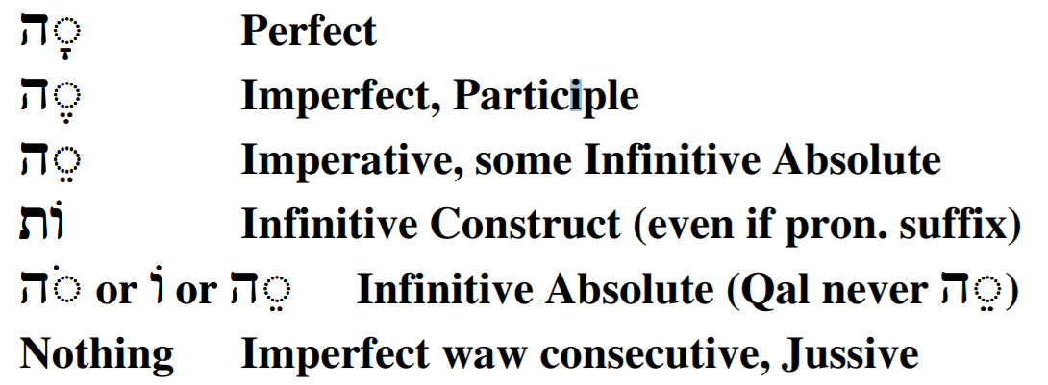

## 25.8 Top 10 Niphal Verbs

1. לָחַם - (Q, N) to fight, do battle with (167x in Niphal Stem)
2. שָׁבַע - (N) to swear, swear (take) an oath, adjure (154x)
3. מָצָא - (Q) to find (out), reach, obtain, achieve; (N) be found, be found sufficient (142x)
4. רָאָה - (Q) to see, perceive, understand; (N) appear, become visible (101x)
5. עָשָֹה - (Q) to do, make, create, acquire, prepare, carry out; (N) be done, be made (99x)
6. שָׁאַר - (N) to remain, be left over, survive (94x)
7. נָבָא - (N) to prophesy, be in a state of prophetic ecstasy (87x)
8. נָתַן - (Q) to give, put, set; (N) be given (83x)
9. אָסַף - (Q) to gather (in), take in, take away; (N) be gathered, be taken away (81x)
10. יָתַר - (N) to be left over, remain (81x)

## Word Warm-up

[Click to open Word Warm-up video in a new tab](https://youtu.be/Pq3PWd41uQE)

## Verses Warm-up

[Click to open Verses Warm-up video in a new tab](https://youtu.be/hgbj52voNtw)

## Ruth Pursuit

YOUR QUEST

Identify, parse, and translate the five Niphal verbs in Ruth 1.

You are likely unfamiliar with the meanings of at least two of these. Identify the Niphal forms by their diagnostics, then identify and look-up the meaning of the root.

By now, if you have been completing your Ruth Pursuit table along with each Lesson, you may have noted that there aren’t that many words left in the passage that we haven’t translated. This may make it easier for you to identify the remaining verbs by process of elimination, but do make sure you understand WHY the words you select are Niphal.

* [Blank copy of Ruth 1](https://drive.google.com/file/d/1qcfTKAlTJGChC2eYCMhSbY2w-ibzCcDV/view?usp=sharing)
* [Ruth Pursuit Answer Key #25](./images/25_Ruth_Pursuit_KEY.pdf)

## Hebrew Quest Study Passage: John 1

[Blank copy of John 1 in Hebrew](https://docs.google.com/document/d/1jWt3rS5Z5az2X_gCRO4Wg9mS4svUIHa5CrjUoqg-xnk/view?usp=sharing)

1. Read through the passage straight through
2. Now re-read the passage critically, highlighting ([lexicon here](https://holylanguage.com/resources-dictionaries.php) and translating (you will need to parse verbs to translate) 3.[Watch Izzy’s *Hebrew Quest* video (video opens in a new tab)](https://holylanguage.com/john-1.php)
3. After the video, assess your translation. How close was it?
4. How did the Ruach HaQodesh speak to you through the passage?

Optionally, you may complete the passage memorization in Memrise [here](https://app.memrise.com/course/5406435/hebrew-quest-lessons-1-to-40/28/garden/learn/?source_element=level_details_session&source_screen=level_details).

## X Quest Quiz

Open Quest Quiz #xx in a new window

## X Claim your next Twelve Tribes Badge!

Check to be sure you have have completed all activities through this lesson, then fill out the form below.

Check to be sure you have completed all ACTIVities here, complete the certification below, and your badge will be on its way!

# 26 The Piel Stem - Strong Verbs

The Piel stem occurs 6,473 times in the Hebrew Bible. It appears in the Perfect 2,120 times, Imperfect 2,446 times, Imperative 436 times, Infinitive Construct 708 times, Infinitive Absolute 84 times, and Participle 679 times

Many students find the Piel is one of the easier stems to identify. It is one of only three Verb stems (along with the Pual and Hitpael) that has a Dagesh Forte in $R_{2}$. The Piel is easily distinguished from the Pual, which has a steady U-class vowel and the Hitpael, which has a unique prefix.

In addition to the Dagesh Forte, the Piel has a $Pre$ combination that (in the strong form) is relatively free from confusion with any other Hebrew Verb Stem.

**LESSON ITINERARY**

1. Understand the meaning of the Piel Stem
2. Identify the distinctive diagnostics of the Piel Strong conjugations

## First Thought

### בִּשְׂפָתַ֥י סִפַּ֑רְתִּי כֹּ֝֗ל מִשְׁפְּטֵי־פִֽיךָ׃

*With my lips I have told of All the ordinances of Your mouth (Psalms 119:13)*

-brief meditation-

Listen to the verse in Hebrew:

Your browser does not support the audio element.

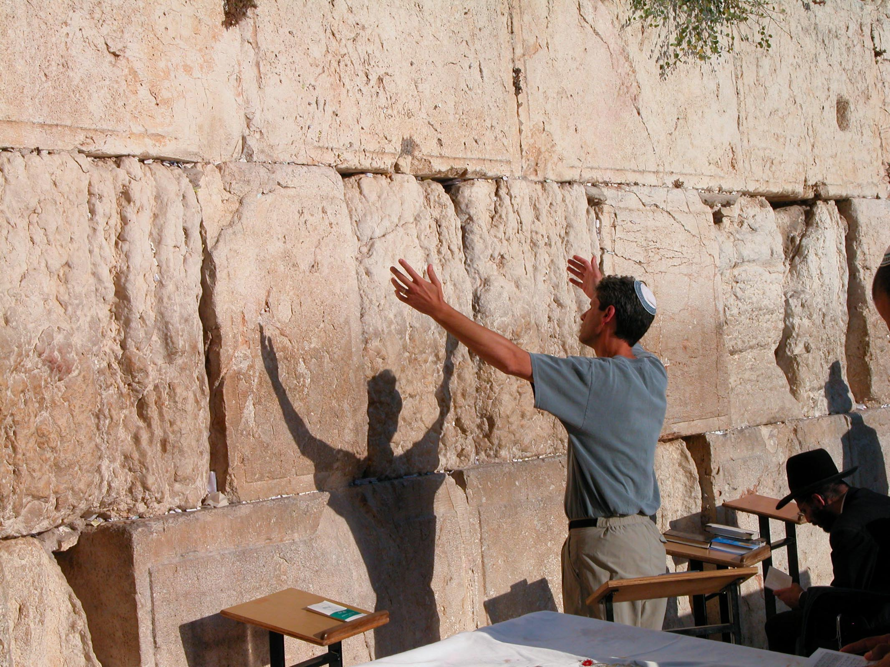

Figure 26.1: Man with arms upraised at Western Wall. Courtesy of the [Pictorial Library of Bible Lands](https://www.bibleplaces.com)

## 26.1 Piel Verb Stem Table

|  |  |  |  |
| --- | --- | --- | --- |
|  | Active Voice | Passive Voice | Reflexive Voice |
| Simple Action | Qal | Niphal | Niphal |
| Cause a State | *PIEL* | Pual | Hitpael |
| Cause an Action | Hiphil | Hophal |  |

* Reminders:
  + The table gives broad generalization; many verbs do not fit neatly into the table’s definitions
  + Use a lexicon/dictionary to check the meanings in different stems
  + Many Tables like this one will label the 2nd row as “Intensive Action” but this is a controversial topic in the academic community

## 26.2 Piel Meanings

* Cause a state (‘factitive’)
  + מִלֵּא
    - Q - He filled
    - D (Piel) - He caused to be full אָנַשף
    - Q - He was angry
    - D - He made angry
* Do something repeatedly (‘iterative’)
  + הָלַךְ
    - Q - He walked
    - D - He walked around
* Declarative - he declared innocent
* Denominative (verb made from noun) - He acted as a priest (כִּהֵן from כֹּהֵן “priest”)
* Intensive?
  + שִׁבֵּר
    - Q - He broke
    - D - He smashed
      * This is hotly debated
      * Perhaps he caused it to be in a state of brokneness?
      * Perhaps he broke repeatedly?

## 26.3 Piel is the D stem because $R_{2}$ takes a Doubling Dagesh Forte

* In fact, when you see a Dagesh in $R_{2}$, it’s more than likely either a Piel form or a 1-נ verb that has assimilated. If you see three root letters, it’s probably a Piel
  + Two other Stems take a Dagesh in $R_{2}$- Pual (Lesson 28) and Hitpael (Lesson 34). As we will learn in those Lessons, both forms are easily distinguished from Piel.
* Gutturals, Resh, SQiN eM LeVY letters reject the Daghesh Forte
  + SQiN eM LeVY discussed later in this Lesson
  + Gutturals/Resh discussed in Lesson 27

## 26.4 Memorize piēl - paēl

The Piel is remarkably consistent.  
While there are distinctive $Pre$ and $V_{S}$ combinations, it’s easiest to remember the Stem by the mnemonic “PIEL - PAEL”

* piēl in PERFECT
 $V_{1}=I$

 $V_{S}=\overset{‾}{E}$ + in the 3rd person
    - קִטֵּל - DP3ms
  + $V_S = A in the 2nd/1st person
    - קִטַּ֫לְתָּ - DP2ms
* paēl in ALL OTHER CONJUGATIONS
 $V_{1}=A$

 $V_{P}=:$ + (or Hateph Patach in DI1cs), where applicable
 $V_{S}=\overset{‾}{E}$

 + יְקַטֵּל - DI3ms
  + קַטֵּל - DM2ms/D∞/DA
  + מְקַטֵּל - DPtMS
* The Piel $V_{S}$ formula is:

$$V_{S_{D}}=\overset{‾}{E}(A)∼\overset{‾}{E}$$

## 26.5 Pay attention when $R_{2}$ is a SQiN eM LeVY consonant

* As we have mentioned previously, SQiN eM LeVY is a mnemonic for a group of letters that can reject a Dagesh Forte when the letter has a Sheva
  + S - סצשׁסֹ
  + Q - ק
  + N - נ
  + M - מ
  + L - ל
  + V - ו
  + Y - י
* If you see a SQiN eM LeVY consonant with a Sheva, it might have a “hidden” Daghesh Forte
* DIwc
  + The Iwc has a Dagesh in the Imperfect Preformative
  + the DI preformative has a Sheva
  + Therefore, DIwc3ms and DIwc3mp lose Dagesh
  + DIwc3ms - Not *וַיְּקַטֵּל, but וַיְקַטֵּל
  + DIwc3mp - Not *וַיְּקַטְּלוּ, but וַיְקַטְּלוּ
* Forms with reduced $V_{2}$
  + Example DP3cp - Not *שִׁמְּרוּ, but שִׁמְרוּ

## 26.6 Piel: what to memorize

* Parsing code D - Dagesh Forte in $R_{2}$
* “piēl - paēl”
  + This is easier than remembering the $Pre$ and $V_{S}$ combinations separately
  + piēl - Perfect $V_{1}=I$
  + paēl - everywhere else: $V_{1}=A$
  + $V_{S}=E$ everywhere except Perfect 1st/2nd person (where $V_{S}=A$)
* $V_{P}=:$ in all Strong Conjugations with preformatives
  + This compares to $V_{P}=I$ in the Qal
* Participle preformative מ (all stems except Qal and Niphal)
* The SQiN eM LeVY exceptions
  + $R_{2}$ and $DIwc$

## 26.7 Piel Perfect Strong

|  |  |  |  |
| --- | --- | --- | --- |
| Sing | Paradigm | Plural | Paradigm |
| 3ms | קִטֵּל | 3cp | קִטְּלוּ |
| 3fs | קִטְּלָה |  |  |
| 2ms | קִטַּ֫לְתָּ | 2mp | קִטַּלְתֶּם |
| 2fs | קִטַּלְתְּ | 2fp | קִטַּלְתֶּן |
| 1cs | קִטַּ֫לְתִּי | 1cp | קִטַּ֫לְנוּ |

* 3rd person $Pre$ is distinctive Hireq+Dagesh+Tsere
* 1st/2nd person $Pre$ is Hireq+Dagesh+Patach

X Piel Perfect Strong from *Hebrew Quest* Chapter 15

Your browser does not support the audio element.

֫## Piel Imperfect Strong

|  |  |  |  |
| --- | --- | --- | --- |
| Sing | Paradigm | Plural | Paradigm |
| 3ms | יְקַטֵּל | 3mp | יְקַטְּלוּ |
| 3fs | תְּקַטֵּל | 3fp | תְּקַטֵּ֫לְנָה |
| 2ms | תְּקַטֵּל | 2mp | תְּקַטְּלוּ |
| 2fs | תְּקַטְּלִי | 2fp | תְּקַטֵּ֫לְנָה |
| 1cs | אֲקַטֵּל | 1cp | נְקַטֵּל |

* Piel Imperfect $Pre$ is very consistent: Sheva+Patach+Dagesh+Tsere
  + Compare to Qal Imperfect $Pre$ of Hireq+Sheva+Holem

X Imperfect Strong from *Hebrew Quest* Chapter 15

Your browser does not support the audio element.

## 26.8 Piel Imperative Strong

|  |  |  |  |
| --- | --- | --- | --- |
| Sing | Paradigm | Plural | Paradigm |
| 2ms | קַטֵּל | 2mp | קַטְּלוּ |
| 2fs | קַטְּלִי | 2fp | קַטֵּ֫לְנָה |

## 26.9 Piel Infinitives Strong

|  |  |
| --- | --- |
| Type | Paradigm |
| ∞ | קַטֵּל |
| A | קַטֵּל |

* Same as DM2ms

## 26.10 Piel Participle Strong

|  |  |  |  |
| --- | --- | --- | --- |
| Sing | Paradigm | Plural | Paradigm |
| ms | מְקַטֵּל | mp | מְקַטְּלִים |
| fs | מְקַטֶּ֫לֶת | fp | מְקַטְּלוֹת |

* Distinctive מְ prefix

### Participle Prefixes in the Derived Stems

Again we present this table for review:

|  |  |
| --- | --- |
| Stem | Prefix |
| Niphal | נִ |
| PIEL | מְ |
| Pual | מְ |
| Hiphil | ַמ |
| Hophal (u-class) | מֻ |
| Hophal (o-class) | ָמ |
| Hithpael | תִמְ |

## 26.11 Piel Parsing Examples

* Word: גדַּ֫לְנוּ
  + The dagesh in the gimmel is a Lene (not preceded by a vowel), but the Dagesh in the Dalet is preceded by a vowel that is not a sheva, so this must be a forte.
    - A Forte in what appears to be $R_{2}$ Should get your attention and you start asking “Is this Piel?”
  + $Pre=$ גִּדַּ, distintly Piel
  + $Sufformative=$ נוּ, Perfect 1cp
  + $Root=$ גדל
  + $V_{S}=A$- We might expect Tsere in the Piel but then we remember that Piel Perfect takes Patach in 1st/2nd person
  + Result: Piel Perfect 1cp, we made great
* Word: אֲדַבֶּר
  + Immediately, note the Daghesh in $R_{2}$- your mind should already be asking “is this Piel?”
    - This could be an assimilated 1-nun verb but you already have what appears to be three-root letters visible
  + Then remember “Piel-Pael” and note this rhymes with Pael. So without doing much analysis, we’re already pretty sure this is a Piel, non Perfect.
  + $Pre=$ אֲדַבּ,
    - We might expect $V_{P}$ of sheva in the Piel but of course the Aleph takes the Hateph vowel
    - The Patach+Dagesh+Tsere combination is consistent with Piel non-Perfect
  + $Sufformative=$ None. With the Aleph preformative, this is I1cs
  + $Root=$ דבר
  + $V_{S}=\overset{‾}{E}$, consistent with Piel (except DP1/2 person)
  + Result: Piel Imperfect 1cs I will speak
* Word: לַמֵּד
  + The Dagesh Forte in $R_{2}$ suggests Piel or assimilated 1-Nun[77]. You also note that the word rhymes with “Pael”, suggesting a “working hypothesis” of Piel, non-perfect.
  + $Pre=$ לַמּ,
  + $Sufformative=$ none. No preformative, no sufformative could be QP, but the vowels don’t match Qal at all. The vowels do match Piel.
    - This can’t be DP because $V_1 \not = I$
    - This can’t be DI because all Imperfects have a preformative
    - This can’t be DPt because DPt begins with מְ
    - DM2ms, D∞, and DA each work
  + $Root=$ למד
  + $V_{S}=\overset{‾}{E}$, consistent with Piel (except DP1/2 person)
  + Result: D(M2ms/∞/A) - Teach! or to teach

## 26.12 Stem Comparison Table

* Here is the Stem Comparison Table showing Qal, Niphal, and now Piel

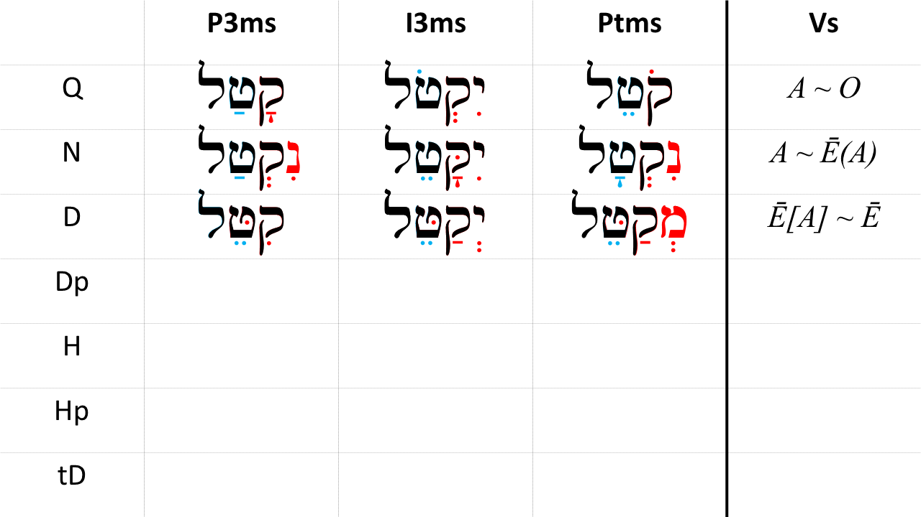

## Word Warm-up

[Click to open Word Warm-up video in a new tab](https://youtu.be/6A3f3WemMmE)

## Verses Warm-up

[Click to open Verses Warm-up video in a new tab](https://youtu.be/NGT8fiuGGp0)

## Worksheets: Piel Strong Paradigms

Use your knowledge of the $Pre$, $Suf$, and $V_{S}$ of the Piel stem, complete the worksheet until you can do it once through correctly.

Strive for pattern recognition over rote memorization.

[Name of worksheet](26_piel_strong_paradigms.pdf)

## 26.13 Ruth Pursuit Analysis

We are now at the exciting stage where we can begin to stitch together an analysis of Ruth 1. This will be much the same as you have done with the Hebrew Quest Study Passages. The main difference is you will not have Izzy’s video explanation. In that sense, you will now be wading a little deeper into the Hebrew pool!

We’re going to do this in small chunks over the next several lessons.

If Ruth 1 is “Act 1” of the drama, then we’ll start with what is essentially “scene 1”: Ruth 1:1-6.

YOUR QUEST

1. Read Ruth 1:1-6 in the Hebrew text and underline any words or forms do you not recognize
   * For the first time, try doing this without any study aids, including your Ruth Pursuit Translation Worksheet
   * Then as needed, look up the words you don’t recognize
2. Using what you have learned about syntax/phrase constructions and context, provide your own interpretative translation (using whatever resources you’d like!)
   * You may wish to compose a structural outline of “mini-scenes” identified by conjunctive or disjunctive clauses, quotations, or other constructions
3. Compare your version with translations such as JPS, KJV, ESV, NASB, NIV, or NLT.
   * At what points do you agree and disagree with translation decisions made by these publications? It’s OK to disagree!

This exercise is for you. You do not have to turn this in and it will not be graded as a part of this course. We would encourage you to share your passage with the Holy Language Institute Tribe for their edification.

## Hebrew Quest Study Passage: Exodus 31

[Blank copy of Exodus 31](https://docs.google.com/document/d/1uRkk2MNy6-8CqSzXQAadDqhnHqUTI6i7Bd6OOxCbYjQ/edit?usp=sharing)

1. Read through the passage straight through
2. Now re-read the passage critically, highlighting ([lexicon here](https://holylanguage.com/resources-dictionaries.php) and translating (you will need to parse verbs to translate) 3.[Watch Izzy’s *Hebrew Quest* video (video opens in a new tab)](https://holylanguage.com/exodus-31.php)
3. After the video, assess your translation. How close was it?
4. How did the Ruach HaQodesh speak to you through the passage?

Optionally, you may complete the passage memorization in Memrise [here](https://app.memrise.com/course/5406435/hebrew-quest-lessons-1-to-40/29/garden/learn/?source_element=level_details_session&source_screen=level_details).

## X Quest Quiz

Open Quest Quiz #xx in a new window

## X Claim your next Twelve Tribes Badge!

Check to be sure you have have completed all activities through this lesson, then fill out the form below.

Check to be sure you have completed all ACTIVities here, complete the certification below, and your badge will be on its way!

# 27 The Piel Stem - Weak Verbs

To comprehend Biblical Hebrew, we must be able to . . .

Say something general bridging the desired outcome above with the learning objectives below

LESSON ITINERARY

1. learning_objective_1
2. learning_objective_2
3. learning_objective_3
4. learning_objective_4
5. learning_objective_5
6. learning_objective_6
7. learning_objective_7

EQUIPMENT CHECK

Before continuing, can you describe the following concepts?

## First Thought

### בֹּ֤אוּ שְׁעָרָ֨יו ׀ בְּתוֹדָ֗ה חֲצֵרֹתָ֥יו בִּתְהִלָּ֑ה הֽוֹדוּ־ל֝֗וֹ בָּרֲכ֥וּ שְׁמֽוֹ׃

*Enter His gates with thanksgiving And His courts with praise. Give thanks to Him, bless His name. (Psalms 100:4)*

Listen to the verse in Hebrew:

Your browser does not support the audio element.

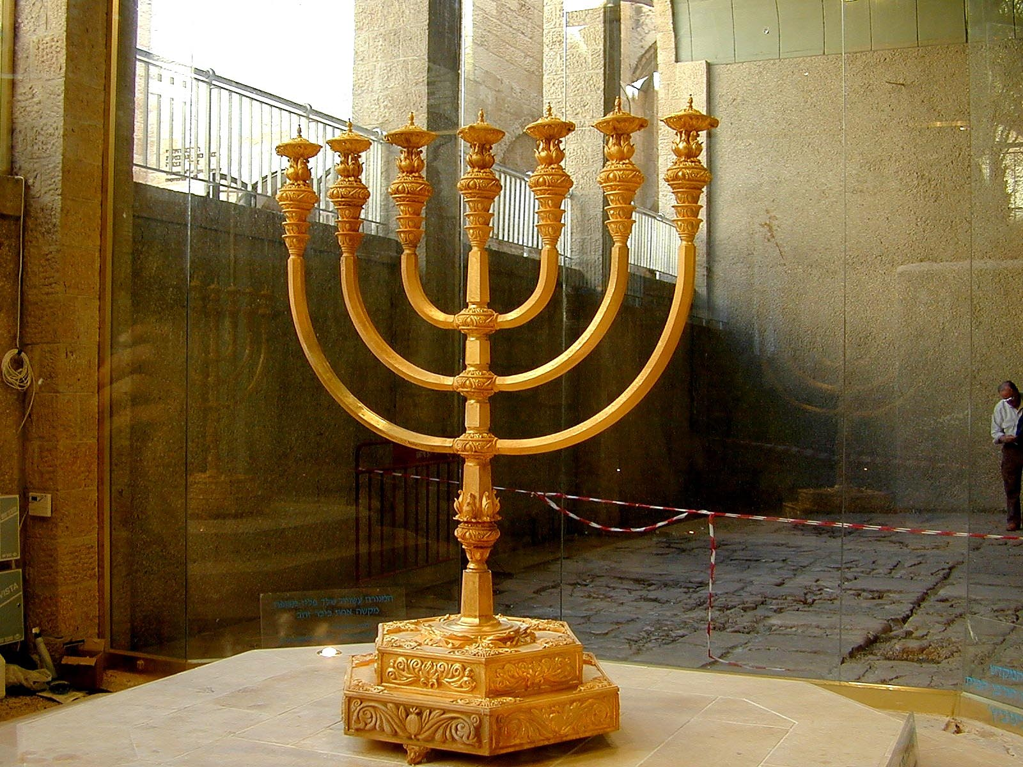

Figure 27.1: Golden menorah for third temple. Courtesy of the [Pictorial Library of Bible Lands](https://www.bibleplaces.com)



## 27.1 3-Guttural

* 3-G verbs will change the Stem Vowel
* In the Piel, we can determine the Stem by the $Pre$ and $Suf$, so we can effectively ignore what happens to the $V_{S}$
* Strong - $V_{S}=\overset{‾}{E}(A)∼\overset{‾}{E}$
* 3-ע/ח - $V_{S}=A∼A$
* 3-א - $V_{S}=\overset{‾}{E}∼\overset{‾}{E}(A)$
* 3-ה - The same as 3-ה in other stems
  + Memorize the 3-ה endings:



## 27.2 2-Aleph/Resh often cause DP $V_{1}=\overset{‾}{E}$ and $V_{1}=\overset{‾}{A}$ in all other forms

* 2-G verbs will take Hateph vowel instead of Vocal Sheva
  + By know, you already know this. Whenever you see a hateph vowel just substitute a Sheva to get back to the Strong paradigm
  + DP3cp - קִטְּלוּ (strong) is נִחֲלוּ (2-G)
* 2-G and 2-ר will reject the Dagesh that is diagnostic of the Piel stem
  + 2-ר/א will almost always have Compensatory Lengthening
    - DP2ms, Not *בִרַּ֫כְתָּ, but יְבֶרַ֫כְתָּ (Hireq lengthens to Tsere)
    - DI3ms, Not *תְּבַרֵךְ, but תְּבָרֵךְ(Patach lengthens to Qamets)
  + 2-ה/ח/ע usually do NOT have compensatory lengthening in Piel
    - DP3cp - Not *נִחֲּמוּ, but נִחֲמוּ

Most verbs either exhibit compensatory lengthening or they do not; however, some verbs may exhibit either pattern.

## 27.3 1-Nun

* As we know, what makes a 1-nun verb weak is the tendency to assimilate when the nun has a sheva
* $V_{1}$ is NEVER a sheva[78] so 1-Nuns are actually strong in the Piel (meaning there are no spelling changes compared to the Piel Strong Verb Paradigms)
* The challenge is that the $Pre$ of a 1-nun Piel Perfect verb is identical to the $Pre$ of a Niphal Perfect verb
* To demonstrate, consider נִגַּ֫שְׁתָּ, which is either DP2ms or NP2ms:
  + We do not know whether the נִ is the nun of the Niphal prefix or the 1-nun of the Root in the Piel
  + We also do not know whether the dagesh in גּ represents the assimilated 1-Nun in the Niphal or the Doubled $R_{2}$ in Piel
  + The $V_{S}=A$ in both the perfect 1st and 2nd person
    - and $V_{S}$ is reduced in the P3fs and P3cp in both stems
  + Context may help if the voice is clearly active or passive, but remember many Niphal meanings are active
  + You may need to consult a reference for these

The good news is that the P3ms $V_{S}$ are not the same in Piel ($\overset{‾}{E}$, as in נִצֵּל) and Niphal ($A$, as in נִַצָּל), so the far more common P3ms forms can be differentiated.

## 27.4 Biconsonantal: the Polel minor stem

* Biconsonantal verbs lack $R_{2}$ so there will be no Dagesh
* What happens is that $R_{3}$ is doubled (as if it were a geminate) and there is a Holem Vav (sometimes written as a defective Holem) at $V_{1}$
* Example רוּם
  + DP3ms רוֹמֵם - this is also the same as DM2ms and D∞
  + DP2ms רוֹמַ֫מְתָּ
* Biconsonantal Piel is sometimes referred to by the mnemonic, pôlēl
* Take note that pôlēl is also the form for the QPt

## 27.5 Geminate

* Gemininate verbs are sometimes strong
  + הִלֵּל or יְהַלֵּל
* Sometimes they are like pôlēl
  + פּוֹרֵר or יְפוֹלֵל

## 27.6 Other weak $R_{1}$ forms

Generally, these are not a problem because we are not trying to reduce $R_{1}$ or put a Dagesh Forte in $R_{1}$

## 27.7 What to Memorize for Piel Weak

* 3-ה verb endings in all stems
* 2-G/2-ר verbs lack the Dagesh in $R_{2}$- may have compensatory lengthening
* 1-נ verbs in DP = NP (except for 3ms)
* The mnemonic, pôlēl, to remind you of Biconsonantal or Gemininate

For most weak verbs, the strong diagnostics of the Piel are retained:

1. Dagesh Forte in $R_{2}$
2. “Piel-Pael” ( $V_{1}=I$ in the Perfect, and $V_{1}=A$ everywhere else)
3. $V_{P}= :$ where applicable (Imperfect and Participle)

## 27.8 Piel Weak Parsing Examples

* Word: כַּלּו

$Pre=$ ּ
  + כַּלּ
    - The Dagesh has us thinking Piel and the Patach fits with a non-Perfect Piel beginning.
    - There is no imperfect preformative, which indicates D(M/∞/A)
  + $Suf=$ וּ -
    - Could be P3cp, but we already ruled Perfect out above.
    - This is also 3mp Imperfect or 2mp Imperative
    - Based only on $Pre$ and $Suf$, we have a strong suspicion this is likely DM2mp
  + $Root=$ כלה -
    - We might think כלו, but there is no such word, and we’re already pretty sure the shurek is the $Suf$
    - When a $Suf$ begins with a vowel, the ה of a 3-ה verb drops.
    - From our vocabulary, we know כלה means “to finish”
  + $V_{S}$ has been erased as is common with 3-ה verbs
  + Result: DI2mp - Finish!
* Word: כִּלּוּ
  + Use the same detective work as כַּלּוֹ above, only the Hireq+Daghesh now takes us down a Piel Perfect trail
  + Result: DP3cp
* Word: שֵׁרְתו

$Pre$ ּ
  + : $V_{1}=\overset{‾}{E}$ might give you pause, but when you look at the next letter, you see a Resh, which rejects the Dagesh forte.
    - The first question to ask is, “I wonder whether this was Hireq+Dagesh originally? Given that there is no other prefix or preformative, this could be Piel Perfect.”
  + $Suf=$ Shurek P3cp/I3mp/M2mp
    - The lack of preformative rules out this being an I3mp
    - There are no imperatives that have $V_{1}=I/\overset{‾}{E}$
  + $Root=$ שׁרת
  + $V_{S}=:$, The original $V_{S}$ (whatever it was) has been reduced by the Sheva of the finite sufformative. As it is, we have enough to conclude that this is Piel Perfect.
  + Result: DP3cp - they served

## 27.9 Top 10 Piel Verbs

1. דָּבַר - (Q) to speak; (D) speak to, with or about (someone or something) (1,085x in the Piel)
2. צָוָה - (D) to command, give an order, charge (487x)
3. שָׁלַח - (Q) to send, stretch out; (D) send, stretch out, send away, expel, let go free (267x)
4. בָּרַךְ - (QPp) blessed, praised, adored; (D) bless, praise (233x)
5. בָּקַשׁ - (D) to seek (to find or obtain), search for, look for, discover, demand, require (222x)
6. כָּלָה - (Q) to (be) complete, be finished, be at an end,come to an end; (D) complete, finish, bring to an end (141x)
7. כָּסָה - (Q) to cover, conceal, hide; (D) cover (up), conceal, clothe (132x)
8. הָלַל - (D) to praise, sing hallelujah (113x)
9. מָלֵא - (Q) to be full, fill (up); (D) fill, perform, carry out, consecrate as priest (111x)
10. שָׁרַת - (D) to minister, serve, attend to the service of God (98x)

## Word Warm-up

[Click to open Word Warm-up video in a new tab](https://youtu.be/b_Iu9NXRQS8)

## Verses Warm-up

[Click to open Verses Warm-up video in a new tab](https://youtu.be/nIcuyVOHIhw)

## Ruth Pursuit

Identify, parse, and translate the two Piel verbs in Ruth 1

Make sure you can identify the Piel forms by their diagnostic indicators: $V_{1}=I∼A$ and a Daghesh Forte in $R_{2}$ that does not represent an assimilated letter in a non-Piel form.

* [Blank copy of Ruth 1](https://drive.google.com/file/d/1qcfTKAlTJGChC2eYCMhSbY2w-ibzCcDV/view?usp=sharing)
* [Ruth Pursuit Answer Key #xx](./images/27_Ruth_Pursuit_KEY.pdf)

## Hebrew Quest Study Passages: Psalms 1 and 27

[Blank copy of Psalms 1](https://docs.google.com/document/d/16fIA7dWqvQ-0GFpcwTC-tKwAr1-GgxDxlQN09_kGX3o/edit?usp=sharing)

[Blank copy of Psalms 27](https://docs.google.com/document/d/13erJPTE91FuYRR8OZWlASBpwn_r_x2YSkS2ikFPcAHc/edit?usp=sharing)

1. Read through the passages straight through
2. Now re-read the passage critically, highlighting ([lexicon here](https://holylanguage.com/resources-dictionaries.php) and translating (you will need to parse verbs to translate)
3. Watch Izzy’s *Hebrew Quest* videos
   * [Psalm 1](https://holylanguage.com/psalm-1.php)
   * [Psalm 27](https://holylanguage.com/psalm-27.php)
4. After the video, assess your translation. How close was it?
5. How did the Ruach HaQodesh speak to you through the passage?

Optionally, you may complete the passage memorization in Memrise [here](https://app.memrise.com/course/5406435/hebrew-quest-lessons-1-to-40/30/garden/learn/?source_element=level_details_session&source_screen=level_details).

## X Quest Quiz

Open Quest Quiz #xx in a new window

## X Claim your next Twelve Tribes Badge!

Check to be sure you have have completed all activities through this lesson, then fill out the form below.

Check to be sure you have completed all ACTIVities here, complete the certification below, and your badge will be on its way!

# 28 The Pual Stem - Strong Verbs

The Pual stem has a diagnostic Qibbuts as $V_{1}$, making this stem super easy to recognize.

The Pual occurs 423 times in the Hebrew Bible:

* Perfect 146
* Imperfect 85
* Participle: 190
* The Pual never occurs in DpM, and occurs only once each in Dp∞ and DpA

LESSON ITINERARY

1. Translate the Pual
2. Recognize the Pual

EQUIPMENT CHECK

Before continuing, can you describe the following concepts?

* The diagnostics of the Piel Strong Paradigm

## First Thought

### בְּחֶ֣סֶד וֶ֭אֱמֶת יְכֻפַּ֣ר עָוֺ֑ן וּבְיִרְאַ֥ת יְ֝הוָ֗ה ס֣וּר מֵרָֽע׃

*By lovingkindness and truth iniquity is atoned for, And by the fear of Adonai one keeps away from evil. (Proverbs 16:6)*

Listen to the verse in Hebrew:

Your browser does not support the audio element.



Figure 28.1: Megiddo pass aerial from northeast. This area was highly strategic throughout antiquity. Whoever held it could control all movement in the region. Pharaoh Thutmose III once remarked, ‘taking Megiddo is like taking 1000 cities.’ This is also the suggested location of the staging area for the so-called ‘Battle of Armageddon’ described in the book of Revelation. Courtesy of the [Pictorial Library of Bible Lands](https://www.bibleplaces.com)



## 28.1 Pual Verb Stem Table and Meaning

|  |  |  |  |
| --- | --- | --- | --- |
|  | Active Voice | Passive Voice | Reflexive Voice |
| Simple Action | Qal | Niphal | Niphal |
| Cause a State | Piel | *PUAL* | Hitpael |
| Cause an Action | Hiphil | Hophal |  |

The Pual is the Passive of the Piel, or sometimes, the passive of the Qal

* שׁלם
  + D: To repay
  + Dp: To be repaid
* הלל
  + Q: To praise
  + Dp: to be praised
* ילד
  + Q: To give birth
  + D: To cause to give birth (be a midwife)
  + Dp: To be born

## 28.2 Parsing Clues - *Pre*: $V_{1}=U$- ALWAYS for strong verbs

* The Pual is very consistent making it easily recognizable
  + $V_{1}=U$- ALWAYS for strong verbs
* Perfect: קֻטּ
* Imperfect: יְקֻט

$V_{P}= :$ ּּ
  + (I1cs/I1cp never occurs)
* Parcitiple: ּמְקֻט

The Qibbuts under the first root consonant distinguishes the Pual Form

## 28.3 Parsing Clues - $V_{S}=A$ and Dagesh Forte in $R_{2}$

* $V_{S}=A$- ALWAYS for strong verbs (unless reduced by the Sheva of the Perfect Sufformative)
  + I.e. $V_{S}=A∼A$
  + Pt lengthens as expected: $V_{S}=\overset{‾}{A}$
* The Pual retains the other diagnostics of the Piel:
  + Daghesh Forte in $R_{2}$

## 28.4 Pual: what to memorize

* Parsing code: Dp
  + ‘D’ because $R_{2}$ is doubled
  + ‘p’ because passive
$V_{P}= :$

$V_{1}=U$

$V_{S}=A$

* Qibbuts ($R_{1}$)+Daghesh+Patach is diagnostic of Pual
* Like Piel, beware when $R_{2}$ is guttural, Resh, or SQiN eM LeVY

## 28.5 X Perfect

Qibbuts in $V_{1}$ always

|  |  |  |  |
| --- | --- | --- | --- |
| Sing | Paradigm | Plural | Paradigm |
| 3ms | קֻטַּל | 3cp | קֻטְּלוּ |
| 3fs | קֻטְּלָה |  |  |
| 2ms | קִטַּ֫לְתָּ | 2mp | קֻטַּלְתֶּם |
| 2fs | קֻטַּלְתְּ | 2fp | קֻטַּלְתֶּן |
| 1cs | קֻטַּ֫לְתִּי | 1cp | קֻטַּ֫לְנוּ |

X Perfect Strong from *Hebrew Quest* Chapter 15

Your browser does not support the audio element.

## 28.6 X Imperfect

* Qibbuts in $V_{1}=U$ always
* If there is a preformative, $V_{P}= :$ always

|  |  |  |  |
| --- | --- | --- | --- |
| Sing | Paradigm | Plural | Paradigm |
| 3ms | יְקֻטַּל | 3mp | יְקֻטְּלוּ |
| 3fs | תְּקֻטַּל | 3fp | תְּקֻטַּ֫לְנָה |
| 2ms | תְּקֻטַּל | 2mp | תְּקֻטְּלוּ |
| 2fs | תְּקֻטְּלִי | 2fp | תְּקֻטַּ֫לְנָה |
| 1cs | אֲקֻטַּל | 1cp | נְקֻטַּל |

X Imperfect Strong from *Hebrew Quest* Chapter 15

Your browser does not support the audio element.

## 28.7 X Participle

* Qibbuts in $V_{1}$ always
* Mem+Sheva prefix always

|  |  |  |  |
| --- | --- | --- | --- |
| Sing | Paradigm | Plural | Paradigm |
| ms | מְקֻטָּל | mp | מְקֻטָּלִים |
| fs | מְקֻטֶּ֫לֶת | fp | מְקֻטָּלוֹת |

### Participle Prefixes in the Derived Stems

Again we present this table for review:

|  |  |
| --- | --- |
| Stem | Prefix |
| Niphal | נִ |
| Piel | מְ |
| PUAL | מְ |
| Hiphil | ַמ |
| Hophal (u-class) | מֻ |
| Hophal (o-class) | ָמ |
| Hithpael | תִמְ |

## 28.8 Pual Parsing Examples

* Qibbuts ($R_{1}$)+Daghesh+Patach is diagnostic of Pual
* Word: גִּדְּלוּ
  + Result: DP3cp
* Word: גֻּדְּלוּ
  + Result: DpP3cp

## 28.9 Stem Comparison Table

* Here is the Stem Comparison Table showing the stems we have studied thus far

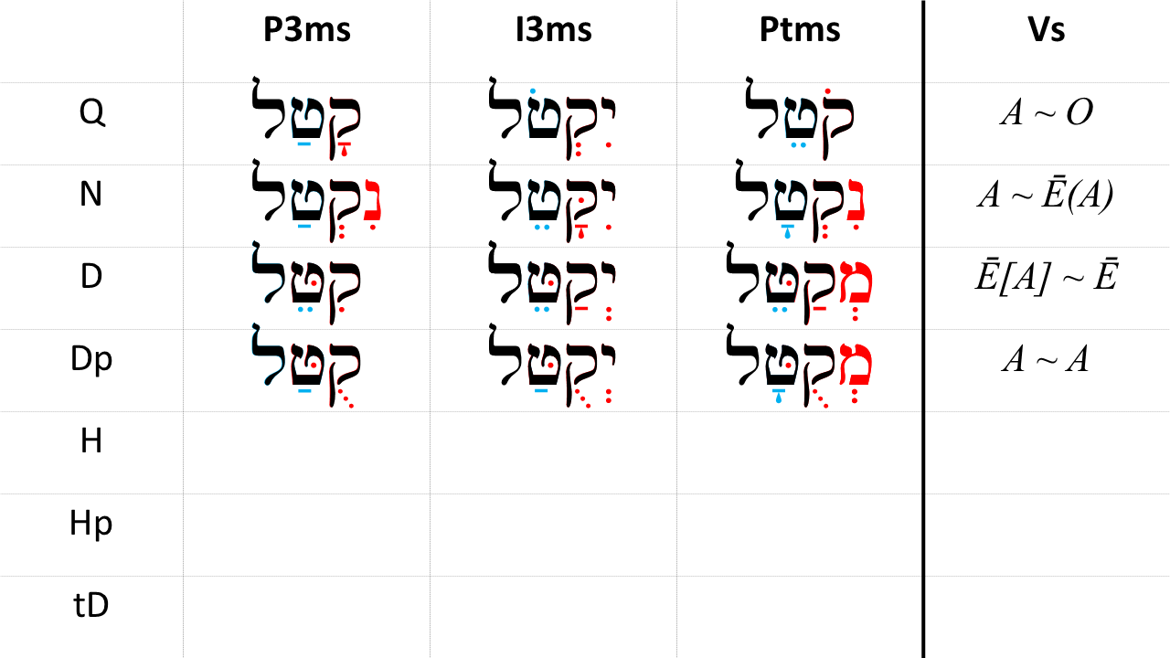

## Word Warm-up

[Click to open Word Warm-up video in a new tab](https://youtu.be/ujh7gojxD9Q)

## Verses Warm-up

[Click to open Verses Warm-up video in a new tab](https://youtu.be/x6Sg3_NbX3w)

## Ruth Pursuit Analysis

It’s time for the next segment of translating Ruth. This time, we’ll start with “Scene 2”: Ruth 1:7-10.

YOUR QUEST

1. Read Ruth 1:7-10 in the Hebrew text and underline any words or forms do you not recognize
   * For the first time, try doing this without any study aids
   * Then as needed, look up the words you don’t recognize
2. Using what you have learned about syntax/phrase constructions and context, provide your own interpretative translation
   * You may wish to compose a structural outline of “mini-scenes” identified by conjunctive or disjunctive clauses, quotations, or other constructions
3. Compare your version with translations such as JPS, KJV, ESV, NASB, NIV, or NLT.
   * At what points do you agree and disagree with translation decisions made by these publications?

This exercise is for you. You do not have to turn this in and it will not be graded as a part of this course. We would encourage you to share your passage with the Holy Language Institute Tribe for their edification.

## X Claim your next Twelve Tribes Badge!

Check to be sure you have have completed all activities through this lesson, then fill out the form below.

Check to be sure you have completed all ACTIVities here, complete the certification below, and your badge will be on its way!

## OPTIONAL Worksheets: Pual Paradigm

After you have memorized the information in the “what to memorize” section, see if you can reconstruct the Pual paradigm using this worksheet.

[Pual Strong Paradigms](28_pual_strong_paradigms.pdf)

## OPTIONAL Hebrew Quest Study Passage: Revelation 1

YOUR HEBREW QUEST

1. Read through the passage straight through - [Blank copy of Revelation 1](https://docs.google.com/document/d/1EfxyZpTDzP-eaXgVAx4nWcdETV_fActF8L3l-0QQvGA/copy)
2. Now re-read the passage critically, highlighting ([lexicon here](https://holylanguage.com/resources-dictionaries.php) and translating (you will need to parse verbs to translate) 3.[Watch Izzy’s *Hebrew Quest* video (video opens in a new tab)](https://holylanguage.com/revelation-1.php)
3. After the video, compare your translation with versions such as ESV, NASB, NIV and/or NLT. How close was it?
4. How did the Ruach HaQodesh speak to you through the passage?
5. Complete associated Memrise module [here](https://app.memrise.com/course/5406435/hebrew-quest-lessons-1-to-40/31/garden/learn/?source_element=level_details_session&source_screen=level_details).

# 29 The Pual Stem - Weak Verbs

The distinctive $V_{1}=U$ is maintained in nearly all Pual weak forms. Regardless of other spelling changes, only the Pual has $V_{1}=U$.

It is only when $R_{2}$ rejects the Dagesh Forte AND has Compensatory Lengthening that there is a potential ambiguity.

LESSON ITINERARY

The Pual diagnostic $V_{1}=U$ is maintained in almost every weak verb form

EQUIPMENT CHECK

Before continuing, can you describe the following concepts?

* The Piel weak forms (Lesson 27)
* Pual strong diagnostics (Lesson 28)

## X First Thought

### גִּבּ֣וֹר בָּ֭אָרֶץ יִהְיֶ֣ה זַרְע֑וֹ דּ֭וֹר יְשָׁרִ֣ים יְבֹרָֽךְ׃

*His descendants will be mighty on earth; The generation of the upright will be blessed. (Psalms 112:2)*

As we are approaching the conclusion of the Hebrew GRAMMAR Quest course, a good question to start asking yourself is “what next?” Or, as Yeshua might ask, what are you going to do with this “light” you have been given? How can you enrich the lives of your family, friends and other people in your circle of influence? How can your descendants (whomever that might be in your situation) be blessed by your greater knowledge of Hebrew?

Listen to the verse in Hebrew:

Your browser does not support the audio element.

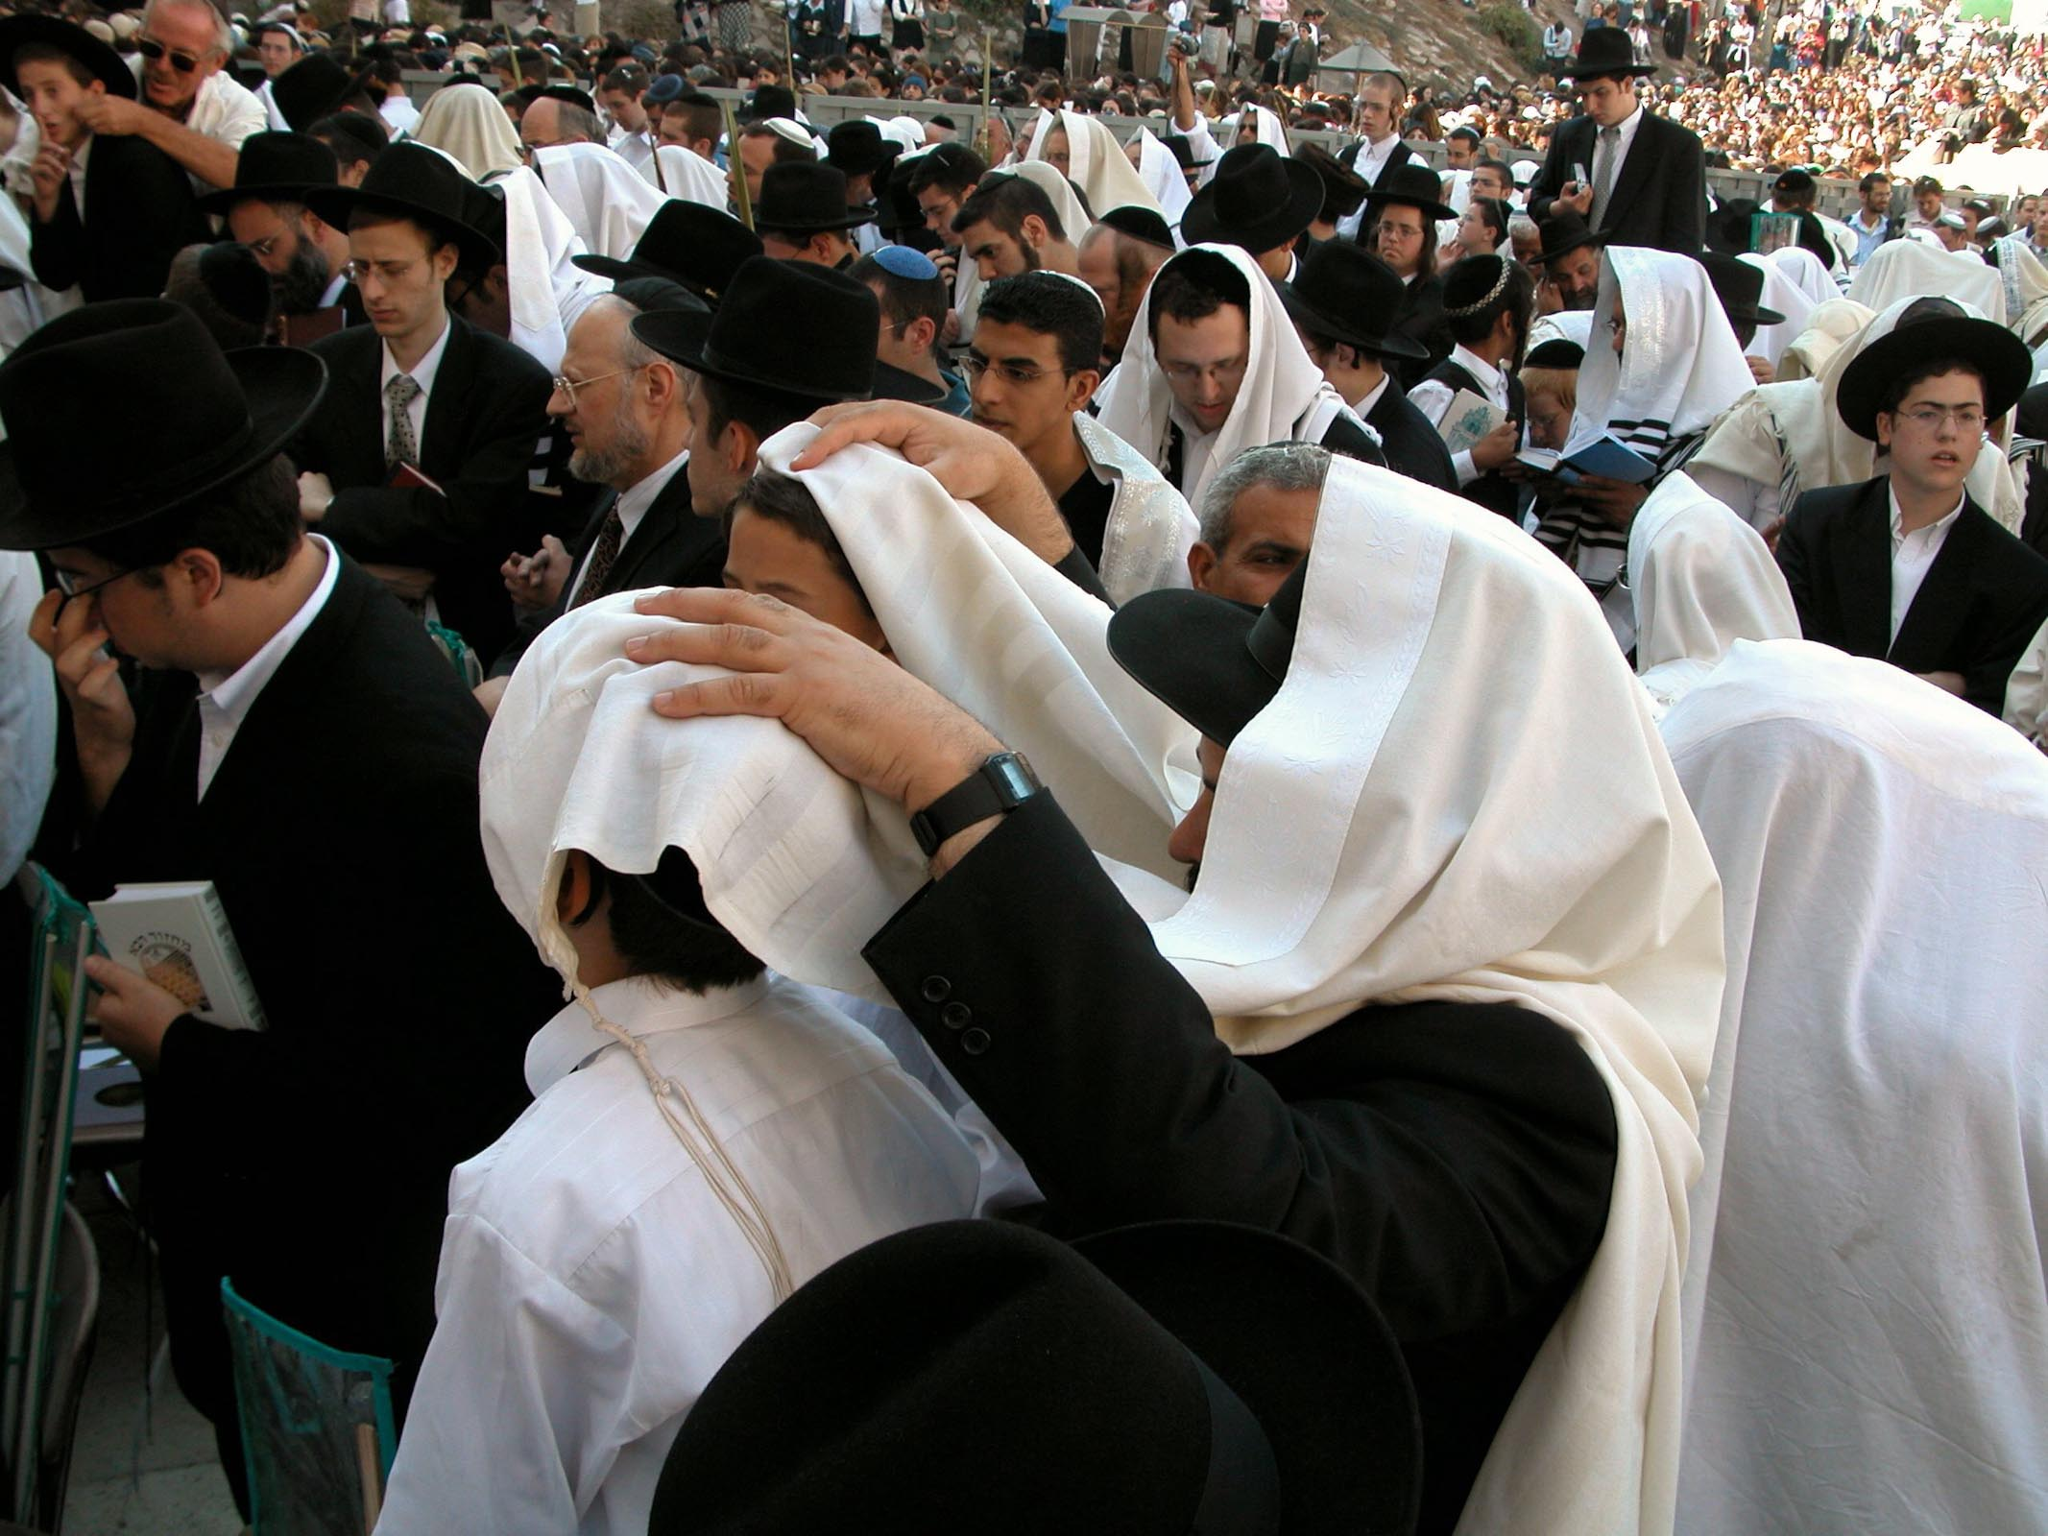

Figure 29.1: Man with hands on sons for priestly blessing. Courtesy of the [Pictorial Library of Bible Lands](https://www.bibleplaces.com)

## 29.1 The Pual diagnostic $V_{1}=U$ is maintained in almost all weak verbs

* $V_{1}=U$ is unique to the Pual stem
* Regardless of other changes that may occur, you will be able to identify the Pual stem in every case, with one exception
* You will still need to know the general weak verb concepts, particularly 3-ה behavior, to make sure you get to the correct Pual conjugation

## 29.2 2-Gutturals Reject Dagesh Forte

* When there is NO compensatory lengthening, $V_{1}=U$, so we can easily identify Pual
* When there IS Compensatory Lengthening, $V_{1}=\overset{‾}{O}$ (Holem)
  + DpP3ms - NOT *בֻּרַּךְ, but בֹּרַךְ
* Ambiguity arises because Qal Participle is also $V_{1}=\overset{‾}{O}$, but only the QPtFS and DpP3FS of a 2-G verb are identical.
* Because the Qal stem is much more frequent than the Pual, a correct 1st guess whenever $V_{1}=\overset{‾}{O}$ is Qal Participle. If you notice that $R_{2}$ is a guttural, you may need to do some more detective work

## 29.3 Biconsonantal: the Polal minor stem

In every respect except for $V_{S}=A$, this is identical to the Polel stem for the Piel discussed in Lesson 27. Polel $V_{S}=\overset{‾}{E}$

## Word Warm-up

[Click to open Word Warm-up video in a new tab](https://youtu.be/OO2Hy6apXlg)

## Verses Warm-up

[Click to open Verses Warm-up video in a new tab](https://youtu.be/YiO_gyPz-nM)

## 29.4 Ruth Pursuit

Not surprisingly, there are not Pual verbs in Ruth 1. We’ll skip the Ruth Pursuit for this lesson.

## Hebrew Quest Study Passage: Psalms 145

[Blank copy of Psalms 145](https://docs.google.com/document/d/1PjBUYB3ws2mdtdbHZsRz3Ji1W2dwyAvon3wJCrsP6qo/edit?usp=sharing)

1. Read through the passage straight through
2. Now re-read the passage critically, highlighting ([lexicon here](https://holylanguage.com/resources-dictionaries.php) and translating (you will need to parse verbs to translate) 3.[Watch Izzy’s *Hebrew Quest* video (video opens in a new tab)](https://holylanguage.com/psalm-145.php)
3. After the video, assess your translation. How close was it?
4. How did the Ruach HaQodesh speak to you through the passage?

Optionally, you may complete the passage memorization in Memrise [here](https://app.memrise.com/course/5406435/hebrew-quest-lessons-1-to-40/28/garden/learn/?source_element=level_details_session&source_screen=level_details).

## X Quest Quiz

Open Quest Quiz #xx in a new window

## X Claim your next Twelve Tribes Badge!

Check to be sure you have have completed all activities through this lesson, then fill out the form below.

Check to be sure you have completed all ACTIVities here, complete the certification below, and your badge will be on its way!

# 30 The Hiphil Stem - Strong Verbs

With the Hiphil stem, we move into the bottom row of our verb table. There are approximately 10,000 occurrences of the Hiphil stem in the Bible. The Hiphil stem has the nuance of causing an action, entering into a state, or declaring a state. Activities for this lesson include identifying Hiphil verbs in Ruth chapter one and reading verse by verse through Exodus 19.

LESSON ITINERARY

1. Understand the meaning of the Hiphil Stem to understand our Bible
2. Identify the Hiphil Beginning Combinations
3. Identify the $V_{S}$ pattern for when we can’t rely on the Beginning Combination
4. Understand the Hiphal Strong paradigms

## First Thought

### לְכוּ־נָ֛א וְנִוָּֽכְחָ֖ה יֹאמַ֣ר יְהוָ֑ה אִם־יִֽהְי֨וּ חֲטָאֵיכֶ֤ם כַּשָּׁנִים֙ כַּשֶּׁ֣לֶג יַלְבִּ֔ינוּ אִם־יַאְדִּ֥ימוּ כַתּוֹלָ֖ע כַּצֶּ֥מֶר יִהְיֽוּ׃

*“Come now, and let us reason together,” Says Adonai, "Though your sins are as scarlet, They will be as white as snow; Though they are red like crimson, They will be like wool. (Isaiah 1:18)*

This is a famous memory verse for traditional Jews and Christians/Believers in Messiah alike. How beautiful to be able to read and hear in the original Hebrew! Meditate on it!

יַאְדִּ֥ימוּ is Hiphil Imperfect 3ms

Listen to the verse in Hebrew:

Your browser does not support the audio element.

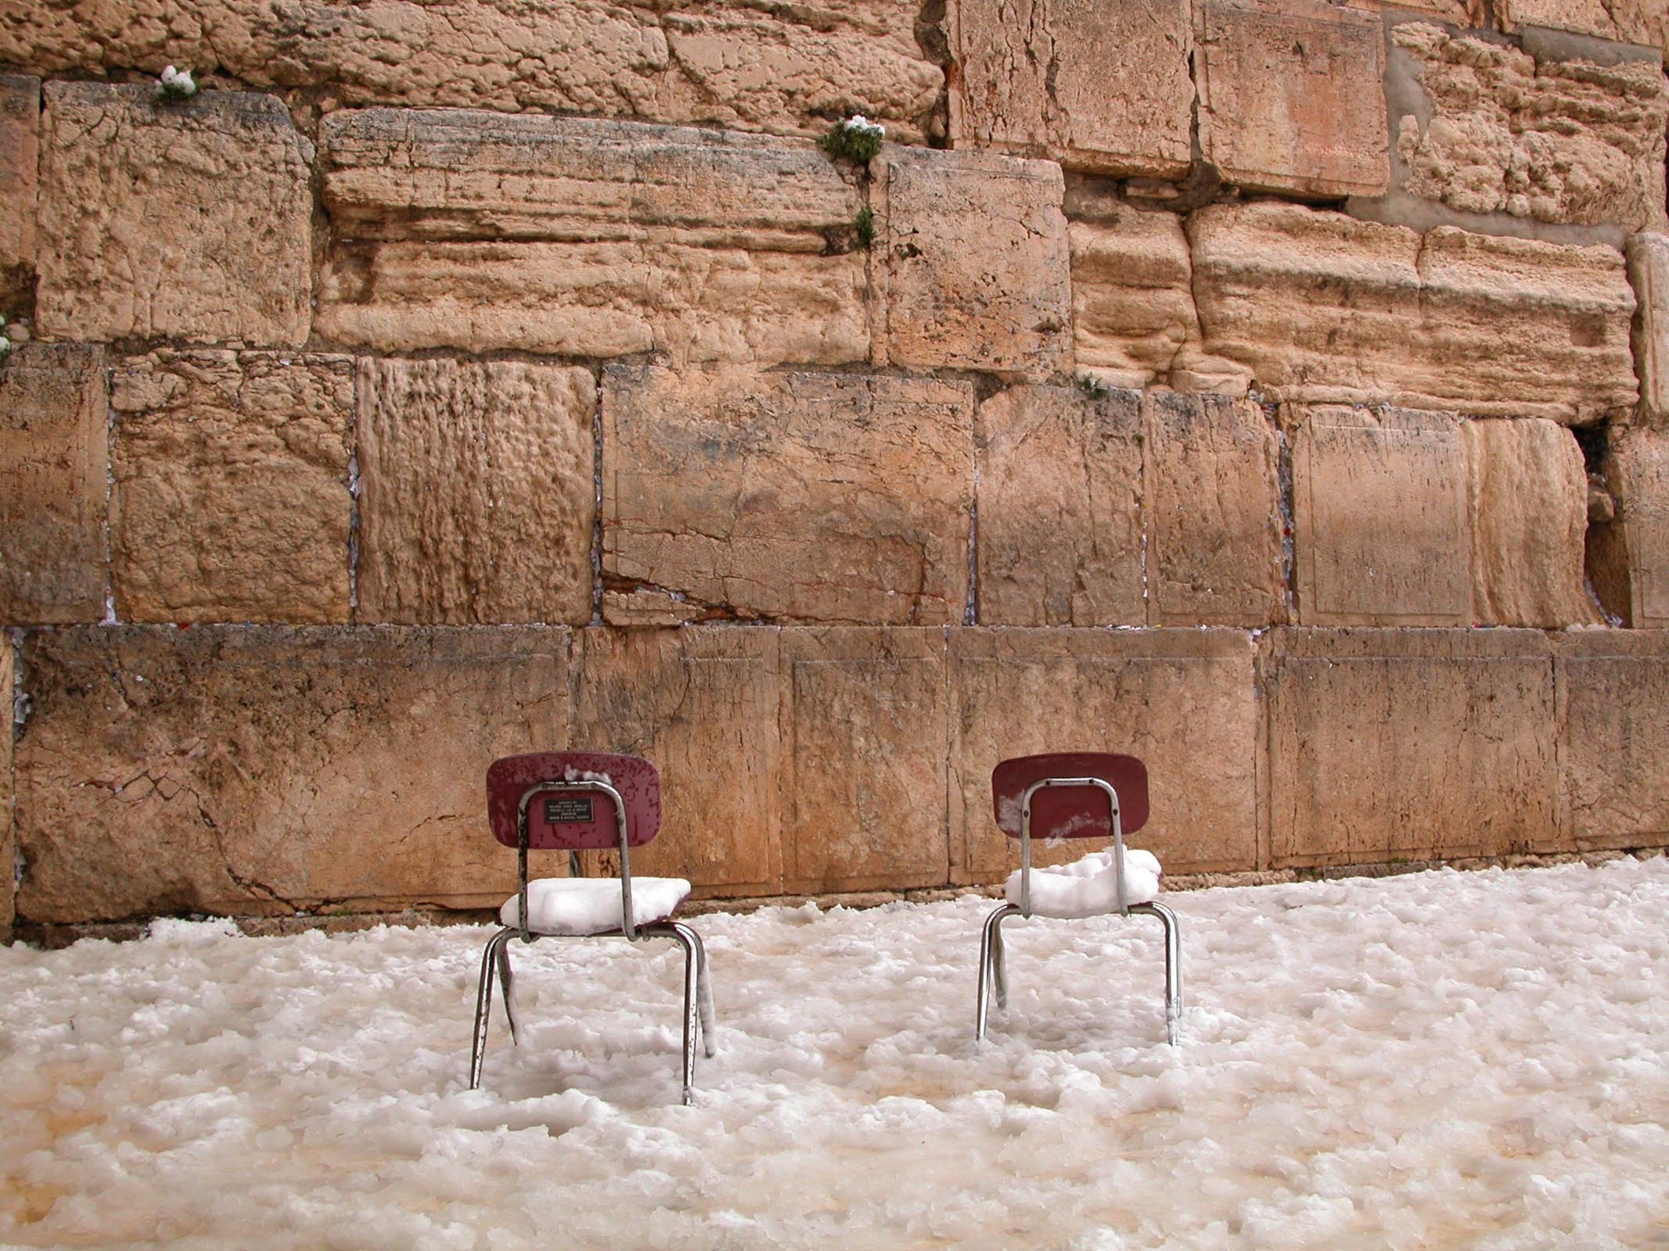

Figure 30.1: Western Wall with Chairs and Snow. Courtesy of the [Pictorial Library of Bible Lands](https://www.bibleplaces.com)

## 30.1 Meaning of the Hiphil

|  |  |  |  |
| --- | --- | --- | --- |
|  | Active Voice | Passive Voice | Reflexive Voice |
| Simple Action | Qal | Niphal | (Niphal) |
| Cause a State | Piel | Pual | Hitpael |
| Cause an Action | **HIPHIL** | Hophal |  |

Meanings:

* Causing an action
  + יצא
    - Q - to go out
    - H - to cause something to go out, i.e. to bring out
  + Sometimes passive of Qal - אכל
    - Q - to eat
    - H - to cause to eat, i.e. to feed
* To enter into or declare the state expressed by Qal
  + זקן
    - Q - to be old
    - H - to grow old
  + רשׁע
    - Q - to be guilty/wicked
    - H - to declare guilty
* Can also be simple action, like the Qal

Parsing Code: H (Hiphil)

## 30.2 Hiphil Strong Word Initial Combinations - Think “HIphil-HAphil”

* Preformatives
  + Hiphil verbs have preformative ה
  + Imperfects and Participles have the usual preformatives
 $V_{P}$

 + Remember “Hiphil-Haphil” (like “Piel-Pael”)
  + $V_{P}=I$ in the PERFECT (“Hiphil”)
  + $V_{P}=A$ EVERYWHERE ELSE (“Haphil”)
$V_{1}=:$

* $Pre$ combinatons are therefore:
  + הִקְ - HP
  + יַקְ - HI, and so forth for the other Imperfect forms
  + מַקְ - HM/H∞/HA
  + מַקְ - Pt
* In most cases, the “Hiphil-Haphil” mnemonic for $V_{P}$ is sufficient to identify the Hiphil stem
* Exceptions are when $R_{1}$ is a weak consonant - we will study these scenarios in Lesson 31

## 30.3 Hiphil

* + The Participle is usually the Perfect $V_{S}$ lengthened. In this case, Hireq+Yod is already long so no change.
* $V_{S}(HA)=\overset{‾}{E}$ as expected.

Note when $V_{S}=\hat{I}$, it may be written defectively as Hireq. It never reduces because it is an unchangable long vowel, even when it is written as Hireq.

### Exception to $V_{S}$ pattern

$V_{S}(HM2ms)=\overset{‾}{E}$

* #V_S(HIwc) is often Ē instead of Î (Hireq+Yod) when there is no pronominal suffix
  + הַקְטֵל
  + וַיַּקְטֵל

## 30.4 Don’t confuse ְ הִ with Niphal Preformative ָּּ הִ

* Hiphil - הִקְטִיל
  + No Daghesh Forte in $R_{1}$
* Niphal - הִקָּטֵל
  + Daghesh Forte in $R_{1}$
  + $V_{1}$ = Qamets

## 30.5 Don’t confususe Hiphil Imperfect ְ יַ with Qal Imperfect ְ יִ

* Remember “Hiphil” = Perfect; “Haphil” everywhere else
* Imperfect $V_{P}$ of Hireq is NOT Hiphil
* Ambiguity arises with 1G verbs because of the Rule of Sheva (“Hateph copy-cat”)
* As we’ve discussed, in 1G situations, we can’t necessarily rely on the stem’s $Pre$ to determine the stem
  + $V_{P}$ and $V_{1}$ will be Patach and Hateph Patach in both Hiphil and Qal
  + The Hiphil $V_{S}$ will be Hireq+Yod
    - HI3ms - יַעֲמִיד
    - QI3ms יַעֲמֹד
* 3ה lose their stem vowel so 1G+3ה are truly ambiguous
  + (Q/H)I3ms - יַעֲלֶה
  + Our trusted friend, context, will determine whether he “went up” (Qal), or whether he “brought (something) up” (Hiphil)

## 30.6 Hiphil Perfect Strong Paradigm

As with the other stems, we list these paradigms to aid in your recognition of these forms. It is not necessary to memorize these like you had to do with the Qal paradigms.

|  |  |  |  |
| --- | --- | --- | --- |
| Sing | Paradigm | Plural | Paradigm |
| 3ms | הִקְטִיל | 3cp | הִקְטִ֫ילוּ |
| 3fs | הִקְטִ֫ילָה |  |  |
| 2ms | הִקְטַ֫לְתָּ | 2mp | הִקְטַלְתֶּם |
| 2fs | הִקְטַלְתְּ | 2fp | הִקְטַלְתֶּן |
| 1cs | הִקְטַ֫לְתִּי | 1cp | הִקְטַ֫לְנוּ |

Hiphil Perfect Strong Paradigm from *Hebrew Quest* Chapter 15

Your browser does not support the audio element.

## 30.7 Hiphil Imperfect Strong Paradigm

|  |  |  |  |
| --- | --- | --- | --- |
| Sing | Paradigm | Plural | Paradigm |
| 3ms | יַקְטִיל | 3mp | יַקְטִ֫ילוּ |
| 3fs | תַּקְטִיל | 3fp | תַּקְטֵ֫לְנָה |
| 2ms | תַּקְטִיל | 2mp | תַּקְטִ֫ילוּ |
| 2fs | תַּקְטִ֫ילִי | 2fp | תַּקְטֵ֫לְנָה |
| 1cs | אַקְטִיל | 1cp | נַקְטִיל |

Hiphil Imperfect Strong Paradigm from *Hebrew Quest* Chapter 15

Your browser does not support the audio element.

## 30.8 Hiphil Imperative Strong Paradigm

|  |  |  |  |
| --- | --- | --- | --- |
| Sing | Paradigm | Plural | Paradigm |
| 2ms | הַקְטֵל | 2mp | הַקְטִ֫ילוּ |
| 2fs | הַקְטִ֫ילִי | 2fp | הַקְטֵ֫לְנָה |

Hiphil Perfect Strong Paradigm from *Hebrew Quest* Chapter 15

Your browser does not support the audio element.

## 30.9 Hiphil Infinitives Strong

|  |  |
| --- | --- |
| Type | Paradigm |
| ∞ | הַקְטִיל |
| A | הַקְטֵל |

$V_{S}$ will distinguish the two Infinitive forms. HA has a Tsere. * Note that HM2ms and HA are identical (contest will distinguish)

## 30.10 Participle Strong

|  |  |  |  |
| --- | --- | --- | --- |
| Sing | Paradigm | Plural | Paradigm |
| ms | מַקְטִיל | mp | מַקְטִילִים |
| fs | מַקְטֶ֫לֶת or מַקְטִילָה | fp | מַקְטִילוֹת |

* The מ prefix, which characterizes the Participle in the Piel, Pual, Hiphil, and Hophal stems
* $V_{S}$ = Hireq+Yod throughout (except for one of the FS forms)

### Participle Prefixes in the Derived Stems

|  |  |
| --- | --- |
| Stem | Prefix |
| Niphal | נִ |
| Piel | מְ |
| Pual | מְ |
| HIPHIL | ַמ |
| Hophal (u-class) | מֻ |
| Hophal (o-class) | ָמ |
| Hithpael | תִמְ |

## 30.11 Strong Summary

* In most cases, the “Hiphil-Haphil” mnemonic for $V_{P}$ is sufficient to identify the Hiphil stem - $V_{P}=I$ (Hireq) in the PERFECT, and $V_{P}=A$ (Pathach) in ALL OTHER CONJUGATIONS
  + The exceptions come when $R_{1}$ is a weak letter (discussed in Lesson 31)
* Hiphil Beginning Combination:
  + ְ הִ - HP
  + ְ יַ - (etc) HI
  + ְ הַ - HM/H∞/HA
  + ְ מַ - HPt
 $V_{S}=Î[A]∼Î(Ē)$

 + It’s important to memorize the $V_{S}$ formula for each derived stem for those times when we can’t rely on the beginning combination

## 30.12 Stem Comparison Table

* Here is the Stem Comparison Table showing the stems we have studied thus far

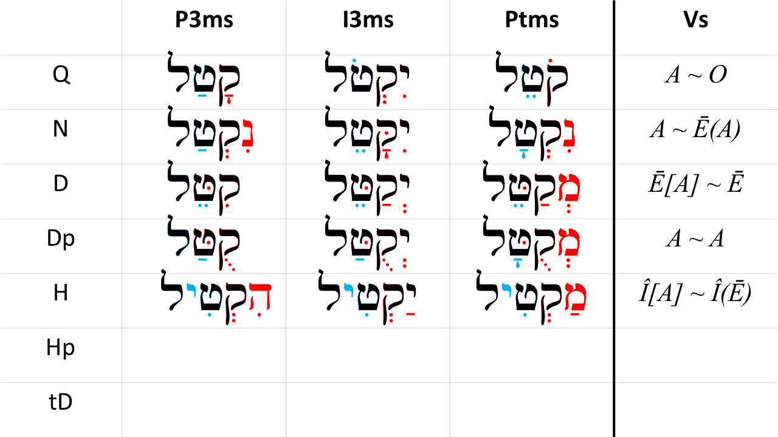

## Hiphil Strong Paradigm Worksheet

Our focus is on recognition, not repetition. As we stated, in most cases, the “Hiphil-Haphil” mnemonic for $V_{P}$ is sufficient to identify the Hiphil stem.

After you have reviewed the Anki material for this lesson, test yourself by completing the [Hiphil Paradigm Worksheet](./images/30_hiphil_strong_paradigms.pdf) using the $Pre$ and $V_{S}$ patterns you have learned. Repeat until you can complete a column without referring to the answers.

## Word Warm-up

[Click to open Word Warm-up video in a new tab](https://youtu.be/mBTsk07nIwQ)

## Verses Warm-up

[Click to open Verses Warm-up video in a new tab](https://youtu.be/-WjxwqdN5UQ)

## Ruth Pursuit Analysis

It’s time for the next segment of translating Ruth. We’ll continue with “Scene 2”: Ruth 1:11-14.

YOUR QUEST

1. Read Ruth 1:11-14 in the Hebrew text and underline any words or forms do you not recognize
   * As needed, look up any words you don’t recognize
2. Using what you have learned about syntax/phrase constructions and context, provide your own interpretative translation
   * You may wish to compose a structural outline of “mini-scenes” identified by conjunctive or disjunctive clauses, quotations, or other constructions
3. Compare your version with translations such as JPS, KJV, ESV, NASB, NIV, or NLT.
   * At what points do you agree and disagree with translation decisions made by these publications?

## Hebrew Quest Study Passage: Exodus 19

[Blank copy of Exodus 19](https://docs.google.com/document/d/1OGYrVxUGGPbwi8ioGi1bnt_vwA4YCNE2XZ2l3GQ8rQM/edit?usp=sharing)

* DO: File | Make a copy to store in your local Google Drive so you can highlight and edit
* DON’T: Request Edit Access

1. BEFORE WATCHING THE VIDEO, read through the passage on your own straight through one time - pick up as much as you can
2. Now re-read the passage critically
   1. Highlight any words you do not know and look them up in a [lexicon](https://holylanguage.com/resources-dictionaries.php)
   2. Parse as many verbs as you can
   3. Sketch out a translation - there is a blank line between each verse
3. Now, using your marked-up copy of the passage, [watch Izzy’s *Hebrew Quest* video (video opens in a new tab)](https://holylanguage.com/lesson-33.php)
4. After the video, assess your translation. How close was it?
   * You may wish to check your parsing [here](https://scholarsgateway.com/search/WLC-ESV/Exocus/19)
   * Check the “verbs” box to highlight all of the verbs in the passage, then hover over each verb for parsing information
5. How did the Ruach HaQodesh speak to you through the passage?

Optionally, you may complete the passage memorization in Memrise [here](https://app.memrise.com/course/5406435/hebrew-quest-lessons-1-to-40/33/garden/learn/?source_element=level_details_session&source_screen=level_details).

## X Quest Quiz

Open Quest Quiz #xx in a new window

## X Claim your next Twelve Tribes Badge!

Check to be sure you have have completed all activities through this lesson, then fill out the form below.

Check to be sure you have completed all ACTIVities here, complete the certification below, and your badge will be on its way!

# 31 The Hiphil Stem - Weak Verbs

To comprehend Biblical Hebrew, we must be able to . . .

Say something general bridging the desired outcome above with the learning objectives below

**LESSON ITINERARY**

1. learning_objective_1
2. learning_objective_2
3. learning_objective_3
4. learning_objective_4
5. learning_objective_5
6. learning_objective_6
7. learning_objective_7

**EQUIPMENT CHECK**

Before continuing, can you describe the following concepts?

* Parsing code H
* Hiphîl-Haphîl

$V_{S}=\hat{I}(A)∼\hat{I}(\overset{‾}{E})$

## First Thought

### תּ֘וֹרַ֤ת יְהוָ֣ה תְּ֭מִימָה מְשִׁ֣יבַת נָ֑פֶשׁ עֵד֥וּת יְהוָ֥ה נֶ֝אֱמָנָ֗ה מַחְכִּ֥ימַת פֶּֽתִי׃

*The precepts of Adonai are right, rejoicing the heart; The commandment of Adonai is pure, enlightening the eyes. (Psalms 19:8)*

The *Hebrew Quest* Study Passage for this lesson will continue with Exodus 20, the 10 commandments. Let us delight in the Law of Adonai!

Listen to the verse in Hebrew:

Your browser does not support the audio element.

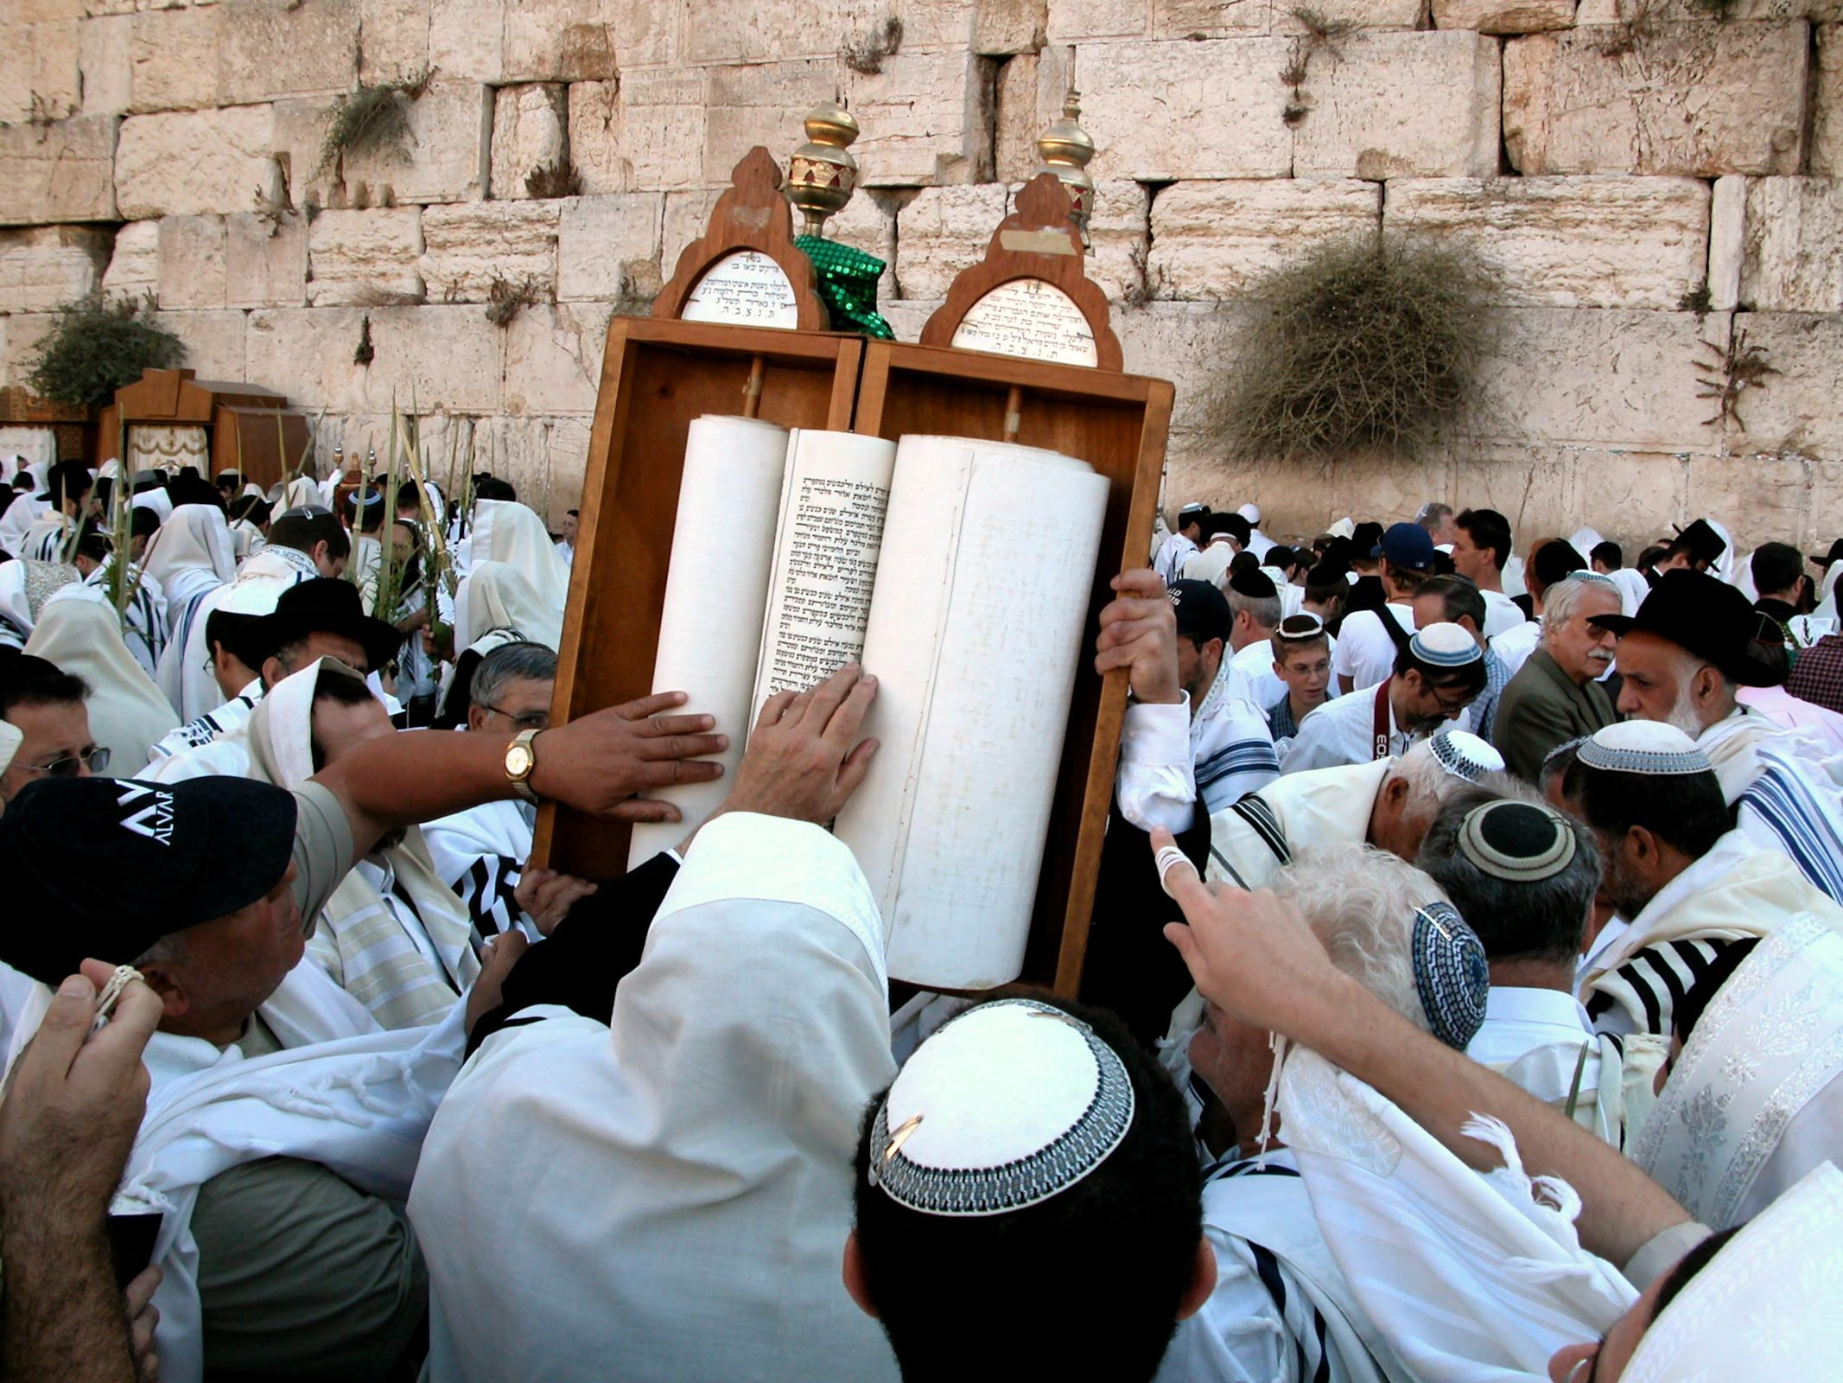

Figure 31.1: Men touching Torah Scroll at Western Wall. Courtesy of the [Pictorial Library of Bible Lands](https://www.bibleplaces.com)

## 31.1 Weak Verbs Review:

Since the impacts of Hophal weak verbs are more similar to Niphal (and less similar to Piel/Pual), let’s review some key concepts:

* A weak consonant affects the vowels that touch it
  + A weak $R_{1}$ affects $V_{P}$ and $V_{1}$ (but NOT $V_{S}$)
  + A weak $R_{2}$ affects $V_{S}$ and $V_{1}$ (but NOT $V_{P}$)
  + A weak $R_{3}$ affects $V_{S}$ and sufformative (but NOT $V_{1}$ or $V_{P}$)
* Biconsonantals and Geminates affect everything
* Gutturals take Hateph, not Sheva
  + In Hiphil Strong, $V_{1}$ always takes Sheva

## 31.2 1-Guttural

* Hiphil 1G $V_{1}$ takes Hateph vowel - $V_{P}$ affected by Rule of Sheva
  + HP -הֶעֱמִיד
  + All others:יַעֲמִיד
    - Qal Imperfect also beginsיַעֲ
    - Distinguish by Hiphil $V_{S}=\hat{I}$, which never reduces -יַעֲמִיד
    - Qal $V_{S}=O$-יַעֲמֹד

## 31.3 3-Hei

3-Hei lose the stem vowel and are ambiguousיַעֲלֶה - (Q/H)I3ms

## 31.4 X : what to memorize

## 31.5 Top 10 Hiphil Verbs

## Word Warm-up

[Click to open Word Warm-up video in a new tab](https://youtu.be/1R3dK5gr8pA)

## Verses Warm-up

[Click to open Verses Warm-up video in a new tab](https://youtu.be/Y7p9lMZ79FY)

## Ruth Pursuit

YOUR QUEST

Identify, parse, and translate the five Hiphil Verbs in Ruth 1.

Make sure you are able to identify the diagnostic indicators of these Hiphil verbs.

* [Blank copy of Ruth 1](https://docs.google.com/document/d/1bcT1J-fcVmD1Zn5Jk2nj0560tEddcgtbYZLkwaVVuyE/copy)
* [Ruth Pursuit Answer Key #31](./images/31_Ruth_Pursuit_KEY.pdf)

## Hebrew Quest Study Passage: Exodus 20

[Blank copy of Book ##](https://docs.google.com/document/d/1GSOQ432ytSqqvBEBOU2jI55cAiVWqzW9nmC-HRGWJvs/copy)

1. Read through the passage straight through
2. Now re-read the passage critically, highlighting ([lexicon here](https://holylanguage.com/resources-dictionaries.php) and translating (you will need to parse verbs to translate) 3.[Watch Izzy’s *Hebrew Quest* video (video opens in a new tab)](https://holylanguage.com/lesson-34.php)
3. After the video, assess your translation. How close was it?
4. How did the Ruach HaQodesh speak to you through the passage?

Optionally, you may complete the passage memorization in Memrise [here](https://app.memrise.com/course/5406435/hebrew-quest-lessons-1-to-40/34/garden/learn/?source_element=level_details_session&source_screen=level_details).

## X Quest Quiz

Open Quest Quiz #xx in a new window

## X Claim your next Twelve Tribes Badge!

Check to be sure you have have completed **all activities** through this lesson, then fill out the form below.

Check to be sure you have completed all ACTIVities here, complete the certification below, and your badge will be on its way!

# 32 The Hophal Stem - Strong Verbs

Of the seven major stems, the Hophal occurs with the least frequency (396 times, roughly split between the Perfect, Imperfect and Participle). Like the Pual, the Hophal has some distinctive characteristics making it relatively straightforward to identify.

LESSON ITINERARY

1. Meaning of the Hophal Stem
2. Hophal Strong paradigms

EQUIPMENT CHECK

Before continuing, can you describe the following concepts?

* The meaning of the Hiphil stem

## First Thought

### וְהָ֣אֲנָשִׁ֔ים טֹבִ֥ים לָ֖נוּ מְאֹ֑ד וְלֹ֤א הָכְלַ֙מְנוּ֙ וְלֹֽא־פָקַ֣דְנוּ מְא֔וּמָה כָּל־יְמֵי֙ הִתְהַלַּ֣כְנוּ אִתָּ֔ם בִּֽהְיוֹתֵ֖נוּ בַּשָּׂדֶֽה׃

*Yet the men were very good to us, and we were not insulted, nor did we miss anything as long as we went about with them, while we were in the fields. (1 Samuel 25:15)*

The Hebrew Quest Study Passage for this lesson is the story of David and Goliath from 1st Samuel 17. The geographic detail in the passage reminds us that although the narratives we read in the Hebrew Bible took place thousands of years ago and thousands of miles away, they nonetheless involved real people at real places. HaShem had them recorded for a reason. Through our study of Hebrew, we are able to connect with these great stories in a more intimate way. Praise Him for that!

Listen to the verse in Hebrew:

Your browser does not support the audio element.

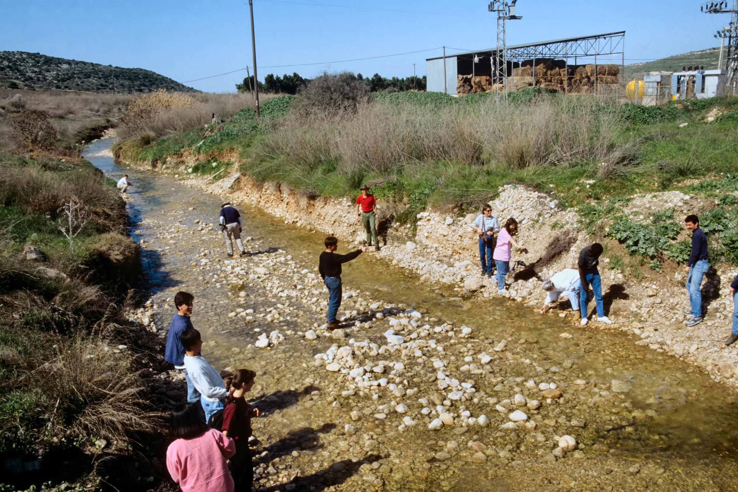

Figure 32.1: Elah brook with students picking smooth stones. Courtesy of the [Pictorial Library of Bible Lands](https://www.bibleplaces.com)

## 32.1 Meaning of the Hophal

|  |  |  |  |
| --- | --- | --- | --- |
|  | Active Voice | Passive Voice | Reflexive Voice |
| Simple Action | Qal | Niphal | (Niphal) |
| Intensive | Piel | Pual | Hitpael |
| Cause an Action | Hiphil | **HOPHAL** |  |

Meanings:

* Being Caused to Do Something
* Passive of Hiphil - יצא
  + Q - he went out
  + H - he brought out
  + Hp - he was brought out
* Sometimes passive of Qal - נתן
  + Q - to give
  + Hp - to be given

Parsing Code: Hp (passive of Hiphil)

## 32.2 Hophal Strong Parsing Clues - *Pre*: Think “Houûphal”

* Preformatives
  + Hophal verbs have preformative ה like the Hiphil
  + Imperfects and Participles have the usual preformatives
* $V_{P}=$ O, U, or Û, indicates Hophal (so a mnemonic for this Stem might be: “houûphal”)
  + The Hophal occurs with either u-class or o-class
  + O - Qamets Hatuf הָקְטַל
  + U - Qibbuts הֻקְטַל
  + Û - Shureq
    - הוּרַד (Iי)
    - הוּשַׁט (Biconsonantal)
    - הוּחַל (Geminate)
  + HŌ or HȎ almost always Hiphil 1-Yod (7x Hp)
* Hophal Strong Beginning Combinations are therefore (ק represents any non-weak letter):
  + הָקְ or הֻקְ - HpP
  + יָקְ or יֻקְ - (etc) HpI
  + מָקְ or מֻקְ - HpPt[79]

QAMETS HATUF

* We learned many lessons ago that $V_{1}$ of ָ followed by $V_{2}$ of Sheva is potentially ambiguous
  + QAMETS followed by VOCAL Sheva *or* QAMETS HATUF followed by SILENT Sheva
* When $V_{P}$ is ָ followed by $V_{1}$ of Sheva or Hateph Qamets Hatuf, $V_{P}$ is ALWAYS QAMETS HATUF
* Therefore, in the Hophal Stem, הָקְטַל is pronounced “hoq-TAL” (rhymes with “Hophal”).

## 32.3 Hophal Strong Parsing Clues - $V_{S}$ = A

* P,I,M,∞ is A ַ , like Pual  
* Particle stem is lengthened P3ms as expected - HpP3ms uses A ַַ so HpPt uses Ā ָ (only 8 Hp∞ and 2 HM in the Bible)  
* Absolute is Ē ֵַ as expected (only 6 HpA in the Bible)

## 32.4 Hophal Perfect Strong

* The standard Perfect sufformatives
* $V_{S}=$ Patach
* $V_{P}$ is variable between Qibbuts and Qamets Hatuf. Only the O-class is listed below and in the audio.
* Translate - “(he) was made king.”

|  |  |  |  |
| --- | --- | --- | --- |
| Sing | Paradigm | Plural | Paradigm |
| 3ms | הָקְטַל | 3cp | הָקְטְלוּ |
| 3fs | הָקְטְלָה |  |  |
| 2ms | הָקְטַ֫לְתָּ | 2mp | הָקְטַלְתֶּם |
| 2fs | הָקְטַלְתְּ | 2fp |  |
| 1cs | הָקְטַ֫לְתִּי | 1cp | הָקְטַ֫לְנוּ |

Hophal Perfect Strong from *Hebrew Quest* Chapter 15

Your browser does not support the audio element.

## 32.5 Hophal Imperfect Strong

* The standard Imperfect preformatives and sufformatives
* $V_{S}=$ Patach
* $V_{P}$ is variable between Qibbuts and Qamets Hatuf. Only the O-class is listed below and in the audio.
* Translate - “(he) will be made king”

|  |  |  |  |
| --- | --- | --- | --- |
| Sing | Paradigm | Plural | Paradigm |
| 3ms | יָקְטַל | 3mp | יָקְטְלוּ |
| 3fs | תָּקְטַל | 3fp | תָּקְטַ֫לְנָה |
| 2ms | תָּקְטַל | 2mp | תָּקְטְלוּ |
| 2fs | תָּקְטְלִי | 2fp | תָּקְטַ֫לְנָה |
| 1cs | אָקְטַל | 1cp | נָקְטַל |

Hophal Imperfect Strong from *Hebrew Quest* Chapter 15

Your browser does not support the audio element.

## 32.6 Hiphal Participle Strong

* The standard Participle prefix (מ)
* The standard $V_{S}$- lengthening of P3ms (Patach to Qamets
* The standard inflectional endings of the Participle
* Again, both Qibbuts and Qamets Hatuf are used interchangably
* Translate - “being made king”

|  |  |  |  |
| --- | --- | --- | --- |
| Sing | Paradigm | Plural | Paradigm |
| ms | מָקְטָל | mp | מָקְטָלִים |
| fs | מָקְטֶ֫לֶת | fp | מָקְטָלוֹת |

### Participle Prefixes in the Derived Stems

Again we present this table for review:

|  |  |
| --- | --- |
| Stem | Prefix |
| Niphal | נִ |
| Piel | מְ |
| Pual | מְ |
| Hiphil | ַמ |
| HOPHAL (u-class) | מֻ |
| HOPHAL (o-class) | ָמ |
| Hithpael | תִמְ |

## 32.7 Hophal Strong Summary

* Like $V_{1}$ in the Pual, the Hophal has a distinguishing O or U class $V_{P}$
* $V_{S}$ is almost always Patach
  + There is expected lengthening to Qamets in the Participle
  + The rare Infinitive Absolute has the expected Tsere (see Ruth Pursuit below)

## 32.8 Stem Comparison Table

* Here is the Stem Comparison Table showing the stems we have studied thus far

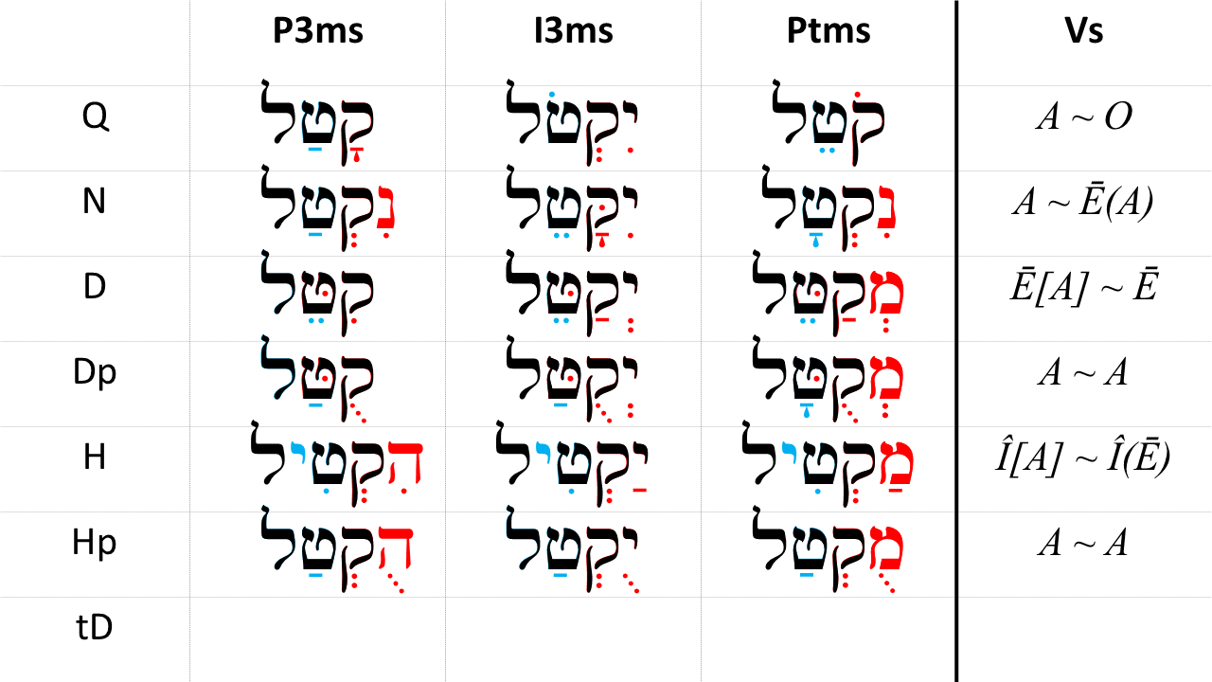

## Word Warm-up

[Click to open Word Warm-up video in a new tab](https://youtu.be/MdXXlMyr4Lg)

## Verses Warm-up

[Click to open Verses Warm-up video in a new tab](https://youtu.be/O5CU62O94Cw)

## OPTIONAL: Hophal Parsing Worksheet

If you desire additional paradigm practice, you may use this [Hophal parsing worksheet](./images/32_hophal_strong_paradigms.pdf)

There are no Hophal verbs in Ruth 1 so there will be no Ruth Pursuit for Lessons 32 or 33.

* There ARE two Hophal verbs in 2:11. Can you find them?
  + וַיַּ֤עַן בֹּ֙עַז֙ וַיֹּ֣אמֶר לָ֔הּ הֻגֵּ֨ד הֻגַּ֜ד לִ֗י כֹּ֤ל אֲשֶׁר־עָשִׂית֙ אֶת־חֲמוֹתֵ֔ךְ אַחֲרֵ֖י מ֣וֹת אִישֵׁ֑ךְ וַתַּֽעַזְבִ֞י אָּבִ֣יךְ וְאִמֵּ֗ךְ וְאֶ֙רֶץ֙ מֽוֹלַדְתֵּ֔ךְ וַתֵּ֣לְכִ֔י אֶל־עַ֕ם אֲשֶׁ֥ר לֹא־יָדַ֖עַתְּ תְּמ֥וֹל שִׁלְשֽׁוֹם׃
  + We mentioned previously that there are only six HpA forms in all of the Hebrew Bible (and some sources say there are only five). One of those forms is in Ruth 2:11. Note how $V_{S}$ is Tsere for the HpA verb, and how $V_{S}$ is Qamets in the HpP3ms verb that follows.
  + The verb root is נגד
  + The Daghesh Forte in the Gimmel represents the assimilated 1נ
* Dr. Beckman explains, “Infinitive Absolutes typically underscore the certainty of something. But in this past tense context where Boaz uses the word כֹּל, it seems more likely that his is referring to the completeness of the report that he has received.”[80]

## Ruth Pursuit Analysis

It’s time for the next segment of translating Ruth. We’ll continue with “Scene 2”: Ruth 1:15-19a.

YOUR QUEST

1. Read Ruth 1:15-19a (the first וַיְהִי marks the start of 19b) in the Hebrew text and underline any words or forms do you not recognize
   * There is one Hitpael form in this passage in verse 18 that we have not yet studied
2. Using what you have learned about syntax/phrase constructions and context, provide your own interpretative translation
3. Compare your version with translations such as JPS, KJV, ESV, NASB, NIV, or NLT.
   * At what points do you agree and disagree with translation decisions made by these publications?

## X Claim your next Twelve Tribes Badge!

Check to be sure you have have completed all activities through this lesson, then fill out the form below.

Check to be sure you have completed all ACTIVities here, complete the certification below, and your badge will be on its way!

## OPTIONAL Hebrew Quest Study Passage: 1 Samuel 17

::: {.box .map} YOUR HEBREW QUEST

1. Read through the passage - [Blank copy of 1 Samuel 17](https://docs.google.com/document/d/1jX0OyJq3--vHWysXkZfXKNDCUFvOf04TalAEQInX6C8/copy)
2. Now re-read the passage critically
   1. Highlight any words you do not know and look them up in a [lexicon](https://holylanguage.com/resources-dictionaries.php)
   2. Parse as many verbs as you can
   3. Sketch out a translation - there is a blank line between each verse
3. Now, using your marked-up copy of the passage, watch Izzy’s *Hebrew Quest* video (video opens in a new tab)
   * [part 1](https://holylanguage.com/samuel-17.1.php)
   * [part 2](https://holylanguage.com/samuel-17.2.php)
4. After the video, assess your translation. How close was it?
   * You may wish to check your parsing and translation [here](https://scholarsgateway.com/search/WLC-ESV/1%20Samuel/17)
   * Check the “verbs” box to highlight all of the verbs in the passage, then hover over each verb for parsing information
5. How did the Ruach HaQodesh speak to you through the passage?

Optionally, as we discussed in Lesson 17, you may complete the passage memorization in the separate Anki deck, or in Memrise [here](https://app.memrise.com/course/5406435/hebrew-quest-lessons-1-to-40/##/garden/learn/?source_element=level_details_session&source_screen=level_details).

# 33 The Hophal Stem - Weak Verbs

Hophal weak verb forms are about five-times as frequent as strong verbs. As with all the forms, we start with the strong verb diagnostics, which make it easier to understand the spelling changes that occur with weak verbs. By now, you should be well-acquainted with the concepts discussed in this lesson.

**LESSON ITINERARY**

1. 1G and 3ה Verbs prefer Qamets Hatuf as $V_{P}$
2. 1נ assimilates with $R_{2}$ as expected
3. Geminate/Biconsonantal Verbs prefer Shureq as $V_{P}$

**EQUIPMENT CHECK**

Before continuing, can you describe the following concepts?

* Identify Hophal Perfect, Imperfect, and Imperative Strong verbs

## First Thought

### נִשְׁאַ֥ר בָּעִ֖יר שַׁמָּ֑ה וּשְׁאִיָּ֖ה יֻכַּת־שָֽׁעַר׃

*Desolation is left in the city And the gate is battered to ruins. (Isaiah 24:12)*

As people of God, we are sometimes faced with situations where we are tempted to ask, “How could He let this happen?” The people of Isaiah’s time who witness the destruction of Jerusalem surely had similar questions. Most of the time, we can not provide a satisfactory answer. The only true choice is to relinquish any notion that we can control the situation and, like Job, trust in Him no matter what the outcome.

Listen to the verse in Hebrew:

Your browser does not support the audio element.

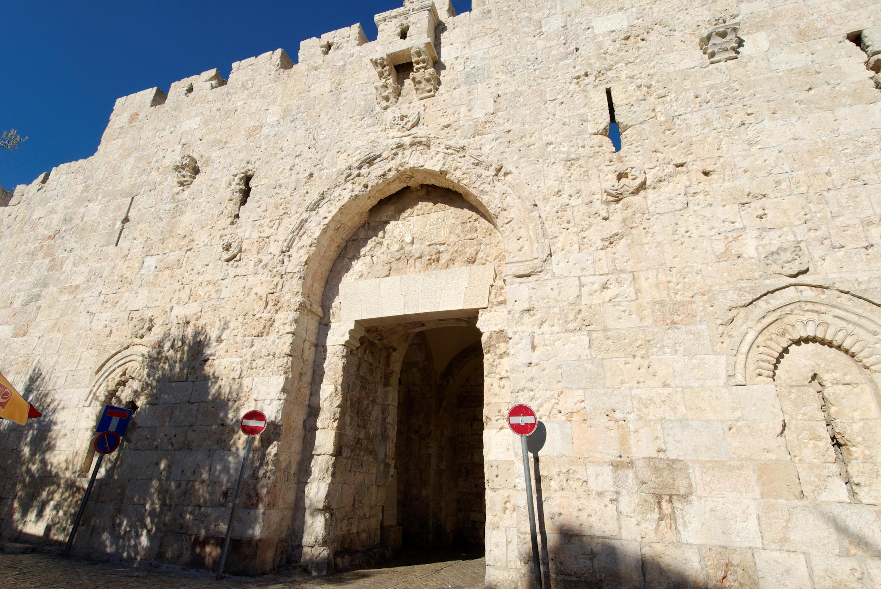

Figure 33.1: Zion Gate from south. The pockmarks in the walls are remants of the 1967 war to liberate the Old City. This time, the gate was battered but held! Courtesy of the [Pictorial Library of Bible Lands](https://www.bibleplaces.com)

## 33.1 1G and 3ה Verbs prefer Qamets Hatuf as $V_{P}$

* $V_{1}$ will generally be Hateph Qamets Hatuf
* $V_{S}$ follows the strong paradigm

## 33.2 1נ assimilates as expected

* Since $V_{1}$ is a Sheva, 1נ assimilates just as it does with QI and NP
* $R_{2}$ will take a Daghesh Forte, if allowed
* We saw this in the Ruth Pursuit of Lesson 32
  + הֻגֵּ֨ד הֻגַּ֜ד לִ֗י - “it has thoroughly been declared to me”
    - The verb root is נגד - to tell
    - The Daghesh Forte in the Gimmel represents the assimilated 1נ

## 33.3 Geminate/Biconsonant prefer Shureq as $V_{P}$

* The medial letter of the biconsonantal verb is dropped
* Only one geminate consonant is preserved - where possible, a Daghesh Forte will appear in the remaining consonant
* The Holem+Vav as connecting vowel in some forms of the Perfect is another indicator of the geminate verb

## 33.4 Top 10 Hophal Verbs

1. מוּת - (Q) to die; (H) kill, put to death; (Hp) be killed, suffer death (69x in the Hp)
2. נגד - (H) to tell, announce, report; (Hp) be told, be announced, be reported (35x)
3. בוֺא - (Q) to go in, enter, come to; (H) bring (in), come (in); (Hp) be brought (24x)
4. שׁזר - (HpPt) twisted; always spelled (21x all in Exod 26–39)
5. נכה - (H) to strike, smite, strike dead, destroy; (Hp) be struck down dead, be beaten (16x)
6. שׁלך - (H) to throw (down, into or away), cast; (Hp) be thrown, be cast (13x)
7. יבל - (H) to bring (as gift or tribute), lead; (Hp) be brought, be led (11x)
8. יצק - (Q) to pour (out); (Hp) be cast, be poured out, be emptied out (8x)
9. פקד - (Q)to attend, number, appoint, visit; (H) appoint, entrust; (Hp) be appointed (8x)
10. גלה - (Q) to uncover, reveal, disclose; (H) take into exile; (Hp) be deported (7x)

## Word Warm-up

[Click to open Word Warm-up video in a new tab](https://youtu.be/DDh5Oy485WU)

## Verses Warm-up

[Click to open Verses Warm-up video in a new tab](https://youtu.be/sTvLGMtaSpw)

## Ruth Pursuit

## OPTIONAL *Hebrew Quest* Study Passage: Psalms 45

YOUR HEBREW QUEST

1. Read through the passage - [Blank copy of Psalms 45](https://docs.google.com/document/d/1Wt1c4OYlK0y2EZnqczRG2U3BhTEzklbHIVg4eNyFhhs/copy)
2. Now re-read the passage critically
   1. Highlight any words you do not know and look them up in a [lexicon](https://holylanguage.com/resources-dictionaries.php)
   2. Parse as many verbs as you can
   3. Sketch out a translation - there is a blank line between each verse
3. Now, using your marked-up copy of the passage, [watch Izzy’s *Hebrew Quest* video (video opens in a new tab)](https://holylanguage.com/psalm-45.php)
4. After the video, assess your translation. How close was it?
   * You may wish to check your parsing [here](https://scholarsgateway.com/search/WLC-ESV/Psalms/45)
   * Check the “verbs” box to highlight all of the verbs in the passage, then hover over each verb for parsing information
5. How did the Ruach HaQodesh speak to you through the passage?
6. Complete Memrise [here](https://app.memrise.com/course/5406435/hebrew-quest-lessons-1-to-40/37/garden/learn/?source_element=level_details_session&source_screen=level_details).

# 34 The Hithpael Stem - Strong Verbs

This is one of the shortest and easiest chapters in Hebrew GRAMMAR Quest.

If you’ve made it this far, you’ve earned it!

There are just under 1000 instances of the Hitpael stem:

* tDP - 161
* tDI - 491
* tDM - 78
* tD∞ - 104
* tDA - 3
* tDPt - 147

## First Thought

### וַיַּסֵּ֧ב חִזְקִיָּ֛הוּ פָּנָ֖יו אֶל־הַקִּ֑יר וַיִּתְפַּלֵּ֖ל אֶל־יְהוָֽה׃

*Then Hezekiah turned his face to the wall and prayed to Adonai (Isaiah 38:2)*

Today in Jerusalem, the Western Wall is considered the holiest spot in Judaism. It is said to be the closest spot one can get to the Holy of Holies. While this wall was built in the time of King Herod (well after Hezekiah’s time), modern Jews and God-fearing gentiles consider it an honor to be able to follow in the tradition of Hezekiah and pray at the wall.

While we may be physicially removed from Jerusalem and the Western Wall, like Daniel, we can turn towards Jerusalem and bring our petitions to HaShem just as Hezekiah did centuries ago.

Why don’t you stop what you’re doing and pray towards Jerusalem right now?

Listen to the verse in Hebrew:

Your browser does not support the audio element.

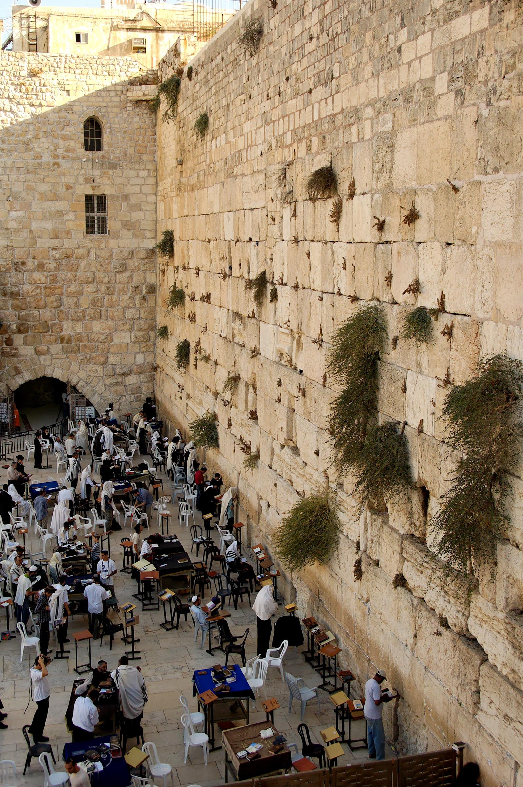

Figure 34.1: Men Praying at Western Wall. Courtesy of the [Pictorial Library of Bible Lands](https://www.bibleplaces.com)

## 34.1 Meaning

|  |  |  |  |
| --- | --- | --- | --- |
|  | Active Voice | Passive Voice | Reflexive Voice |
| Simple Action | Qal | Niphal | (Niphal) |
| Intensive | Piel | Pual | **HITPAEL** |
| Cause an Action | Hiphil | Hophal |  |

Meanings:

* Reflexive of the Piel - קדשׁ
  + Q - to be holy
  + D - to be sanctified
  + tD - to sanctify oneself
    - Because this is the most common use, the parsing code is tD - t because a Hitpael preformative always contains ת, and D because, like the Piel, $R_{2}$ takes a Doubling Daghesh Forte (if possible)
* Reciprocal - ראה
  + Q - to see
  + tD - to look at one another
* Iterative - הלך
  + Q - to walk
  + tD - to walk back and forth, or, to walk (as a way of life)
* Simple active - פלל
  + tD - to pray

## 34.2 Parsing Clues - *Pre*: a distinctive "_h_IT" prefix

The Hitpael is probably the easiest stem to identify:

* All conjugations have a distinctive prefix:
  + הִתְקַטֶּל - tDP3ms, tDM2ms, tD∞, or tDA
  + יִתְקַטֶּל - tDI3ms, and so forth for the remaining imperfect stems.
    - tDI1cs preformative is אֶתְ
  + מִתְקַטֶּל - tDPtms
  + The preformative always has תְ ִ (except for I1cs)
    - So, if a verb begins with “hIT”, “yIT”, “mIT”, etc, (and $R_{1}$ is not ת or ט) it’s probably Hitpael

Also:

* $R_{2}$ takes Daghesh Forte
* $V_{1}$ is Patach

## 34.3 Parsing Clues - $V_{S}=/barE[A]/sim/barE$

* tDP2ms and tDP1cs have $V_{S}$ = ַ , otherwise it’s very consistent

The Preformative alone is sufficient to identify the Hitpael stem

## 34.4 Perfect Strong

* The standard Perfect sufformatives
* $V_{S}=$ Patach
* “Signature” tD Prefix: הִתְ

|  |  |  |  |
| --- | --- | --- | --- |
| Sing | Paradigm | Plural | Paradigm |
| 3ms | הִתְקַטֵּל | 3cp | הִתְקַטְּלוּהִתְקַטְּלָה |
| 2ms | הִתְקַטַּ֫לְתָּ | 2ms | הִתְקַטַּלְתֶּם |
| 2fs | הִתְקַטַּלְתְּ | 2fs | הִתְקַטַּלְתֶּן |
| 1cs | הִתְקַטַּ֫לְתִּי | 1cs | הִתְקַטַּ֫לְנוּ |

Hitpael Perfect Strong from *Hebrew Quest* Chapter 15

Your browser does not support the audio element.

## 34.5 Imperfect Strong

* The standard Imperfect preformatives and sufformatives
* $V_{S}=$ Patach
* “Signature” tD Prefix: יִתְ (or the applicable Imperfect preformative)

|  |  |  |  |
| --- | --- | --- | --- |
| Sing | Paradigm | Plural | Paradigm |
| 3ms | יִתְקַטֵּל | 3mp | יִתְקַטְּלוּ |
| 3fs | תִּתְקַטֵּל | 3fp | תִּתְקַטֵּ֫לְנָה |
| 2ms | תִּתְקַטֵּל | 2mp | תִּתְקַטְּלוּ |
| 2fs | תִּתְקַטְּלִי | 2fp | תִּתְקַטֵּ֫לְנָה |
| 1cs | אֶתְקַטֵּל | 1cp | נִתְקַטֵּל |

* Note the standard Imperfect preformatives followed by a תְ

Hitpael Imperfect Strong from *Hebrew Quest* Chapter 15

Your browser does not support the audio element.

## 34.6 Imperative Strong

|  |  |  |  |
| --- | --- | --- | --- |
| Sing | Paradigm | Plural | Paradigm |
| 2ms | הִתְקַטֵּל | 2mp | הִתְקַטְּלוּ |
| 2fs | הִתְקַטְּלִי | 2fp | הִתְקַטֵּ֫לְנָה |

## 34.7 Infinitives Strong

|  |  |
| --- | --- |
| Type | Paradigm |
| ∞ | הִתְקַטֵּל |
| A | הִתְקַטֵּל |

Although these forms are identical to tDP3ms and tDM2ms, the infinitive forms are infrequent. The tDA only appears three times in the Hebrew Bible.

## 34.8 Participle Strong

|  |  |  |  |
| --- | --- | --- | --- |
| Sing | Paradigm | Plural | Paradigm |
| ms | מִתְקַטֵּל | ms | מִתְקַטְּלִים |
| fs | מִתְקַטֶּ֫לֶת | fs | מִתְקַטְּלוֹת |

Note the מִתְ prefix in every form, with the characteristic מ of the Participle.

### Participle Prefixes in the Derived Stems

We are now able to complete this table.

|  |  |
| --- | --- |
| Stem | Prefix |
| Niphal | נִ |
| Piel | מְ |
| Pual | מְ |
| Hiphil | ַמ |
| Hophal (u-class) | מֻ |
| Hophal (o-class) | ָמ |
| HITPAEL | תִמְ |

## 34.9 Stem Comparison Table

* Here is the complete Stem Comparison Table listing $Pre$ and $V_{S}$ for each stem and the three major conjugations:

 ## Word Warm-up {-}

[Click to open Word Warm-up video in a new tab](https://youtu.be/U7bGSrESfco)

## Verses Warm-up

[Click to open Verses Warm-up video in a new tab](https://youtu.be/unjNAqluDpk)

## Hitpael Parsing Worksheet

If you desire additional paradigm practice, you may use this [Hitpael parsing worksheet](./images/34_hithpael_strong_paradigms.pdf)

## 34.10 Ruth Pursuit Analysis

It’s time for the Final segment of translating Ruth . We’ll move on to “Scene 3” which concludes “Act 1”: Ruth 1:19b-22

YOUR QUEST

1. Read Ruth 1:19b-22 (the first וַיְהִי marks the start of 19b) in the Hebrew text and underline any words or forms do you not recognize
2. Using what you have learned about syntax/phrase constructions and context, provide your own interpretative translation
3. Compare your version with translations such as JPS, KJV, ESV, NASB, NIV, or NLT.
   * At what points do you agree and disagree with translation decisions made by these publications?

## OPTIONAL *Hebrew Quest* Study Passage: Leviticus 23

YOUR HEBREW QUEST

1. Read through the passage - [Blank copy of Leviticus 23](https://docs.google.com/document/d/1QlmWYqkD6NNOM0VcJCrJbB_ntpuXnoCCdpqJ0m6xcqU/copy)
2. Now re-read the passage critically
   1. Highlight any words you do not know and look them up in a [lexicon](https://holylanguage.com/resources-dictionaries.php)
   2. Parse as many verbs as you can
   3. Sketch out a translation - there is a blank line between each verse
3. Now, using your marked-up copy of the passage, [watch Izzy’s *Hebrew Quest* video (video opens in a new tab)]
   * [Part 1](https://holylanguage.com/leviticus-23.1.php)
   * [Part 2](https://holylanguage.com/leviticus-23.2.php)
4. After the video, assess your translation. How close was it?
   * You may wish to check your parsing and translation [here](https://scholarsgateway.com/search/WLC-ESV/1%20Samuel/17)
   * Check the “verbs” box to highlight all of the verbs in the passage, then hover over each verb for parsing information
5. How did the Ruach HaQodesh speak to you through the passage?
6. Complete the passage memorization in Memrise [here](https://app.memrise.com/course/5406435/hebrew-quest-lessons-1-to-40/38/garden/learn/?source_element=level_details_session&source_screen=level_details).

# 35 The Hithpael Stem - Weak Verbs

CONGRATULATIONS ON REACHING THE FINAL CHAPTER OF HEBREW GRAMMAR QUEST!

In this Lesson we will briefly look at the spelling changes of the Hitpael weak verbs, a minor stem called the Hitpolel, and a second minor stem called Hishtapel that only has one word (but it’s a very important word).

**LESSON ITINERARY**

1. Understand key spelling changes in the Hitpael stem
2. Describe the Hitpolel minor stem
3. Identify the Hishtapel minor stem in the Bible

**EQUIPMENT CHECK**

Before continuing, can you describe the following concepts?

* You are able to identify the Hitpael preformatives in all conjugations.

## First Thought

### וְנָמַ֤סּוּ הֶֽהָרִים֙ תַּחְתָּ֔יו וְהָעֲמָקִ֖ים יִתְבַּקָּ֑עוּ כַּדּוֹנַג֙ מִפְּנֵ֣י הָאֵ֔שׁ כְּמַ֖יִם מֻגָּרִ֥ים בְּמוֹרָֽד׃

*The mountains will melt under Him And the valleys will be split, Like wax before the fire (Micah 1:4)*

Our prayer at Holy Language Institute is that you have drawn closer to HaShem through Hebrew, His Holy Language. While we are proud of you and excited for you that you have completed the course, we have an all-too-human tendency to boast in our success. Let us give glory to Him who alone has the power to call down fire from heaven. The Hebrew Quest Study Passage for this Lesson is the story of Elijah on Mount Carmel in 1 Kings 18 where HaShem did exactly that. May we always be reminded that we do all things through Yeshua who gives us strength.

Listen to the verse in Hebrew:

Your browser does not support the audio element.



Figure 35.1: Muhraqa statue of Elijah on Mount Carmel (1 Kings 18). Courtesy of the [Pictorial Library of Bible Lands](https://www.bibleplaces.com)



## 35.1 $R_{2}$ can lose Daghesh Forte

* By now, you are very familiar with this concept
* The Hitpael verb MAY lose if $R_{2}$ is SQiN eM LeVY consonant with a Sheva
* The Hitpael verb WILL lose if $R_{2}$ is Guttural or Resh
  + With ע, ה, and ח there is usually no compensatory lengthening
  + With א and ר $V_{1}$ will lengthen from Patach to Qamets
    - הִתְבָּרֵךְ tDP3ms of ברך, “he blessed himself”

## 35.2 Transposition of ת and $R_{1}$ when $R_{1}$ is sibilant

* The sibilants are the same letters as the “S” SQiN eM LeVY letters
* The ancients found it easier to pronounce הִשְׁתַּמֵּר* instead of הִתְשַׁמֵּר
  + English has this too: we find it more “comfterble” to pronounce “comfortable” as “comfterble” - we transpose the “r” and “t”
  + Hebrew transposes the “ת” of the Hitpael preformative with the s-sound of $R_{1}$
* This can be an initial challenge since the ְ הִ looks like Hiphil
  + If you think the root is שׁתם, then you have a stray ר that doesn’t fit anywhere
  + Four-letter roots do exist but are exceptionally rare in the Hebrew bible - there is no root = שׁתמר
* The vowels of the Hitpael strong are the same
* Examples:
  + הִסְתַּתֵּר - he hid himself
  + הִשְׂתַּכֵּר - he earned wages for (hired) himself[81]

## 35.3 Preformative תְ assimilates when $R_{1}$ is ז ד ט ת,

* If $R_{1}$ is ז ד ט ת (i.e. the “dental” letters) the ת of the Hithpael preformative will assimilate into $R_{1}$ and remain as a Daghesh Forte
* This can present a potential ambiguity with Niphal; however, note $V_{1}$ is *QAMETS* in Niphal compared to *PATACH* in Hitpael, and $R_{2}$ will have a Daghesh Forte in Hitpael:
  + הִדַּבֵּר - tDP3ms
  + הִדָּבֵר -NM2ms

## 35.4 Hitpolel is tD of some Biconsonantal and Geminate Verbs

* $R_{3}$ is doubled
* $V_{1}$ is וֹ
* This is an irregular form, but these words maintain diagnostic Hitpael preformative
  + הִתְרוּמֵם - Hitpolel (P3ms/M2ms/∞/A), רוּם
  + יִתְרוֹמֵם - Hitpolel I3ms, רוּם
* Same meaning as a normal Hitpael

## 35.5 חָוָה - Hishtapel Stem

* חָוָה gets its own stem: Hishtapel
* חָוָה occurrs 173 times in the Bible, only in Hishtapel
* חוה means: to prostrate oneself in worship (as to God, or another diety) or submission (as to a king)
* Since חָוָה is a 3ה verb, it will consistently exhibit the distinctive 3ה endings
  + הִשְׁתַּחֲוָה - HstP3ms - he worshipped
  + תִּשְׁתַּחֲוֶה - HstI2ms - you will worship
  + הִשְׁתַּחֲווּ - HstM2mp/HstP3mp - (you all) worship!/they worshipped
  + הִשְׁתַּחֲוֹת - Hst∞ - to worship, to bown down
  + מִשְׁתַּחֲוֶה - HstPtms - worshiping, bowing down
* Bible Examples:
  + וְהִשְׁתַּחֲו֧וּ לַיהוָ֛ה - (and) they will worship Adonai (Isa 27:13)
  + וַיִּשְׁתַּחוּ אַבְרָהָם לִפְנֵי עַם הָאָרֶץ - (and) Abraham bowed down before the people of the land (Gen 23:12)
  + וְנִשְׁתַּחֲוֶה וְנָשׁוּבָה אֲלֵיכֶם - (and) we will worship and we will return to you (Gen 22:5)

## 35.6 Top 10 Hitpael Verbs

1. פלל - (tD) to pray, make intercession (80x in the tD)
2. הלך - (Q) to go, walk; (tD) walk about, move to and fro (64x)
3. יצב - (tD) to take one’s stand, stand firm, station oneself, resist (48x)
4. נבא - (tD) speak or behave as a prophet, be in a state of prophetic ecstasy (28x)
5. חזק - (Q) to be strong, have courage; (tD) strengthen oneself (27x)
6. קדש - (Q) to be holy, set apart or consecrated; (tD) show or keep oneself holy (24x)
7. הלל - (D) to praise, sing hallelujah; (tD) boast (23x)
8. טהר - (Q) to be clean, be pure; (tD) purify or cleanse oneself (20x)
9. יחשֹ - (tD) to be enrolled in a genealogical list; (tD∞ as noun) genealogy (20x) 10 אבל - (Q) to mourn, lament; (tD) observe mourning rites (19x)

## Word Warm-up

[Click to open Word Warm-up video in a new tab](https://youtu.be/lCKxr4BLfmM)

## Verses Warm-up

[Click to open Verses Warm-up video in a new tab](https://youtu.be/G7286j0gy80)

## Ruth Pursuit

YOUR QUEST

Identify the lone Hitpael verb in Ruth 1. In fact, there are no other Hitpael verbs in the remainder of Ruth.

* [Blank copy of Ruth 1](https://docs.google.com/document/d/1bcT1J-fcVmD1Zn5Jk2nj0560tEddcgtbYZLkwaVVuyE/copy)
* [Ruth Pursuit Answer Key #35](./images/35_Ruth_Pursuit_KEY.pdf)

## X Claim your next Twelve Tribes Badge!

Check to be sure you have have completed **all activities** through this lesson, then fill out the form below.

Check to be sure you have completed all ACTIVities here, complete the certification below, and your badge will be on its way!

## OPTIONAL_Hebrew Quest_ Study Passage: 1 Kings 18

YOUR HEBREW QUEST

1. Read through the passage - [Blank copy of 1 Kings 18](https://docs.google.com/document/d/1YmsEP2tiOf2qtI3xSM_HJ0sgTYUtV8Up86UIFotRtNY/copy)
2. Now re-read the passage critically
   1. Highlight any words you do not know and look them up in a [lexicon](https://holylanguage.com/resources-dictionaries.php)
   2. Parse as many verbs as you can
   3. Sketch out a translation - there is a blank line between each verse
3. Now, using your marked-up copy of the passage, [watch Izzy’s *Hebrew Quest* video (video opens in a new tab)](https://holylanguage.com/kings-18.php)
4. After the video, assess your translation. How close was it?
   * You may wish to check your parsing and translation [here](https://scholarsgateway.com/search/WLC-ESV/1%20Samuel/17)
   * Check the “verbs” box to highlight all of the verbs in the passage, then hover over each verb for parsing information
5. How did the Ruach HaQodesh speak to you through the passage?
6. Complete the passage memorization in Memrise [here](https://app.memrise.com/course/5406435/hebrew-quest-lessons-1-to-40/40/garden/learn/?source_element=level_details_session&source_screen=level_details).

# X Conclusion

We would like to take a moment and recap all that you have accomplished in His strength. Each section will also have tips and references on where you can go next.

## Hebrew Quest Study Passages

You have studied 20 distinct passages, most of which were full chapters of the Hebrew Bible or passages from the Delitsch Hebrew New Testament. You have also completed the 17-lesson “Premium Proverbs” study.

**Next steps**: If you haven’t yet finished *Hebrew Quest* this is where you should head next.

## Ruth Pursuit - Intermediate Hebrew

* You have skimmed, if not read entirely through, Ruth Chapter one at least 35 times!

**Next steps**: Continue with Intermediate Hebrew!

* You can review [Dr. Beckman’s Notes on Ruth](./images/00_Ruth_notes.pdf)
* We can recommend two Intermediate Hebrew books:
  + [A Workbook for Intermediate Hebrew](https://www.amazon.com/gp/product/0825423902/&tag=holylanginst-20), by Robert B. Chisholm, Jr., which contains a verse by verse expositional grammar study through the books of Ruth and Jonah
  + The same author has [From Exegesis to Exposition: A practical Guide to Using Biblical Hebrew](https://www.amazon.com/gp/product/B009UOG4N4/&tag=holylanginst-20)

# (APPENDIX) Appendices

# 36 Anki info and FAQ

Strength and Endurance Builds Muscle



If one wants to build strength, she might use a weight machine. If one wants to build endurance and overall health, she might use the treadmill. Most people will want to use a combination of both. What does this have to do with Anki (whatever that is)? I’m glad you asked!

Anki is Gym Equipment for your Brain

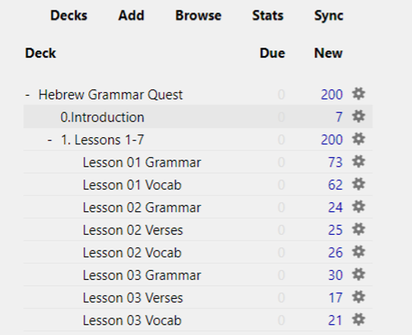

Figure 36.3: Anki Home Screen

Anki is free[82] flashcard application that contains a unique algorithm to present you with cards to review at just the right times.

Thus, it is not just a flashcard program but is a tremendous strength and endurance tool for learning, and it is where we will be spending the bulk of your time in the course. It has become the “go-to” for many medical school students to learn all the intricate facts they have to know.

It is beyond our scope to give you a complete tutorial on Anki. There are plenty of blogs and videos posted by the Anki community, which you can find from a simple websearch: Anki tuturial.

## Installation

**Anki NOTE**: Eventually, you can do all work from a mobile device. *For the initial Anki install, you do need to do these steps from a desktop*[83] *computer*.

Follow the steps outlined on the Quick Start page.

## Customize Anki Settings

1. Change USER1 Name
   1. In Anki, click File, then Switch Profile
   2. Select “User 1,” then Rename and type your name
2. Change global settings
   1. Click Tools, then Preferences.
      1. On the Basic tab, some people prefer night mode - if this is you, check the Night Mode box
      2. On the Scheduling tab:
         1. Check the box that says Anki 2.1 Scheduler.
         2. Note the hour the next day starts -
            * You want to set this for a time where you will NOT be doing reviews.
            * For most people, 4:00 am is a safe time, but if you’re routinely awake at 4:00 am, set this field to be earlier or later.

### Below is the main set you will want to change. Enter these numbers carefully:

1. Back on the main page, click the gear wheel to the right of “Hebrew Grammar Quest” and select “Options”
   1. New Cards[84]
      * Steps = 10 1440 4320
      * New cards/day = 200
      * Graduating interval = 15
      * Easy interval = 60
      * Starting ease = 250%
      * Bury related new cards... = Up to you but we recommend - CHECKED
   2. Reviews[85]
      * Maximum reviews/day = 9999
      * Easy bonus = 130%
      * Interval modifier = 100
      * Maximum interval = 210
      * Bury related reviews... = Up to you but we recommend - CHECKED
   3. Lapses
      * Steps = 10
      * New interval = 60
      * Maximum interval = 1
      * Leech threshold = 8
      * Leech action = TAG ONLY

Your settings should look like this: 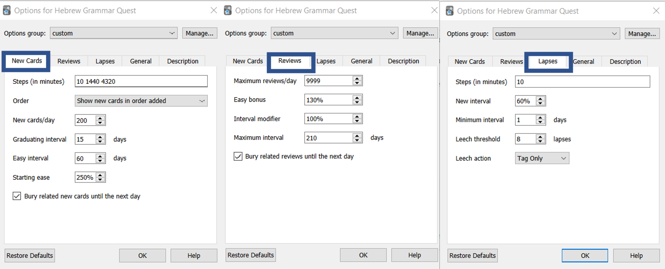

Return to Quick Start page

## How do I access Anki on my mobile device?

After you have installed Anki, loaded a deck and then synched to your Ankiweb account, theoretically, you do not ever need to access the non-mobile version again.

There are versions of the mobile app in the Google or Apple store. As we mentioned above, the apple version is a one-time cost of $25. Once you download the app, you can login with your same Ankiweb account and, if you synched from the desktop version of the software, you should see the Hebrew GRAMMAR Quest deck appear.

You can also access a [web-based version of Anki (login with your Ankiweb credentials)](https://ankiweb.net/decks/). Functionality is a bit more limited, but it is generally sufficient for the learning aspects. Please note you will need the not be able to meet the Graduation Process requirements for the Certificate or Diploma using only ankiweb.net

One note: if you plan to go back and forth between a computer and a mobile device, make sure you sync after each session.

Here are the steps:

1. On your laptop/desktop: Sync → Log In → log in using your account information
2. If a pop-up window asks you, choose “**Upload to** AnkiWeb”
3. On your phone, download and install the Anki app.
   * The Android app is free. The iPhone app costs $25.
4. On your phone, start the Anki app and log in using your account information
5. If a pop-up window asks you, choose “**Download from** AnkiWeb”
6. Anki will now automatically keep your work on your phone and laptop/desktop in sync.

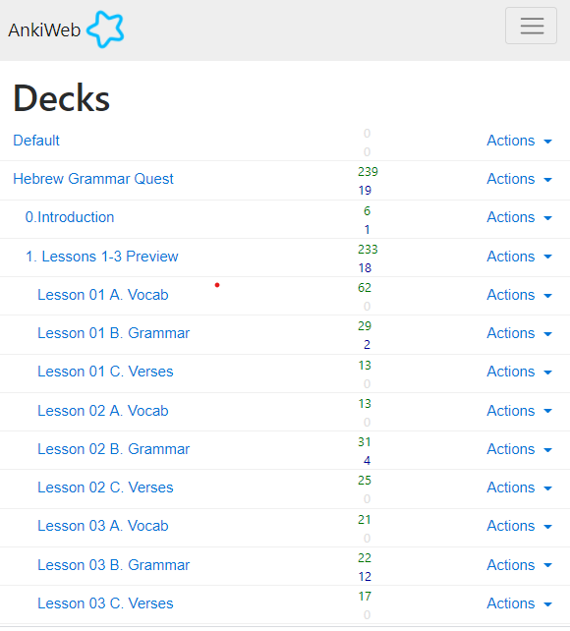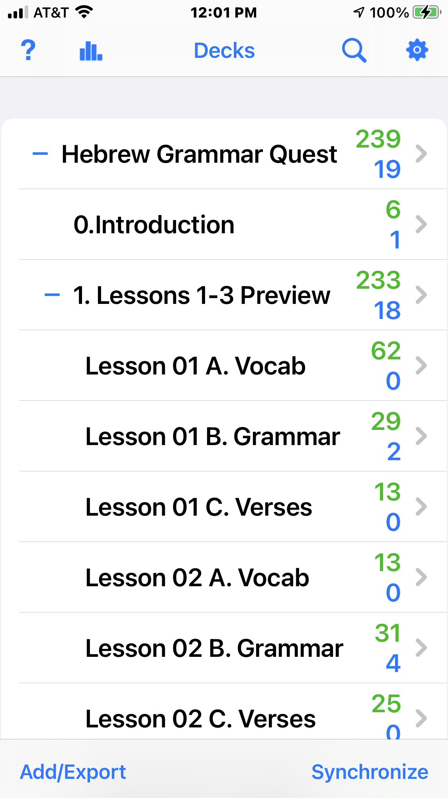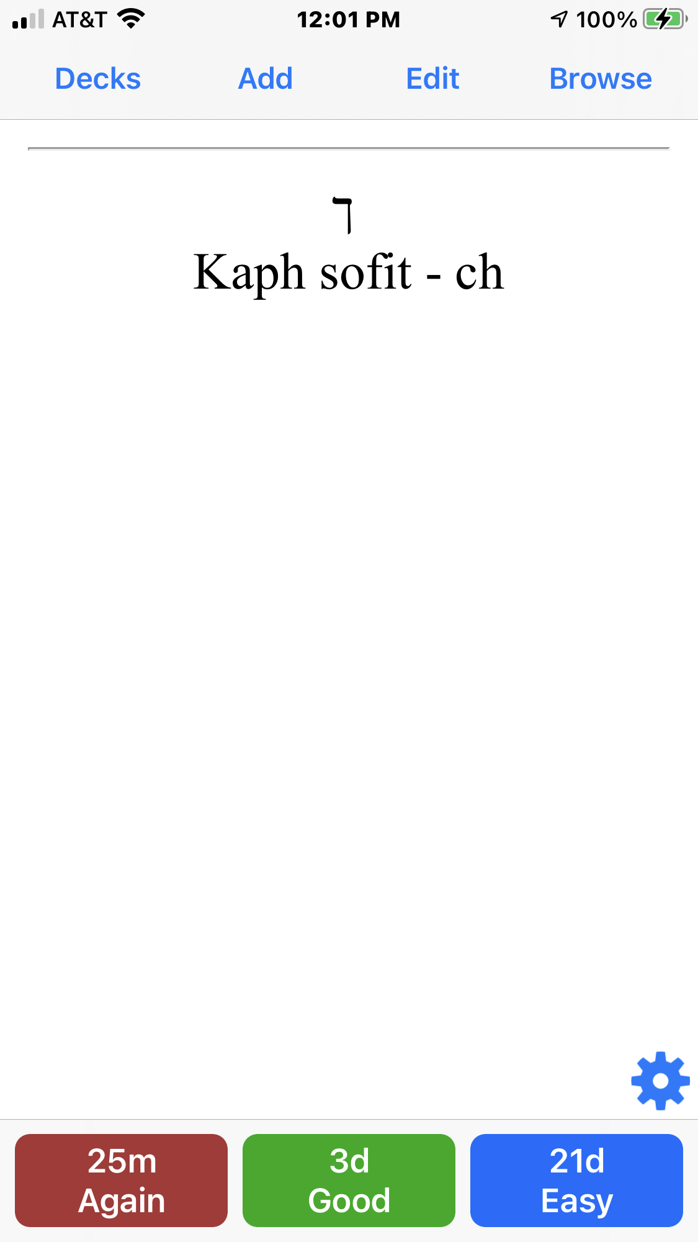

## How do I navigate within Anki?

* Click the +/- buttons to expand/collapse the folders within the Anki deck 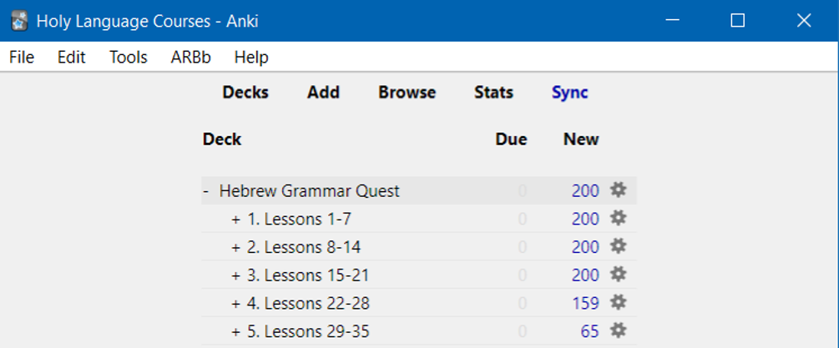
  + To start with Lesson 01 Vocabulary, expand to reveal this deck, click on Lesson 01 Vocabulary and click the STUDY NOW button
* Many cards have “hints” - click on the hint button to reveal
  + If you needed a hint, be sure to select Again on the answer side. See discussion below. 
* For cards that have audio, it should play when you are first shown the card. If you need to hear the audio again, hit the play button
* When you are ready to see the answer, click Spacebar, Enter, or the Show Answer button

## How do I know when to hit the Good button on a **Vocabulary** or **Grammar** card?

We suggest using the following guidelines to select the most appropriate answer.

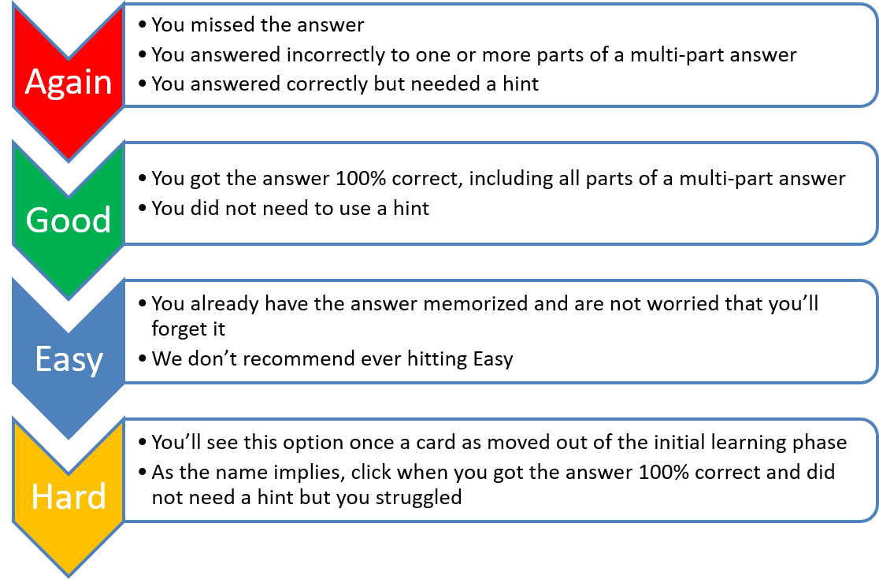

Figure 36.10: Anki Response Definitions

* There is no “value judgment” to hitting Again – you will learn on your timeline
* Be honest with yourself!
* If you doubt, between Again and Good, select Again.

## How do I know when to hit the Good button on a **Verse Translation** card?

While the same general guidelines apply to all cards, one of the main goals of this course is to give you the ability to translate from Hebrew to English at a basic level.

Below are some guidelines for answering the Verse Translation cards: * You do not necessarily need to be able to translate the entire passage from memory. Suppose you can comfortably read the Hebrew. Your translation is roughly similar to the English answer (it doesn’t have to be exact). In that scenario, you should hit good. 1. If your translation is missing one or more words (again excluding roughly equivalent meanings), you should select again. 1. If you need to use a hint, you should select again until you can translate without needing to refer to the hint. 1. We do not recommend selecting easy. An exception might be when you are confident that you already have the word, rule, or passage memorized.

Most importantly, be patient with yourself. It may take you many tries in the early going before you can hit good.

Learning a new language is not easy. We applaud you for the Hebrew learning road you are now taking!

## What are Anki Add-ons?

* Add-ons are small packages that extend the base application of Anki.
* Many add-ons are geared towards the developers/editors of decks, but there are a few that enhance the end-user experience
* To access, select Tools, Add-ons, then click Get Add-ons...
* You will then be asked for the add-on code, which will install the add-on
* Click Browse Add-ons to be taken to the Anki Add-on website, where you can get the code
* For example, this add-on will change the button colors:
  + The KING of Button Add-ons - 374005964.

## How often should I expect to work in Anki?

The best case is DAILY.

Once you get going, you may find you look forward to it.

There is a custom add-on called Review Heatmap. At the time we are writing this Guidebook, the Add-on is still in beta, so it’s not available on the Anki Add-on page.

* [Click here to download](./images/review-heatmap-v1.0.0-beta.1-anki21.ankiaddon)
* Then double-click and restart Anki
* You will now see a grid that shows you your daily reviews to keep you motivated

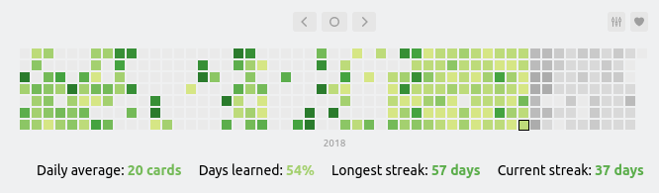

Figure 36.11: Keep your daily Anki streak going!

## How do I know when I’m done with a deck?

Learning and active-recall is an on-going process. In theory, Anki will keep scheduling reviews until you delete the deck. This follows a “use it or lose it” philosophy. If we spend a day learning some material but then don’t think about it again for two weeks, we’re likely to forget most of it.

So while this could be an indefinite process, we do have some guidelines as they pertain to the Course Checklist and the Certificate/Diploma.

* For the Course Checklist, all cards should be moved out of the New category and into the Young or Mature categories, with no cards Suspended or Buried.
* To qualify for a Certificate or Diploma, all cards must be in the Mature category with no cards New, Young, Suspended, or Buried.

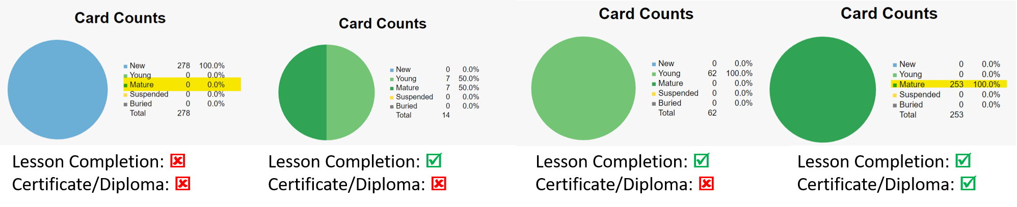

Figure 36.12: DESKTOP Card Counts chart from Anki Stats showing all cards = Mature

See the next two pages for more information on how to locate your statistics.

## Anki Completion Requirements for theCourse Checklist

For each lesson, we are looking for all cards to be moved out of the New category and into the Young or Mature categories, with no cards Suspended or Buried. Below are the steps to check.

*You must do the steps below from a Desktop (or laptop) or the ios/Android mobile app. Statistics are not available from the ankiweb.net site*.

1. In Anki, select the applicable deck, for example “Lesson 01 A.Vocab”
   1. On mobile, once you tap the deck it may take you into the deck information section.
   2. Click the left arrow in the upper left of the screen to access the bar chart icon
2. Click on Stats (desktop) or tap the Bar chart icon (mobile)
3. Scroll down to the Card Counts pie graph
4. If all cards are Young or Mature with no cards New, Suspended, or Buried as shown on the acceptable examples below, you can mark that deck as completed on your Course Checklist



Figure 36.13: DESKTOP Card Counts chart from Anki Stats showing all cards = Mature

## Anki Completion Requirements for the Certificate

To be eligible for the Certificate[86] and Diploma, you will need to provide a screenshot from the Anki Stats. The Card Counts pie chart should reflect ALL cards for the unit are in the Mature row.

*You must do the steps below from a Desktop (or laptop) or the ios/Android mobile app. Statistics are not available from the ankiweb.net site*.

1. In Anki, select the applicable unit, for example “Hebrew Grammar Quest::1. Lessons 1-3”
   1. On mobile, once you tap the deck it may take you into the deck information section.
   2. Click the left arrow in the upper left of the screen to access the bar chart icon
2. Click on Stats (desktop) or tap the Bar chart icon (mobile)
3. Scroll down to the Card Counts pie graph
4. If all cards are Mature with no cards New, Young, Suspended, or Buried, and you have done everything else for that unit on the Course Checklist, you are ready to apply for your unit completion Certificate or Diploma. CAPTURE A SCREENSHOT as directed below:
   * Desktop: Make sure the Statistics window is aligned on top of the main Anki widow so that the course name is visible as shown in the image below: 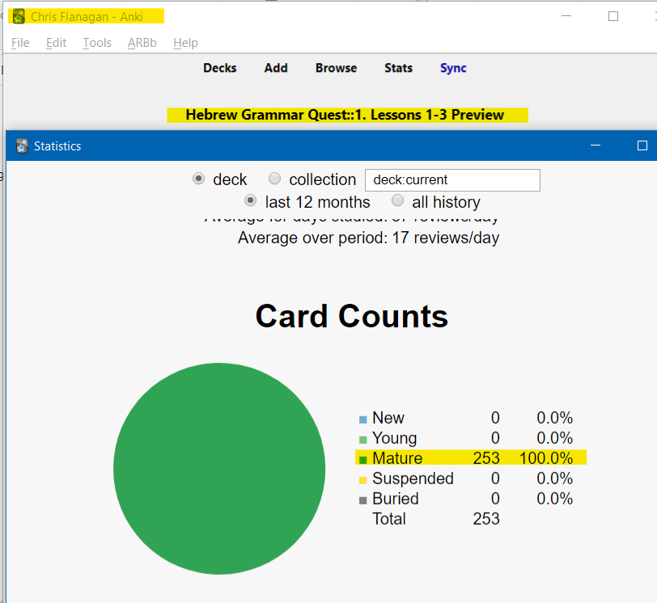
   * Mobile - simply capture a screenshot showing the Card Counts statistics as shown below:

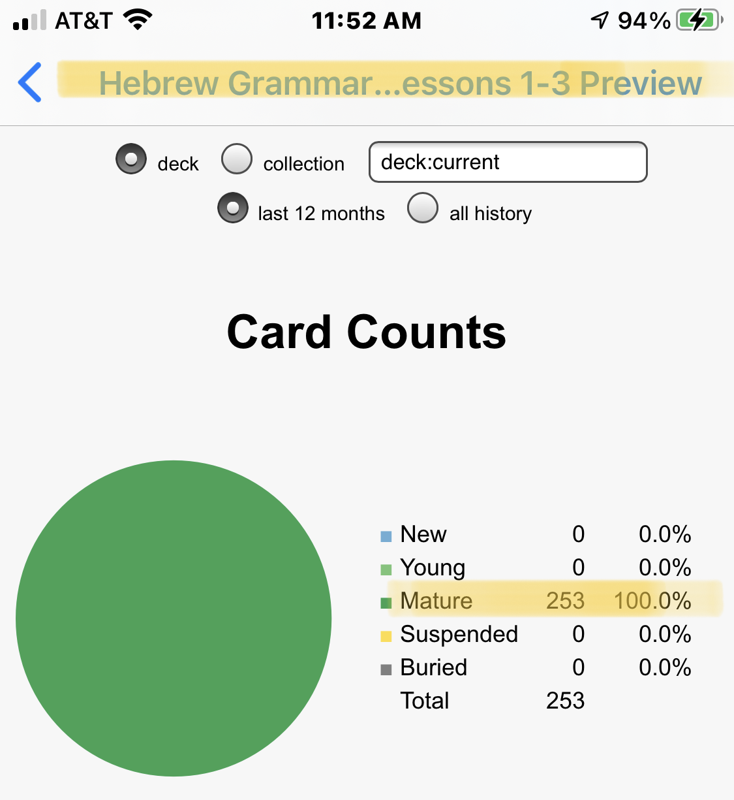

## What do the different card stages mean?

There are a few different terms Anki uses for different stages of card maturity:

* New Cards
  + Unseen - A card you have not seen!
  + Learn - a card you have seen that is in the initial learning phase. Based on our settings above, you need to get a card correctly three consecutive times for three days in a row (4320 minutes) to move from Learn to Young.
* Review Cards
  + Young - a card that has “graduated” from the Learn stage, but has a calculated review interval of less than 21 days
  + Mature - a card that has a calculated review interval greater than 21 days
* Lapse - a card formerly in the Review category that was answered incorrectly
  + Relearn - the phase to describe a lapsed card that you are relearning

## Can I add an image or a hint?

* If you would like to edit a card, such as to add a picture or change/add a hint - you can do this. Just press E.
  + You can do this from either the “question” or the “answer” side of the card
  + We do not recommend you change the word, definition or audio fields
  + To add an image simply copy and paste into the image field 

## Can I modify the layout of a card?

The short answer is yes, but you would need to learn more about how Anki works. Such a discussion is beyond our scope with this book. Still, if you are interested in learning more about Anki, there are dozens of YouTube videos.

### Proceed with caution:

With the above caveat, if you are comfortable with Anki, we have added some extra Note Types.

1. Click Browse.
2. Select the card(s) you wish to change
3. If you want to be tested on both Hebrew-to-English and reverse, English-to-Hebrew, select note type Vocab Basic Hebrew/English.
4. If you have added images and want Anki to test you on Hebrew-to-English, English-to-Hebrew, and Image-to-Hebrew, select note type Vocab Basic Hebrew/English/Image.
5. If you have added images and only want to be tested on Hebrew-to-English and Image-to-Hebrew, select note type Vocab Basic Hebrew/Image.
6. If you want to be tested audio to Hebrew (and reverse), select note type Vocab Basic Hebrew/Audio - the Aleph-bet cards use this note type Just be aware that changing to one of these optional note types will double (or triple if you chose Hebrew/English/Image) the number of vocabulary cards. If you decide you want to go back to Hebrew-to-English, repeat steps 1-4 and select Note Type Vocab Basic Hebrew.

## What does There are more new cards available, but the daily limit has been reached mean?

Anki is doing precisely what we told it to do in the settings! As much as possible, we want to let Anki tell *us* when to work.

* We go when it tells us there are cards to learn or review
* We stop when it tells us there are no cards

1. We set new cards to 200 - it’s essential not to overload yourself.
   * Generally, if you work one deck at a time, e.g. Lesson 01 A. Vocab, then Lesson 01 B. Grammar and so on, you will be less likely to hit the daily limit
   * You can keep going using the Custom Study. Do note the warning: You can increase the limit in the options, but please bear in mind that the more new cards you introduce, the higher your short-term review workload will become.
2. We checked bury related cards.
   * If an answer has two parts in two separate questions, we want to make sure you answer the second question from your knowledge, not because you just saw the solution on a related card
   * If you want to work on these cards anyway, click Unbury.

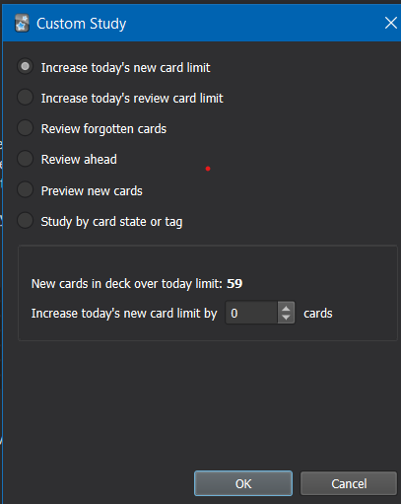

Figure 36.17: With Custom Study you can temporarily increase your daily new cards

## How do I submit screenshots for the Certificate?

# 37 More Hebrew Quest and Hebrew GRAMMAR Quest FAQ

* What is the difference between Hebrew Quest and Hebrew GRAMMAR Quest?
* Do I need to complete Hebrew Quest before I start Hebrew GRAMMAR Quest?
* When I complete this course, should I go back and finish Hebrew Quest?
* I haven’t started either course. Which should I do first?

## What is the difference between Hebrew Quest and Hebrew GRAMMAR Quest?

* Both courses are born of the same Holy Language Learning philosophy: the optimal method to interact with the Sacred Scriptures is by *doing*
* Hebrew Quest was intentionally designed to get students into Hebrew texts with as little “grammar” as possible
* Hebrew GRAMMAR Quest is designed to fill a gap for those students who want to know more about the inner workings of Hebrew but wish to do so in a fun, low-pressure format (as opposed to taking a formal Hebrew course or trying to read an academic-level textbook on their own)
* Also, we know that everyone learns a little differently
  + Many can view the 40 lessons of Hebrew Quest, and they “get it” concerning Hebrew
  + Others may have found themselves getting stuck on the “grammar” sections of Hebrew Quest and need some more in-depth grammar preparation before returning to the study passages
  + Still others made it through some or all of Hebrew Quest and have a desire to know more
* As we said earlier, wherever you find yourself, if you are interested in digging deeper, you have come to the right place!

## Do I need to complete Hebrew Quest before I start Hebrew GRAMMAR Quest?

* Emphatically - **No!**
  + This grammar course starts from the beginning (with learning the Aleph-bet) and assumes no prior knowledge of Hebrew
* With that said, the more of Hebrew Quest you have completed, the more comfortable you may find it is to work through the grammar material
* If we were to categorize as “good,” “better,” “best” in terms of Hebrew Quest completion, here’s what we would say:
  + **Good**:
    - You have completed some or no Hebrew Quest lessons
    - This means that the first three lessons of Hebrew GRAMMAR Quest might take you a little longer, but once you have that foundation, you’ll be up to speed
  + **Better**:
    - You have completed through Hebrew Quest Lesson 12 (the Aleph-bet and Vowels)
    - This means the first three lessons will go a little more quickly for you
  + **Best**:
    - You have completed through Lesson 15 (verbs) and beyond
    - This means that more of the concepts presented in Hebrew GRAMMAR Quest will tend to be things you have heard before versus brand new

## When I complete this course, should I go back and finish Hebrew Quest?

Hebrew GRAMMAR Quest is an extension of Hebrew Quest, not a substitute.

* So the answer to the question is, **ABSOLUTELY!**
* In fact, the most logical next step after completing a first-year Hebrew grammar course is to dig into the Scriptures and start reading.
* Hebrew Quest, starting with Lesson 16, is all about reading Hebrew[87].
* To say it differently, Hebrew Quest and Hebrew GRAMMAR Quest complement one another in a circular (and maybe slightly paradoxical!) form:
  + The more Hebrew Quest you have completed, the more you will get out of Hebrew GRAMMAR Quest, and
  + The more Hebrew GRAMMAR Quest you have completed, the more you will get out of Hebrew Quest
  + Either way, you can’t go wrong! The most important thing is to start.

## I haven’t started either course. Which should I do first?

* If the word “grammar” makes your stomach churn, then start with (and stick with) **Hebrew Quest**!
* Otherwise, we can suggest doing the first 16 lessons of **Hebrew Quest** - this will take you in-depth through the Aleph-bet and give you an overview of Grammar and give you an introduction to reading Proverbs.
  + Also plan to do Hebrew Quest Memrise or Anki so you can pick up your first two Certificates as outlined [here](https://holylanguage.com/graduate.html)
* Then hop over to this course and get a firm foundation of Hebrew grammar
* Then go back to Hebrew Quest lesson 17 and the study passages will have extra life for you
* This will likely take you a long time to complete both[88], but remember the proverb about the best time to plant a tree: “The best time was 20 years ago. The second-best time is today.”

Whichever direction you take, we would encourage you to ultimately complete both **Hebrew Quest** and **Hebrew GRAMMAR Quest**.

# 38 Other FAQ

* There are many books out there to learn Hebrew. What makes Hebrew GRAMMAR Quest different?
* What are the course Activities?
* Will I be required to buy anything?
* Who will (and who might not) benefit from Hebrew GRAMMAR Quest?
* What if I am a Bible teacher? Should I take this course?

## There are many books out there to learn Hebrew. What makes Hebrew GRAMMAR Quest different?

* As we say above, we want students to learn by **doing**
  + While **Hebrew GRAMMAR Quest** will cover the same concepts as a typical first-year Hebrew textbook, the instructional design team at Holy Language Institute are big proponents of *active* learning as opposed to passive learning
  + Reading a book is mostly a passive activity
  + Therefore, our goal for this interactive, self-contained book is to provide a quick orientation to the concepts[89]
* Textbooks have their place, but in our view, your “real” learning will take place when you complete the ACTIVities (see the root of the word “active” in there?)
  + This is the impetus behind the current “flipped classroom” philosophy in traditional education

## Will I be required to buy anything?

* **NO**. Other than being a subscriber to Holy Language Institute, you will not need to purchase anything for this course (unless you want to)
* We would like to disclose that the iOS version of the Anki app requires a one-time purchase through the Apple store of $25
  + Note: Holy Language Institute has nothing to do with this policy and receives nothing should you decide to purchase the app
  + The developers of Anki provide every other platform for free and say they use the proceeds from the iOS app to fund these different platforms and program enhancements
  + While the price is steep for an app, most online reviews say the cost is justified (a few pennies a day over a year)
  + If you have an Apple device and do not wish to purchase the app, you may use a web-based version of mobile Anki at no charge (you won’t be able to use it offline)
* There are lots of additional resources available that accompany Basics of Biblical Hebrew for free and to purchase - we will incorporate many of the free resources into this book package
* In other words, we have designed this book so that you should not need to purchase any additional learning materials
* With that said, if you wish to purchase *Basics of Biblical Hebrew* or any of the accompanying resources for a more in-depth Grammar study, some options are below[90]
  + [Basics of Biblical Hebrew Textbook](https://www.amazon.com/gp/product/031053349X/&tag=holylanginst-20)
  + [Basics of Biblical Hebrew Workbook](https://www.amazon.com/gp/product/0310533554/&tag=holylanginst-20)
  + [Basics of Biblical Hebrew Laminated Reference Card](https://www.amazon.com/gp/product/031026295X/&tag=holylanginst-20)
  + We would appreciate it if you would use one of the affiliate links, which allows Holy Language Institute to receive a small commission

## Who will (and who might not) benefit from Hebrew GRAMMAR Quest?

* Hebrew GRAMMAR Quest is focused on reading and understanding Hebrew for the English speaker.
  + If you desire to read the Hebrew Scriptures in the original language and have a greater comprehension of what you read, this course is for you!
  + If one was looking to be a fluent writer or speaker[91] of Hebrew, or teach Hebrew in a formal academic setting, this course probably would not fully meet that person’s goals (although it would be a terrific first step).
* This course focuses on Biblical Hebrew, not Modern Hebrew.
  + If you are looking to translate “can you direct me to the railway station?”, we apologize, but this course will not benefit you!
* Hebrew GRAMMAR Quest is designed to be self-directed and (mostly) stress-free.
  + By design, it does not have the accountability and rigor of a traditional academic program.
    - By saying it does not have “academic rigor,” we are **NOT** saying this course will be **easy**.
    - You will likely spend *many* hours on this course, mostly in Anki.
    - We believe it will be a tremendous investment you can make for the kingdom and the impact you can have on others.
    - When you start to see your knowledge building up in Anki, we believe you will find it rewarding and fun as well.
  + Those who are seeking more of an academic/seminary type of setting might fare better with a traditional, instructor-led, Hebrew course (but the more of THIS course you complete, the easier THAT course will be!).

## What if I am a Bible teacher? Should I take this course?

* We believe this course, in conjunction with **Hebrew Quest**, would prepare a pastor or teacher of a traditional Christian or Messianic congregation to have a basic understanding of the Hebrew text to be able to exegete and communicate beginning and intermediate level Hebrew/Hebraic concepts to a lay audience.
  + Additionally, for those who have had first-year Hebrew at seminary (perhaps many years ago) but have struggled to apply knowledge of the original language to their vocation, or for those pastors/teachers who may have never taken a grammar course in Hebrew, ***our prayer is that this course, along with Hebrew Quest, will give new life to Hebrew application in that person’s teaching ministry***[92].

# 39 Lexicon

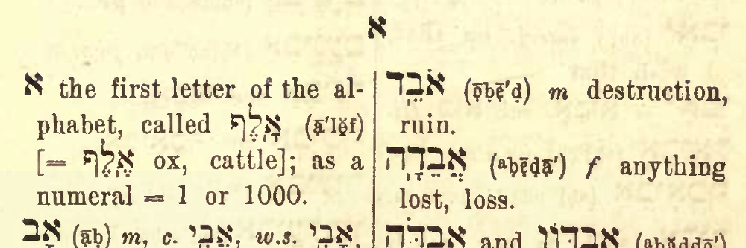 The authors of Basics of Biblical Hebrew have created an abridged Lexicon to accompany this course. This document is nice as vocabulary words are indexed to the Lesson #, and irregular plural forms and selected construct forms are also included.

[Open/download BBH Lexicon](./images/BBH_Lexicon.pdf)

You are also encouraged to check out the Lexicon resources in the [Holy Language Heritage Library](https://holylanguage.com/resources-dictionaries.php). They are much more exhaustive.

# About Holy Language Institute



***Jesus is Jewish.***

What if you could get closer to him through Hebrew?

Read on to see what “Following Yeshua, in a Hebrew way, together” means to us.

## Following Yeshua

When the first disciples heard “follow me”, they understood they were being invited into a relationship with this Rabbi from Nazareth. Through this journey of discipleship they would become like him and go on to change the world with him. They knew that following Yeshua was all about knowing Yeshua. That’s what our learning experiences are all about.

## In a Hebrew Way

The disciples of Jesus joined him in reading the Hebrew Bible and praying the Hebrew prayers. That’s why this isn’t just a language - it’s a way of following in the footsteps of the Master, a way of encountering the King of the Jews through the language of his people.

## Together

The men and women who followed Yeshua became a safe and loving community. Same with us! As an organization we’re Holy Language “Institute”. As a community of disciples we’re the Holy Language “Tribe”. Together we’re a movement, making disciples and changing the world.

***LEARN MORE:***

[Email sign-up](https://holylanguage.com/index.html)

[Become a member](https://holylanguage.com/subscribe.html) to access the full Hebrew GRAMMAR Quest course, as well as our complete library of teaching materials.

# Acknowledgments

All honor and glory to Yeshua, our Lord. שֵׁם יְהוָה אֶקְרָא

Our thanks to Dr. Gary Pratico and Dr. Myles Van Pelt for Basics of Biblical Hebrew, the seminary textbook that inspired the format of **Hebrew GRAMMAR Quest**. We encourage any of our students who wish to go further with Hebrew grammar to purchase the textbook or any related materials.

Additionally, our thanks to Dr. John Beckman for making his extensive library of materials to accompany Basics of Biblical Hebrew freely available for reuse under CC-BY-SA.

Yihui Xie is the genius who developed the [Bookdown](https://bookdown.org/) tool, which is the engine behind publishing this interactive book. Without Bookdown, we would not have been able to achieve those bullet points listed on the What we wanted in our course page related to the ease of lifting the project and making it available to our subscribers for free, while maintaining a professional look.

Finally, we thank YOU for your interest in this course!

# About the designer of this book

* Chris Flanagan has been a member of HLI since 2013 and joined as a ministry volunteer in 2015.
* He has completed Hebrew Quest as a student, which planted a desire to dig deeper into the original languages. He has completed both Hebrew and Greek courses at the seminary level.
* He has worked on a number of projects for HLI from an instructional design standpoint, including leading of “Hebrew Quest Memrise” and now “Hebrew Grammar Quest”
  + This work is simply a compilation of many various first-year Hebrew resources, which he has knitted together to present in an original and engaging format
  + For this reason, he likes to refer to himself as the “designer” or “compiler” of this dynamic Hebrew learning tool, and not the “author” of a static book
* Professionally, Chris has worked in the healthcare compliance field for over 30 years
* Personally, Chris is married and has two men in college. He and his wife, Sarah, love to travel, especially to Israel; (which, as you can tell, has inspired the format of each lesson in this book)



Figure 39.1: Chris Flanagan

# 40 X LessonTitle

To comprehend Biblical Hebrew, we must be able to . . .

Say something general bridging the desired outcome above with the learning objectives below

**LESSON ITINERARY**

1. learning_objective_1
2. learning_objective_2
3. learning_objective_3
4. learning_objective_4
5. learning_objective_5
6. learning_objective_6
7. learning_objective_7

**EQUIPMENT CHECK**

Before continuing, can you describe the following concepts?

## X First Thought

### X

*verse (reference 1:1)*

-brief meditation-

Listen to the verse in Hebrew:

Your browser does not support the audio element.



Figure 40.1: Capernaum and Mount of Beatitudes - suggested location of Yeshua’s teachings we call ‘the Sermon on the Mount’ (Matthew 5-7). Courtesy of the [Pictorial Library of Bible Lands](https://www.bibleplaces.com)



## 40.1 X Point1

## 40.2 X Point2

## 40.3 X Point3

## 40.4 X Verb Stem Table

## 40.5 X Meanings

## 40.6 X Strong Word-initial Combinations

## 40.7 X Strong Stem Vowels

## 40.8 X : what to memorize

## 40.9 X Perfect Strong

|  |  |  |  |
| --- | --- | --- | --- |
| Sing | Paradigm | Plural | Paradigm |
| 3ms | ***** | 3cp | ***** |
| 3fs | ***** |  |  |
| 2ms | ***** | 2mp | ***** |
| 2fs | ***** | 2fp | ***** |
| 1cs | ***** | 1cp | ***** |

X Perfect Strong from *Hebrew Quest* Chapter 15

Your browser does not support the audio element.

## 40.10 X Imperfect Strong

|  |  |  |  |
| --- | --- | --- | --- |
| Sing | Paradigm | Plural | Paradigm |
| 3ms | ***** | 3mp | ***** |
| 3fs | ***** | 3fp | ***** |
| 2ms | ***** | 2mp | ***** |
| 2fs | ***** | 2fp | ***** |
| 1cs | ***** | 1cp | ***** |

X Imperfect Strong from *Hebrew Quest* Chapter 15

Your browser does not support the audio element.

## 40.11 X Imperative Strong

|  |  |  |  |
| --- | --- | --- | --- |
| Sing | Paradigm | Plural | Paradigm |
| 2ms | ***** | 2mp | ***** |
| 2fs | ***** | 2fp | ***** |

## 40.12 X Infinitives Strong

|  |  |
| --- | --- |
| Type | Paradigm |
| ∞ | ***** |
| A | ***** |

## 40.13 X Participle Strong

|  |  |  |  |
| --- | --- | --- | --- |
| Sing | Paradigm | Plural | Paradigm |
| ms | ***** | mp | ***** |
| fs | ***** | fp | ***** |

## 40.14 X Parsing Examples

* Word:

$WI=$

$Sufformative=$

$Root=$

$V_{S}=$
  + *****
  + Result:
* Word:

$WI=$

$Sufformative=$

$Root=$

$V_{S}=$
  + *****
  + Result:
* Word:

$WI=$

$Sufformative=$

$Root=$

$V_{S}=$
  + *****
  + Result:

## X Word Warm-up

Click to open Word Warm-up video in a new tab

## X Verses Warm-up

Click to open Verses Warm-up video in a new tab

## X Anki

* Lesson xx A. Vocab
* Lesson xx B. Grammar
* Lesson xx C. Workbook
* Lesson xx D. Study Verses

## X Worksheets: NameOfWorksheet

Name of worksheet

## X Ruth Pursuit

Your Quest: Find all xxx Verbs in Ruth 1 (Yellow)

* [Blank copy of Ruth 1](https://drive.google.com/file/d/1qcfTKAlTJGChC2eYCMhSbY2w-ibzCcDV/view?usp=sharing)
* [Ruth Pursuit Answer Key #xx](./images/xx_Ruth_Pursuit_KEY.pdf)

## X Hebrew Quest Study Passage: Book

Blank copy of Book ##

1. Read through the passage straight through
2. Now re-read the passage critically, highlighting ([lexicon here](https://holylanguage.com/resources-dictionaries.php) and translating (you will need to parse verbs to translate) 3.[Watch Izzy’s *Hebrew Quest* video (video opens in a new tab)](https://holylanguage.com/john-1.php)
3. After the video, assess your translation. How close was it?
4. How did the Ruach HaQodesh speak to you through the passage?

Optionally, you may complete the passage memorization in Memrise [here](https://app.memrise.com/course/5406435/hebrew-quest-lessons-1-to-40/28/garden/learn/?source_element=level_details_session&source_screen=level_details).

## X Quest Quiz

Open Quest Quiz #xx in a new window

## X Claim your next Twelve Tribes Badge!

Check to be sure you have have completed **all activities** through this lesson, then fill out the form below.

Check to be sure you have completed all ACTIVities here, complete the certification below, and your badge will be on its way!

Avraham, Yisrael. 2012. “Hebrew Quest.” 2012. <https://holylanguage.com/quest.html>.

Beckman, John. 2012. “Materials for Basics of Biblical Hebrew, Second Edition.” 2012. <https://hebrewsyntax.org/bbh2new/>.

DeLauro, David. 2009. “Scholars Gateway.” 2009. <https://scholarsgateway.com/>.

Pratico, Gary D, and Miles V Van Pelt. 2007. *Basics of Biblical Hebrew: Grammar*. Grand Rapids, MI: Zondervan.

Stiles, Wayine. 2013. “How to Prepare for a Holy Land Tour.” Wayne Stiles. February 20, 2013. <https://waynestiles.com/how-to-prepare-for-a-holy-land-tour/>.

Xie, Yihui. 2016. *Bookdown: Authoring Books and Technical Documents with R Markdown*. Boca Raton, Florida: Chapman; Hall/CRC. <https://github.com/rstudio/bookdown>.

Xie, Yihui, Christophe Dervieux, and Emily Riederer. 2020. *R Markdown Cookbook*. Boca Raton, Florida: Chapman; Hall/CRC. <https://bookdown.org/yihui/rmarkdown-cookbook>.

1. Minor or parenthetical/non-essential points will be included as footnotes throughout each lesson.
2. We are following the same chapter organization as the textbook Basics of Biblical Hebrew, while extensively leveraging supplemental materials created by Dr. John Beckman, which he has generously made available for free to the Hebrew learning community. See the Course Structure and our Acknowledgments pages for additional information.
3. See appendix for more information on Anki if you are not familiar with it.
4. For example, in a seminary course, the 36 lessons in Basics of Biblical Hebrew are usually completed in 16 weeks.
5. For example, there is usually an emphasis on writing Hebrew and conducting English-to-Hebrew translations. While these may be important skills to become fluent in Hebrew, one does not need these skills to read and understand the Bible.
6. See discussion on “The Fog” in the appendix
7. *Sofit* is just the Hebrew word for final
8. “Final Kaf,” “Final Mem,” etc., are also terms you may hear.
9. See also Lesson 3 of Hebrew Quest
10. The ז is also a sibilant, but as it turns out, it is not generally affected by the SQiN eM LeVY exception.
11. "Seminary Hebrew" is a term borrowed from Dr. John Beckman. We don’t say "Seminary Hebrew" to be disrespectful; we only mean to differentiate between the two pronunciation types.
12. Please read Izzy’s statement on the Covenant Name: “When I filmed Hebrew Quest I read God’s Hebrew name as”Yahweh“. This is a relatively common practice in academic circles and was also an expression of my personal love for God’s holy name. Since then though I’ve encountered conclusive evidence that Yeshua and his disciples followed the Jewish tradition of saying”Adonai" instead of using the Sacred Name. It’s my deep conviction that we should follow the example of Messiah and his apostles, so I’ve returned to saying “Adonai” (Hebrew for “the LORD”) or “Hashem” (Hebrew for “the Name”) instead of using the Sacred Name, and I encourage our students to do likewise."
13. The color is to let you know what color the answer key will use, but feel free to highlight in any color, underline, change the font color, or otherwise identify anyway you like.
14. Image Source: Originally uploaded as en:<File:Example> of biblical Hebrew trope.svg on 04:27, 19 November 2006 (UTC) by en:User:SyntaxError55.
15. We will learn that Hebrew loves to break the rules. In the next lesson, we will learn about an exception to the “vowel comes after” rule, called the *furtive patach*.
16. Many academic textbooks will use the term “Shewa” instead of “Sheva”. Both words mean the same thing.
17. We’ll explain what this means in the next lesson
18. “Defective”, in this sense, does not have a negative connotation.
19. Mayim is one syllable as we will learn in Lesson 3. הַשָּׁמַיִם means “the heavens.” From now on, we won’t always provide a translation for every new word you encounter. It’s more important that you focus on the concepts. You will have PLENTY of vocabulary work in Anki!
20. The * means this is not a real Hebrew word, but we show it in this form for illustration.
21. Not entirely unlike the English apostrophe in words like *can’t*.
22. Remember we said in the introduction that content in “light” information boxes should usually be memorized. You will want to memorize the Dagesh Forte rule.
23. Strictly speaking, there are exceptions. We only have one in this course and we won’t see it until Unit 4.
24. Yes, a patach. Dagesh Forte
25. No. Dagesh Lene
26. No. Dagesh Lene. The “hyphen” looking mark is called a Maqquef. It has the same function as the Hyphen does in English.
27. No, it is preceded by a Sheva. Dagesh Lene.
28. Yes, a Hiriq. Dagesh Forte
29. An answer key is on page two. Repeat this worksheet until you can complete it correctly entirely from memory. The translation column is optional.
30. In most word processors, you won’t be able to isolate the vowel to highlight. Get as close as you can.
31. The other vowels that use hei are less common, but we will see them when we discuss verbs.
32. We haven’t learned to spot Qamets Hatuf yet, and Qibbuts does not appear in this passage
33. You should be able to make out the word that has the Hateph Qamets Hatuph
34. In at least three of the cases, you should be able to figure out who is speaking.
35. Once published, the full thirty-five lesson course will have a badge to be claimed after every two to three lessons. There is only one badge available in the preview version of the course.
36. Later in the course, we will learn about a mark called a maqqef, which is like a hyphen in English. In Hebrew, the word to the right of the Maqqef technically does not have an accent.
37. Modern Hebrew has words (mostly borrowed from other languages) that don’t always follow this rule
38. Hebrew has a very elaborate system of [cantillation marks](https://en.wikipedia.org/wiki/Hebrew_cantillation) that also serve to indicate where the accent of the word is. are used for chanting and singing. A study of these marks is beyond the scope of this book.
39. <small) If there is a syllable AFTER the accented syllable, technically it is called “Posttonic,” but you will not encounter this term for the remainder of this course.
40. A Sheva at the **end** of a word is **always silent**, even when it is the second of two consecutive Shevas.
41. These vowels often but do not always reduce (see section 3.6). Unchangeable long vowels will never reduce.
42. With this said, “buy” it makes a handy mnemonic for remembering this word means ‘house’, as there are a few look-alike words.
43. Unfortunately, many Tanachs DO not differentiate.
44. Not all endingless nouns are MS. Some common words are endingless but are classified as FS: אֶ֫רֶץ (land), עִיר (city), and אֶ֫בֶן (stone). When this occurs, most vocabulary lists will mark the word as “(F)”.
45. When you see an asterisk in the context of a word form, it means this form is impossible. The form is being shown for illustrative purposes only.
46. Hebrew Grammars have what are called “paradigm words” to represent any combination of consonants meeting the patter. קטל is a paradigm for any three strong (non-guttural) letters, עמד represents any guttural in the first position, and בחר represents any guttural in the second position. The examples use these paradigm words.
47. In contrast, *Basics of Biblical Hebrew* places significant emphasizes on learning the spelling rules. This is not wrong; it is just not our approach.
48. Or, as Dr. Van Pelt likes to say “virtually NO DOUBLING, because nothing changes.”
49. Pronominal suffixes are the subject of Lesson 9
50. Lesson 10
51. A chuckle-worthy example is 1st Samuel 6:3 when the Philistines realize that the Ark is causing nothing but trouble for them. They purposed to send the Ark back to Israel, but said “send it not empty!” They sent it back with trespass offerings representing the plagues they suffered: five golden mice and, apparently, five golden hemorrhoids!
52. As with most grammar rules, there are exceptions. For now, stick with these definitions of Type 1 and Type 2.
53. Note: Many English Bibles contain a footnote at Ruth 1:20 that Naomi means “pleasant”; however, the precise etymology of Naomi’s name is unclear. While her name appears to have a Type 1 1CS suffix, since it is a proper name, we are not including it in our answer key.
54. מִ֭שְׁלֵי שְׁלֹמֹ֣ה is a construct chain that means “THE proverbs of Solomon.”מִזְמ֗וֹר לְדָ֫וִ֥ד means “a psalm of (to) David”, but this is not a construct chain.
55. That is the next to last syllable position.
56. Odd 1-35, 39, 41, 42, 44, 45, 47 are Absolute; 37 and 38 are ambiguous; even 2-36, 40, 43, 46, and 48 are Construct. Most often it is “Long vowel, not a vowel letter” that identifies absolute.
57. ב is used as a placeholder. *Basics of Biblical Hebrew* has these as lowercase letters, while Beckman’s version uses uppercase. As you know by now, Hebrew GRAMMAR Quest primarily follows Beckman’s conventions.
58. Of all the vowel letters, Hebrew verbs tend to use only these three as stem vowels
59. Older Hebrew grammars, including “Essentials of Biblical Hebrew” available in the holylanguage.com resource library, refer to these as “Pe”, “Ayin” and “Lamed” positions, from the verb פעל, which is the root for the verb “to do”.
60. Hebrew grammars such as *Basics of Biblical Hebrew* use קטל as the “paradigm verb”, where the ק = any consonant in $R_{1}$, ט = $R_{2}$, and ל = $R_{3}$. This is somewhat awkward as the verb קטל means “to kill.” See the discussion on this later in this lesson.
61. Some grammars classify “Corhortative” and “Jussive” as “Verb Moods” and the remaining as “Verb Tenses.”
62. Remember, the * means the Hebrew word is an impossibility, but is shown for illustrative purposes
63. A Daghesh is a Forte if it is preceded by a vowel that is not a Sheva.
64. Even those verbs with three weak letters are still referred to as ‘doubly weak’
65. An imperfect verb *with* the Vav Consuctive changes the verb’s aspect to Perfect. We’ll study this in Lesson 17.
66. Historically the QI $Pre$ did not come the Rule of Sheva, however pretending that it did makes it easy to recognize QI 1G verbs.
67. “MAY seize” here is intentional. Sometimes אחז is regular and sometimes it is “angry.”
68. Also, you could imagine one of the dots of the Tsere representing the dropped Yod - turn it into a Yod and you have $\hat{I}$, which is a more normal-looking QI $Pre$. If you “see” this and it helps, great! If you don’t, forget about it and don’t let it confuse you!
69. Scholars debate whether this has any meaning. “Paragogic” is Greek for “dragged along.”
70. This is the mathematical symbol for “does not exist”; in our context, it means there are no examples of the QP2fp with a pronominal suffix in Scripture.
71. If you ever have a need to generate the infinity symbol on a desktop computer, ∞, make sure the Num Lock is on (and use the numbers on the keypad layout, not the ones on the top row), hold down the Alt key and type 236, then let go of the Alt key. On a phone, you can often type infinity and the ∞ symbol will appear.
72. The technical term for the first statement is the *protasis*, and the second statement is called the *apodosis*.
73. Chisholm. *A Workbook for Intermediate Hebrew*, page 286.
74. ibid. p. 133
75. When in doubt, CHALOT provides a spelling of each word used. P. 165 includes נִכְרָֽת as Niphal Perfect.
76. See CHALOT p. 150
77. Of the three examples on this page, this is the only one where a 1-nun might be plausible. We have the ל which is a common prefix to an infinitive construct. If there was a verb נמד, we might want to probe this further as a possible ∞, but we don’t know a verb נמד. Even if we did, the vowels don’t match up. We DO know a verb למד though. Like in other areas of life, when we have a set of multiple possibilities, the most direct path is often the correct one.
78. To “connect the dots”, if $V_{2}$ MUST be a Dagesh Forte, than $V_{1}$ MUST be a vowel that is not a sheva.
79. The remaining conjugations are rare in the Hebrew Bible, so we will skip them.
80. Beckman. “Notes on Ruth” p. 27. <https://hebrewsyntax.org/bbh2new/00_Ruth_notes.pdf>
81. BBH mentions that there are three times n the Bible when $R_{1}$ = צ, not only will the ת switch places, it will change to ט.
82. all platforms are free, except for the iOS app, which costs $25. The developers use the proceeds to fund future development. Most reviews say the cost is worth it if you have Apple devices and use Anki regularly.
83. By “desktop” we generically mean a desktop or laptop computer (as opposed to a mobile device) running a Windows, Mac, or Linux operating system.
84. See <https://docs.ankiweb.net/#/deck-options?id=new-cards> for additional information
85. See <https://docs.ankiweb.net/#/deck-options?id=reviews> for additional information
86. Certificates are not available in the Preview Version of Hebrew GRAMMAR Quest.
87. Although, with your more in-depth knowledge, you may be able to go a little faster. If the Hebrew Quest videos are too slow for you, click the “Settings” gear icon in the bottom right corner of the video, click “Speed,” and then select a faster speed.
88. It probably is not entirely unreasonable to be able to do two lessons per week, but be prepared to spend a LOT of time in Anki (or Memrise, for Hebrew Quest). One lesson per week is probably a better pace. In any case remember you get out of it what you put into it. It’s a marathon, not a sprint!
89. If you’re looking for a stand-alone textbook, there is none better than Basics of Biblical Hebrew.
90. Before purchasing, we would like to make our students aware that the authors of these materials take an academic, as opposed to a reverential approach regarding God’s Holy Name. You will see the transliteration of the Tetragrammaton printed on nearly every page. While we believe this is unfortunate and unnecessary, Basics of Biblical Hebrew remains an excellent resource for an in-depth study of first-year Hebrew grammar.
91. There are speaking activities beginning with Lesson 3, but this is more to engage additional senses in the learning process and not to become a fluent reader.
92. This book’s compiler can testify to this!